Comparing 31 European Countries Responses to the Covid-19 Crisis
Mads Dagnis Jensen, Kennet Lynggaard and Michael Kluth

Introduction
The Covid-19 pandemic erupting in 2020 represented the perfect storm for national political systems. The crisis that emerged in the wake of the pandemic was multidimensional in nature. It fundamentally challenged political institutions, political processes and virtually all policy sectors. This study examines similarities and differences in how governments across all 27 EU member states in addition to the UK, Iceland, Norway and Switzerland responded to the Covid-19 pandemic. We set out to map European governments responses to the pandemic and examine to what extent the policy processes deviate from normal policymaking. By inquiring: who were empowered and disempowered in the policy process compared to normal policymaking, we also seek to gauge whether the crisis has had a lasting impact on the examined polities. To his end, the role of politicization and de-politicization on both policy outcomes and in affecting the relative influence of executives, legislatures, interest groups and other actors is investigated.
Structure and questions
Based on 31 country chapters in an edited book about to be published by Palgrave MacMillan and an author survey detailed below, we shall first summarize European governments policy responses to the pandemic. In order to understand similarities and differences in Covid-19 responses we first examine if variations reflect geographic North-South-East cleavages which largely corresponds to different levels of affluence, economic distributional legacies and democratic embeddedness highlighted as structural determinants of response patterns by notable examples of the already substantial Covid-19 policy literature. Secondly, we assess patterns of governance looking at which actors were empowered and disempowered in the policy process and what was the mode of interaction between actors compared to normal policymaking. Third, we look at variations in the dynamics of politicization. Finally, we discuss to what extend patterns of governance and different dynamics of politicization may have affected variation in policy responses while gauging the long term impacts on the polities.
Structural determinants of Policy Responses to Covid-19 and country groupings
A spawning academic literature has emerged in wake of Covid-19 dealing with numerous aspects of national and international responses. But relatively little has been published seeking to conduct structured comparisons of policy outcomes or for that matter comparing the impact of polity variables on variations in national responses. Hence European comparisons on how polity variables such as patterns of governance and politicization relate to Covid-19 government responses are limited but their numbers are rapidly growing.
A 2020 special issue of Policy and Society edited by Capano et al. (2020) offered a comprehensive survey of relevant policy literature in an endeavour to explain variations in the commencement, speed, and scope of government response to the pandemic in nine countries and one territory. Dimensions singled out included skills, policy capacities and past experiences highlighting the importance of structural factors.
A number of ‘global’ qualitative and comparative studies have come out with a substantial European representation. Hence Greer, King, Fonseca and Peralta-Santos, (2021) survey more than 43 territories, countries and regions and finds that: 1. Social policies have been decisive in ensuring compliance among socio-economic vulnerable groups thus broadening Covid-19 response policy options. 2. Regime type was not a particularly conclusive variable for policy responses except that authoritarian regimes were less inclined to employ social policies to enhance compliance opting rather to rely on coercive measures. 3. Formal political institutions was of little importance when comparing unitary vs federal states but clearly mattered when comparing majoritarian vs consensual systems 4. The relationship between dedicated public health capacity and government response was weak.
Egger, Magni-Berton, Roché and Aarts (2021) examined a number of hypotheses explaining variation in government responses to the pandemic among EU member states. The first three hypotheses concerned the initial severity of the pandemic and the capabilities available to states. Initial severity had little impact on policies adopted while only the most aggregate capacity measurements of health expenditure of GDP and sovereign debt relative to GDP correlated with the stringency of measures adopted. Generally, affluence correlated negatively with stringency. The remaining hypotheses focused on public trust, checks-and-balances, state of emergency, prevalence of authoritarian political culture and the ideology of authoritarian parties. The study found that public trust mattered, but was strongly correlated with affluence and health spending relative to GDP. In terms of politics, variations in checks-and-balances were found to be of limited importance on stringency as the Pandemic triggered a rally around the flag effect. The likelihood of declaring a state of emergency did not correlate with checks-and-balances but it would seem the powers of the police and military was restricted ones a state of emergency was declared in states with strong checks-and-balances. Countries with a long democratic tradition were more cautious in adopting stringent measures but there was no significant correlation between party ideological preferences for authoritarianism and policy responses. In sum long term structural factors such as affluence and democratic and distributional legacy outweighed specific pandemic related or contemporary domestic policy issues in explaining variation.
Taking cues from the above, the countries covered by this study are each assigned one of three broad groupings: North, South and East. Besides geography, this division reflect the structural features highlighted in the literature including democratic institutional entrenchment, affluence and distributional policy legacies.
The Northern grouping include affluent states with strongly entrenched democratic institutions and a prolonged practice of re-distribution. While the comparative welfare state literature (e.g. Esping-Andersen, 1990) offer typologies identifying at least three distinct models adopted by the countries in this grouping, they are treated in unison to reduce complexity and to highlight their shared high level of professionalism in welfare service delivery, including the health sector, and proactive use of Treasurer to reduce inequality.
The Southern grouping share an intermediate level of affluence although some are now being overtaken by economically successful states in the Eastern grouping. Yet, the Southern grouping has had a longer period of intermediate affluence reflected in savings, pensions systems and asset pricing according them somewhat higher financial resilience than in the Eastern grouping. Institutional entrenchment is fairly robust but marked by the more recent adoption of democracy (Portugal, Spain, Greece) or independence (Malta, Cyprus) in several states. Countries in the Southern grouping all aspire to maintain welfare states but fall short of attaining levels of compensation and service provision enjoyed by the North. This has fueled a comparative welfare state literature seeking to identify a distinct Mediterranean model (e.g. Ferrera, 1996).
The Eastern grouping all transitioned from socialism to liberal democracy after the cold war. They range from intermediate to low levels of affluence which on average remains lower than in the Southern grouping. Life savings were often wiped out for older generations during the transition and pensions schemes and asset markets were reset after the cold war. Institutional retrenchment is limited reflected in several prominent examples of democratic backsliding in major states such as Hungary and Poland. Welfare state service provision and redistribution mechanisms are rudimentary compared to the Northern and Southern groupings.
All groupings collect a fairly disparate mix of countries with many borderline cases. Estonia is also a Nordic state and fit many features assigned to the Northern grouping. Despite its affluence, France shares institutional traits similar to prominent states in the Southern grouping and some British welfare state scholars would likely question the wisdom of placing the United Kingdom in the same grouping as Scandinavia. Hence the groupings are simplifications and approximations solely employed to explore how structural factors such as institutional entrenchment, affluence and public welfare provision align with polity and politics factors such a patterns of governance and politicization.
Methods
This chapter combines insights drawn from all country contributions with a comprehensive unique data set created in connection with the book through an expert survey among all authors. The strength of expert surveys is the generation of standardized data based on respondents' in-depth knowledge of the topic though, importantly, any interpretation of the data must consider the perceptual nature of the survey responses. While the survey consists of one response per country, many answers were collective assessments involving two or more experts reflecting the mostly co-authored book chapters.
The survey was conducted in Qualtrics and answers to most of the questions were randomized. The survey was tested on a group of people with expertise in survey designs and adjustments were made based on their feedback. After collecting responses, data have been cleaned and processed. Data are used descriptively enabling us to examine both the breadth and depth of the field, but it does not allow us to uncover latent or causal relationships.
The survey cover government policy responses to the Covid-19 crisis for the period February 2020 to May 2021, where responses have been divided into different phases including first lockdown, first reopening, second lockdown and second reopening. For comparison, respondents defined a benchmark pre-pandemic level designated ‘normal circumstances’ for their respective countries. It should be noted that, while the lion’s share did, not all states applied lockdowns and subsequent reopening’s.
Throughout the survey a distinction is made between containment and closure, health policies and economic policies. Following the Oxford Tracker on Government Responses to Covid-19 (Hale et. al., 2021 p. 530), containment and closure include restrictions on e.g. gathering sizes, mobility and stay at home requirements. Health policies include ensuring the availability of intensive care units, testing & vaccination policies, information campaigns and use of personal protection equipment. Economic polices encompass public income support for workers and businesses, debt & contract relief and general fiscal measures.
Due to the limited time horizon, we are not able to assess any possible long-lasting impact of the pandemic on policy-making, but with the caveat that one must be careful in interpreting on the basis of the average of ordinal-like variables, some interesting patterns can be observed both in relation to variation across actors and overtime as well as the combination of the two.
Policy Responses
What patterns in European government responses to Covid-19 can we discern at the policy level? For a start 17 of the 31 countries declared a state of emergency. This is a notable cleavage with at least a temporary impact on patterns of governance. Hungary being a prominent example of what is at stake, did not initially specify the duration of the emergency fueling fears it might constitute yet another step away from Budapest’s adherence to the liberal-democratic model. Yet, eventually parliament lifted the state of emergency in the summer of 2020. However, the strictness of lockdowns does not appear to be related to whether governments declared a state of emergency. Countries imposing a state of emergency while enforcing some of the strictest lockdowns count France, Italy, Spain and Portugal and several Baltic and Balkan states. At the same time, some countries declaring a state of emergency did not adopt particularly strict lockdowns such as Finland, Iceland and Estonia. Belgium, which did not enact a state of emergency, still adopted draconian measures on pair with Spain and Italy.
Similarities and differences in policy responses can also be examined in relation to dimensions of scope and invasiveness. We do so by assessing: i.) scope in terms of the number of citizens subject to regulations and measuring ii.) invasiveness in terms of how intrusive instruments are in terms of restricting civil liberties, economic wellbeing and daily lives of citizens. Below the two dimensions are mapped for containment and closure policies, economic responses and health measures. On aggregate health system policies have the greatest scope, followed by containment and closure policies whereas economic policies exhibit the narrowest scope. Containment and closure policies are deemed most invasive, followed by health policies while economic policies are least invasive. Restrictions on gathering size & cancellation of public events are considered to both have the greatest scope and highest degree of invasiveness.
Figure 1. Scope and Invasiveness of Covid-19 policy responses

Furthermore, there seem to be a relationship between policies with a high degree of invasiveness and scope and their perceived level of efficacy. Hence containment and closure policies are assessed as the most efficacious and economic policies the least. Health policy occupies a middle position, even though it differs only slightly in efficacy from containment and closure policies.
Figure 2. Policy Efficacy

How does policy responses correspond to the three geographical groupings? South and East European countries were far more likely to declare a state of emergency than central and North European countries. The left of map 1 indicates countries which imposed a state of emergency with a dark shade while the map to the right depicts the three groupings North, South, East. The Southern grouping has largely declared emergencies together with most Eastern states with Poland as a notable exception. The Northern group is more split as Finland, Iceland, France and Luxembourg all took the emergency route.
Map 1: State of Emergency vs North, South, East
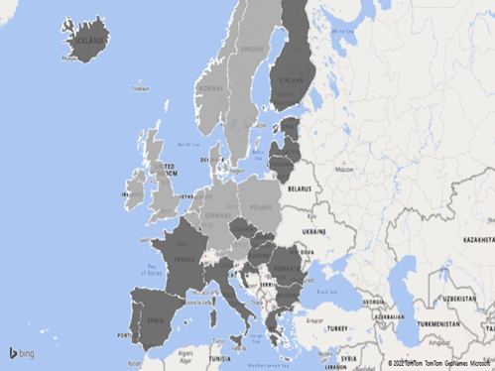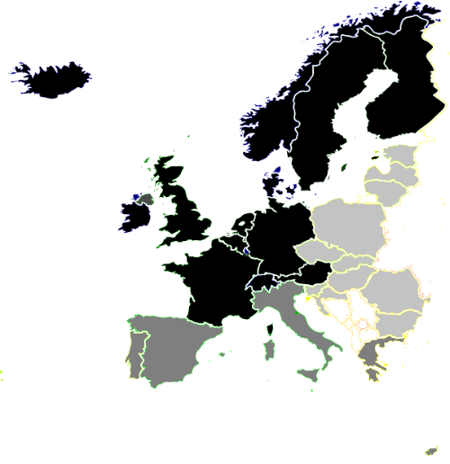
The picture is muddier regarding invasiveness and scope (see Map 2). Sweden is in a category of its own due to its lax containment and closure approach. Other countries, however, which instigated strict lockdowns, came across as less invasive in relation to e.g. test and tracing. Hence France, Italy, Spain, Belgium together with many Baltic and Balkan states invoked highly invasive lockdowns, yet overall assessments of the level of invasiveness differ due to either the addition or absence of accompanying measures. Germany, the UK, the Nordic countries and the Netherlands leveraged their capacity to test and trace in a manner which was arguably invasive, but in turn avoided severe lockdowns.
Countries can be grouped in three clusters according to policy scope and invasiveness. The first ‘cluster’, marked in light gray, solely contain Sweden with a very low score on scope and invasiveness in relation to containment and closure and health policy. Scope and even invasiveness regarding economic measures is noticeably higher reflecting the country’s comprehensive welfare state. The second cluster, depicted in a slightly darker gray, is composed of Cyprus, Greece, Malta, Portugal and Spain from the South, Denmark, Finland & United Kingdom from the North and Latvia, and Romania representing the East. They share higher scores on policy scope and invasiveness compared to the other two clusters except from the scope of economic policies where Sweden (cluster one) takes the top position. Cluster three comprises Poland, Bulgaria, Croatia, Czech Republic, Slovakia, Estonia, Lithuania and Hungary from the East and Germany, Ireland, the Netherlands and Switzerland from the North, while Italy is the only Southern state. They are similar to cluster two within containment and closure policies, but score much lower on the degree of invasiveness of economic policies and health systems policies and somewhat lower regarding the scope of health system policies.
Map 2: Invasiveness & Scope of adopted measures vs North, South, East
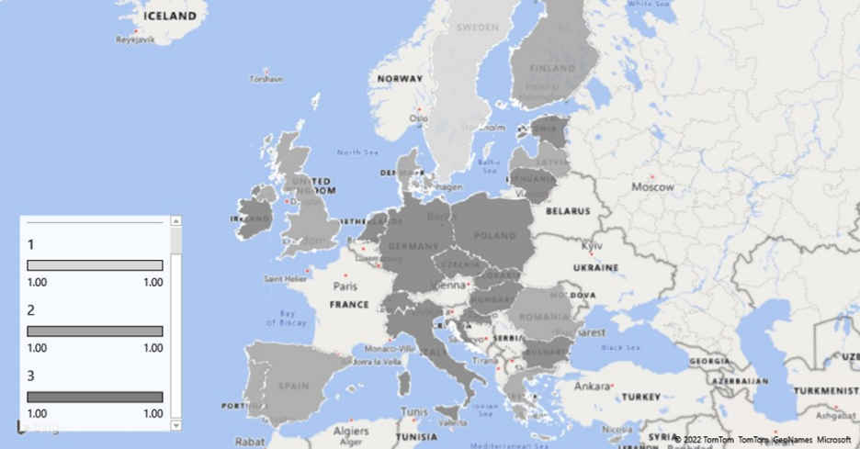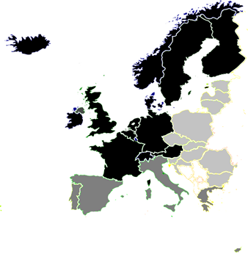

In terms of the overall efficacy of national responses, the more affluent West European countries fare better than its Eastern neighbors with the UK, the Netherlands and Spain being notable negative exceptions while Bulgaria, Latvia and Hungary bucked the dismal Eastern pattern. Map 3 present assessments of overall efficacy with the darkest shades indicating the highest score. Italy’s performance is on pair with the Northern cluster despite the harrowing scenes from Bergamo at the very beginning of the pandemic. This could reflect that the country is the most affluent member of the Southern cluster.

Map 3: Overall Policy Efficacy vs North, South, East
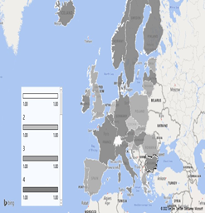
Between De-politicisation and Politicization: From ‘rallying behind the flag’ to re-politicisation What were the dynamics of politicization during the pandemic? Authors were asked: “How would you characterize the political dynamics among political parties in different phases?”. A five-point scale was offered ranging from 'not at all politicized' to 'highly politicized'. The former entailed non-governing political parties interacted with the government in a cordial manner and proposed solutions were adopted through consensus. The latter applied when non-governing parties interacted with the government in an antagonist manner.
On aggregate, data suggest a modest degree of conflict in the various phases of the pandemic compared with normal policy-making albeit politicization increased over time. The moderate level of conflict may reflect a rally round the flag effect, where political parties downplayed differences in the face of an external threat to the political system. Yet it may also be indicative of a strengthening of the executive branch during the pandemic. Although the degree of conflict remained below the default level during normal circumstances, politicization increased after the first lockdown as non-government parties began to question policies possibly in order to narrow the electoral gains of the government benefitting from a wider rally round the flag effect from the populace at large.
Figure 3. Level of politicization during the pandemic

When looking across the various specific policies that have been most prone to conflict, these are concerned with the freedom of individuals such as face mask requirements, testing policy and contact tracing, but also policies which affect the wellbeing of children and their parents including school closures. Economic policies proved only moderately conflictual which may seem surprising at first glance, but perhaps reflects that the economic crisis in the wake of lockdowns is seen as an external shock uniting right- and left-wing parties in support of businesses and jobs. The least politicized measures are those that either concern the external environment or investments in the health care system.
Figure 4. Level of politicization during the pandemic across policy responses

Despite substantial politicization in the legislative branch, Covid-19 measures enjoyed more support in parliaments than in the public. There is little variation in public support across the three policy areas, whereas parliamentary support for health policies is weaker than for economic policies, which seems in line with the pattern of politicization of different policy areas.
Figure 5. Parliamentary and Public support for government responses

This is further mirrored in media attention to the three policy domains. Economic policies on average thus received the least attention and coverage was less polarized compared to containment, while closure policies received the most media attention together with health policies, but coverage of the latter was more polarizing than the former.
Figure 6. Media attention

Data suggest that three clusters are optimal in relation to the level of political conflict which cut across our North, South, East divide. The three clusters differ in relation to the level of conflict and whether this changes in the different phases. Cluster one include Czech Republic, Estonia, Germany, Latvia, Lithuania, Malta, Netherlands, Poland, Romania, Slovakia, Slovenia & Spain and exhibit the highest level of conflict, but also the smallest change from normal policy-making and between the different phases of the pandemic. Cluster two include Cyprus, Finland, France, Iceland, Norway, Portugal & the United Kingdom and enjoy the lowest level of conflict, but also the highest level of change from normal policymaking and between the phases of the pandemic. Cluster three encompass Austria, Belgium, Croatia, Denmark, Greece, Hungary, Ireland, Italy & Luxembourg and displays a moderate level of conflict and a considerable drop in the first lockdown and reopening, but less so in the second lockdown and reopening. The Southern states are equally distributed across three politicization clusters, while the Eastern countries are more consistent as they occupy only two clusters in the proportion 1 to 4. The Northern states are nearly equally split between two clusters with two additional members in the third while Sweden did not fit any due to the absence of a first lockdown and reopening. This suggest that there is limited correspondence between the structural features underpinning our North, South, East divide and patterns of politicization.
Map 4 – Level of Politicization vs North, South, East
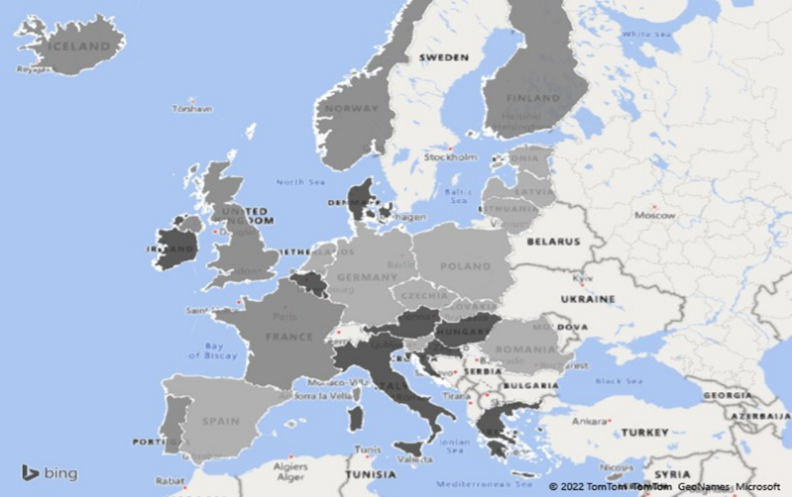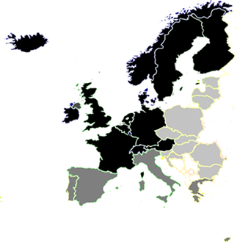

Patterns of Governance: Executive management and empowered independent government experts
The image of executives monopolizing the polity space during the crisis is only partially supported by our data. Hence while governments were slightly more involved in devising policy responses compared to normal policy making, this was only moderately at the expense of parliamentary involvement. Certain other actors eclipsed governments in terms of their policy involvement during crisis management compared with normal policy making. This applies to both experts, public administrations and regional authorities.
Figure 7. The involvement of different types of actors during the pandemic

Central administrations form part of the executive but the observation that their involvement surpasses that of governments compared with normal policy making is likely due to the considerable need for coordinated policy responses across many areas. Yet, there is considerable variability indicated by a high standard deviation when it comes to the involvement of regions between the different countries. Not surprisingly, experts experience the most significant boost in their policy-making involvement during the pandemic.
A similar pattern emerges when inquiring about the level of influence among the above actors. Hence Governments experience a modest increase compared to normal policy making. Administrations and regions, however, do not on aggregate enhance their influence despite greater involvement in devising policy responses to the pandemic. Experts, by contrast increase their influence beyond the level of their expanded level of involvement while Parliaments and Courts, suffer a decline of influence exceeding their diminished involvement.
Despite reports of social groups mobilizing against pandemic measures taken by the government, the expert evaluations shows that their influence is low compared to normal policy making. The influence of interest groups follows the same trajectory of their involvement entailing decline in relation to lockdowns and expansion during reopening’s.
Figure 8. The influence of different types of actors during the pandemic

The institutional affiliation of the most influential experts once again highlights the executive branch as employees of government agencies had a stronger impact on policy responses than expertise hailing from e.g. international organizations, the private sector and NGO’s including independent Think Tanks. University based experts and their colleagues from research institutes, often publicly funded, nearly attain a comparable level of influence as government agency employees. The lower reliance on expertise in relation to economic measures likely reflect the considerable knowledge on macro-economic management possessed by ministries which contrast the limited experience with containment measures at this scale. While relevant ministries also have solid experience with health issues, the comprehensive actions warranted by the Covid-19 pandemic has been unmatched in most countries for generations.
Figure 9. The influence of different types of experts during the pandemic

The survey data on expert influence produce four clusters. The first cluster comprises Germany and Sweden and is characterized by having the highest level of expert influence across all three policy domains. The second cluster is composed of Bulgaria, Hungary, Netherlands, Romania, & Slovakia and has the lowest level of expert influence across the policy areas. The third and largest cluster contains Spain, Croatia, Denmark, Estonia, Finland, France, Greece, Italy, Latvia, Lithuania, Norway, Poland & Switzerland. Here experts score the second highest influence across the policy areas and NGO expertise have higher influence on economic and health policies than in cluster one. The fourth cluster is made up of Belgium, Czech Republic, Portugal, & United Kingdom, which scores second lowest on expert influence across the policy domains. In spatial terms, it is closer to the third cluster when it comes to closure and containment policies and health system policies, but closer to cluster two on economic policies.
In short seven Northern countries host very influential experts while the same applies to Poland and the three Baltic republics, the most northern located members of the Eastern group and Croatia. They are joined by the three most populous Southern states. Five Eastern countries grant less influence to experts as is also the case in three Northern and one Southern state. Hence the Eastern group is evenly split while the majority of Northern and Southern states are prone to lend an ear to expertise.
Map 5 – Expert Influence vs North, South, East
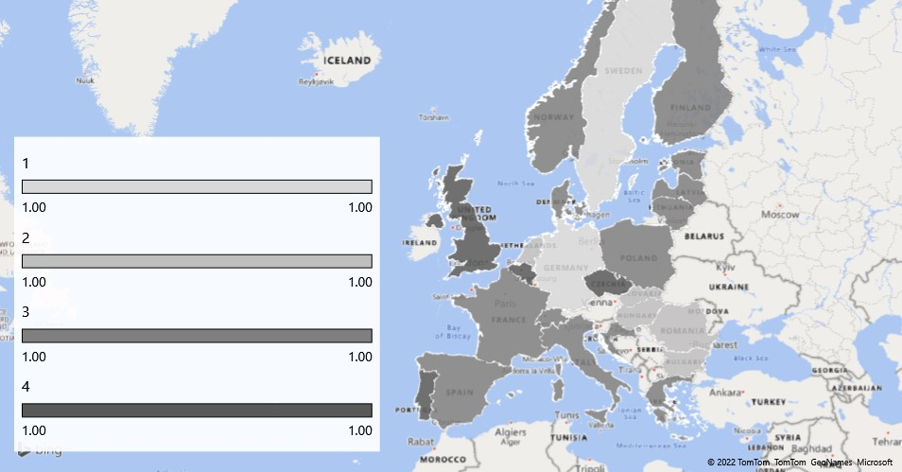
Despite strong reliance on government agency experts, respondents generally assess the autonomy of expertise fairly high, particularly regarding containment and closure policies and health provisions. On a five-point scale from ‘unrestricted autonomy’ to ‘no autonomy’ scores average 3,57 for the former. Regarding the level of consensus between experts and governments scores are uniformly high across the three policy areas.
Figure 10. Expert autonomy and Government-Expert consensus

Reduced parliamentary influence and growing interest group clout during reopening’s invoke the ‘decline of parliaments in Europe’ debate from the heydays of neo-corporatism (e.g. Wilson, 1983). Further evidence for this can be seen by examining the extent to which Covid-19 related legislation has been put to the vote in parliament. Here the assessment is that for approximately 38 percent all or most of the Covid-19 related legislation have been voted through the parliament.
Figure 11. Parliamentary involvement in passing Covid-19 legislation
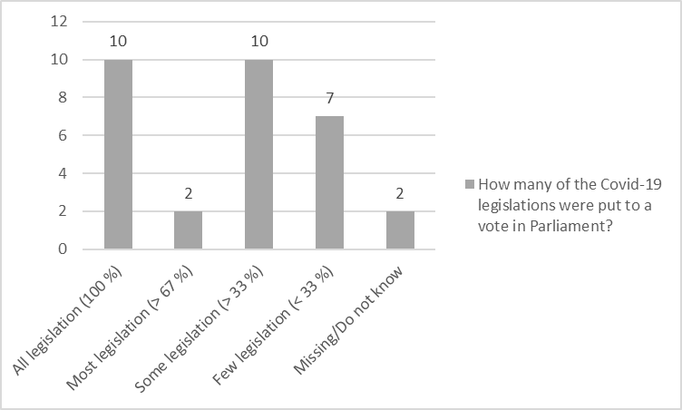
Data furthermore suggest that command and control from the center increased from normal policy-making during the different phases of the pandemic and especially during the first lockdown. Conversely, we saw a drop in decisions taken through majority voting which is normally associated with the parliament – particularly at the first lockdown. Executive dominance is further substantiated when looking at negotiations among interdependent actors which was lower than normal in relation to lockdowns but higher than normal when it comes to reopening’s. This may indicate that the executive takes charge when it comes to lockdowns whereas reopening’s are negotiated among a range of key actors in a manner resembling neo-corporatism. Finally, unilateral decision of the actors based on economic incentives drops below the normal level during the two lockdowns but is higher in the two reopening’s.
Figure 12. Mode of policy making during the pandemic

The survey data suggest that three clusters on the modes of coordination are optimal. In the first cluster we find Cyprus, Czech Republic, Norway, Spain & the United Kingdom, which are displaying a moderate use of command and control and a comparatively low use of other coordination modes. The second cluster comprises Belgium, Denmark, Estonia, Finland, Germany, Greece, Iceland, Ireland, Italy & Romania. In comparative terms this cluster makes more use of negotiations and unilateral decision making, though command and control remains the most important even if it on average is used less than in the cluster one and three. The third cluster contains France, Hungary, Latvia, Lithuania, Poland, Slovakia & Slovenia, which comparatively speaking makes more use of command and control and voting than in the two other clusters and scores in the middle when it comes to the two other coordination modes.
The geographical cluster division in map six shows that the first cluster consists of countries from both North, South and East marked with the darkest shade of gray. Cluster two with the second darkest shade of gray consists primarily of six Northern states but also contain two Eastern and two Southern representatives. The third cluster by contrast encompass mainly Eastern countries with the addition of France.
An arduous reading could be institutional entrenchment has limited impact on modes of governance. Provided modes of governance co-varies with political outputs such as efficacy or invasiveness these findings could prove a challenge for the assumption in the Covid-19 literature that structural factors such as institutional entrenchment explain variations in government responses.
Map 6 – Modes of Governance vs North, South, East
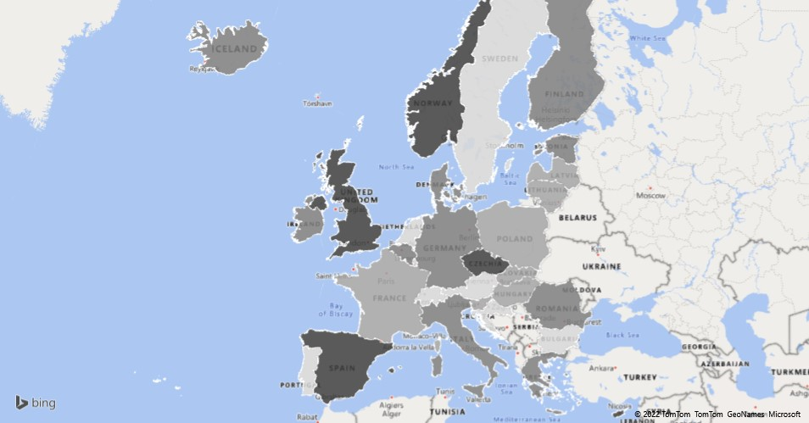
While modes of governance relying on command and control does suggest executive dominance, the power centralization effect can be somewhat mitigated if other actors exhibit sufficient autonomy. Authors assessed autonomy levels of different actors vis-à-vis the central government in handling the Covid-19 crisis on a five-point Likert-scale ranging from ‘unrestricted autonomy’ to ‘no autonomy’. Most non-executive actors had partial autonomy, but regions, health authorities and interest groups generally had more autonomy than municipalities, the police and social groups. This reflects that region’s in some countries have a certain constitutionally or legislatively mandated degree of autonomy not extended to municipalities. Secondly, being a health crisis, health authorities were granted considerable room for maneuver. Thirdly, interest groups had more leeway than social movements, which may not be so surprisingly given that the former usually have closer links with governments and are better organized. Finally, the police remained under tight government control which is reassuring given that many courts stepped back during the pandemic.
Figure 13. Autonomy of non-executive actors

Given the pandemic extended for two years, both policies and patterns of governance evolved. A major aspect of this development was policy learning. Experienced gained from past crises was of limited value possibly reflecting the comprehensive impact of the pandemic, which was unlike anything current generations of policy makers had encountered. Positive experiences of other countries and domestic policy feedback also had a limited impact on learning which is somewhat surprising. Some countries did draw on positive lessons from Germany and select Asian countries. Most learning incurred from other countries' negative experiences. Italy and Sweden stand out in this regard. While the Italian pandemic management was not particularly catastrophic, it was the first EU member to be severely affected and other countries accordingly had time to prepare based on the Italian experience. Sweden’s initial lax pandemic management and accompanying excess mortality served as negative experience for other countries. Finland, the UK and the Netherlands initially pursued a comparable approach, but soon aligned with continental practices as Sweden’s death toll was reported. The EU and WHO were important sources of policy learning in several countries with the former slightly exceeding the latter. The reason why the EU appears a little more important than the WHO, which is wholly dedicated to health issues, is precisely because the EU has a broad focus useful in a crisis as a multi­faceted as the Covid-19 pandemic.
Figure 14. Patterns of policy learning

Processing the survey data revealed no fewer than seven clusters as optimal for policy learning. The first cluster comprise five countries evenly distributed across our North, South, East divide: Malta, Romania, Slovenia, Sweden & Switzerland. They score below average in learning from other countries positive and negative experiences but is in the top when it comes to policy learning from other international organizations. The second cluster is made by Finland, Latvia, Norway & United Kingdom predominantly draw from the North and share below average scores in learning from the EU, WHO and other International Organizations. The third cluster consist of Austria, Bulgaria, Cyprus, Estonia & Portugal covering all three geographical groups and stand out on their low score in policy learning from feedback from implemented policies, WHO and other international organizations. Spain alone makes up the fourth cluster scoring low in learning from previous crisis management, other countries negative experience & policy feedback, but the highest when it comes to other countries positive experience, the EU and WHO. The fifth cluster encompass Denmark, France, Iceland, Italy & Lithuania, which is a majority Northern congregation with a single representative from each of the remaining two groups, and score lower when it comes to learning from the EU but is in front regarding policy learning from previous crisis management, other countries negative experience & policy feedback. The sixth cluster include Czech Republic & Netherlands and scores comparatively low on all items. Finally, the seventh cluster of Greece from the South, Northerly Luxembourg & Poland from the East, scores lower for previous crisis management, other countries positive experience & other international organizations. This multitude of clusters will overwhelm any three-pronged typology, but three of the four numerically biggest clusters had countries from both North, South and East and accordingly learning align poorly with our structurally derived groupings.

Map 7 – Policy Learning vs North, South, East
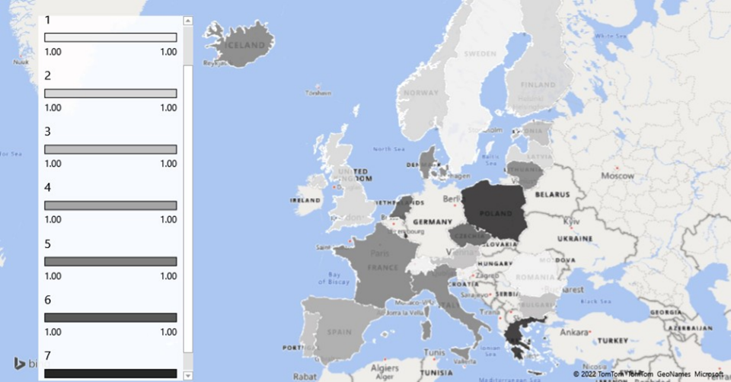
Conclusion
This study has explored the significant variation in government responses to the Covid-19 pandemic in 31 European countries including all 27 EU member states. National approaches ranged from laisses faire to draconian lockdowns. Sweden represents a case of the former which persisted while her neighbors went through the first cycle of lockdown and reopening. It was only partially aligned over a year into the pandemic but remained less intrusive then in the 26 remaining EU members. The United Kingdom, and to a lesser extend the Netherlands, also pursued a more permissive containment and closure policy than most other European states. While the UK dubbed their version ‘protecting the weak’, initial mortality trends in Sweden nearly suggest Stockholm opted for a ‘sacrifice the frail’ approach – something the chief epidemiologist at Public Health Agency of Sweden (PHAS) were indeed accused of considering (Expressen, 12 August, 2020; Foreign Policy, 22 December, 2020). London and the Hague eventually adjusted their paths while Sweden remained an outlier throughout the pandemic despite modest alignment in the second year.
Germany represented the golden standard for a balanced approach seeking to proactively manage containment and closure while refraining from adopting outright draconian measures. Several states looked to Berlin for inspiration and the country gained a reputation for having struck an equitable balance resulting in lower mortality rates than in neighboring France and Belgium not to mention severely affected Mediterranean nations such as Italy and Spain.
Interestingly, the strictness of lockdowns does not appear to be related to whether or not governments declared a state of emergency. Countries imposing a state of emergency while enforcing some of the strictest lockdowns count France, Italy, Spain and Portugal and several Baltic and Balkan states. At the same time, some countries declaring a state of emergency did not adopt particularly strict lockdowns such as Finland, Iceland and Estonia. Belgium, which did not enact a state of emergency, still adopted draconian lockdown measures on pair with Spain and Italy.
A common trend in all the countries covered, however, has been a strengthening of the executive at the expense of parliaments, even if this development has on aggregate not been as severe as anticipated. While parliaments have indeed suffered diminished influence on Covid-19 government responses compared to their role in ‘normal’ policy making, they regained a substantial stake in the process at the second reopening. In most instances parliamentary ‘moderation’ seemed more a reflection of ‘rally round the flag’ effects than formal exclusion of the legislature by the executive. Even in Hungary, which adopted a very far-reaching state of emergency allowing the executive to rule by decree for an initially unspecified period, parliament managed to repel this after a few months.
Polity perseverance is also reflected in patterns of politicization which in most countries increased over time and generally flared up in relation to reopening’s which in any case suggested a partial return to ‘normalcy’. Interestingly, national variance in patterns of politicization had little bearing on adopted policies. Despite politicization and growing critical media scrutiny of government policy, public support for the government’s handling of the pandemic remained robust in most countries and interest groups managed to regain access to policy making particularly when negotiating terms for reopening and economic compensation packages. While the aggregate standing of parliaments remained below pre-pandemic levels, legislators gradually clinched back their influence as decision making through majority voting on Covid-19 measures bounced back towards ‘normal’ policy making levels during the second reopening. Interest groups even exceeded their sway at negotiations for both reopening’s compared to normal policy making.
Over the course of the pandemic, Courts of Law and social groups suffered the largest drop in influence on government responses compared to normal policy making while experts witnessed the largest hike. The boost in the influence of expertise significantly exceeded the modest increase in executive dominance. While full-blown technocracy is a daunting prospect, the character of responses enacted to counter the pandemic was novel to the generation of policy makers in charge. Seeking advice under those circumstances arguably has democratic merits. Expert influence in the domain of economic responses was notably lower than in respectively containment and closure and health measures. This supports the suggestion that levels of expert influence reflect the magnitude of executive expertise present in ministries. Hence, proficiency in economics is much higher among ministers and central civil servants than knowledge of epidemiology.
All in all, the long-term effects on democracy of the pandemic in Europe seems insignificant and the viability of Western models of governance has furthermore been boosted by a rally around liberal democracy and values by Russia’s war in Ukraine.
References
Capano, G., Howlett, M., Jarvis, D. S. L., Ramesh, M., & Goyal, N. (2020). Mobilizing policy (in) capacity to fight COVID-19: Understanding variations in state responses. Policy and Society, 39(3), 285-308.
Egger CM, Magni-Berton R, Roché S and Aarts K (2021) I Do it My Way: Understanding Policy Variation in Pandemic Response Across Europe. Frontiers in Political Science 3:622069. doi: 10.3389/fpos.2021.622069
Esping-Andersen, Gøsta (1990), The three worlds of welfare capitalism. Princeton, New Jersey: Princeton University Press.
Expressen (12 August, 2020) https://www.expressen.se/nyheter/qs/interna-radslaget-om-flockimmunitet/ (accessed May 2022).
Ferrera, Maurizio (1996), The 'Southern Model' of Welfare in Social Europe. Journal of European Social Polic, 6(1): 17–37. https://doi.org/10.1177%2F095892879600600102
Foreign Policy (22 December, 2020) (https://foreignpolicy.com/2020/12/22/sweden-coronavirus-covid-response/?fbclid=IwAR1STOgyICe-MGNnnj8GGv4jTxVF_npYOJ_sIDgcKEhiATiLqpzKyNDhaCU (accessed May 2022)
Greer, Scott L., Elizabeth J. King, Elize Massard da Fonseca & André Peralta-Santos (eds.) (2021) Coronavirus Politics The Comparative Politics and Policy of COVID-19. Ann Arbor, University of Michigan Press.
Hale, Thomas, Noam Angrist, Rafael Goldszmidt, Beatriz Kira, Anna Petherick, Toby Phillips, Samuel Webster, Emily Cameron-Blake, Laura Hallas, Saptarshi Majumdar & Helen Tatlow (2021), A global panel database of pandemic policies (Oxford COVID-19 Government Response Tracker). Nature Human Behaviour 5(4): 529–538 https://doi.org/10.1038/s41562-021-01079-8
Wilson, Frank L. (1983), Review: Interest Groups and Politics in Western Europe: The Neo-Corporatist Approach. Comparative Politics, 16(1): 105-123. https://doi.org/10.2307/421599

Copenhagen Business School, Roskilde University, Roskilde University

