Network-oriented performance management systems in international organizations: the case of the European Union

Marco Amici, Denita Cepiku, Lorenzo Costumato

*University of Rome Tor Vergata, Department of Management and Law (Italy)*

#### **Abstract**

#### In the hunt of effective solutions to the emerging global challenges fuelled by the financial, health, security and environmental threats, the demand for better performing international organizations is increasingly pressing. Forms of globalization as the recent COVID-19 health emergency influenced people’s life simultaneously and call for a broader role of international organizations created to foster mutual collaboration among states to better face such globalization processes. In this scenario, the latter are constrained by high expectations to solve complex transnational problems, from one side, and by the continuous lament of poor performance, from the other.

#### This also brings legitimacy problems, which, according to the output legitimacy perspective, could be addressed by enhancing performance. In fact, the output legitimacy is linked with the effective results produced by the respective organization, in other words, the degree to which actions taken by international organizations are legitimized depends on their capacity to deliver the results. A good performance could reduce the gap between the increased powers acquired by international organizations and the perceived lack of legitimacy, but, on the other side, inadequate performance could question their legitimacy and credibility.

#### Improvements in performance thus lead to an increased legitimacy of the organization as such, but how the results achieved by international organizations are measured? How are performance management systems embedded in international organizations? While there is no shortage of research and studies assessing performance management systems in public sector organizations, the performance management systems of international organizations attracted very little attention in literature.

#### This paper intends to advance the knowledge on the performance management of international organizations by relying on the concept of networks’ governance and networks’ performance defined in literature. In such perspective international organizations display the key characteristics of networks. Consequently, a network-oriented performance measurement system should facilitate collaborative relations among the partners of an international organization on the one hand and, on the other hand, can support the evaluation of their results from an outcome-based perspective. Building on such literature, the proposed work will investigate how complexity and network concepts are applied to the administrative context of international organizations, by analysing the characteristics of the performance management system of the European Union. The case study will focus on assessing whether it is network oriented able to capture the exogenous and endogenous determinants of network performance.

**1. The conceptualization of international organization and the relation with networks**

The term “international organizations” refers to a wide variety of formal structures with both common elements as well as specific peculiarities, which call for clarification. As noted by Brechin and Ness (2013), scholars of international organizations “seem to typically focus on inter-governmental organizations, and at times, seem to use the term interchangeably. This can be confusing”. In the same vein, Dijkzeul and Beigbeder (2003) claim that “sometimes the term international organization is used to include multinational corporations, bilateral organizations, multilateral organizations, and international non-governmental organizations (INGOs).” “Other times, only UN organizations are covered by this term.” Most commonly, the term international organization is used to refer to “all forms of non-state actors working at international or global levels” (Brechin & Ness, 2013). According to this, intergovernmental organizations (IGOs) can be considered a subset of the international organizations’ category together with international non-governmental organizations (INGOs). The reference work on this topic is the Yearbook of International Organizations published yearly, since 1999, by the Union of the International Associations (UIA). It contains the list[1] of all types of international organizations according to different criteria[2].

Based on such classification, Bauer (2007) proposes a different categorization of international organizations focused on the type of decision-making systems adopted. In his view, international organizations whose members are predominantly sovereign states can be considered as "public international organizations." They differ from "private international organizations" whose members are mainly private actors. Public international organizations can have an intergovernmental or supranational character. This latter refers to the different decision-making system adopted by international organizations. In supranational organizations, member states transcend national boundaries or interests and take the decisions by majority voting system, while in intergovernmental organizations state governments play a more prominent role, and unanimity applies. Consequently, following the Yearbook of International Organizations, the “public international organizations” are those international organizations (Bauer, 2007):

1. based on a formal instrument of agreement between the governments of nation-states;
2. including three or more nation-states as parties to the agreement;
3. having intergovernmental or supranational character;
4. possessing a permanent secretariat performing ongoing tasks.

Relying on the concept of networks defined in literature (Agranoff & McGuire, 1998; Ferlie & Pettigrew, 1996; Ferlie et al., 2011; O’Toole, 1997; Milward & Provan, 2003; Provan & Milward, 1995; 2001; Provan & Sebastian, 1998), international organizations can also be seen as networks of organizations. According to O’Toole (1997:45), networks can be defined as “structures of interdependence involving multiple organizations or parts of thereof, where one unit is not merely the formal subordinate of the others in some larger hierarchical arrangement” or as a form of organizing essential governance functions across independent actors (Elliott & Salamon, 2002). The key features of networks include:

* the orientation towards addressing complex policy problems that cannot be solved by one actor alone, and require the collaboration of several actors ﻿(Mandell, 2001; Agranoff & McGuire, 2003; Koppenjan & Klijn, 2004);
* high interdependencies (that can be perceived at different degrees of intensity by each node of the network) between actors, which could bring to sharing resources owned by different actors, in terms of knowledge, financial, instrumental, and human resources ﻿(Hanf & Scharpf, 1978);
* complex interactions between actors because each actor may have different expectations and because each actor has its perception of problems, solutions, and strategies (﻿Hanf & Scharpf, 1978; Agranoff & McGuire, 2003; McGuire & Agranoff, 2011).

International organizations display the key characteristics of networks (Bingham & O’Leary, 2007; Rhodes, 1996; Klijn & Teisman, 1997; Agranoff, 2003). Among them:

* International organizations are composed of other organizations (nation-states), each with its interests and objectives that have to be met.
* Both common and different missions exist. Hence, states' missions can at any time clash with the mission of the entire network / international organization;
* Diversity among network members' cultures exist which may present conflict management challenges within the network itself;
* Different methods of operation, diverse degrees of hierarchy and management control exist, which may affect what a network can and cannot achieve and the speed at which it is accomplished;
* Network members have different stakeholder groups and different funders;
* Network members have different degrees of power, despite network rules which may give an equal vote to each member;
* Networks typically are formed to address multiple issues and complex problems that are not easily solved by one nation-state;
* Interdependency regarding the distribution of resources between various network members, the goals they pursue and their perceptions of their resource dependencies;
* There are continuing interactions among network members to exchange resources and negotiate shared purposes.

Considering international organizations, the concept of networks can be applied at two different levels. The first level focuses on networks in which international organizations are members. In this case, the international organization is a network member. The second level brings us in considering the international organization as a network of organizations where the nation-states are the network nodes. This perspective will be the one assumed in our analysis and within the forthcoming case study on European Union.

As we know from the literature, network governance is one of the most investigated issues in such collaborative environment (Keast et al., 2014; Klijn & Koppenjan, 2016). In 2007, Provan and Kenis have categorized three different governance models of inter-organizational networks that can be helpful in the identification of similarities among networks and how international organizations’ work.

First, network governance may or may not be brokered. In the first case, the network can be brokered by all the organizations involved, as peers, or by an organization or a small group of members whose act as leaders. When all the organizations participate in network governance, we can refer to a “shared governance”. Instead, when the network is characterized by the presence of a stronger organization (or a small group of organizations) with enough power and resources to lead the network, we can refer to the “lead-governance” model. Naturally, there is a trade-off between these two models, moving from a highly decentralized form in the shared-governance, to a more centralized one in the lead-governance model. To summarize, the two governance models differ in the level of centralization of management and the degree of inclusiveness/participation of the government entity in the network itself (Moretti, 2017).

Another relevant distinction concern whether the network is internally or externally brokered. At one extreme, we observe inter-organizational networks governed collectively by their members (shared-governance) or by a leader organization (lead-governance). On the opposite, there are networks in which an external structure, linked to the network at different intensity degrees, has the governance responsibility. Literature (Provan & Kenis, 2007; Kenis & Provan, 2009) has defined this structure as a Network Administrative Form (NAO) that can be either voluntarily established by network actors or mandated as part of the network formation process (Provan & Kenis, 2007). Figure 1 visually represents the described models of network governance.

Each governance form has certain key features, strengths, and weaknesses. In practice, no one model is better or more effective than the others. Choosing one form instead of another should depend on the desired outcomes and the types of actors involved. By looking at international organizations’ definitions that we have considered in previous paragraphs and anticipating the case study on European Union, the NAO governance model seems to be a powerful magnifying glass for describing international organizations as inter-organizational networks.

More in detail, the basic idea of the NAO model is that an *ad hoc* administrative structure is responsible for the management of the network. Because of the inefficiency of shared-governance model and potential problems deriving from the dominance of one leader organization, the NAO model can be seen as an alternative (Kenis & Provan, 2009). By mentioning Provan and Kenis's (2007) studies, in the NAO model, although network members still interact with one another (as in the shared-governance form), the government of the network is centralized (as in the lead-governance). Unlike what happens in the lead-governance model, the NAO is not a member of the network with its value, mission, and goals. The NAO governs the network from the extern and may be modest in scale, consisting only of a small group of people, or it may be a formal structure with specific staff, organogram, and physically distinct offices (Provan et al., 2005).

This latter configuration often occurs in international organizations where new institutional actors were established to manage the network and provide support for the goals’ achievement. These structures often include representatives from the network members and are responsible for all the strategic-level network issues. With this structure, network participants and groups may interact and work with one another (the dotted lines), but activities and key decisions are coordinated through and by a separate, independent entity (Kenis & Provan, 2007). Furthermore, the presence of an NAO can act as a driver for gaining both internal and external legitimacy by fostering the trust among the network members and, also, giving actors that are not within the network an identifiable structure to interact with. The NAO enable the solution of three main trade-offs between the shared-governance and the leader-governance models (see figure 2).

**Figure 1 - Source: Kenis and Provan, 2009**

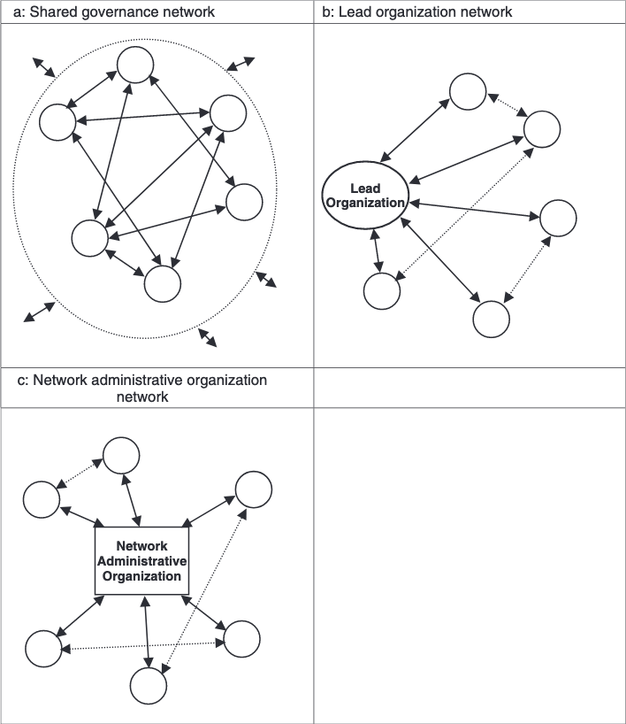

**Figure 2 - Trade-offs among shared-governance and leader-governance (own elaboration)**



**2. The role of international organizations and the management deficit**

The increased importance in number, scope, and size of international organizations does not seem to correspond to a similar theoretical and empirical attention by scholars. Several authors (Bauer, 2007; Balint & Knill, 2007; Brechin & Ness, 1988) complain about the lack of a comprehensive and systemic approach to the study of international organizations, especially concerning their internal management. According to Dijkzeul and Beigbeder (2003), “over the last two decades, the debate on international organizations has been characterized by a continuous lament that more and better studies are required.” The lack of a comprehensive theory explaining the behaviour of international organizations is still probably the main evidence. The reasons, according to Bauer (2007), are probably “due to the fact that international organizations topic falls between the boundaries of several social sciences sub-disciplines”, namely international relations, organizational sociology, public administration, and business administration. The intensity, scope, and research focus of such discipline’s *vis à vis* international organizations varied considerably along time. The study of international organizations by international relations scholars, for example, after the second world war witnessed a considerable development (Brechin & Ness, 1987) “to such an extent that international organizations were viewed not so much as a subfield but as practically the core of the discipline” (Rochester, 1986). On the same vein, Bauer (2007) notes that international organizations have been the focus of scholarly interest for many years[3]. Such interest was characterized by little or no interaction between the different disciplines, which dealt with the study of international organizations separately. According to Brechin and Ness (1987:2), the “gap between the study of international organizations and the sociology of organization is deep and persistent” adding “for reasons unknown, international organizations […] have not been studied much from a sociological perspective”. One year before, Jonsson (1986: 39) had noted that “the relations between organization theory and the study of international organizations […] has largely been one of mutual neglect.” Similarly, Dijkzeul and Beigbeder (2003: 16) considered the “lack of interaction among scholars from the disciplines of international relations, business administration and public administration,” one of the general shortcomings in the study of international relations. They did not find any relevant interactions between international relations theory and management and organization theory – apart from few exceptions (Allison, 1971; Jervis, 1976; Cox & Jacobson, 1973) – concluding “disciplinary myopia often persist.”

Each discipline has been concerned with a particular aspect of international organizations, thus preventing, so far, a systematic understanding of their role and functioning. Similarly, Bauer et al. (2017:4) stress how “historically there has been a kind of mutual disregard preventing interdisciplinary debate. Public administration was not interested in international bureaucratic issues, while international relations did not look systematic at the intra-organizational features of international organizations”. Bauer (2007) points out how international relations and comparative politics restricted their research interests on the relations between sovereign states and international organizations and how these latter affect domestic politics and policies. The main theoretical traditions in international relations, although with different visions, mainly looked at international organizations as a sort of device or platform for transnational decision making, ignoring their bureaucratic interior (Bauer, 2007). At the same time, organizational sociologists focused their research interests in the study of the functioning of modern organizations, but scarcely noting the existence of the international organizations (Brechin & Ness 1987). Gordenker and Sanders (1978) suggest that possible reasons for the lack of integration between political scientists and sociologists’ work lies in the fact that these latter only focused their attention on business firms and governments which do not provide applicable models for international organizations. The disciplines studying both internal functioning of organizations and their relationships are business administration and public administration. Despite this, Dijkzeul and Beigbeder (2003:10) acknowledge that “attention to international organizations from a business administration point of view is minimal” as the focus is on “private enterprise and international organizations falls outside the realm.” Similarly, in Public Administration, the main research focus is on no-profit and national public organizations, although international organizations are not as marginalized as in business administration (Dijkzeul & Beigbeder, 2003). In their relevant contribution to understanding the functioning of international organizations, Dijkzeul and Beigbeder (2003) suggested more considerable attention on actual management issues of international organizations, including the management of resources and the achievement of results. In fact, according to them, the conventional type of study suffers from three important shortcomings. These latter include (Dijkzeul & Beigbeder, 2003):

* the insufficiently appropriate theory about the actual functioning of international organizations;
* a lack of interaction of scholars from the disciplines of international relations, business administration and public administration;
* a choice of units of analysis, concepts, and research methodology that blocks attention to such issues as implementation, internal functioning and deviations from mandate, but emphasizes such issues as decision making and the role of states.

Despite such a complex picture, the time has come to re-connect the research programs of the different academic disciplines towards a more integrated approach to the study of international organizations (Bauer et al., 2017). In the following paragraphs, the different perspectives of the study of international organizations will be briefly explored.

**3 The different ways to generate legitimacy: input and output legitimacy**

The debate over the legitimacy of international organizations is a very complex topic, around which lawyers, political scientists and moral philosophers were confronted for a long time to find answers to the following questions: Are international organizations legitimate? What gives international organizations the right to exercise power? From where they receive their legitimacy? (Schneller, 2010). The search for a comprehensive answer triggered an extensive debate among the different epistemic communities of scholars (Zurn, 2004; Scharpf, 2004; Beetham, 1991; Schneller, 2010) on the use of different theories and approaches that would be impossible to analytically reconciling here. For our purposes, it would be enough to focus on the most common approaches dealing with the legitimacy of international organizations.

The first distinction found is between input, social, and output legitimacy. Input legitimacy looks at the way the will of people is represented in decisions taken by the organizations (Mehde, 2007). This kind of legitimacy is linked with the formal ties between the electorate and the decision-making system of the organizations. It is concerned with the way the people elect their representatives and how these latter represent them in the context of the international organizations (, 2007). According to Dahl (1989), input legitimacy requires that the following five criteria must be fulfilled: the effective participation of the citizens; voting equality at the decisive stage; an enlightened understanding of the matters to be decided; the citizens’ control over the agenda; and the inclusion of all adults subject to the binding collective decisions of the association. Together with input legitimacy, social legitimacy (Weiler, 1991) shares a similar focus on people but includes those backings which consider the legitimacy of different forms of democratic rule to be dependent in one way or another on the social context in which a political system operates (Schimmelfennig, 1996). According to the social legitimacy approach, individuals are not atomistic constituents of society (Schimmelfennig, 1996). These latter are born and socialized into communities from which they acquire their values and normative orientations, developing a collective identity and a sense of belonging (Schimmelfennig, 1996). Consequently, democracy is not a form of rule that can be established by whatever association of individuals but only by social groups. It follows that the political order at the level of international organizations must protect the communities (by consensual decision-making) to which the collective identities of the individuals are oriented (Schimmelfennig, 1996). Nevertheless, from a practical point of view, input and social legitimacy appear to lack the desirable substance when applied to international organizations, triggering the complex debate over their democratic deficit. Both approaches suggest that the only way to increase legitimacy would be the direct involvement and participation of individuals or groups in the decision-making system (Mehde, 2007). This happens through the act of voting, which produces little or no chance of influence the decisions even at the national level (Mehde, 2007). At the international level, the situation is worse. There are no direct elections in the context of international organizations[4] and the link between the electorate at the national level and the international decision-making is weak.

By contrast, output legitimacy focuses on the positive results that any state or administrative entity brings about. According to Scharpf (2004), the output legitimacy is linked with the effective results produced by the respective organization. It does not require a pre-existent collective identity, but only “the perception of a range of common interest that is sufficiently broad and stable to justify international arrangements for collective action” (Scharpf 2004:12). Consequently, the legitimacy of a political system depends on its capacity to achieve the citizens' goals and solve their problems effectively and efficiently (Schimmelfennig, 1996). The higher this capacity, the more legitimate the system (Schimmelfennig, 1996).In other words, the degree to which actions taken by international organizations are legitimized depends on the results of such actions. Output legitimacy highlights democracy as "government for the people" in contrast with the input legitimacy perspective of “governing by the people” outlined above. Differently, this approach is not concerned with the structure of the democratic process but on its capacity to deliver the results. It is democratic insofar as the output is in the interest of the citizens. Dahl and Tufte (1973:135) define "system capacity" as the capacity of a polity "to respond fully to the collective preferences of its citizens." On a similar vein, Buchanan and Keohane (2006:422) stress “how the justification for having global governance institutions is primarily if not exclusively instrumental: we value them because of the benefits they bring, rather than regarding them as intrinsically valuable.” Consequently, “if an institution exhibits a pattern of egregious disparity between its actual performance, on the one hand, and its self-proclaimed procedures or major goals, on the other, its legitimacy is seriously called into question” (Buchanan & Keohane, 2006:422). According to this approach, legitimacy is invariably linked to performance, and improvements in performance lead to an increased legitimacy of the organization as such (Mehde, 2007). As stressed by Gutner and Thompson (2010:228), “for most of the international organizations, performance is the path to legitimacy and our ability to understand performance […] is crucial”. Nevertheless, such perspective poses several practical difficulties and includes ambiguous elements to deal with (, 2007). The difficulty in measuring the results of international organizations as long as there is no direct contacts with citizens or the fact that acceptance refers only to a group of people smaller than the entire population affected are just the most relevant (Mehde, 2007). Agreeing on what is considered an effective and accepted output for an international organization could be a quite complex issue. For example, considering the different output legitimacy conceptions developed by Moravcsik (2004), those attached to the libertarian approach will consider a government legitimate if it provides an effective protection of individual liberties against “potentially arbitrary, corrupt and tyrannical power” (Moravcsik, 2004:339). By contrast, those favoring the social democratic model will consider legitimate an organization bringing about equality and social justice (Moravcsik, 2004). On a different level, measuring the results of different organizations imply the adoption of distinct and specific criteria difficult to generalize in analytical terms. But as noted by Gutner and Thompson (2010:229), in times were international organizations are confronted with new and relevant challenges posed by the globalization process and need to reform, “it is critical that scholars do more than sit passively on the sidelines.” Therefore, although such difficulties, the output legitimacy perspective can be a crucial leverage to shift the debate on the alleged democratic deficit of international organizations, from the traditional legalistic and political approach to the management side of international organizations. The output legitimacy perspective is of significant interest as it correlates the performance of international organizations to their legitimacy. From one side, a good performance could reduce the gap between the increased powers acquired by international organizations and the perceived lack of legitimacy, but, on the other side, inadequate performance could question their legitimacy and credibility.

***4. Performance management: recent trends and substance***

The trend towards reforming public sector organizations is closely associated with the increasing orientation of public management towards performances. According to several authors (Pollitt & Bouckaert, 2017; Hood, 1991; Hood & Peters, 2004), performance management is the core of public management. Consequently, public sector reforms included a strong emphasis on adopting performance management systems, to the point that, as put it by Radin (2000:168), “if there is a single theme that characterizes the public sector in the 1990s, is the demand for performance.

Performance is not a unitary concept and encompasses different meanings and levels. As for the concept, in literature, different definitions of performance can be found. Bovaird (1996:147) formulated a generic description of performance “as a set of information about the achievement of varying significance to different stakeholders.” More commonly, performance can be defined as an organization’s ability to achieve agreed objectives. Consequently, assessing organizational performance means analyzing the outcome produced as well as the process leading to the outcome in terms of efficiency, effort, and skills (Gutner & Thompson, 2010). Different models and metrics are generally employed to measure the performance of organizations according to the extension and intensity of the performance measurement.

The extension of a performance management system can be measured along two different dimensions, span, and depth. Span of performance can be defined as the horizontal expansion of the results and is linked to the mechanistic relationship between inputs, activities, and outputs (Bouckaert & Halligan, 2008). The latter is defined as the quantitative and qualitative results in terms of services or products, generated by processing inputs. (Bouckaert & Halligan, 2008). Normally outputs are never considered an end in themselves, and as much as they are, more easily can be transferred to the private sector (Bouckaert & Halligan, 2008). Conversely, the less an output is an end in itself, the more belongs to the public sector (Bouckaert & Halligan, 2008). Outputs then leave the organization and enter the society, and their effect is defined as an outcome. This latter should be the primary concern in assessing public sector performance. Therefore, as much as a performance management system is able to measure outcomes as much wider is the span. Although some claimed that also outcomes and effects are not the ultimate aim of public sector organizations, being this latter “guaranteeing a functional level of trust by citizens in all its institutions and organizations” (Pollitt & Bouckaert, 2008). Similarly, Gutner and Thompson (2010) proposes a similar metric to measure the different levels of performance achieved by an organization focused on macro outcomes at one end of a continuum and process-based indicators on the other. In this case, the span will be narrow as much as the system will be focused on measuring the internal processes carried out within the organization to achieve the agreed objectives. Conversely, it will be is wider as much as the performance system can measure the ability of the organization to solve problems and enhance welfare (outcomes). Nevertheless, outcomes or effects are generally realized with the contribution of several organizations. Thus, performance management systems should not be just organized at the level of a single organization (micro-level) but at least at the level of policy field (meso-level) or government-wide (macro-level) (Bouckaert & Halligan, 2008). This is related to the vertical dimension of performance, which is defined as performance depth. Also, performance can be conceived at the individual or organizational level (Talbot, 2005). Combining span and depth of performance can result in a different focus of performance systems.

**5. Assessing performance management systems in international organizations**

As described above, span and depth of performance vary across reform models and public administration frameworks, as shown in several comparative performance studies (Bouckaert & Halligan, 2008; Valotti et al., 2010). By contrast, the extension and intensity of performance management systems of international organizations attracted little attention in literature. Despite measuring the performance of international organizations is more complex and challenging, compared to national governments, this should not prevent us from dealing with such complexities. As put by Gutner and Thompson (2010:234), “understanding and explaining the performance of international organizations is uniquely difficult and – uniquely interesting.”

International organizations share many complexities with public sector organizations when it comes to defining performance, as they often have multiple goals broadly defined and are influenced by many stakeholders with different degrees of power (Perrow, 1986; Moe, 1989). Gutner and Thompson (2010) identify three different common obstacles:

* the lofty mandates of international organizations that prevent the possibility of judging performance effectively;
* the “eye of beholder problem” in the performance evaluation, consequently performance can vary significantly depending on the analyst;
* the issue of self-evaluation, as all international organizations evaluate themselves based on performance objectives set and methods of measuring them, preventing objective evaluations and leading to self-serving ones.

Moreover, international organizations are distinct from public sector organizations as they are governed by states and their performance is linked to the ability of governments to cooperate and collectively manage large organizations (Lyne at al., 2016). Member states, moreover, could have sometimes diverging performance objectives. In the same vein, Mehde (2007) notes that international organizations are accountable too many people and to many different governments. Consequently, they need to satisfy a great number of highly diverse actors having very different and sometimes conflicting interests. At the same time, they lack a single public as a point of reference as well as a general election encompassing all the citizens affected by the activities of international organizations, except one case, the European Union. On the one hand, creating satisfactory results is a very ambitious task in this respect; on the other, international organizations need to avoid situations in which they are blamed for poor performance for problems they are not responsible for (Mehde, 2007). Additionally, international organizations do not generally engage in service provisions but rather deal with more intangible goods, although with variations. The preservation of environment or cultural heritage can be more tangible than peace or financial stability, but in any case, difficult to measure (Kaul et al., 1999). Nevertheless, as described in the previous paragraph, performance measurement can significantly differ in terms of span and depth, and outcome indicators are not the only performance metric used to monitor organizational performance. According to the performance metric proposed by Gutner and Thompson, (2010), with macro-outcomes at one end and more process-based indicators at the other, there is a wide range of indicators we can use for measuring international organizations’ results. Alongside the outcome perspective, we could focus on the micro-level of the international organization, measuring the efficiency in performing the functions and tasks necessary to achieve higher objectives. In this case the level of analysis is different, the outcome perspective is linked to the international organization’s action, that is responsible for achieving the ultimate objectives set in the treaties, whereas the efficiency is generally related to the functioning of the international organization secretariat performing the administrative and management duties (also referred as the international public administration). The two levels are linked, although efficient administrative bodies could have little impact on the achievement of higher objectives (Gutner & Thompson, 2010). A third possibility could be looking at an intermediate level between process and outcome, which is defined in public policy literature as “outputs” or “intermediate outputs” (Levy at al., 1974). The latter refers to the intermediate output of the international organization activities, for example, the number of programs financed to reduce illegal migration flows or the number of environmental legislation produced to decrease air pollution. In this case, although the effects of such output on the final problem is not automatic, likely, an organization that performs well in the output production can more easily achieve their objectives in terms of outcome (Gutner & Thompson, 2010). Equally, a focus on process indicators is more appropriate in case we are interested in assessing the functioning of the administrative secretariat and understanding whether there is a relation between micro and macro-level performance. The limitation of focusing on process indicators is that good process performance does not necessarily translate into outcome performance (Gutner & Thompson, 2010).

Moving to the outcome orientation of international organization performance, helpful insights on how to measure the problem-solving capacity of international organizations can come from regime-effectiveness literature, which explores in more detail the concepts of effectiveness and outcomes and explain their variation (Young, 1999; Underdal & Young, 2004). According to Underland (2012:11), regime effectiveness can be described as whether the regime can “solve the problem that motivated its establishment.” In other words, if an environmental regime can objectively increase the physical state of the environment (Gutner & Thompson, 2010).

Nevertheless, the regime effectiveness has different limitations when applied to international organizations. The international organization is only one element of the regime - the latter generally includes multiple international organizations and other actors - and consequently, the outcome cannot be associated with a single organization (Gutner & Thompson, 2010). However, outcome measures can be difficultly attributed to a single international organization. According to Gutner and Thompson (2010), outcome-based indicators may be appropriate in case international organizations have a predominant role in a given policy area with objectively measurable solutions. Inappropriate in case political factors outside of their control constrained them (Gutner & Thompson, 2010). Nevertheless, such a condition, in reality, is extremely difficult to observe. More commonly, international organizations, even if not included in any regime, need to interact with multiple actors and be subject to external factors, to achieve the higher objectives set in the constitutional treaties. In other words, as international organizations are more and more confronted with the production of global public goods, with transnational and diffuse character, these latter will result from a combination of the interactions among different public and private actors at the global level. Consequently, the public policy process at the global level is increasingly seen as “an interaction in which the different actors exchange information about problems, preferences, and means, and trade-off goals and resources” (Kickert et al., 1997:24). In this respect, a contribution to understanding the role of international organizations as a producer of global public goods can come from the network theory. The policies at the international level are now shaped through organizational networks and their effectiveness depends “on the ability and willingness of a variety of organizational actors, public and private to work together” (Metcalfe, 2000:828).

In this context, the role of international organizations in managing networks is a crucial aspect for increasing the effectiveness of global public production, and consequently to achieve the final objective they have been created. According to network theory, different authors (Agranoff & McGuire, 2001; Milward & Provan, 2003; Mayntz, 1998) recognize in the public sector organizations those entitled to steer and coordinate networks due to their specific peculiarities and strategic coordination mechanisms, as funding, normative regulations and objectives setting (Meneguzzo, 2006). *Mutatis mutandis*, it is reasonable to expect that international organizations should play the same strategic role at the international level in the coordination of international policy networks for the production of global public goods*.*

From a performance management perspective, the focus moves toward network performance, which, as described above, characterizes the New Public Governance reform model. Although the highlighted complexities, the performance management systems of international organizations should be performance network-oriented. In other words, the performance measurement system should support collaborative relations among the network members and evaluate their performance. From an operational point of view, the performance management systems should focus on measuring the outcome (the global public goods) that must be considered, in the case of international organizations, as collaborative results. They should include specific indicators for measuring the performance of networks and monitoring the elements useful to detect under which conditions networks are able to perform better (Kenis & Provan, 2009).

By looking at the literature on the performance management in a network, many studies have analyzed the drivers of network performance, in different policy areas and contexts. The main drivers that have been identified are the structure of the network, the level of trust between partners, the behavior of network managers, implemented management strategies and resource distribution among partners (Costumato, 2021).

Provan and Milward (1995) were the first to propose a framework for the conceptualizing and measuring of public network performance, which deals with the relationship between context, structure and the effectiveness of four mental health delivery networks (Cristofoli and Macciò, 2018). Since then, network performance has been explored by various authors and from multiple perspectives. In 2001, another work by Provan and Milward, considers three performance variables in a network: the outcome produced for the benefit of each partner, the outcome achieved for the community at large as well as the network level outcome. They conclude that performance management in a network is relevant to motivate the network members about the convenience to remain in the network compared to other organizational forms (Provan & Milward 2001). Starting from Provan and Milward works (1995, 2001) some authors have assumed a single organization point of view, exploring how networks can foster better performance results for any partner within the network (Giacomini et al., 2018; Provan et al., 2005; Kiefer & Montjoy, 2006; May and Winter, 2007; LeRoux et al., 2010). Others have assumed a whole network perspective in an effort to understand how best to measure the results of collaboration (Mandell, 1994; Provan & Milward, 1995; Provan and Sebastian, 1998; Keast et al., 2004; Van Raaij, 2006; Lindencrona et al., 2009; Provan et al., 2009; Herranz, 2010). Finally, some authors have analyzed network performance assuming the beneficiaries’ point of view (Provan & Milward, 1995; Provan & Sebastian, 1998; Cristofoli et al., 2015; Raab et al., 2013; Cristofoli and Markovic, 2016). From our perspective, examining the performance of the network as a whole can enhance the understanding of how international organizations can be described from a network perspective and how collective outcomes can be achieved (Provan et al., 2007). Furthermore, the literature have identified two main components influencing network performance at the three different levels, exogenous elements over which network managers have little control, and endogenous elements that can be instrumentally used by the network manager (Cepiku, 2013). The exogenous elements include:

* The type of network, its voluntary nature, and the level of network development (Kenis & Provan, 2009). The authors suggest that all network members should firstly share the measurement system of network performance and all external factors influencing such performance should be identified (Kenis & Provan, 2009).
* The fact that network objectives should be preliminary set with the agreement of all members (goal consensus) and then subject to periodic evaluation to guarantee that the contribution of each organization is in line with its capacity to deliver it. (Voets et al., 2008).
* The form of the network i.e., shared governance, lead organization or network administrative form (Kenis & Provan, 2009).
* The type of network relations that can be of collaborative or social type or competitive or market type (Herranz, 2010).
* The complementarity of partners, their number and the geographical location as well as their trust and previous collaboration history (Cepiku, 2013)

The endogenous elements influencing network performance include the network management processes and the leadership style (Cepiku, 2013). The importance of the process variable has been acknowledged by several authors (McGuire & Agranoff, 2007; Klijn et al., 2010), which emphasize the importance of measuring not only the performance network but also the quality of interaction among the network members (Cepiku, 2013). Network interaction can be influenced by many factors, including, a wise design, the use of forums, agreements supporting accountability, conflict management, and trust-building activities (Crosby & Bryson, 2010).

Despite the broad literature on public network performance, several gaps must be identified. The current literature has developed separated streams: exogenous Vs endogenous perspective; process-oriented Vs structural approaches; whole networks Vs single organization as unit of analysis; and static Vs dynamic view of the network (Cepiku, 2013).

To overcome these gaps, we can refer to a theory-based model (figure 3) that contributes to the existing literature and will be the base for the case study on European Union. First, the model highlights the link between several categories of determinants that were usually analyzed autonomously. The exogenous-endogenous dichotomy does not allow identifying other relevant determinants that can influence the network and can be influenced by the network itself. It means that not all the determinants listed in figure 2 are beyond the management’s control, while others – internal and external resources – can be influenced by the network management (Cepiku, 2013).

Second, in our model we argue that the governance design of the network (shared-governance, leader organization, NAO) cannot be a-priori listed within the exogenous determinants (Kenis & Provan, 2009). If the network is mandated, the governance configuration could be determined top-down or by law. In this case the governance model must be considered as an exogenous factor. For this reason, the main exogenous factor in the presented model is the type of inception.

Third, the model distinguishes between the process and structural characteristics of the network management and the network management outcomes in terms of the quality of interaction among members: Based on this, the network management is considered a determinant, while the outcomes of the quality of interactions are intermediate results. By looking at the results considered in the model, we distinguish between three levels of outcomes: community-level outcomes and single organizational-level outcomes as final results; and the network-level outcomes as intermediate results (Provan & Milward, 2001).

Fourth, the dynamic view of network performance provided, supports the argument that the relation between the determinants and the intermediate and final results is bidirectional.

**Figure 3 - A dynamic Multidimensional Model of Network Performance. Source: Cepiku, 2013**

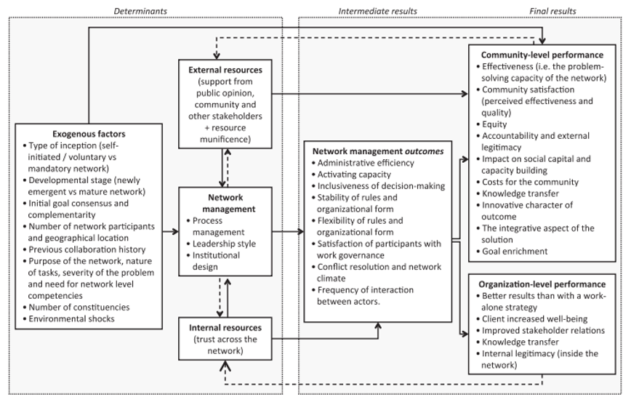

**6. The case study: assessing functioning of the European Union performance framework**

The European Union (EU), within the realm of international organizations, can be classified as a regional organization of general-purpose although with unique characteristics compared to other traditional regional organizations. The EU encompasses different aspects of both inter-governmentalism and supranationalism, according to the different sectors of competence, as well as a relevant number of functions. These include, normative and rule creation, collecting information and monitoring trends, mediating role as well as operational functions including allocating resources and providing financial assistance. Such a complexity raised several issues about the nature of the EU. The coexistence of both aspects, as well as its evolutionary process, softened the initial perception of the EU as an international organization.

Comparing to the origins of foundation in 1951, the EU widened significantly its scope through what Haas defined as “functional spillovers” (Haas 1958:257). The EU thus moved from an economic integration project to a political one with a consequence of deepening the ties with the member states. These delegated parts of their sovereignty in specific fields[5] at the EU level, until the point that today the majority part of the policymaking in the European countries is commonly referred to as EU policy, decided within the EU institutional framework. At the same time, in the most sensitive areas, including internal affairs and security, defense and foreign policy, education policy as well as economic and fiscal policy, the EU acts as a traditional international organization mainly to facilitate intergovernmental bargains.

These are regulated by two EU founding treaties: the Treaty of the European Union (TEU) and the Treaty on the Functioning (TFEU) of the European Union. The first sets out the fundamental principles and norms the EU is based upon, as well as the objectives, the values, and organization’s competences, whereas the second is focused on setting the rules for the functioning of the European institutions and the decision-making procedures. The decisions making system of the EU is based on the following organizational design, including:

* the European Council, which gathers all the EU heads of state or government to provide strategic input for the EU action;
* the Council of Ministers of the European Union made up of national Ministries and mainly dealing with legislative functions;
* the European Parliament, directly elected by the European citizens and involved together with the Council of Minister in the legislative process;
* The European Commission, promoting the general interest of the EU and acting as the executive body of the EU, participating in almost all stages of the EU policymaking, being the administrative body of the EU[6].

All EU institutions works within a common performance framework described in the next paragraphs.

***6.1 The strategic levels of the EU performance framework***

The EU performance framework, simplified in figure 4, is composed of three different but interrelated strategic layers, the international layer, the European Union layer and the member states layer.

**Figure 4 – Performance management levels in the European Union**



The international strategic level includes strategies elaborated at the international level, above the EU, mainly aiming at producing or preserving the global public goods. Among these, particular attention was given by the EU to the UN 2030 Agenda for Sustainable Development (“UN 2030 Agenda”), adopted by world leaders in 2015, which represents the new global sustainable development framework balancing its three dimensions, economic, social and environmental. It sets out 17 Sustainable Development Goals (SDGs) to eradicate poverty and achieve sustainable development by 2030 worldwide ensuring that no one is left behind (European Commission 2016b). The Agenda includes 169 underlying targets and an indicator framework composed of 230 indicators agreed at the UN level to monitor the progress towards the achievement of the SDGs. The goals and targets of the UN 2030 Agenda have the following characteristics, are global, universally applicable and interlinked.

The EU strategic levelis the core of our analysis and includes all the priorities and the objectives set at the EU level and their link with the international strategies. Within the EU strategic level, some performance documents address to all EU institutions and bodies while others are specific for each institution. The following strategic documents belong to the first group.

* *The Founding Treaties of the EU*

Like all international organizations, the founding treaties of the EU set the EU limits, competences, and functions as well as the general objectives the EU aims to achieve (Box 1). These latter are laid down in the art. 3 of the Treaty of the European Union (TEU). Although broadly defined, the capacity to achieve these objectives should justify (or not) the very existence of the organization.

**Box 1 – The general objectives of the European Union**

|  |
| --- |
| Article 3 (TEU)  1. The Union's aim is to **promote peace**, its values and the well-being of its peoples.  2. The Union shall offer its citizens an **area of freedom, security and justice** without internal frontiers, in which the **free movement of persons** is ensured in conjunction with appropriate measures with respect to external border controls, asylum, immigration and the prevention and combating of crime.  3. The Union shall establish an **internal market**. It shall work for the sustainable development of Europe based on balanced **economic growth and price stability**, a **highly competitive social market economy**, aiming at **full employment and social progress,** and a **high level of protection and improvement of the quality of the environment**. It shall promote scientific and technological advance.  It shall **combat social exclusion and discrimination**, and shall **promote social justice and protection**, **equality between women and men**, solidarity between generations and protection of the rights of the child.  It shall promote **economic, social and territorial cohesion**, and solidarity among Member States.  It shall **respect its rich cultural and linguistic diversity** and shall ensure that Europe's cultural heritage is safeguarded and enhanced.  4. The Union shall establish an **economic and monetary union** whose currency is the euro.  5. In its relations with the wider world, the Union shall uphold and **promote its values and interests** and contribute to the protection of its citizens. It shall contribute to peace, security, the sustainable development of the Earth, solidarity and mutual respect among peoples, free and fair trade, eradication of poverty and the protection of human rights, in particular the rights of the child, as well as to the strict observance and the development of international law, including respect for the principles of the United Nations Charter.  6. The Union shall pursue its objectives by appropriate means commensurate with the competences which are conferred upon it in the Treaties. |

* *The EU ten-year strategy*

It is a shared strategy between the EU and the member states designed to achieve a shared set of strategic objectives based on those laid down in the art. 3 of the Treaty of the European Union. The EU long term strategy includes priorities, objectives, and targets to focus on EU and member states’ actions over ten-years (table 1). The first long-term strategy, known as the Lisbon strategy, covered a period of ten years from 2000 to 2010 with a mid-term review in 2005. It was based on three priorities (economy, social protection, and environment) as well as equipped with clear objectives and indicators. At the end of 2010, a new long-term strategy known as Europe 2020 was launched covering the period 2010 – 2020, having a similar format, including three priorities, five thematic areas, eight targets monitored by nine headline indicators (and sub-indicators) as well as seven flagship initiatives.

**Table 1 – Priorities of the Europe 2020 strategy vs General objectives (art. 3 TEU)**

|  |  |  |  |  |
| --- | --- | --- | --- | --- |
| **Europe 2020 Strategy (2010 - 2020)** | | | | **General objectives (art. 3 TUE)** |
| **Priorities** | **Thematic Areas** | **Targets** | **Headline Indicators** |
| 1. Smart Growth | 1. R&D and innovation | 1.Increasing combined public and private investment in R&D to 3 % of GDP | 1.Gross domestic expenditure on R&D (% of GDP) | […] highly competitive social market economy […] (art. 3.3) |
| 2.Education | 2.Reducing school drop-out rates to less than 10% | 2.Early leavers from education and training, total (3) (% of population aged 18–24) | […] combat social exclusion and discrimination […] (art. 3.3) |
| 3.Increasing the share of the population aged 30–34 having completed tertiary education to at least 40 % | 3.Tertiary educational attainment, total (3) (% of population aged 30–34) |
| 2. Sustainable Growth | 3.Climate change and energy | 4.Reducing greenhouse gas emissions by at least 20 % compared to 1990 levels | 4.Greenhouse gas emissions (2) (Index 1990 = 100) | […] high level of protection and improvement of the quality of the environment […] (art. 3.3) |
| 5.Increasing the share of renewable energy in final energy consumption to 20 % | 5.Share of renewable energy in gross final energy consumption (%) |
| 6.Moving towards a 20% increase in energy efficiency | 6.Primary energy consumption (Million tonnes of oil equivalent) |
| 7.Final energy consumption (Million tonnes of oil equivalent) |
| 3. Inclusive Growth | 4.Employment | 7.Increasing the employment rate of the population aged 20–64 to at least 75 % | 8.Employment rate age group 20–64, total (% of population) | […] full employment and social progress […] (art. 3.3) |
| 5.Poverty and social exclusion | 8. Lifting at least 20 million people out of the risk of poverty and social exclusion | 9.People at risk of poverty or social exclusion, EU-28 (Million people) | […] combat social exclusion and discrimination […] (art. 3.3) |

Thematic areas and targets are strictly interlinked, for example, higher educational levels are associated with better employability, which in turn increases employment rates and helps to reduce poverty (Eurostat 2016). Finally, the targets of the Europe 2020 strategy have been also translated into national targets, to reflect the different economic and social conditions as well as the level of their contribution towards the implementation of the Europe 2020 strategy. The EU ten-year strategies provide a comprehensive and common strategic framework for both the EU and the member states. The objectives and targets of the EU ten-year strategy should feed the strategic plans at the EU institutions level, as well as at the level of the member states. The achievement of Europe 2020 objectives will thus greatly depend on the effective synergy between EU and national actions. The monitoring and reporting mechanism assessing the implementation of the Europe 2020 was partly integrated into the economic surveillance framework known as the “EU Semester” related to fiscal and economic policy coordination. Also, progress towards the achievement of Europe 2020 targets can be monitored in the Eurostat web portal[7] allowing each indicator to be tracked at European and national levels.

For the current period 2020 – 2030 the EU has not yet adopted a common ten-year strategy despite the European Commission published at the end of January 2019, a reflection paper “Towards a Sustainable Europe by 2030” outlining three possible scenarios on how to better integrate the UN 2030 Agenda into the post-2020 EU strategic framework. The three envisaged scenarios aimed at opening the debate among the citizens, stakeholders, and governments on how to prepare the next EU strategic agenda, outlining different responses that are neither restrictive nor prescriptive (European Commission, 2019). The breakout of the Covid-19 pandemic in January 2020 moved the attention on the recovery measures and stopped the debate on the adoption of the long-term EU common strategy which has not yet been adopted by the European Union.

* *Strategic Agenda of the European Council.*

An additional source for strategic inputs at the EU level comes from the European Council, composed by the EU national head of States and governments. According to art. 15 of the Treaty of the European Union (TEU), the European Council *“*shall provide the Union with the necessary impetus for its development and shall define the general political directions and priorities thereof.”In doing this the European Council adopted in June 2019 the “A New Strategic Agenda 2019-2024”, composed of five fields, priorities, and actions[8] to guide the EU work for the next five years (table 2). Contrary to the Europe ten-year strategy, the strategic agenda adopted by the Council does not include targets or indicators to feed the reporting and monitoring system.

**Table 2 - Strategic Agenda of the European Council**

|  |
| --- |
| **Main priorities (2019-2024)** |
| 1. Protecting citizens and freedoms |
| 2. Developing our economic base: the European model for the future |
| 3. Building a climate neutral, green, fair and social Europe |
| 4. Promoting Europe’s interests and values in the world |

* *EU sectorial policy strategies and objectives.*

The EU also sets strategies and objectives at the level of the sectorial policies according to the main areas of competence of the EU (see art. 6 TFUE). They include, among others, the EU Energy strategy[9], the EU Health strategy[10], the Consumer Policy Strategy[11], the Strategic Framework for Education and Training 2020[12], the EU Cohesion policy, the EU Climate action, the Global Strategy for the European Union’s Foreign and Security Policy (EUGS), etc. Generally, for each policy strategy, the EU sets medium and long-term objectives, linked to higher strategic documents as was the case when the Europe 2020 strategy was in place. For example, the Cohesion policy thematic objectives set for the period 2014-2020 and guiding the implementation of the European Structural and Investment Funds were aligned to the Europe 2020 strategy as shown in table 3.

**Table 3 – Comparison between Europe 2020 strategy and the EU Cohesion Policy objectives (2014-2020)**

|  |  |  |  |  |
| --- | --- | --- | --- | --- |
| **Europe 2020 strategy (2010 - 2020)** | | | **EU Cohesion Policy (2014 - 2020)** | |
| Priority | objective | target | Thematic Objectives (TOs) | **ESI Funds** |
| 1. Smart Growth | Increase employment | 75% of the 20–64-year-olds to be employed | 1. Strengthening research, technological development and innovation | ERDF, ESF, EAFRD, EMFF, Cohesion fund |
| Increase in R&D expenditure | 3% of the EU's GDP to be invested in R&D | 2. Enhancing access to, and use and quality of information and communication technologies |
| 3. Enhancing the competitiveness of small and medium-sized enterprises (SMEs) |
| 2. Sustainable Growth | Climate change and energy sustainability | greenhouse gas emissions 20% (or even 30%, if the conditions are right) lower than 1990 | 4. Supporting the shift towards a low-carbon economy in all sectors |
| 5. Promoting climate change adaptation, risk prevention and management |
| 20% of energy from renewables | 6. Preserving and protecting the environment and promoting resource efficiency. |
| 20% increase in energy efficiency |
| 7. Promoting sustainable transport and removing bottlenecks in key network infrastructures |
| 3. Inclusive Growth | Education | Reducing the rates of early school leaving below 10% | 8. Promoting Sustainable and quality employment and supporting labour mobility |
| at least 40% of 30-34–year-olds completing third level education | 9. Promoting social inclusion, combating poverty and any discrimination |
| Fighting poverty and social exclusion | at least 20 million fewer people in or at risk of poverty and social exclusion | 10. Investing in education, training and vocational training for skills and lifelong learning |

The missing adoption of a long-term EU strategy for the current period 2020-2030 prevents the possibility to link the EU sectorial policies objectives to a higher and shared performance framework.

* *The EU multiannual financial framework*

The above-mentioned documents set the multiple performance framework at the EU level setting the goals to achieve through all possible means. These latter can take different forms, legislative or non-legislative acts, policy coordination activities, or spending programsframed within the Multiannual Financial Framework. This latter lays down the maximum annual amount which the EU can spend in the different policy fields for seven years. The MFF thus defines the maximum annual ceiling for EU expenditure as a whole and per budgetary headings. The current MFF (2021 – 2027) groups the EU expenditures under seven main headings, which form the basis for the elaboration of the EU annual budget. The current MFF (2021 – 2027) is structured as follows:

* 1. Single Market, Innovation and Digital
  2. Cohesion, Resilience and Values
  3. Natural Resources and Environment
  4. Migration and Border Management
  5. Security and Defence
  6. Neighbourhood and the World
  7. European Public Administration

The maximum funding committed for these areas is set at EUR 1.074 billion for the 7 years to which has been added the NextGenerationEU instrument, the temporary recovery instrument created to fuel Europe's recovery from the coronavirus crisis. Consequently, the total amount of the EU resources available reached the unprecedent amount of 1.824 billions of Euros for the period 2021-2027. The previous MFF (2014-2020) budget headings reflected the Europe 2020 objectives, although there was no clear linkage. This is partially because the MFF comprises the EU’s wider policy competences which goes beyond the priorities set by the Europe 2020 strategy. In the current period the missing adoption of the ten-year strategy prevent linking the MFF 2021-2027 budget headings to higher strategic objectives.

* *The EU Spending programs*

The EU budget is a key instrument for achieving the priorities set at different EU levels and it is implemented by the EU Spending programs, linked to the seven MFF headings as they run for the same period.

**Table 4 – headings and programs 2021-2027**

|  |  |
| --- | --- |
| **MFF Headings (2021-2027)** | **Main EU Spending Programs (2021-2027)** |
| * 1. Single Market, Innovation and Digital | Horizon Europe, Connecting Europe Facility, Single Market Program, Digital Europe Program, Invest EU |
| * 1. Cohesion, Resilience and Values | ERDF and Cohesion Fund, European Social Fund+, Erasmus+, European Solidarity Corps, Creative Europe, Justice, Rights and Values |
| * 1. Natural Resources and Environment | Energy Transition, European Agricultural Guarantee Fund (EAGF), European Agricultural Fund for Rural Development (EAFRD), European Maritime and Fisheries Fund, LIFE |
| * 1. Migration and Border Management | Asylum and Migration Fund, Integrated Border Management Fund |
| * 1. Security and Defence | Internal Security Fund, Nuclear Decommissioning, European Defende Fund, Military Mobility, RescEU |
| * 1. Neighbourhood and the World | Neighbourhood, Development and International Cooperation Instrument (NDICI), Humanitarian Aid, Common Foreign and Security Policy (CFSP), Overseas Countries and Territories, Pre-Accession Assistance |

The EU spending programs are adopted by the Council and the European Parliament through a legal act in the form of a Regulation, which sets the objectives, contents, and financial allocations as well as their performance framework. The performance framework includes objectives and indicators to monitor the achievement of the EU spending programs results and demonstrate how these latter are being used to achieve policy goals (European Commission 2018c). In the previous programming cycle 20i4-2020, all EU spending programs have been conceived to contribute to the achievement of the Europe 2020 strategy goals, the UN Sustainable Development Goals, and the Commission Political Priorities. To make clear such contribution, for the Europe 2020 strategy goals, the European Commission estimated the financial contribution of the single EU spending programs to the three priorities of the Europe 2020 strategy (smart, sustainable, and inclusive), based on ex-ante estimation of commitments appropriations[13]. Table 5 shows the financial resources included in the draft budget 2019 linked to Europe 2020 priorities and representing 66% of the total of the EU budget for the same year.

**Table 5 – Financial contribution of the EU programs to the Europe 2020 priorities (mil EUR)**

|  |  |  |  |
| --- | --- | --- | --- |
|  | **Draft Budget 2019** | | |
| Europe 2020 Strategy | **Smart Growth** | **Sustainable Growth** | **Inclusive Growth** |
| Topics | innovation, education, digital society | competitiveness, climate, energy and mobility | employment and skills, fighting poverty |
| **EU Spending programs (2014-2020)** | **21.215,60** | **65.626,70** | **19.213,80** |
| Total Europe 2020 strategy |  |  | 106.056,10 |
| Total Budget (Commission - Sect III) |  |  | 161.500,30 |
| **Europe 2020 / EU budget** |  |  | **66%** |

Whereas for the UN Sustainable Development Goals and the Commission Political Priorities the link with the EU spending programs is less organic, although the Commission recently presented the most relevant spending programs linked to the two strategic frameworks.

* *The Recovery and Resilience Facility and the National Recovery and Resilience Plans*

The aim of the Recovery and Resilience Facility (RRF) is to mitigate the economic and social impact of the coronavirus pandemic and make European economies and societies more sustainable, resilient and better prepared for the challenges and opportunities of the green and digital transitions. The Facility is a temporary recovery instrument. It allows the Commission to raise funds to help Member States implement reforms and investments that are in line with the EU’s priorities and that address the challenges identified in country-specific recommendations under the European Semester framework of economic and social policy coordination. It makes available €723.8 billion (in current prices) in loans (€385.8 billion) and grants (€338 billion) for that purpose.

The Facility is structured around six pillars: green transition; digital transformation; economic cohesion, productivity and competitiveness; social and territorial cohesion; health, economic, social and institutional resilience; policies for the next generation. It entered into force on 19 February 2021. It finances reforms and investments in Member States from the start of the pandemic in February 2020 until 31 December 2026.

To benefit from the support of the Facility, Member States submit their *Recovery and Resilience Plans* to the European Commission. Each plan sets out the reforms and investments to be implemented by end-2026 and Member States can receive financing up to a previously agreed allocation.

The Recovery and Resilience Facility is performance based. RRF funds are disbursed when Member States have fulfilled key steps in the implementation of the reforms and investments included in the recovery and resilience plans. These key implementation steps are referred to as milestones and targets. Milestones represent a qualitative implementation step, targets a quantitative implementation step. The milestones and targets each Member State has to achieve are set in a Council Implementing Decision.

Fulfilment of agreed milestones and targets towards achieving the reforms and investments in the plans will unlock regular payment. The RRF includes 14 common indicators related to each pillar (Delegated Regulation EU 2021/2106). The common indicators show the progress of the implementation of the recovery and resilience plans towards common objectives and the overall performance of the RRF. Member States report on the common indicators twice a year, by the end of February and the end of August. The first reporting have taken place in February 2022.

***6.2 The role of the European Commission in the EU strategic framework***

Among the EU different institutions, the European Commission is the most strategic actor in the EU decision-making system. According to the article 17 of the TEU the main objective of the European Commission is to “promote the general interest of the Union and take appropriate initiatives to that end” to achieve the goals laid down in the treaties[14]. In this respect, it is often labeled as the engine of the European integration process and the Commission can be seen as the supporting administration focusing on the management and implementation of the European policies. Within the EU strategic framework, the European Commissionis the most relevant institution contributing to the achievement of the EU objectives (European Commission, 2018). The performance framework of the European Commission is thus an integral part of its work and is implemented through a strategic framework composed of the following different elements:

* *(planning) The European Commission Political Guidelines*

The planning phase starts with the adoption of the Political Guidelines also known as Commission’s priorities, covering the five-years of President of the European Commission’ s mandate. The Political Guidelines describe the main priorities and policy areas the European Commission commits to focus for the next five years period. The Political Guidelines are essentially a political document, generally divided into broad objectives or policy areas aiming at providing a comprehensive picture of the President’s view on the most important political issues of the next five years. Consequently, no specific objectives or performance indicators have been set at this level[15]. The previous Junker’s Commission Political Guidelines were in line with the Europe 2020 strategy, especially the first four priorities, whereas the others reflect the EU’s broader international role. To achieve its political priorities the European Commission relies on a variety of methods, including the EU budget and the EU spending programs, the legislation, policies, and coordination. Internally, the President of the European Commission assigns to each Commissioner a specific thematic portfolio and in the Commissioner’s mission letterspells out the specific goals he/she will be responsible to contribute to the achievement of the political guidelines. Table 6 compares the political priorities set by the Presidents of the European Commission since 2000.

**Table 6 – the European Commission priorities: an overview**

|  |  |  |  |  |
| --- | --- | --- | --- | --- |
| *Lisbon Strategy (2000 – 2010)* | | *Europe 2020 Strategy (2010 – 2020)* | | *(no strategy)* |
| ***2000-2004***  ***Shaping a new Europe***  ***(Prodi Commission)***.  *Five years objectives:*   1. Promoting new forms of governance 2. A stable Europe with a stronger voice in the world 3. A new economic and social agenda 4. A better quality of life | ***2005-2009***  ***A Partnership for***  ***European Renewal***  ***(Barroso I Commission)***  *Five years objectives:*   1. Prosperity 2. Solidarity 3. Security 4. Promoting European values in the world 5. Top priority: growth and jobs | ***2010-2014***  ***Political Guidelines***  ***(Barroso II Commission)***  *Five key challenges*   1. Restarting economic growth today and ensuring long-term sustainability and competitiveness for the future 2. Fighting unemployment and reinforcing our social cohesion 3. Turning the challenge of a sustainable Europe to our competitive advantage. 4. Ensuring the security of Europeans. 5. Reinforcing EU citizenship and participation. | ***2014-2019***  ***Political Guidelines***  ***(Junker Commission****)*  *Ten policy areas*   1. A New Boost for Jobs, Growth and Investment 2. A Connected Digital Single Market 3. A Resilient Energy Union 4. A Deeper and Fairer Internal Market 5. A Deeper and Fairer Monetary Union 6. A Reasonable and Balanced FTA with US 7. An Area of Justice and Fundamental Rights 8. Towards a New Policy on Migration 9. A Stronger Global Actor 10. A Union of Democratic Change. | ***2019-2024***  ***Political Guidelines***  ***(Van der Layer Commission****)*  *Six priorities*   1. A European Green Deal 2. A Europe fit for the Digital Era 3. An economy that works for people 4. A Stronger Europe in the World 5. Promoting of our European way of life |

* *(planning) The State of the Union speech*

The second component is the State of the Union speech held in September (n-1), where the President of the European Commission spells out the political priorities for the year to come in the [European Parliament](http://en.wikipedia.org/wiki/European_Parliament) plenary session. The State of the Union speech has been recently introduced by the last Treaty reform in 2009 on the image of the [USA's State of the Union](http://en.wikipedia.org/wiki/State_of_the_Union_address) speech, to make political life of the Union more democratic and transparent. In the Union’s speech, the President of the European Commission translates the multiannual political guidelines in annual priorities. These latter are then included in Commission Work Program (CWP), whose adoption is preceded by discussions and negotiations between the European Commission, the European Parliament and the EU Council of Ministers.

* *(planning) The European Commission Work Program (CWP)*

The discussions and negotiations among the EU institutions over the State of the Union speech lead to the adoption of the annual European Commission Work Program (CWP). This latter is a key element of the planning cycle translating the political priorities into the concrete actions the European Commission commits to carry out in the year to follow. The CWP contains a list of all legislative and non-legislative acts the European Commission commits to adopt in the implementation year, divided into two parts.

* the first part includes a general description of the main areas and priorities the European Commission will take action;
* the second part (annexes) contains:
  + a list of the “new initiatives” grouped around the main political priorities, and for each a description of the scope and objectives foreseen;
  + a list of “simplification initiatives (REFIT)[16]” aiming to decrease the complexity of EU law system and reducing the administrative burdens and costs;
  + a list of the priority pending proposals still to be adopted included in the European Commission Work Program of the previous years[17];
  + a list of withdrawals or modifications of pending proposals[18].

The structure of the CWP is oriented to highlight the core initiatives the European Commission committed to achieve in the short term and their link to the long-term priorities[19]. At the same time, it is also an important political, technical, and practical document, providing a very transparent representation of the main actions the European Commission is intended to deliver in the next years, allowing all the stakeholders to better monitor the European Commission’s activities and to increase their engagement (Hardacre 2010).

* *(planning) Strategic Plans and Annual Management Plans*

The next documents are elaborated on an annual basis by each DGs and Services and aiming to translate the Commission’s political priorities into sectorial operational actions.

* The first is a five-year Strategic Plan (SP) translating the European Commission Political Guidelines in the long-term objectives, impact and results indicators associated with long term targets;
* The second is the Annual Management Plan (AMP) focused on the same European Commission Political Guidelines but including only output indicators associated with short-term targets to achieve within the year.

The common structure of the Strategic Plan[20] includes the following elements:

The first part is focused on “Delivering on the Commission priorities” and includes:

* the DG mission statement,
* the operating context,
* the strategy
* the key performance indicators.

The DG mission includes the treaty obligations, while the in the operating context the DG describes the competences, the financial instruments and programs they are responsible for. This latter is a relevant aspect for many DGs in charge of managing a relevant number of financial programs with different management modes. The third section concerns with the elaboration of the five-year DG strategy to support the delivering of the Commission political priorities as specified in the Commissioner’s mission letter, in which the President of the Commission spells out the role and the responsibilities of each DG in delivering the goals of the President agenda. The strategy includes:

* The General objectives*,* that are the Commission priorities relevant for the DG, and the associated impact indicators
* The Specific objectives, that are the DG policy-related objectives linked to the general objectives and the associated output/results indicator.

In this section, each DG needs to develop its integrated performance framework matching the relevant Commission priorities (general objectives) from one side and specific objectives the DG is responsible for that contribute to the achievement of the general objectives from the other. This need also to be linked to the related priorities of the ten-year strategy (when adopted) as well as the relevant thematic policy strategies and program performance frameworks. The analysis of the strategic plans across the DGs reveals that, although sharing a common structure, each DG elaborated its performance framework with different levels of detail. In figure 5 the strategy map of the Directorate General for Employment and Social Affairs (DG EMPL) for 2019-2024 representing the link between the Commission general objectives, the different specific DG objectives as well as with the different typologies of instruments available to achieve the specific objectives which in turn contribute to the achievement of the general ones.

**Figure 5 - DG Employment and Social Affairs objectives. Source (European Commission, 2021 – SP DG EMPL)**

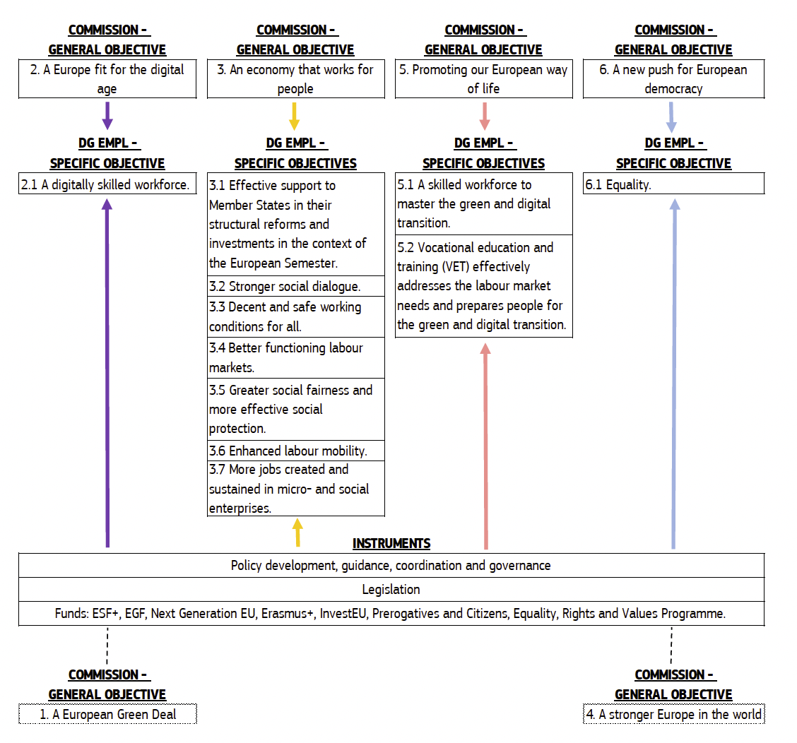

Also (figure 6), for each Commission general objective, the DG draws:

* an intervention logic map explaining “how the planned actions carried out by the DG EMPL, or together with the Member States in case of shared management programs, contribute to the delivery of the Commission priorities.”(European Commission 2016c: 8)

**Figure 6 – Intervention logic map of DG Employment and Social Affairs. Source (European Commission, 2021 – SP DG EMPL)**

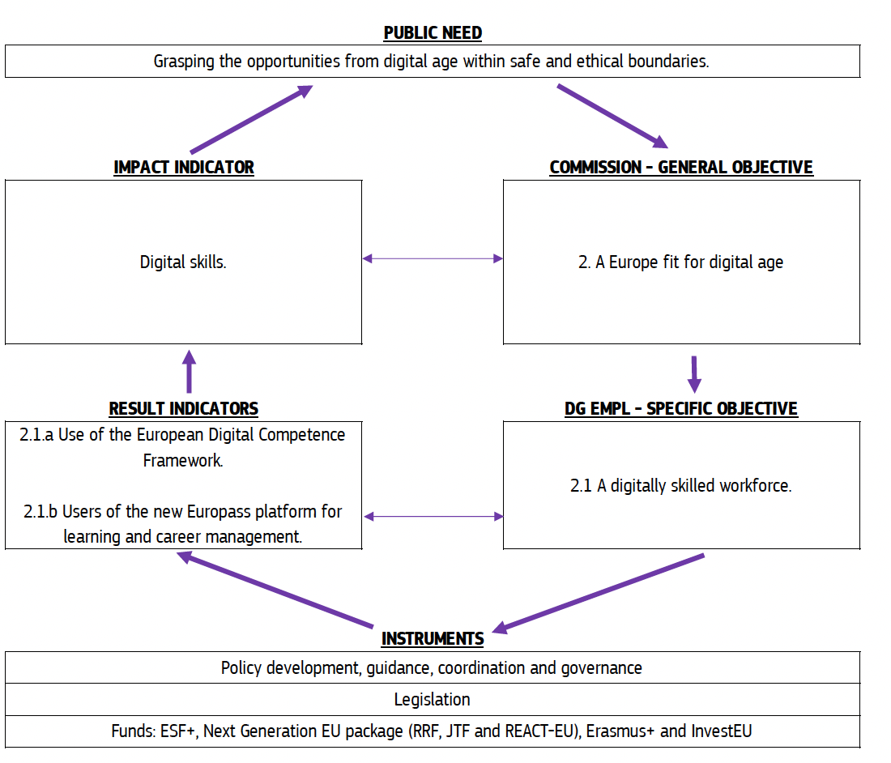

* a performance framework (figure 7) defining “the specific objectives under the first general objective and the corresponding indicators. Their full formulation, definition, milestones and targets are presented in annex 1.” (European Commission 2016c)

**Figure 7 – Performance framework of the DG Employment and Social Affairs. Source (European Commission, 2021 – SP DG EMPL)**

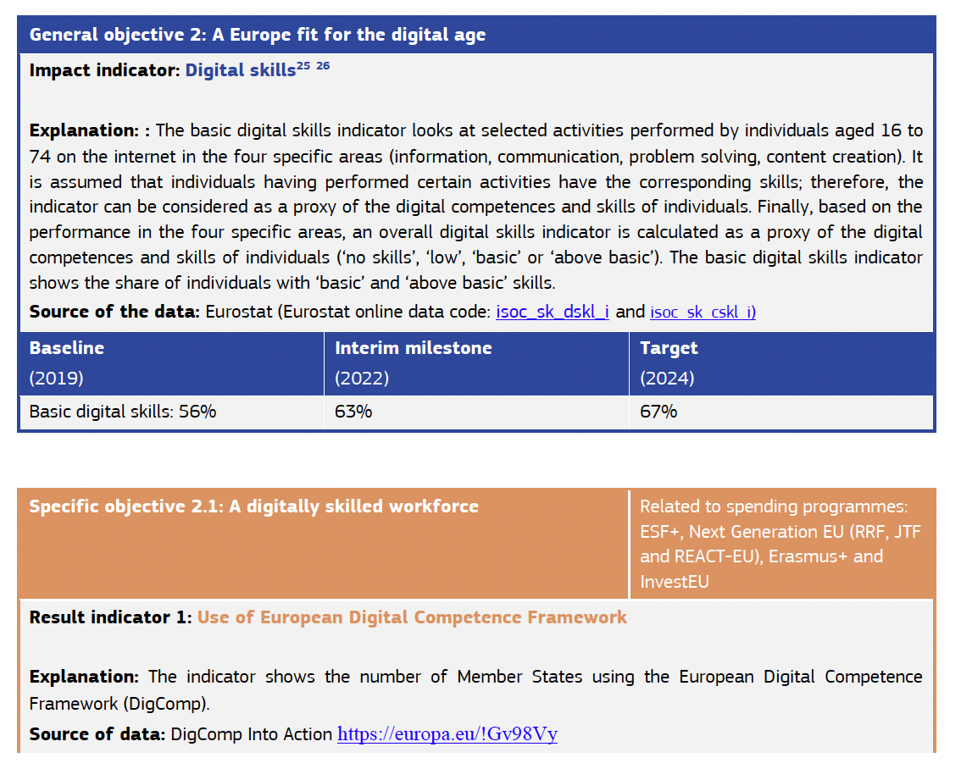

The impact indicators associated to the Commission priorities should provide a measure of the outcome of the DG action, beyond the immediate effect. Consequently, outcomes are evaluated at the end of the five-year strategic cycle[21]. As outlined above, the delivery of the results and impacts are subject to several exogenous factors, which complicate the identification of the specific contribution of the EU policy actions in the wider macro-economic context. In addition, some of the objectives and indicators are linked to the implementation of the EU spending programs implemented through shared management with the Member States on which the DG has limited control (European Commission, 2021 – SP DG EMPL). Among the external factors influencing the impact of their actions, several DGs identified the capacities of the member state administrations to effectively managing the EU spending programs (European Commission 2015d).

The fourth section of the strategic plan consists of a selection of Key Performance Indicators (KPI) monitoring the core aspects of the DGs’ policies. They are selected to better represent the ability of the DG to deliver the identified challenges. The KPIs are directly linked to the ten European Commission political objectives and indirectly to the five objectives and targets of the Europe 2020 strategy or relevant objectives set by other EU Regulations or EU spending programs. Figure 8 shows an example of KPIs included in the Strategic Plan (SP) of the DG Regional and Urban Policies.

**Figure 8 – The Key Performance Indicators (KPI) of the DG Regional and Urban Policy [22]**

The second part of the Management Plans is related to organizational management. This includes the identification of the organizational components necessary for the execution of the DGs strategy plan. For all DGs the main components include (European Commission 2016a):

* 1. Human Resource Management
  2. Sound and Financial Management
  3. Fraud and Risk Management
  4. Digital Transformation and Information management
  5. Sound environmental management

For each component, several objectives and output indicators are identified, including the verification source, the baseline, and a long-time perspective target. The objectives set in this section mainly aim at increasing the efficiency of DG’s internal processes in the key strategic areas as well to contribute to the policy achievements.

The second document elaborated at the DG level is the Annual Management Plan. This latter describes the actions of the DG for the year, and how these latter contribute to the achievement of the DG's multiannual specific objectives set in the Strategic Plans. The Annual Management Plans identify the focus areas as well as the main outputs that should be delivered and aim at monitoring the performance expectations (European Commission 2016a). Coherently with the shorter time perspective, the AMPs include the identification of outputs to be delivered associated with outputs indicators linked to results and impact indicators set in the strategic plans. The common structure of the new Management Plans include:

* the description of the main outputs to be achieved for the year. In this section, each DG classifies the main actions leading to the outputs to achieve the general and specific objectives set in the strategic plan, as represented in the figure 9.

**Figure 9 - Description of the main outputs, DG Regio. Source (European Commission, 2021 – SP DG EMPL)**

* *(reporting) General Report on the activities of the European Union*

The general report on the activities of the European Union is published in February (n+1) and gives evidence to the main progress towards the European Commission political guidelines[23]. The document is structured around the ten political guidelines and describes the main activities carried out by the Commission in that domain as well as the main achievements. It is an accessible and readable document for the general public and stakeholders.

* *(reporting) The Annual Activity Report (AAR)*

The *Annual Activity Report (AAR)* is the main document monitoring the performance achievement at the level of the Directorate Generals and Services and is published within June (n+1). The AAR reports the activities carried out by the DGs as well as the value of the different sets of indicators included in the strategic and in the annual management plans. The current structure of the AAR is the following:

* the first part of the AAR describes the key results and progress towards the achievement of the general and specific objectives of the DG as outlined in their Strategic Plans;
* the second part acknowledges how the achievements described in the previous section were delivered by the DG. It includes the description of the organizational management and internal controls that support management's assurance on the achievement of the financial management and internal control objectives. The last part deals with other components of organizational management: human resources, better regulation principles, information management, and external communication.
* the annexes contain several additional information concerning different management aspects of DGs competence, including the EU programs, the EU decentralized agencies, etc. The last section reports the performance tables showing:
  + the value of the outcome/impact indicators associated with the general and specific objectives of the DGs (included in the strategic plans);
  + the outputs delivered included in the Management plans and related either to general and specific objectives or to organizational management objectives.

The third strategic layer is at the level of the EU Member States and includes the national strategies and the related performance frameworks. In the previous decade (2010-2020), EU and member states shared two different but linked performance frameworks. The first was the Europe 2020 strategy strategic framework and the second was EU structural funds performance framework (figure 10).

* The achievement of the Europe 2020 targets heavily depended on member states coordinating their efforts with the EU. To facilitate such coordination, the targets of the Europe 2020 were translated at national level in a way that EU-level goals will be achieved only if all member states will reach their national targets[24]. This allowed to consider the initial situation of each member states to better define their level of ambition.

**Figure 10 – National targets of the Europe 2020 strategy**

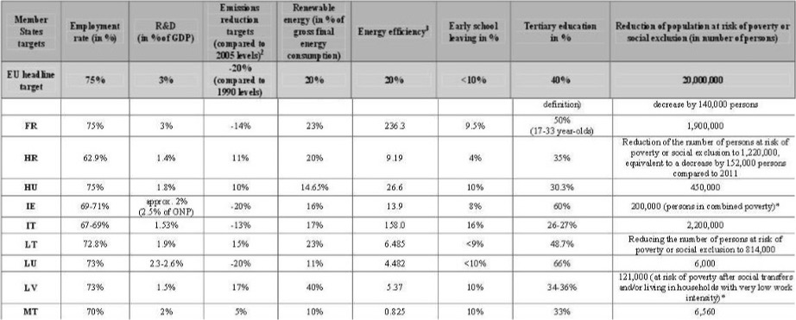

A second shared performance framework is linked to the management of the EU structural funds. The EU Member states manage a large part of the EU budget through the shared management model of the EU spending programs, which account for approximately 80% of the EU budget. The bulk of these programs corresponds to the European Structural Investments funds (ESIF)[25], for which the Commission and the member states are jointly responsible for their implementation. Also, the use of structural funds is based on the principle of complementarity and requires the co-financing of the operative programs from the member states. As described above, to increase the results orientation of the ESI funds the Commission together with the member states adopted a shared performance framework for monitoring, reporting and evaluate the use of the ESI funds. Consequently, all managing authorities share the same common objectives set for all ESI funds and need to define their indicators and targets to account for how the resources managed are directed towards the common objectives.

Considering the missing adoption of a new shared ten-year strategy at the EU level, in the current decade (2020-2030), EU and member states only share the new ESI funds performance framework.

**7. Conclusions**

The strategic framework of the EU appears as a rather complex performance system with multiple strategic frameworks in place at different levels of the organization and outside. Despite the progress towards a more coherent and effective performance chain, several disconnections between documents set at different levels and with different perspectives time still affect the EU performance management system.

The first disconnection is the missing of a shared and medium-term strategy for the decade 2020-2030 between EU institutions and the member states. The lack of a common strategic framework at high level including targets and indicators obstacle the possibility to link performance objectives set at the different levels with the EU institutions and member states.

The second disconnection is that the time-perspective of the different EU strategic documents is not aligned. In fact:

* the long-term EU strategies, as the Lisbon strategy and the Europe 2020 strategy, have a time span of ten years (from 2000-20201, 2010 to 2020 etc.);
* the Multiannual Financial Framework (MFF) and the EU spending programs have formally a time of seven years (currently from 2021 to 2027). Although the actual length is over 13 years, considering that the proposals are first made two years before (n-2) and the spending programs have an eligibility period three years after (n+3) the end of the programming period;
* the strategic agenda of the European Council has a time of five years (currently 2019-2024);
* the Commission mandate linked to the Commission’s political guidelines is set for five years following the electoral cycle of the European Parliament (currently from 2019-2024).

The time of the ten-year strategy (currently missing) is thus not aligned with the Multiannual Financial Framework and the EU spending programs in turns are not synchronized with the Commission political guidelines which are set for five years following the electoral cycle of the European Parliament. Also, the previous EU spending programs (n+3) overlap with the current programming period. The consequence is that the actual period of the strategic documents prevents the achievement of the strategic goals through implementing policy more effectively and efficiently (European Parliament 2017).

The third shortcoming is linked to the presence of multiple and overlapping strategic frameworks within the same organization. This can impede clarity and transparency in the performance chain, affecting the coherence between the higher-level strategic goals and more intermediate and operational objectives as well as the accountability framework (OECD 2017). The clarity of the EU strategic framework will depend on the level of complementarity of such documents as the different frameworks cover different kinds of areas. For example, the main documents setting the EU strategic frameworks, the UN Agenda, the ten-year strategy, and the Council Agenda have different time perspectives, include different objectives or sometimes the objectives are similar but measured with different indicators or as in the case of the Council agenda, the indicators are missing. Also, the monitoring and reporting mechanisms are diverse, while the Europe 2020 strategy was fully integrated in the EU semester for policy coordination with the EU member states, the Commission deals with monitoring, reporting and reviewing progress towards the Sustainable Development Goals in the EU context (European Commission 2016a).

In the previous decade, the ten-year strategy Europe 2020 and the MFF covered different areas of competence. Although some relevant shifts were made in the MFF (2014-2020) to better align it with the EU strategic objectives, the expenditures’ structure still reflected the traditional division, with almost 70% of expenditures related to agriculture and cohesion policy (European Parliament 2017). Whereas in the Europe 2020 strategy little space is dedicated to both areas. In the current decade the absence of the ten-year strategy prevents any kind of analysis. The relation between the MFF and the EU spending programs is more linear, as all EU spending programs are split into the different budget chapters grouped within the budget headings which corresponds to a policy area. Nevertheless, each spending program has its performance framework and no single performance frameworks exist at the level of the MFF headings or policy area. This can make difficult for stakeholders to understand, for example, what the budget as a whole, or the single budget headings, are trying to accomplish (OECD 2017). The new reporting mechanism elaborated by the Commission which integrates information on financial expenditures and program performance in a single document (the AMPR) is definitively more accurate and informative than in the past. Nevertheless, for the general public is still very complex to come to terms with it. For this reason, the communication on performance should be further improved. To this regard, the OECD in a recent assessment report on Budgeting and Performance in the European Union suggests the EU to adopt a single document including the goals and objectives that the EU Budget intends to achieve “to be structured by reference to the existing EU budget headings, drawing together the various goals and objectives that are already articulated in various other policy domains […] and specifying, in each policy area, a limited number of headline targets to be pursued during the course of the budget year” (OECD 2017).

The fourth aspect concerns whether the EU performance framework is network oriented. In fact, measuring impact and results of the EU’s actions should be connected to a deeper performance management system, as the outcome are generally realized by the contribution of a range of organizations. In the case of the EU, the performance management is deeper as much as the performance levels (International, European and national) are linked and integrated. In other words, as much as the objectives and targets are shared and commonly used across the different strategic levels by different actors, as much as deep is the performance management system. The outcome planned at the EU level can be achieved only in collaboration with member states’ contribution, as these latter hold relevant responsibilities either in managing EU spending programs (indirect and shared management model) as well as in adopting legislative and non-legislative initiatives in their areas of competence. Their action is thus crucial for the achievement of the objectives set by the EU level; consequently, the depth of the performance management system adopted will depend on the degree of integration with the performance management system of the member states. In other words, as much as the objectives and indicators set at the European level will be integrated into the national performance management systems, as much as deeper will be the whole EU performance system. The Commission is deeply aware of the crucial role of the member states in achieving the objectives set and vice versa, member states believe to achieve the objectives more effectively at the European level. Said that performance accountability requires mutual trust and effective cooperation, indispensable for setting up a rational, shared and deeper performance system (Stiglitz, 2003). In this respect, some initiatives have been carried out to increase the coordination of performance systems.

As described above, the EU and the member states currently share two performance frameworks, the Europe 2020 strategy and the performance framework for the ESI funds. As for the Europe 2020 strategy, the European Commission and member states set together the main important priorities and targets as well as those of the main EU policy areas[26]. Consequently, common objectives and indicators are set at different levels, including the policy areas (meso-level) as well as at the level of the single organization (micro-level). All member states formally committed to achieve the objectives set at the European level and different monitoring and evaluation mechanisms have been introduced to this purpose, as described above. Nevertheless, the mechanisms for monitoring member states’ compliance are rather weak, as the whole performance mechanism is still prevalently based on mutual collaboration and policy coordination, especially in the policy areas of member states’ competence, typical of the network approach. As stressed by Metcalfe (1992; 2000), all different configuration of policy governance at the EU level are all network-based and managed through organizational networks[27]. Such networks need to be managed effectively by the European Commission to achieve the desired and planned objectives. Despite this, the Commission “has never been comfortable with the task of building and strengthening networks of close working relationships with national administrations, […] maintaining an arms-length relationship and an attitude of watchfulness, if not mistrust towards them “(Metcalfe, 1992). This attitude also influences the coordination of performance. Often, instead of strengthening the collaboration with member states towards a common performance objective, the Commission perceives the national administration as an external factor threatening the achievement of performance objectives. For example, in the EU program management field, the role of member states administration is often included in the Strategic Plans, in the section dedicated to the “main external factors influencing the achievement of the intended results”, together with economic and financial crises[28]. Consequently, also the performance of the network is not adequately assessed, despite its relevance in the EU policy cycle. As outlined above, the performance measurement systems should support the collaborative relations among the network members and evaluate their performance, including specific indicators for measuring the performance of networks. From the case-study analysis, there is no evidence of specific indicators assessing the way the different EU policy networks are performing.

Finally, although further investigation is needed, the depth of the European Commission management system seems still very much dependent by the willingness of member states to incorporate priorities, targets, and indicators in their national performance system, although different mechanisms have been set up to agree on common objectives, priorities and targets. The poor attitude of the European Commission towards the network approach and the weak coordination mechanism could hamper this process. At the same time, the current structure of the Commission performance system is more coherent with a deeper level of performance measurement system and with a higher level of integration of their components.

**References**

* Agranoff, R. and McGuire, M. 1999. Managing in network settings, Review of Policy Research, 16(1):18-41.
* Agranoff R. and M. McGuire. 2001. Big Questions in Public Network Management Research, Journal of Public Administration Research and Theory, 11(3):295-326.
* Agranoff R. and M. McGuire. 2003. Collaborative Public Management: New Strategies for Local Governments, Georgetown University Press.
* Allison G.T. 1971. Essence of Decision Making: Explaining the Cuban Missile Crisis, New York, HarperCollins Publishers.
* Balint T. and C. Knill. 2007. The Limits of Legitimacy Pressure as a Source of Organizational Change: The Reform of Human Resource Management in the OECD, in “Management Reforms in International Organizations”, eds. Bauer M., Knill C., Nomos.
* Bauer M.W. 2007. Introduction: Management Reform in International Organizations, in “Management Reforms in International Organizations”, eds. Bauer M., Knill C., Nomos.
* Beetham D. 1991. The legitimacy of power. London, Macmillan Education Ltd.
* Bouckaert G. and J. Halligan. 2008. Managing performance: International comparisons, Routledge.
* Bovaird T. 1996. Performance Assessment of Service Quality: Lessons from UK National Initiatives to Influence Local Government. Quality, Innovation and Measurement in the Public Sector, Peter Lang, Frankfurt.
* Bingham L. B., and R. O’Leary. 2007. Conclusion: Parallel Play, Not Collaboration: Missing Questions, Missing Connections, Public Administration Review, 66:161-167.
* Buchanan A. and R.O. Keohane. 2006. The legitimacy of global governance institutions, Ethics & International Affairs, 20(4):405-437.
* Cepiku, D. 2013. Network performance: toward a dynamic multidimensional model, in Keast, R., Mandell, M. and Agranoff, R. (Eds), Network Theory in the Public Sector, Routledge, New York.
* Costumato, L. 2021. Collaboration among public organizations: a systematic literature review on determinants of interinstitutional performance, International Journal of Public Sector Management, 34(3):247-273.
* Cox R. W. and H. J. Jacobson. 1973. The Anatomy of Influence: Decision Making in International Organization, New Heaven, Yale University Press.
* Cristofoli, D., Maccio, L. and Pedrazzi, L. 2015. Structure, mechanisms, and managers in successful networks, Public Management Review, 17(4):489-516.
* Cristofoli, D. and Markovic, J. 2016. How to make public networks really work: a qualitative comparative analysis, Public Administration, 94(1):89-110.
* Crosby, B.C. and Bryson, J.M. 2005. A leadership framework for cross-sector collaboration, Public Management Review, 7(2):177-201.
* Dahl R.A. 1989. Democracy and its Critics, Yale University Press.
* Dahl R.A., E. R. Tufte. 1973. Size and Democracy (Vol. 2), Stanford University Press.
* Dijkzeul D. and Y. Beigbeder. 2003. Introduction in Rethinking International Organizations: Pathologies & Promise, New York, Berghahn Books.
* Eurostat. 2016. Smarter, greener, more inclusive? Indicators to support the Europe 2020 Strategy.
* Giacomini, D., Sancino, A. and Simonetto, A. 2018. The introduction of mandatory inter-municipal cooperation in small municipalities: preliminary lessons from Italy, International Journal of Public Sector Management, 31(3):331-346.
* Gordenker L. and P. R.Sanders. 1978. Organization Theory and International Organization, Paul Taylor and A.J.R. Groom, eds., International Organization: A Conceptual Approach, New York, Nichols Publishing Co.
* Haas E. B. 1958. The Uniting of Europe, Stanford: Stanford Univ. Press
* Herranz Jr, J. 2010. Network Performance and Coordination: A Theoretical Review and Framework, Public Performance & Management Review, 33(3):311-341.
* Hood C. 1995. The New Public Management in the 1980s: Variations on a Theme, Accounting, Organizations and Society, 20(2):93-109.
* Hood, C., G. Peters. 2004. The Middle Aging of New Public Management: into the Age of Paradox?, Journal of Public Administration Research and Theory, 14(3):267-282.
* Jervis R. 1976. Perception and Misperception in International Politics, Princeton, Princeton University Press
* Jonsson C. 1986. Inter-organization Theory and International Organization, International Studies Quarterly, 30(1):39–57
* Kaul I., I. Grunberg and M.A. Stern. 1999. Global public goods, Oxford University Press.
* Keast, R., Mandell, M.P. and Brown, K. 2004. Network structures: working differently and changing expectations, Public Administration Review, 64(3):363-371
* Kenis, P. and K. G. Provan. 2009. Towards an Exogenous Theory of Public Network Performance, Public Administration, 87:440–456.
* Kickert, W.J.M., Klijn, E.H. and Koppenjan, J.F.M. 1997. Managing Complex Networks: Strategies for the Public Sector, SAGE Publications, London.
* Kiefer, J.J. and Monjoy, R.S. 2006. Incrementalism before the storm: network performance for the evacuation of New orleans”, Public Administration Review, 66(s1):122-130
* Klijn, E.H., Steijn, B. and Edelenbos, J. 2010. The impact of network management on outcomes in governance networks, Public Administration, 88(4)1063-1082.
* Koppenjan & Klijn, 2004;
* LeRoux, K., Brandenburger, P.W. and Pandey, S.K. 2010. Interlocal service cooperation in US cities: a social network explanation, Public Administration Review, 70(2):268-278.
* Lindencrona, F., Ekblad, S. and Axelsson, R. 2009. Modes of interaction and performance of human service networks A study of refugee resettlement support in Sweden, Public Management Review, 11(2):191-215
* Mandell, M. 1994. Managing interdependencies through program structures: a revised paradigm, The American Review of Public Administration, 24(1):99-121
* May, P.J. and Winter, S.C. 2007. Politicians, managers, and street-level bureaucrats: influences on policy implementation, Journal of Public Administration Research and Theory, 19(3):453-476.
* Mayntz, R. 1998. Socialist Academies of Sciences: the Enforced Orientation of Basic Research at User Needs, Research Policy, 27(8):781-791
* McGuire, M. and R. Agranoff. 2007. Answering the Big Questions, Asking the Bigger Questions:
* Expanding the Public Network Management Empirical Research Agenda, Public Management Research Conference
* McGuire, M. and R. Agranoff. 2011. The limitation of public management network, Public Administration, 89(2):265-284
* Mehde, V. 2007. Creating a Missing Link? Administrative Reforms as a Means of Improving the Legitimacy of International Organizations, in “Management Reforms in International Organizations”, (eds.) Bauer M., Knill C., Nomos.
* Metcalfe, L. 1992. After 1992: Can the Commission Manage Europe?, Australian Journal of Public Administration, 51(1):117-130.
* Metcalfe, L. 2000. Reforming the Commission: will Organizational Efficiency Produce Effective Governance?, Journal of Common Market Studies, 38(5):817-841
* Milward H.B. and K.G. Provan. 2003. Managing networks effectively, in “National Public Management Research Conference”, Georgetown University, Washington, DC October
* Moe, R.C. 1994. The Reinventing Government Exercise: Misinterpreting the Problem, Misjudging the Consequences, Public Administration Review, 54(2):111-122.
* Moravcsik, A. 2004. Is there a ‘Democratic Deficit’ in World Politics? A Framework for Analysis, Government and opposition, 39(2):336-363.
* Moretti, A. 2017. The network organization – a governance perspective on structure, dynamics and performance, Palgrave Macmillan.
* O’Toole, L.J. 1997. Treating networks seriously: practical and research-based agendas in public administration, Public Administration Review, 57(1):45-52.
* Perrow, C. 1986. Economic theories of organization, Theory and society, 15(1):11-45.
* Pollitt, C. and G. Bouckaert. 2017. Public Management Reform: A Comparative Analysis - Into The Age of Austerity, Oxford University Press
* Provan, K.G. and Kenis, P. 2008. Modes of network governance: structure, management, and effectiveness, Journal of Public Administration Research and Theory, 18(2):229-252.
* Provan, K.G. and Milward, H.B. 1995. A preliminary theory of interorganizational network effectiveness: a comparative study of four community mental health systems, Administrative Science Quarterly, 40(1):1-133.
* Provan, K.G. and Milward, H.B. 2001. Do networks really work? A framework for evaluating public sector organizational networks, Public Administration Review, 61(4):414-423.
* Provan, K.G. and Sebastian, J.G. 1998. Networks within networks: service link overlap, organizational cliques, and network effectiveness, Academy of Management Journal, 41(4):553-563.
* Provan, K.G., Veazie, M.A., Staten, L.K. and Teufel-Shone, N.I. 2005. The use of network analysis to strengthen community partnerships, Public Administration Review, 65(5):603-613.
* Provan, K.G., Fish, A. and Sydow, J. 2007. Interorganizational networks at the network level: a review of the empirical literature on whole networks, Journal of Management, 33(3):479-516.
* Provan, K.G., Huang, K. and Milward, H.B. 2009. The evolution of structural embeddedness and organizational social outcomes in a centrally governed health and human services network, Journal of Public Administration Research and Theory, 19(4):873-893.
* Raab, J., Mannak, R.S. and Cambr e, B. 2013. Combining structure, governance, and context: a configurational approach to network effectiveness, Journal of Public Administration Research and Theory, 25(2):479-511.
* Rhodes, R. A. W. 1996. The New Governance: Governing without Government, Political studies, 44(4):652 – 667
* Scharpf, F. W. 2004. Legitimationskonzepte jenseits de Nationalstaats, Discussion Paper 04/6, Koln, Max Planck Institute for Study of Societies
* Schimmelfennig F. 1996. Legitimate Rule in the European Union, Center for German and European Studies, University of California at Berkeley
* Schneller, L. 2010. Conceptions of Democratic Legitimate Governance in the Multilateral Realm: The Case of the WTO, Living Reviews in Democracy, Volume 2 – 2010
* Stiglitz, J. 2003. Democratizing the International Monetary Fund and the World Bank: Governance and Accountability, International Journal of Policy, Administration, and Institutions, 16(1):111–139
* Talbot, C. 2005. Performance management, The Oxford Handbook of Public Management.
* Vallotti G., R. D. Galli, A. Orlandi, S. Rota and M. Sicilia. 2010. Research Project “La misurazione e la valutazione della performance nella PA Centrale”, Scuola Nazionale Amministrazione, Roma
* Van Raaij, D.P.A.M. 2006. Norms network members use: an alternative perspective for indicating network success or failure, International Public Management Journal, 9(3):249-270.
* Voets, J., W. Van Dooren and F. De Rynck. 2008. A Framework for Assessing the Performance of Policy Networks, Public Management Review, 10(6):773-790
* Weiler, J.H. 1991. Problems of Legitimacy in Post 1992 Europe, Aussenwirtschaft, 46(3):4
* Zurn, M. 2004. Global Governance and Legitimacy Problems, Government and Opposition, 39(2):260–287

**N0tes**

1. The Yearbook contains a directory of names and addresses, as well as profiles of organizations (historical and structural information, specifics on activities, events, and publications as well as biographies of important members), [www.uia.org](http://www.uia.org).
2. Criteria include Type A, B, C.
3. See Barnett, Finnmore (1999, 2004), Rochester (1989), Brenchin (1988), Dijkzeul and Beigbeder (2003).
4. Except in the case of the European Union. Since 1979, the citizens of the member states directly elect their representatives to the European Parliament.
5. According to the division of competences agreed between the EU and the Member States, “the Union shall have exclusive competence in the following areas: (a) customs union; (b) the establishment of the competition rules necessary for the functioning of the internal market; (c) monetary policy for the Member States whose currency is the euro; (d) the conservation of marine biological resources under the common fisheries policy; (e) common commercial policy.” (Art. 3 of TFUE). “Shared competence between the Union and the Member States applies in the following principal areas: (a) internal market; (b) social policy, for the aspects defined in this Treaty; (c) economic, social and territorial cohesion; (d) agriculture and fisheries, excluding the conservation of marine biological resources; (e) environment; (f) consumer protection; (g) transport; (h) trans-European networks; (i) energy; (j) area of freedom, security and justice; (k) common safety concerns in public health matters, for the aspects defined in this Treaty. (Art. 4.2 TFUE). “The Union shall have the competence to carry out actions to support, coordinate or supplement the actions of the Member States. The areas of such action shall, at European level, be: (a) protection and improvement of human health; (b) industry; (c) culture; (d) tourism; (e) education, vocational training, youth and sport; (f) civil protection; (g) administrative cooperation.” (Art. 6 TFUE).
6. The EU institutional framework includes also the Court of Justice, the European Central Bank and European Court of Auditors as well as other consultative bodies as the European Committee of the Regions and Economic and Social Committee.
7. See <https://ec.europa.eu/eurostat/web/europe-2020-indicators>.
8. The five priorities are 1. Jobs, growth and competitiveness, 2. Empowering and protecting citizens, 3. Energy and climate policies, 4. Freedom, security and justice, 5. The EU as a strong global actor.
9. See <https://ec.europa.eu/energy/en/topics/energy-strategy>.
10. See <http://ec.europa.eu/health/strategy/objectives/index_en.htm>.
11. See <http://ec.europa.eu/consumers/eu_consumer_policy/our-strategy/index_en.htm>.
12. See <http://ec.europa.eu/education/policy/strategic-framework/index_en.htm>.
13. The estimation is made considering the complexities of such calculation, due to the multi-dimensional character of the initiatives funded within the single programs as well as the multi-level governance-based approach of such initiatives involving diverse stakeholders (EU member states, local authorities etc.)(European Commission 2018b).
14. See art. 3 TUE.
15. Although the Political Guidelines do not include indicators, these latter are identified in the Strategic Plans of the DGs and Services for each Commission priority. These statistical indicators are high-level context indicators designed to track the longer-term and indirect impacts of EU action.
16. REFIT is the European Commission's Regulatory Fitness and Performance program to make EU law simpler and to reduce regulatory costs without compromising policy objectives. REFIT thus contributes to a clear, stable and predictable regulatory framework supporting growth and jobs. (European Commission, 2015e).
17. The Annex III of the CWP 2019 includes 84 pending proposals still to be adopted in 2019.
18. The Annex IV of the CWP 2019 includes 10 proposals subject to modifications or withdrawals.
19. Together with the Work Program (CWP), the Commission also publishes the “list of planned Commission Initiatives”, listing the CWP initiatives that are yet to be adopted as well as the foreseen initiatives that derive from the various agendas, including Communications, International Agreements, delegated and implemented acts, and other legislative and non-legislative initiatives that are not foreseen in the CWP.
20. Considering that the Junker Commission term of office ends on 2019, there is a disclaimer on the documenting saying that “the current Commission's term of office runs until 31 October 2019. New political orientations provided by the incoming Commission for the subsequent period will be appropriately reflected in the strategic planning process”.
21. The targets are generally set to 2020. For impact indicators linked to 2014-2020 spending programs the target has been set to 2023 (end of the implementation of the 2014-2020 programs).
22. The key performance indicators are included in the Strategic Plan of the DG Regional and Urban Policy (2016-2020), page 27.
23. The report is published following art. 249(2) of the Treaty on the Functioning of the European Union.
24. In a few cases Member States have not set up national targets or cumulatively the national targets are not ambitious enough to reach the EU-level goal. For example, the fulfillment of all national targets in the area of employment would bring the overall EU-28 employment rate up to 74 %, which would still be one percentage point below the Europe 2020 target of 75 %. (Eurostat 2016).
25. The European Structural and Investments funds include the following funds: the European Regional Development Fund (ERDF), the European Social Fund (ESF), the Cohesion Fund (CF), the European Agricultural Fund for Rural Development (EAFRD), the European Maritime and Fisheries Fund (EMFF).
26. See for example the Strategic Framework on Education and Training (ET 2020) <http://ec.europa.eu/education/policy/strategic-framework/index_en.htm>.
27. Metcalfe (2000) identifies the following governance models in the EU decision-making system, the Community method (ex. Agricultural Policy), the EU Regulatory Model (ex. Internal Market and Competition Policy), the Multilevel Governance (ex. Cohesion policy Policy), the Coordination and Benchmarking ( ex. Research and Development, Environment, Employment) and Intensive Inter-governmentalism (ex. Foreign Policy Justice).
28. See for example the Strategic Plan 2016-2020 of the Directorate General for Regional and Urban Policy (DG REGIO), page 26.