Agency governance in integrated administrative systems
Evidence from a large-scale study

Jarle Trondal, Gjermund Haslerud and Nadja S. Kühn
University of Oslo and University of Agder, Norway

Paper prepared for the EUSA International Biennial Conference, Denver, US, May 9-11, 2019.
First draft

Abstract
This paper observes that government agencies are engaged in two parallel worlds of executive governance that fuel contending opportunities and constraints. Two contributions are made: (1) Theoretically, two conceptual images of agency governance are outlined deriving distinct predictions on how agencies are likely to act when embedded in integrated multilevel administrative orders such as the European Union (EU). The paper thus expands our understanding of an embedded “coordination dilemma” facing domestic agencies involved in EU governance processes. The paper also suggests how these images are dependent on moderator variables. (2) Benefiting from a novel large-N (N=1963) survey on agency officials, the paper observes that domestic agencies feature compound behavior characterized by compromises and abilities to navigate conflicting concerns – such as those of domestic governments and EU-level institutions. Moreover, the data shows how this coordination dilemma is mediated through and conditioned by existing domestic institutions, practices, and traditions, thus contributing to a differentiated European administrative order.

Introduction
Empirical and prescriptive studies are voluminous on how public governance is and should be conducted in situations of risk and uncertainty (Quarantelli et al. 2018; Boin et al. 2017). How public governance is conducted in situations of what recent literature has described as turbulence is less understood (Ansell et al. 2017; Vigoda-Gadot and Mizrahi 2014). Turbulence has been defined as an embedded feature of contemporary public governance processes which requires public organizations to face every-day governing challenges of variable kinds: situations where events, demands, and support interact and change in ´variable, inconsistent, unexpected and/or unpredictable ways´ (Ansell et al. 2017: 1; Easton 1965; Gunnell 2011; Miller 1971). This study offers a case study of governance under embedded turbulence by examining on how government agencies maneuver when embedded in integrated multilevel administrative orders. Domestic central administration is engaged in two parallel worlds of executive governance and may experience opportunities and constraints at both levels because different institutions may send different information, signals and mandates to domestic civil servants (Dehousse 2008; Egeberg and Trondal 2018).
The contribution of the paper is twofold:
- First, it outlines two conceptual images of agency governance: a dyadic and a compound approach. These images derive distinct propositions as to how agencies are likely to act when embedded in integrated multilevel administrative orders such as the European Union (EU). The paper also suggests how these images dependent on moderator variables at the domestic level.
- Secondly, the analysis benefits from a novel large-N (1963) survey on agency officials in the Norwegian central administration. The data-set is comprehensive by spanning the whole population of government agencies. The results suggest that domestic agencies feature compound behaviour characterized by compromises and abilities to navigate conflicting concerns – such as those of domestic governments and EU-level institutions. Secondly, the data suggests how this dilemma is mediated through, and conditioned by, existing domestic institutions, practices, and traditions, thus contributing to a differentiated European administrative order (e.g. Bauer and Trondal 2015). The paper thus expands our understanding of the “coordination dilemma” that face domestic agencies embedded in EU governance processes (Egeberg and Trondal 2016).

Generalizing the argument, government agencies increasingly maneuver in situations where state sovereignty is under persistent stress. Mutual dependence, international cooperation and delegation to non-elected bodies challenge nation-states´ capacity to make democratically accountable decisions. These developments have spurred vibrant scholarly debate on the reliance of political sovereignty in a globalized world (e.g. Dahl 2000; Olsen 2018; Rosenau 1990). Much less understood, however, is the shifting role of government agencies and what role public administration play in making sovereignty resilient (Egeberg and Trondal 2015). As the public administration of states serves as core state powers, defined as ´institutional significance for state building´ (Genschel and Jachtenfuchs 2014: 10), the role of public agencies is key to understand sustained state sovereignty. Putting public administration center stage in the study of democratic governance, Dwight Waldo (1952) coined the “Administrative State”, emphasizing the semi-autonomous role of public administration. Since Waldo, government agencies have become fundamental to public governance in advanced democracies. Their tasks range from collecting and analyzing information, coordinating, and regulating. Agencies represent a vertical fragmentation of the polity and a supply of administrative capacities to solve regulatory challenges, and they are organizational compromises between a need for political steering and requisite professional autonomy and technical regulation. Government agencies are organized at arm’s length from their parent ministries, ensuring agencies to operate relatively insulted from political steering but at the same time organizationally exposed to ‘capture’ from EU-level institutions and processes (Egeberg and Trondal 2017).

This paper adds to a mounting literature on the changing role of public governance in an integrated multilevel European executive order (Bauer and Trondal 2015; Goetz and Meyer-Sahling 2008; Trondal 2010). This literature has been preoccupied with studying EU-level agencification (e.g. Egeberg and Trondal 2017; Levi-Faur 2011; Rittberger and Wonka 2011) and the interconnected nature of the EU-level and national-level agencies both with respects to substantive policy-making and implementation as well as to administrative change and reform (Bach and Ruffing 2018; Curtin and Egeberg 2008; Egeberg and Trondal 2018; Trein and Maggetti 2018). This literature has shown how the European administrative system represents a multilevel and nested network administration (e.g. Bach and Ruffing 2018), where administrative bodies at different levels of government ‘are linked together in the performance of tasks…’ (Hofmann and Turk 2006: 583). However, one challenge plagues contemporary scholarship which this paper aims to address: How to understand the role of public agencies in the governing of a deeply integrated (yet differentiated) EU multilevel system. Existing literature has failed to understand how agencification at one level affects public governance at another, and thus how shifting features of the state – such as agencification and subsequent networking of agencies – influence democratic governance (Danielsen and Yesilkagit 2014; Egeberg 2006; Egeberg and Trondal 2016; Vantaggiato 2019; Verhoest et al. 2012). Whereas existing literature has mapped patterns of agencification, less is known about how and under what conditions public agencies contribute to the transformation of the EU’s politico-administrative order. Empirically, we lack studies of the actual role of agencies in the policy-making process in the EU. Without it, scholars and practitioners face the double danger of misunderstanding and mistreating it.

The data-set is collected within by far the most integrated EU non-member (Norway). Norway is not a formal EU member, yet it is closely affiliated through 130 agreements, notably a comprehensive and dynamic European Economic Area (EEA) agreement. Norway has been considered a quasi EU-member (Fossum 2019b) since Norway´s is affiliated status grants the Norwegian central administration privileged access to most parts of the EU administration, which in turn opens for administrative integration quite similar to the central administrations of EU member-states. Consequently, despite a lack of political representation in the Council (and the European Parliament), the Norwegian core executive apparatus is tightly integrated with and influenced by the EU´s core executive apparatus (Kühn and Trondal 2018). The “Norway model” is thus coined by administrative integration without political integration through a dense web of administrative agreements, with the EEA agreement being the most encompassing and with the greatest implications for public policy and law (Egeberg and Trondal 1999; Fossum 2019b; Fossum and Graver 2018; Lavenex 2009).

The paper proceeds as follows: The next section outlines a framework for analysis and propositions for empirical enquiry. The next section presents the data-set and methodology applied succeeded by a presentation and discussion of empirical findings. The paper concludes with key findings and implications for this field of study.

A two-step framework for analysis
This section is brought in two steps: The first step outlines competing images of agency governance: A dyadic and a compound approach. The second step suggests how moderator variables might bias agency governance towards either of the two.

Studying public governance and how domestic central administrative institutions adapt to EU affairs is important for several reasons. First, domestic public administration are key institutions to the implementation and practicing of EU jurisprudence. Because the transposition of EU law remains an administrative process relatively isolated from political actors, it is essential to study agencies in order to understand the likelihood of uniform implementation of (EU) law. Domestic decision-making processes are also essential since they are intertwined with the decision-making processes of the EU, notably the Commission and EU agencies. Such interactions might affect power relationships between the ministry and subordinate agencies, between elected politicians and expert officials, as well as between domestic governance systems and the EU.

Step I: Contending images on agency governance
This section expands on two ideas from public administration literature that make distinctive forecasts for agency governance.

Image I: A dyadic image of agency governance builds on the simple conjecture that public administration runs in a world of dyadic and dichotomous worlds, such as politics vs. administration (PAD), normal vs. abnormal, change vs. stability, and so on (e.g. Waldo 1952; Wilson 1887). Turbulence and hybridity is thus understood to be dysfunctional—that is, as exceptional, dangerous, or contradictory (Ansell et al. 2017). In this light, turbulence is seen to push organizations and institutions to their limits and threaten surprising cascading dynamics that undermine the sustainability of existing governance arrangements. Or it might produce maladaptive behaviors that trap governance into suboptimal outcomes. From this perspective, the emphasis is generally not how governing institutions manage turbulence, but how they withstand it and/or ultimately solve it.

Image I builds on the “coordination dilemma” portrayed by contending governing dynamics undermining one another (Egeberg and Trondal 2016). The ambition of strong coordination of governance processes at one level of government is arguably incompatible with strong coordination of governance processes across levels. For example, strong steering of public agencies from the domestic political leadership is arguable adversely related with strong steering from the EU level. Strong coordination by the European Commission vis-à-vis domestic government agencies is thus expected to undermine ministerial political control. Image I suggests both how turbulence generates ambiguities when assessing and suggesting “good” governance solutions (Grindle 2017) as well as challenge attached to “nationally embedding a supranational project” (Bulmer and Joseph 2016: 738).

In the same vein, Image I underscores how ‘better coordination’ becomes difficult when public administration becomes embedded in multilevel structures. The quest for ´order´ has become a shared goal in contemporary political-administrative systems (e.g. Kassim et al. 2017; MacCarthaigh and Molenveld 2018). Recent administrative doctrines have shared a near universal agreement on the desirability of ‘better coordination’ and executive center formation (e.g. Lægreid et al. 2014). Image I, however, assumes that it is impossible to combine strong coordination processes at one level of government with simultaneous strong coordination across levels. To illustrate, the multilevel EU polity is a case in point: The EU borrowed ‘indirect administration’ from classical international organizations (IOs). Decisions assumed by IOs were thus implemented by member states and not by the IO itself (Hofmann 2008). This structure, characterized by relatively weak coordination across levels, is thus compatible with strong coordination at the national level. Similarly, Wolfgang Wessels (1997) showed that the lack of co-ordination in Bonn may have been a prerequisite for advancing the wider ‘European cause’. Poor national coordination is thus not merely a ‘management deficit’ (Metcalfe 1994) but rather a requirement for coordination and steering across levels.

This tension between policy coordination across levels of government and regional/local coordination has been well-known federal states and central-local relations within unitary states (e.g. Fossum and Jachtenfuchs 2017). It has been less recognized in the study of public administration. In this context, national agencies organized at arm’s length from parent ministerial departments and enjoying de facto autonomy vis-à-vis from these departments, thus constituting the very administrative infrastructure for ‘agency capture’ by EU bodies (Peters and Trondal 2013). Consequently, national agencies become building blocks of a multilevel EU administration (Egeberg and Trondal 2018). One empirical proposition follows:

P1: Strong administrative integration across levels of governance are orthogonal to strong national governmental steering, and so we expect significant negative correlations between EU-level and national-level steering.

Image II: A compound image of agency governance, by contrast, contends that public administration is complex and involves multiple actors, ill-structured causal relations, fluid resources, governing logics and dynamics (Olsen 2017; Trondal et al. 2010). Image II sees turbulence as a condition and inherent for public governance, not as a dysfunction (Ansell and Trondal 2017; Howlett and Mukherjee 2018). Similar ideas linger in literature on differentiated European (dis)integration, in which differentiation is seen as a condition for European Union governance (Fossum 2019a). If embedded complexity and contestation is understood to be a condition of contemporary governance, one necessary implication is that efficient and effective governing institutions must manage turbulence as a condition for the governing process. Public governance, consequently, must be analyzed on the basis of continuous variables (Ansell et al. 2017). In this light, public administration has been pictured as hybrid and compound (Emery and Giauque 2014), partly reflecting how public administration relates to a larger political order (Olsen 2018). The idea of the compound administration responds to calls for going beyond ‘the tyranny of dichotomies’ and study ‘mixed political orders blending different forms of governance and organization´ (Olsen 2008: 5-6). Public administration is engaged in several co-evolving worlds of executive governance, for example when national agencies´ practicing of EU law take on multiple roles and hats (Egeberg and Trondal 2018). Similarly, a vast body of literature has pictured executive governance as characterized by the co-existence of institutions, decision-making dynamics, and levels of executive authority (Christensen and Lægreid 2008; Hooghe and Marks 2016; Olsen 2007). Public administration is seen as facing complex and intertwined problems, solutions, institutions and decision-making arenas (Olsen 2007; Shapiro et al. 2006). One effect might be that domestic agencies´ handling of EU affairs are best conceptualized as compound processes in which they mobilize a multi-dimensional repertoire. This idea follows a classical tradition in the study of public administration which argues that robust and legitimate administrative systems tend to balance several competing concerns (e.g. Olsen 2007) and that public governance rests on the mobilization of multiple sets of institutions, resources, interests, values, norms and cleavages of conflict (Pollitt 2016). One empirical proposition follows:

P2: Strong administrative integration across levels of governance complement strong national governmental steering, and so we expect significant positive correlations between EU-level and national-level coordination and steering.

Step II: Interaction effects
Agency governance in integrated administrative systems calls upon agency officials to balance competing concerns from different institutions. Turbulence arises from such tensions which produce ambiguity about what problems, solutions, and consequences to attend to at any time, and what actors are deemed legitimate and efficient (Ansell et al. 2017). This is the case under two particular conditions: First, political organizations such as government agencies are of a different kind than private organizations by being ‘created in order to handle conflicts …’ (Jacobsson et al. 2015: 35) and are thereby turbulent by design. Organized democracies have an embedded partisan responsiveness to a host of different cleavages of conflict (Rokkan 1999), which private organizations clearly have not. As such, governing politically embedded agencies entails a systemic component of turbulence. Secondly, turbulence is conditional for sustained public rule in government systems characterized by multilevel layering of authority (Landau 1969; Olsen 2018). More specifically, in political systems with layered authority when action capacity is distributed across levels, the involved organizations are likely to experience turbulence of scale in their exercise of tasks (Fossum and Jachtenfuchs 2017; Moravcsik 2018; Schmidt 2018). For example, the more the EU is engaged in policy implementation, the more important become issues of administrative coordination across levels – if only because the EU lacks requisite administrative capacities to conduct ’supranational’ policies independently from member states (Bauer and Becker 2014; Heidbreder 2011). Moreover, attempts from one actor to manage/limit turbulence (i.e. by the European Commission) may have turbulence-increasing consequences for others (i.e. member-state agencies).

Cyert and March (1963) suggested three mechanisms for how the firm may cope with such situations turbulence: through local rationalities, through acceptable-level decision rules, and through sequential attention to goals. However, public organizations rarely solve public problems but rather cope with them through organizational design and ´choice architectures´ (Egeberg and Trondal 2018; Thaler and Sunstein 2009). These architectures are materialized in the organizational fabric of government agencies through the vertical and horizontal specialization of departments, through procedures for the recruitment of staff, through the geographical location of offices, through time rules for budgeting, and so on.

This section suggests that the relative importance of either of Image I and II might be conditioned by intervening variables in which third variables affect the relationship between dependent and independent variables. The task is then to causally isolate conditions under which each image is likely to unfold as well as to test their robustness. The method section (see below) specifies seven variables that might intervene and bias agency governance in either direction. Building on recent empirical studies in public governance literature, the following moderators have been selected from the data-set: (i) The degree to which policy fields are affected by EU/EEA/Schengen, (ii) administrative capacity to ensure coordination and collaboration between relevant actors, (iii) the degree to which policy fields require cooperation across and between levels of governance, (iv) the degree to which there are clear and established formal rules on how to conduct tasks, (v) the degree to which there are clear and established formal rules on how to conduct tasks (vi) perceived trust between own agency and parent ministry, and (vii) the degree of politicization of policy fields.

Data and methodology
The study benefits from a unique large-N questionnaire survey that was recently (2016) completed at the agency level in the Norwegian central administration (N=1963). The survey represents the most thorough screening of the Norwegian central administration, and probably one of the most comprehensive data-sets on public governance in national government administrations worldwide. The questionnaire addresses a variety of aspects relating to the role and function of civil servants, distribution of power, patterns of contact, coordination, identification, demographic backgrounds, etc. Table 1 presents the independent and dependent variables of the study, including the moderators. The empirical analysis applies importance of (various) institutions as measurement of the alleged steering dilemma. As specified, two proxies are applied as dependent variables and two as independent variables.

Table 1 Descriptive statistics: Dependent, independent and moderator variables*
 | N** | Value - Max | Value - Min | Value - Do not know | Mean*** | St.dev***
Dependent variables
Importance of parent ministry when central decisions within your policy field are being made | 1178  (1233) | 1- Very important | 5- Not important | 6- 55 | 1.7 | 1
Importance of government when central decisions in your policy field are made | 1035  (1235) | 1- Very important | 5- Not important | 6- 200 | 2.1 | 1.2
Independent variables
Importance of the Commission when central decisions in your policy field are made | 751  (1236) | 1- Very important | 5- Not important | 6- 485 | 3.2 | 1.3
Importance of EU agencies when central decisions in your policy field are made | 670  (1234) | 1- Very important | 5- Not important | 6 - 564 | 3.5 | 1.3
Moderators
Degree to which own policy field is affected by EU/EEA/Schengen | 1374 | 1 – To a very large extent | 5 – Not affected | - | 3.2 | 1.5
Administrative capacity to ensure coordination and collaboration between relevant actors | 1536  (1686) | 1- Very good | 5- Very poor | 6- 150 | 2.6 | 0.9
Degree to which own policy field requires cooperation across and between levels of governance | 1719  (1732) | 1- To a very large extent | 5- To a very small extent | 6 - 13 | 2.8 | 1.2
Degree to which there are clear and established formal rules on how to conduct tasks**** | 1722  (-) | 1 – Very clear rules | 5 – rely on own judgement to a very large extent | - | 2.6 | 1.1
Organizational duplication***** | 1462 | 1 –departments | 4 – no organizational duplication | - | 2.2 | 1.1
Perceived trust between own agency and parent ministry | 1169  (1240) | 1 – Very high | 5- Very poor | 6- 71 | 1.9 | 0.8
Degree of politicization of own policy field | 1232 | 1 – To a very large extent | 5 – To a very small extent | - | 2.7 | 1.2
* Missing values not included
** Includes only values 1-5 (includes value 6 in parenthesis)
*** Includes only value 1-5
**** This variable is 5-scaled: (1) very large degree of formal rules (2) large degree of formal rules (3) neutral (4) rely on own judgement to a fairly large extent (5) rely on own judgement to a very large extent
**** This variable is 4-scaled: (1) departments (2) sections (3) positions (4) no organizational duplication

To empirically evaluate and explore the theoretical propositions explicated above, we use a two-step procedure. First, we explore pairwise correlations within and across various variables clustered at both the national-level and EU-level. Interpreting bivariate correlations singularly does not suffice in evaluating whether agency governance is mainly dyadic or compound. In addition, one needs to look at the broader picture and assess patterns of correlations within and between levels simultaneously. As outlined in the theoretical section, strong positive bivariate correlation across national-level and EU-level may indicate compound agency governance. However, this inference will be weakened, or appear arbitrary, if similar correlation patterns are not consistent for other pairs of variables across levels, or even if variables within levels correlate negatively. Likewise, while strong negative correlations between variables across national and EU levels correspond with a dyadic pattern, such an inference is more convincing if these correlations coexist with positive within-level correlations. If, on the other hand, correlations both within and across levels are strongly negative, the results would be indeterminate in supporting the regularity of a dyadic pattern. Table 2 illustrates this complexity and thus the need to look at broader patterns of correlations. More particularly, the table maps four patterns of pairwise correlations between variables within and across levels, of which two accentuate the ideal-patterns for compound and dyadic governance, respectively.

Table 2 Patterns of pairwise correlations
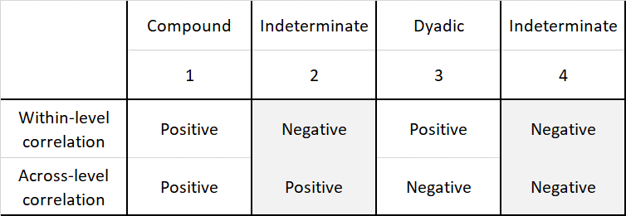

A clear compound governance pattern thus emerges where positive correlations are visible both across and within levels. In a similar vein, a clear dyadic pattern becomes visible when correlations across levels are consistently negative whilst correlations within levels are predominantly positive. Unfortunately, the terrain does not always fit the map. The complexity of interpreting correlational patterns thus increases with the emergence of low or non-significant correlations, within and/or across levels. In such instances, it becomes difficult to determine if a hypothesized strong correlation combined with low or no correlation are pointing towards compound or dyadic tendencies.

One way of taking this complexity into account, is to assess the dynamic and conditional nature of agency governance within the confines of a regression analysis. The next step is thus to explore the relationship between national level and EU-level variables using a classic multiplicative interaction model:

$$Y= β0 + βX+ βZ+ β(XZ)+ ε$$

In this model the outcome variable Y is the perceived importance of institutions at the national level while the key independent variable X is perceived importance of EU-level institutions. The moderator variable Z is included to investigate whether, or to what extent, the strength and/or direction of the relationship between X and Y is conditional, that is, varies with the level of Z. In other words, a multiplicative interaction model enables us to explore whether compound or dyadic tendencies may emerge under different institutional contexts, or, alternatively, whether a relationship is stable across various conditions or contexts. As such, the aim of the analysis is not to explain as much variance as possible but rather to investigate and reveal conditions under which a relationship between an outcome and an independent change. Interactions effects will then be plotted graphically for illustrative and interpretative purposes.

Findings
Table 3 make a test of whether agency governance is mainly dyadic or compound by studying bivariate correlations between ascribed importance to various institutions at the national and at the EU level. Three observations are made: First, we find strong, positive, and significant correlations between ascribed importance of EU-level institutions, with all the correlations being well above ,700. Not surprisingly, the highest correlation in this group is between political institutions at the EU level, namely the EU Parliament and the EU Council (correlation of ,918). Secondly, we also find strong, positive, and significant correlations between ascribed importance of institutions at the national level, albeit these are not as high as in the EU-level cluster. Among national-level institutions, correlation between the government and the national parliament stands out as highest (correlation of ,841). This is followed by correlation between the government and parent ministry at ,533. The remaining correlations in this group are also fairly high, ranging from ,218 to ,494. Third and most importantly, the last set of correlations are those across level of governance. Overall, significant correlations are lower than in the two previous groups, yet most are positive and significant. The highest correlation found is between ascribed importance of the national parliament and the EU council (,264). Most of the remaining correlations are significant, positive, yet moderate.

In sum, we may draw the following two conclusions: First, there are relatively strong positive correlations between ascribing importance to institutions at the same level of governance. This relationship is strongest when it comes to EU-level institutions. Moreover, at the national level, agency officials who ascribe importance to own organization are most likely to ascribe importance to own parent ministry while other ministries and political institutions are deemed less important. This observation is largely due to the fact that government agencies are organized at arm’s length from their parent ministries, entrusting agencies with room of maneuver from political steering. Such vertical specialization ensures that agencies are situated at relative distance from political institutions. Moreover, horizontal specialization ensures that agencies operating in different policy domains operate in relative isolation from one another. As a consequence, the parent ministry becomes the important institution for a majority of agency officials. At the EU level, the distinction between administrative and political institutions is less clear to domestic agency officials, although the correlation between the EU council and EU parliament stands out (,918). The second conclusion we can draw is that while we observe relatively strong correlations within each level of government, we observe relatively lower cross-level correlations. Nonetheless, contrary to the ideal-model Image I, the data does not demonstrate an adverse relationship between governance dynamics across levels. Agency officials may regard both national and European institutions as being of importance, yet it is more likely that they favour one set of institutions over the other. Translated into theoretical terms, Table 3 is overall in accordance with the Image II, albeit insignificant and low cross-level correlation may arguably indicate moderate dyadic tendencies.

Table 3 Inter-correlations matrix on the importance of institutions. Pearson´s r.
 | 1. | 2. | 3. | 4. | 5. | 6. | 7. | 8. | 9.
1.Own organization | 1
2.Parent ministry | ,458** | 1
3.Other ministries | ,218** | ,329** | 1
4.National Parliament | ,238** | ,494** | ,309** | 1
5.Government | ,238** | ,533** | ,335** | ,841** | 1
6.EU Commission | ,030 | ,093* | ,124** | ,196** | ,142** | 1
7.EU agencies | ,015 | ,079 | ,103** | ,151** | ,116** | ,770** | 1
8.EU Council | ,037 | ,176** | ,159** | ,264** | ,214** | ,801** | ,799** | 1
9.EU Parliament | ,026 | ,160** | ,156** | .245** | ,182** | ,767** | ,773** | ,918** | 1
* Correlation is significant at the 0.01 level (2-tailed)
** Correlation is significant at the 0.05 level (2-tailed)

While table 3 serves as a starting point in the analysis of the alleged steering dilemma, the succeeding tables (Tables 4 to 7) examine conditions that might push agency officials towards dyadic or compound directions. Model 3 and 4 test the relationship between ascribed importance of own parent ministry (dependent variable 1) and the importance of three independent variables: the importance ascribed to the Commission, the importance ascribed to EU agencies, and the degree to which own policy area is affected by EEA/EU/Schengen (affectedness)), with the list of moderators. Table 5 and 6 test the relationship between the ascribed importance of the government (dependent variable 2) and the same list of independent variables and moderators. Each table contains six models in which we regress the independent variables on seven different moderators.

Table 4 Relationship between perceived importance of the Commission and the perceived importance of own parent ministry (dependent variable), with interaction effects. Multivariate regression models.
 | Model 1: Cross-level cooperation | Model 2: Administrative capacity | Model 3: Formal rules | Model 4: Organizational duplication | Model 5:  Trust | Model 6:  Politicization
Constant | 1,697 | 1,439 | 2,163 | 1,767 | 1,852 | 1,608
Importance of the Commission | -0,117 | 0,081 | -0,081 | -0,143 | -0,051 | -0,095
Degree to which own policy area is affected by EEA/EU/Schengen (affectedness) | -0,318** | -0,310** | -0,324** | -0,284** | 0,0325** | -0,295**
Interaction importance of the Commission * affectedness | 0,071** | 0,077** | 0,076** | 0,066** | 0,077** | 0,065**
Degree to which own policy field requires cooperation across and between levels of governance (cooperation across levels) | 0,087
Interaction importance of the Commission * cooperation across levels | 0,035
Administrative capacity to ensure coordination and collaboration between relevant actors (admin capacity) |  | 0,211
Interaction importance of the Commission * administrative capacity |  | -0,059 (1)
Degree to which there are formal rules on how to conduct tasks (rules) |  |  | -0,078
Interaction importance of EU * rules |  |  | 0,015
Organizational duplication |  |  |  | 0,074
Interaction importance of EU * organizational duplication |  |  |  | 0,046*
Perceived trust between own agency and parent ministry (trust) |  |  |  |  | 0,080
Interaction importance of EU Commission * trust |  |  |  |  | -0,008
Degree of politicization of own policy field |  |  |  |  |  | 0,127
Interaction importance of the Commission * politicization |  |  |  |  |  | 0,027
* Correlation is significant at the 0.01 level (2-tailed)
** Correlation is significant at the 0.05 level (2-tailed)
(1) Significant at the 0.05 level (one-tailed)

Table 5 Relationship between perceived importance of EU agencies and the perceived importance of own parent ministry (dependent variable), with interaction effects. Multivariate regression models.
 | Model 1: Cross-level cooperation | Model 2: Administrative capacity | Model 3: Formal rules | Model 4: Organizational duplication | Model 5:  Trust | Model 6:  Politicization
Constant | 1,496 | 1,413 | 2,080 | 1,868 | 1,863 | 1,405
Importance of EU agencies | -0,079 | 0,072 | -0,082 | -0,157 | -0,058 | -0,045
Degree to which own policy area is affected by EEA/EU/Schengen (affectedness) | -0,268** | -0,277** | -0,281** | -0,256** | -0,263** | -0,0264**
Interaction importance of EU agencies * affectedness | 0,058** | 0,069** | 0,065** | 0,057** | 0,060** | 0,058**
Degree to which own policy field requires cooperation across and between levels of governance (cooperation across levels) | 0,121
Interaction importance of EU agencies * cooperation across levels | 0,029
Administrative capacity to ensure coordination and collaboration between relevant actors (admin capacity) |  | 0,210
Interaction importance of EU agencies * administrative capacity |  | -0,056
Degree to which there are formal rules on how to conduct tasks (rules) |  |  | -0,069
Interaction importance of EU agencies * rules |  |  | 0,018
Organizational duplication |  |  |  | 0,013
Interaction importance of EU agencies* organizational duplication |  |  |  | 0,056*
Perceived trust between own agency and parent ministry (trust) |  |  |  |  | 0,010
Interaction importance of EU agencies * trust |  |  |  |  | 0,013
Degree of politicization of own policy field |  |  |  |  |  | 0,194
Interaction importance of EU agencies * politicization |  |  |  |  |  | 0,008
* Correlation is significant at the 0.01 level (2-tailed)
** Correlation is significant at the 0.05 level (2-tailed)

Table 6 Relationship between perceived importance of the Commission and the perceived importance of the government (dependent variable), with interaction effects. Multivariate regression models.
 | Model 1: Cross-level cooperation | Model 2: Administrative capacity | Model 3: Formal rules | Model 4: Organizational duplication | Model 5:  Trust | Model 6:  Politicization
Constant | 2,2021 | 2,305 | 2,720 | 1,934 | 1,843 | 1,636
Importance of the Commission | -0,048 | 0,000 | -0,051 | -0,015 | 0,157 | 0,021
Degree to which own policy area is affected by EEA/EU/Schengen (affectedness) | -0,565** | -0,560** | -0,560** | -0,504** | -0,576** | -0,525**
Interaction importance of the Commission * affectedness | 0,120** | 0,125** | 0,119** | 0,107** | 0,127** | 0,108**
Degree to which own policy field requires cooperation across and between levels of governance (cooperation across levels) | 0,199
Interaction importance of the Commission * cooperation across levels | 0,016
Administrative capacity to ensure coordination and collaboration between relevant actors (admin capacity) |  | 0,121
Interaction importance of the Commission * administrative capacity |  | -0,022
Degree to which there are formal rules on how to conduct tasks (rules) |  |  | -0,063
Interaction importance of EU * rules |  |  | 0,014
Organizational duplication |  |  |  | 0,258
Interaction importance of EU * organizational duplication |  |  |  | 0,003
Perceived trust between own agency and parent ministry (trust) |  |  |  |  | 0,398
Interaction importance of the Commission * trust |  |  |  |  | -0,102*
Degree of politicization of policy field |  |  |  |  |  | 0,343
Interaction importance of the Commission * politicization |  |  |  |  |  | -0,005
* Correlation is significant at the 0.01 level (2-tailed)
** Correlation is significant at the 0.05 level (2-tailed)

Table 7 Relationship between perceived importance of EU agencies and perceived importance of the government (dependent variable), with interaction effects. Multivariate regression models.
 | Model 1: Cross-level cooperation | Model 2: Administrative capacity | Model 3: Formal rules | Model 4: Organizational duplication | Model 5:  Trust | Model 6:  Politicization
Constant | 1,475 | 2,077 | 3,519 | 1,591 | 1,911 | 1,676
Importance of EU agencies | 0,076 | 0,032 | -0,277 | 0,079 | 0,103 | -0,018
Degree to which own policy area is affected by EEA/EU/Schengen (affectedness) | -0,503** | -0,522** | -0,518** | -0,454** | -0,538** | -0,489**
Interaction importance of EU agencies * affectedness | 0,106** | 0,118** | 0,111** | 0,097** | 0,121** | 0,103**
Degree to which own policy field requires cooperation across and between levels of governance (cooperation across levels) | 0,372
Interaction importance of EU agencies * cooperation across levels | -0,025
Administrative capacity to ensure coordination and collaboration between relevant actors (admin capacity) |  | 0,223
Interaction importance of EU agencies * administrative capacity |  | -0,041
Degree to which there are formal rules on how to conduct tasks (rules) |  |  | -0,372
Interaction importance of EU agencies * rules |  |  | 0,097**
Organizational duplication |  |  |  | 0,415
Interaction importance of EU agencies * organizational duplication |  |  |  | -0,043
Perceived trust between own agency and parent ministry (trust) |  |  |  |  | 0,382
Interaction importance of EU agencies * trust |  |  |  |  | -0,085 (1)
Degree of politicization of own policy field |  |  |  |  |  | 0,357
Interaction importance of EU agencies * politicization |  |  |  |  |  | -0,003
* Correlation is significant at the 0.01 level (2-tailed)
** Correlation is significant at the 0.05 level (2-tailed)
(1) Correlation is significant at the 0.05 level (1-tailed)

A first observation is that ‘affectedness’ significantly moderates the impact of the independent variable suggesting that the effect of the supranational institution on agency governance is contingent on the degree to which officials are affected by EU/EEA/Schengen. Table 3 shows two significant interaction effects: administrative capacity is significant close to the 0.05 level (1-tailed). Moreover, organizational duplication is significant at the 0.05 level (2-tailed). From this we learn that the effect of the EU Commission on the parent ministry is dependent on administrative capacity and organizational duplication. Similarly, the data reveals that organizational duplication renders significant interaction effects also in table 4, suggesting that the same holds true for the effect of EU agencies on the parent ministry. Table 5 tests the relationship between the Commission and the national government revealing significant interaction effects of trust. This suggests that the effect of the Commission on the national government dependents on significant trust relationships between agencies and their parent ministry. The five remaining moderator variables show no significant effects. Lastly, table 6 reveals that the effect of EU agencies on the national government depends on formal rules and trust, albeit with the latter being merely significant at the 0.05 level in a one-tailed test. Table 8 summarizes selected results by highlighting the significant moderating variables as found across the four main models, where two different dependent variables are regressed on two independent variables, respectively. As illustrated in Table 8, Tables 4 to 7 revealed four significant moderators. The moderating effect of affectedness was consistent across all models. In addition, organizational duplication, perceived trust, and formal rules were also significant moderators in one or more models.

Table 8 Summary of findings*
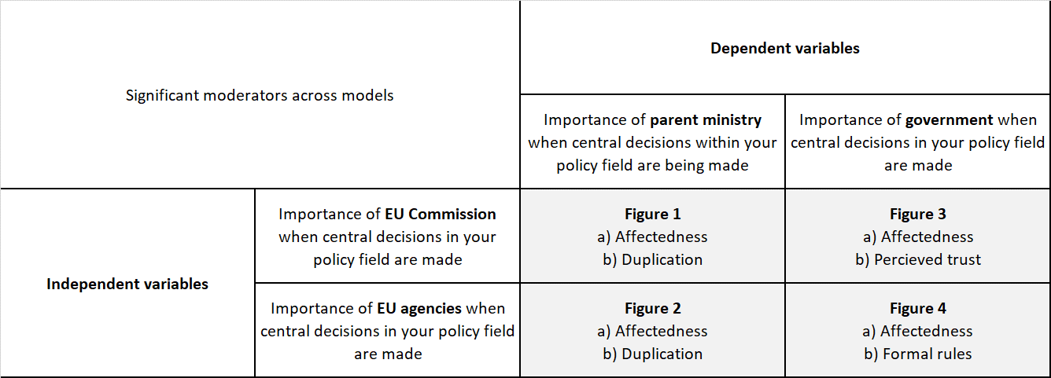
*Includes only 2-tailed significant values

Graphical plots are needed for further interpretation of the interaction effects. To illustrate and examine the conditional nature of agency governance, Figures 1 to 4 plot the interaction effects from Tables 4 to 7. As the plotted lines in Figures 1 to 4 suggests, the relationship between the dependent variables and the independent variables varies across categories of the moderating variables. Each line represents the relationship within a category. Interactions occur whenever lines are not parallel. Unparallel lines may indicate significant and thus important interactions in which a compound or dyadic tendency is amplified or muted. Moreover, if lines are cross-cutting to the extent that they point in different directions, a relationship may change diametrically, from compound to dyadic (or vice versa) within the categories of the moderating variable. To be specific, a compound pattern is recognized by lines pointing upwards, which indicates a positive relationship, while lines pointing downwards reflect a negative relationship conforming to a dyadic pattern. Figure 1a and 1b are graphical illustrations of the moderating effects of affectedness and organizational duplication, respectively.

Figure 1a and 1b Relationship between perceived importance of the Commission and the perceived importance of own parent ministry (dependent variable), with interaction effects.
1a 1b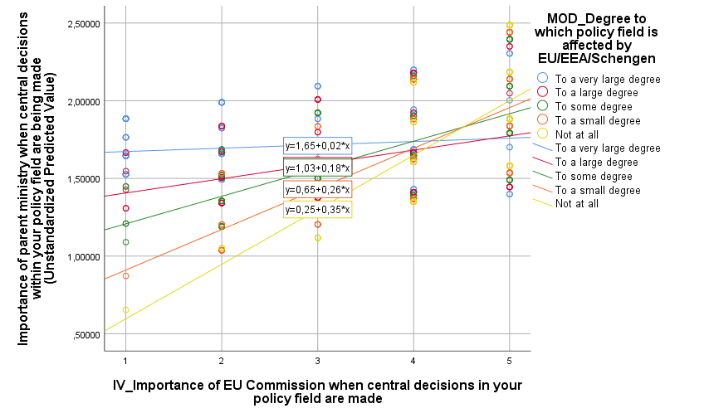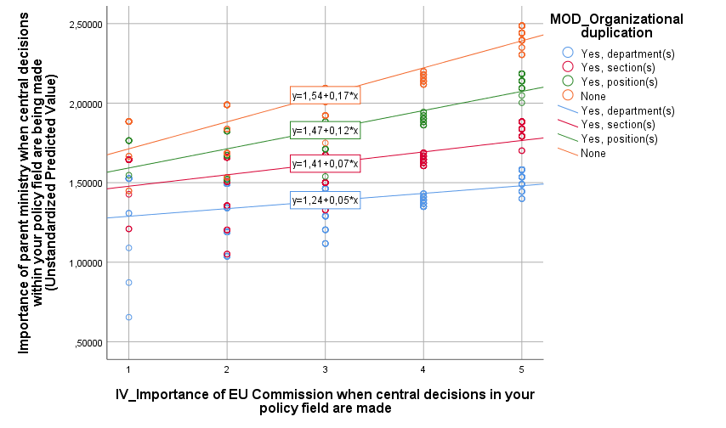
Figure 1a illustrates how the relationship between importance ascribed to the parent ministry and the Commission varies across the range of degrees in affectedness. Crossing lines illustrate a significant interaction effect. As the lines demonstrate, a more compound relationship emerges as affectedness decreases. And likewise, the compound image decreases as affectedness increases. From this we may infer that the effect of EU level institutions is conditioned by the degree of affectedness. Figure 1b demonstrates the moderating effect of organizational duplication. While the interaction is less prominent, the lines illustrates that a compound pattern emerges as duplication increases. This indicates that increasing degree of organizational duplication also increases agencies´ ability to act compound.

Figure 2a and 2b Relationship between perceived importance of EU agencies and the perceived importance of own parent ministry (dependent variable), with interaction effects.
2a 2b
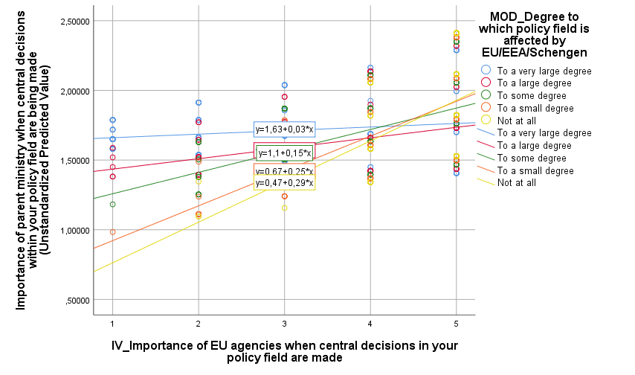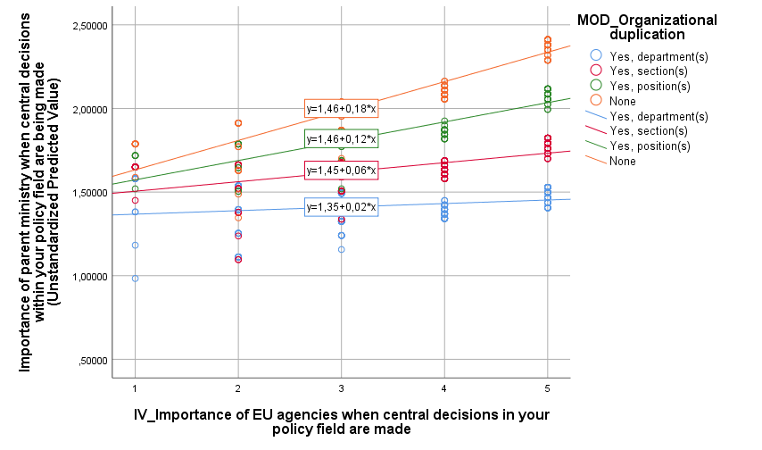

Figure 2a and 2b demonstrate that the previous findings are robust also on the perceived importance of EU agencies as dependent variable. Still, the interaction effects remain almost identical. As perceived affectedness increases, the relationship becomes less compound. And likewise, organizational duplication reinforces the compound pattern.

Figure 3a and 3b Relationship between perceived importance of the Commission and the perceived importance of the government (dependent variable), with interaction effects.
3a 3b
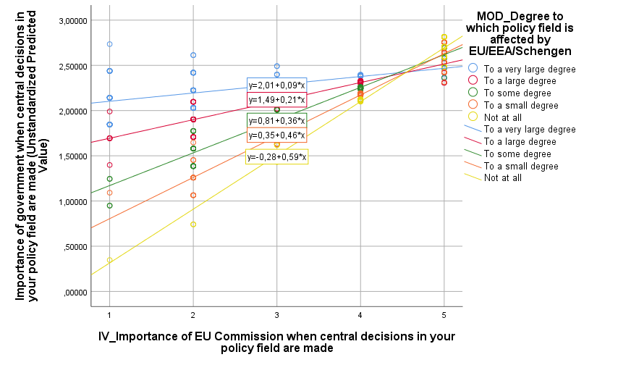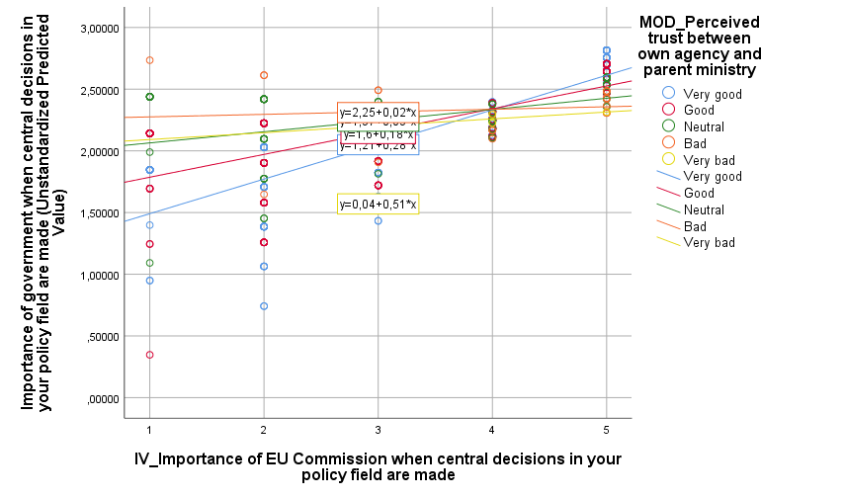
Although less evident, the moderating effect of affectedness remain identical when the dependent variable is changed to perceived importance of government: The compound pattern still decreases as affectedness increases. Another moderator that becomes significant is perceived trust between own agency and parent ministry. As the lines illustrates, a compound tendency becomes more evident as trust increases. Among those reporting lower levels of trust, the relationship weakens. This indicates that higher levels of trust between agencies and ministries increases the stronghold of Image II.

Figure 4a and 4b Relationship between perceived importance of EU agencies and perceived importance of the government (dependent variable), with interaction effects.
4a 4b
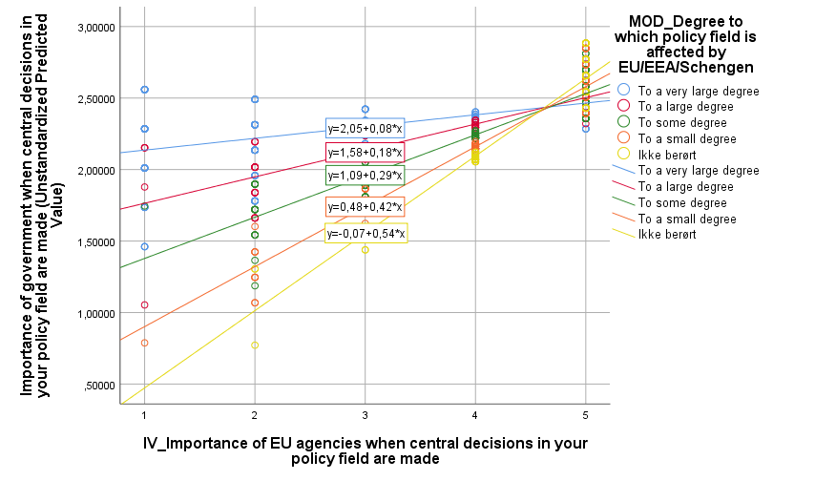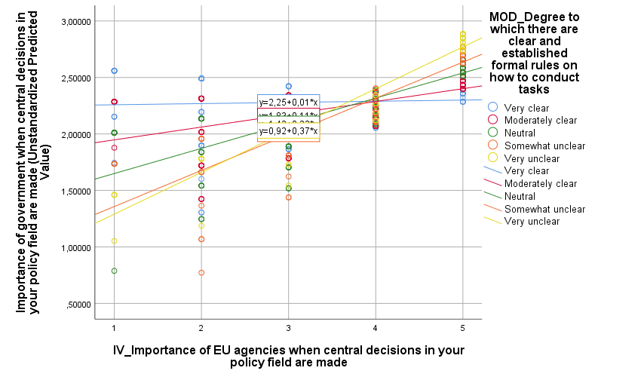

Finally, when plotting the relationship between perceived importance of EU agencies and the perceived importance of the government, the moderating effect of affectedness is still robust. The compound pattern becomes more evident as affectedness decreases. The fourth moderator that turns out significant is the degree to which agency officials report clear and formal rules on how to conduct tasks. In this context, a compound pattern is evident when clear and established rules are present. Where rules are established the relationship, a compound tendency tends to diminish.

Conclusions
This study has outlined a framework for analyzing agency governance in integrated administrative systems. Empirically, data conveys a largely compound (type II) image of agency governance processes under these conditions. The findings align with recent studies that have shown the compound roles of public agencies and their staff (e.g. Dorp and Hart 2019; Egeberg 2006; Bach and Ruffing 2013; Egeberg 2006; Trondal 2011). This paper, however, challenges the alleged “coordination dilemma” (Image I) facing agencies embedded in multilevel structures. Our study also suggests that four significant moderators influence agency governance consistently across all models (Figures 1 to 4). In addition, organizational duplication, perceived trust, and formal rules were also significant moderators in one or more models. These moderators bias agency governance towards Image I and II, however, not changing relationships diametrically from dyadic to compound (or vice versa) within the categories of the moderating variable.

The affiliated status grants the Norwegian central administration privileged access to most parts of the EU administration, which in turn paves the way for deep administrative integration at agency level. Agency-driven administrative integration across levels of governance mobilizes an administrative bias towards agency bodies in strongly affiliated non-member states, which in effect fuels the ´administrative state´. Nonetheless, rather than a binary, or dyadic, understanding of agency governance, this paper supports Image II characterized by agencies making compromises and showing abilities to navigate conflicting concerns

References
Ansell, C. and J. Trondal (2018) ´Governing turbulence: An organizational-institutional agenda´, Perspectives on Public Management and Governance 1(1): 43-57.

Ansell, C., J. Trondal and M. Ogard (eds.) (2017) Governance in Turbulent Times. Oxford: Oxford University Press.
Bach, T. and E. Ruffing (2013) ‘Networking for autonomy? National agencies in European networks’, Public Administration 91(3): 712-26.

Bach, T. and E. Ruffing (2018) ´The Transformative effects of transnational administrative coordination in the European multi-level system´, in E. Ongaro and S. Van Thiel (eds.) The Palgrave of Public Administration and Management in Europe. Houndmills: Palgrave Macmillan.
Bauer, M.W. and S. Becker (2014) ´The unexpected winner of the crisis: The European Commission’s strengthened role in economic governance´, Journal of European Integration 36(3): 213-229.

Bauer, M.W. and J. Trondal (eds.) (2015) The Palgrave Handbook of the European Administrative System. Houndmills: Palgrave Macmillan.

Boin, A., P.´t Hart, E. Stern and B. Sundelius (eds.) (2017) The Politics of Crisis Management. Cambridge: Cambridge University Press.
Bulmer, S. and J. Joseph (2016) ´European integration in crisis? Of supranational integration, hegemonic projects and domestic politics´, European Journal of International Relations 22(4): 725–748.
Christensen, T., and P. Lægreid (2008) ´The challenge of coordination in central government organizations: The Norwegian case´, Public Organization Review 68: 97–116.
Dorp, E.-J. van and P. ´t Hart (2019) ´Navigating the dichotomy: The top public servant´s
role´, Public Administration, DOI: 10.1111/padm.12600.
Curtin, D. and M. Egeberg (2008) ´Tradition and innovation: Europe’s accumulated
executive order´, West European Politics 31(4): 639–661.
Cyert, R. M. and J. G. March (1963) A Behavioral Theory of the Firm. Englewood Cliffs, NJ: Prentice-Hall.
Dahl, R. (2000) On Democracy. New Haven: Yale University Press.
Danielsen, O. A. and K. Yesilkagit (2014) ‘The effects of European regulatory networks on the bureaucratic autonomy of national regulatory authorities’, Public Organization Review 14(3): 353–71.
Dehousse, R. (2008) ´Delegation of powers in the European Union: the need for a multi-principals model´, West European Politics 31(4): 789–805.
Easton, D. (1965) A Systems Analysis of Political Life. New York: John Wiley and Sons.
Egeberg, M. (ed.) (2006) Multilevel Union Administration. Houndmills: Palgrave Macmillan.
Egeberg, M. (2012) ‘How bureaucratic structure matters: An organizational perspective’, in B.G. Peters and J. Pierre (eds.) The SAGE Handbook of Public Administration. London: SAGE.
Egeberg, M. and H. Sætren (1999) ‘Identities in complex organizations: A atudy of ministerial bureaucrats’, in M. Egeberg and P. Lægreid (eds.) Organizing Political Institutions. Oslo: Scandinavian University Press.
Egeberg, M. and J. Trondal (1999) ’Differentiated integration in Europe: The case of the EEA country Norway’, Journal of Common Market Studies 37(1): 133-42.
Egeberg, M. and J. Trondal (2015) ‘National administrative sovereignty – under pressure’, in E.O. Eriksen and J.E. Fossum (eds.) The European Union's non-members. London: Routledge.
Egeberg, M. and J. Trondal (2016) ‘Why strong coordination at one level of government is incompatible with strong coordination across levels (and how to live with it). The case of the European Union’, Public Administration 94(3): 579–592.
Egeberg, M. and J. Trondal (2017) ‘Researching European Union agencies: What have we learnt (and where do we go from here)’, Journal of Common Market Studies 55(4): 675–90.
Egeberg, M. and J. Trondal (2018) An Organizational Approach to Public Governance. Oxford:
Oxford University Press.
Emery, Y., and D. Giauque (2014) ´The hybrid universe of public administration in the 21st century´, International Review of Administrative Sciences 80: 23–32.
Fossum, J.E. (2019a) ´The unbearable lightness of differentiated integration´, unpublished manuscript, ARENA Centre for European Studies, University of Oslo.
Fossum, J.E. (2019b) ´What is the Norway Model? Mode of affiliation or political compromise?´, The Political Quarterly, doi.org/10.1111/1467-923X.12684

Fossum, J.E. and H.P. Graver (2018) Squaring the Circle on Brexit. Bristol: Bristol University Press.

Fossum, J.E. and M. Jachtenfuchs (2017) ´Federal challenges and challenges to federalism. Insights from the EU and federal states´, Journal of European Public Policy 24(4): 467-485.

Genschel, P. and M. Jachtenfuchs (eds.) (2014) Beyond the Regulatory Polity? Oxford: Oxford University Press.
Goetz, K.H., and J.-H. Meyer-Sahlin (2008) ´The Europeanization of national political systems: parliaments and executives´, Living Reviews in European governance.
Gulick, L. (1937) ‘Notes on the theory of organizations. With special references to government in the United States’, in L. Gulick and L. Urwick (eds.) Papers on the Science of Administration. New York: Institute of Public Administration.
Gunnell, J. G. (2011.) ´David Easton and the road to system´, Paper presented at the ECPR General Conference, Reykjavik, Iceland.
Grindle, M. S. (2017) ´Good governance, R.I.P.: A critique and an alternative´, Governance 30: 17–22.
Heidbreder, E. (2011) ´Structuring the European administrative space: policy instruments of multi-level administration, Journal of European Public Policy 18(5): 709-727
Hofmann, H.C.H. (2008) ‘Mapping the European administrative space’, West European Politics 31(4): 662–76.
Hofmann, H.C.H. and A. Turk (eds.) (2006) EU Administrative Governance. Cheltenham: Edward Elgar.

Hooghe, L. and G. Marks (2016) Community, Scale, and Regional Governance. Oxford: Oxford University Press.

Howlett, M. and I. Mukherjee (2018) ´The contribution of comparative policy analysis to policy design: Articulating principles of effectiveness and clarifying design spaces´, Journal of Comparative Policy Analysis 20(1):72-87

Jacobsson, B., J. Pierre and G. Sundstrom (2015) Governing the Embedded State. Oxford: Oxford University Press.

Kassim, H., S. Connolly, R. Dehousse, O. Rozenberg and S. Benjaballah (2017) ´Managing the house: The Presidency, agenda control and policy activism´, Journal of European Public Policy 24(5): 653-674.
Kühn, N.S. and J. Trondal (2018) ´European integration and the administrative state a longitudinal study on self-reinforcing administrative bias´, Journal of European Public Policy, doi.org/10.1080/13501763.2018.1520913
Landau, M. (1969) ´Redundancy, rationality, and the problem of duplication and overlap´, Public Administration Review 29(4): 346–58.
Lavenex, S. (2009) ´EU rules beyond EU borders: theorizing external governance in European politics´, Journal of European Public Policy 16(6): 791-812.
Levi-Faur D. (2011) ‘Regulatory networks and regulatory agencification: towards a single European regulatory space’, Journal of European Public Policy 18(6): 810-29.

Lægreid, P., K. Sarapuu, L. Rykkja and T. Randma-Liiv (eds.) (2014) Organizing for Coordination in the Public Sector. Houndmills. Palgrave Macmillan.

MacCarthaigh, M. and A. Molenveld (2018) ´Coordination in Europe´, in E. Ongaro and S. Van Thiel (eds.) The Palgrave of Public Administration and Management in Europe. Houndmills: Palgrave Macmillan.
Maggetti, M. (2014) ‘The rewards of cooperation: The effects of membership in European regulatory networks’, European Journal of Political Research 53(3): 480-99.
Majone, G. (1996) Regulating Europe. London: Routledge.
Martens, M. (2008) ‘Administrative integration through the back door? The role and influence of the European Commission in transgovernmental networks within the environmental policy field’, Journal of European Integration 30(5): 635-51.
Metcalfe, L. (1994) ‘International policy co-ordination and public management reform’, International Review of Administrative Sciences 60: 271-90.
Miller, E. F. (1971) ´David Easton’s political theory´, The Political Science Reviewer 1: 184–235.
Moravcsik, A. (2018) ´Preferences, power and institutions in 21st-century Europe´, Journal of Common Market Studies, DOI: 10.1111/jcms.12804
Olsen, J.P. (2007) Europe in Search of Political Order. Oxford: Oxford Univ. Press.
Olsen, J.P. (2008) ´The ups and downs of bureaucratic organization´, Annual Review of Political Science 11.

Olsen, J.P. (2017) Democratic Accountability, Political Order, and Change. Oxford: Oxford University Press.
Olsen, J.P. (2018) ´Democratic accountability and the changing European political order´, European Law Journal 24(1): 77-98.
Pollitt, C. (2016) Advanced Introduction to Public Management and Administration. Cheltenham: Edward Elgar.
Rittberger, B. and A. Wonka (2011) ´Introduction: agency governance in the European Union´, Journal of European Public Policy 18(6): 780-789
Rokkan, S. (1999) State Formation, Nation-Building, and Mass Politics in Europe. Oxford: Oxford University Press.
Rosenau, J.N. (1990) Turbulence in World Politics. Princeton, NJ: Princeton University Press.
Schattschneider, E. E. (1975) The Semisovereign People. Fort Worth, TX: Harcourt Brace Jovanovich College Publishers.
Schmidt, V.A. (2018) ´Rethinking EU governance: From ‘old’ to ‘new’ approaches to who steers integration´, Journal of Common Market Studies, DOI: 10.1111/jcms.12783
Shapiro, I., S. Skowronek and D. Galvin (eds.) (2006) Rethinking Political Institutions. New York: New York University Press.
Thaler, R.H. and C.R. Sunstein (2009) Nudge. Improving Decisions About Health, Wealth and Happiness. London: Penguin Books.
Trein, P. and M. Maggetti (2018) ´Reasserting the center of the nation state: How supranational institutions reshape the public sector´, manuscript, University of Lausanne.
Trondal, J. (2010) An Emergent European Executive Order. Oxford: Oxford University Press.
Trondal, J. (2011) ‘Domestic agencies in an emergent European Executive Order’, Journal of European Integration 33(1): 55-74.
Trondal, J. and B.G. Peters (2013) ‘The rise of European administrative space. Lessons learned’, Journal of European Public Policy 20(2): 295-307.
Trondal, J., M. Marcussen, T. Larsson and F. Veggeland (2010) Unpacking International Organisations. Manchester: Manchester University Press.
Quarantelli E.L., A. Boin and P. Lagadec (2018) ´Studying future disasters and crises: A heuristic approach´, in H. Rodriguez, W. Donner and J. Trainor (eds.) Handbook of Disaster Research. New York: Springer.
Yesilkagit, K. (2011) ‘Institutional compliance, European networks of regulation and the bureaucratic autonomy of national regulatory authorities’, Journal of European Public Policy 18(7): 962–79.
Vantaggiato, F.P. (2019) ´Regulatory relationships across level of multilevel governance systems: From collaboration to competition´, Governance, DOI: 10.1111/gove.12409.
Verhoest, K., S. van Thiel, G. Bouckaert, and P. Lægreid (eds.) (2012) Government Agencies. Basingstoke: Palgrave.
Vigoda-Gadot, E. and S. Mizrahi (2014) Managing Democracies in Turbulent Times. Dordrecht: Springer.
Waldo, D. (1952) ´Development of theory of democratic administration´, American Political Science Review 46(1): 81-103.
Wilson, W. (1887) ´The study of administration´, Political Science Quarterly 2(2): 197-222.
Wessels, W. (1997) ‘An ever closer fusion? A dynamic macropolitical view on integration processes’, Journal of Common Market Studies 35(2): 267–299.
Wockelberg, H. (2014) ‘Political servants or independent experts? A comparative study of bureaucratic role perceptions and the implementation of EU law in Denmark and Sweden’, Journal of European Integration 36(7): 731-47.

When selecting respondents, one-third of all officials at the ´A-level´ was selected for the survey. This limitation was pragmatically made due to the huge number of agency officials. The surveys were conducted as online surveys by the Norwegian Social Science Data Service. The overall response rate is around 60%.

