Tax competition and inequality
Program title: The political foundations of tax competition

Philipp Genschel⁺, Hanna Lierse*, Henning Schmidtke^, Laura Seelkopf°, Stefan
Traub°, Hongyan Yang°

⁺European University Institute
* Jacobs University Bremen
^ University of St. Gallen
°Centre for Social Policy Research, University of Bremen

Work in Progress!

Paper prepared for the
14th Biennial Conference of the European Union Studies Association
5th to 7th of March 2015, Boston

Abstract
The baseline model of international tax competition predicts that domestic income inequality will increase: in the worst case progressive taxation on capital is no longer possible and spending levels deteriorate. Given that the median voter is receiving her income mostly from labor, many observers are puzzled that corporate tax competition persists among developed democracies. Even during the economic crisis, hard-hit countries such as Ireland insisted to keep their low corporate tax rate despite pressure from other European countries and with a broad backing of the whole political spectrum. Why do left-wing parties not intervene and call for international tax harmonization if tax competition is detrimental for the poor? It is the aim of this paper to explain the driving forces of tax competition and their consequences on inequality. Specifically, we shed light on why the poor and their representatives in smaller economies have not done much against tax competition. To do so we first build a theoretical model based on asymmetric tax competition in two countries, which we then test empirically. In our model the median voter in both countries is poor; thus the left determines the domestic capital tax rate. Nevertheless, in equilibrium tax competition persists. We show that the rich and the poor of the small country can achieve a higher net income when engaging in international tax competition. This explains why tax competition is politically robust even in a model where the rich have no power over the tax rate. We test the empirical implications of our model against a sample of eight OECD countries and their tax policies over a long time frame from 1960 until today. In conclusion, we discuss the crucial implication from accepting a lower capital tax rate, namely increased domestic and international income inequality.

The lack of harmonization of tax policies in Europe combined with the freedom of capital movement is causing downward tax competition or "tax dumping". One member state's tax cuts can indeed result in another's' public service cuts. European rules need to be adopted regarding taxes which directly, affect (...) other member states behavior - such as taxes on interests from capital and corporate taxes." (ETUC 1995, 17)

At times of international capital mobility, governments can lure international investments by offering lower capital taxes than competing states. This behavior triggers a race-to-the-bottom, in which states undercut each other leading to no or at best, lower capital taxes than under before. According to the baseline model, capital tax competition has one of two potential welfare effects. Either it decreases government revenue, which could be used for redistribution to the poor, or the tax burden is shifted to less mobile bases such as labor income. In any case, the overall welfare effect on income inequality is negative. Nevertheless despite almost twenty years of calls for tax harmonization at the European (if not global) level, not even a minimum corporate tax rate exists. Is there a corporate conspiracy (ICFTU 2006, 37) or why can democratically elected governments not agree on a common policy that allegedly improves the welfare of the majority of their voters?
The answer, we argue, is that structure shapes politics. So far, scholars have either argued that globalization puts similar pressure on all governments to become competition states (Cerny 1997; Jessop 2002) or that structural pressures are in fact not as strong as they appear: there “remains a leftist alternative to free market capitalism in the era of global markets based on classic ‘big government’ and corporatist principles” (Garrett 1998: 4). With regards to international tax competition, we argue that none of them is right. Rather, the demand for the ‘leftist alternative’ is conditioned by the structural position in the world economy. Contrary to the belief that left-wing parties are always in favor of raising capital taxes, many of them in fact support international tax competition. For instance, the Irish Labour Party implemented the corporate tax cut from 32 to 12.5 percent in the early 2000. Furthermore, they even insisted that it remained in place following the economic crisis when the government was pressured for public finance (Labour 2011). So, when do left-wing parties support international tax competition?
The answer comes from the asymmetric model of tax competition, which suggests that the incentives to compete vary with country size (Keen and Konrad 2012, 2013; Wilson 1999). Small states can gain from tax competition: Poaching foreign tax base is potentially welfare-enhancing for them. Large states, by contrast, lose in welfare terms. They are better off farming domestic tax resources. Accordingly, small countries are more likely to engage in aggressive tax competition than large ones. Figure 1 illustrates this by drawing the corporate tax rates weighted and unweighted by population. We argue that the globalization literature has not taken this argument seriously enough. The different welfare outcomes associated with asymmetric tax competition make the size of an economy not something to be additionally controlled for, but an integral part for all models of partisan tax policy choice.

Figure 1: Corporate Tax Rates in the OECD, 1980-2010
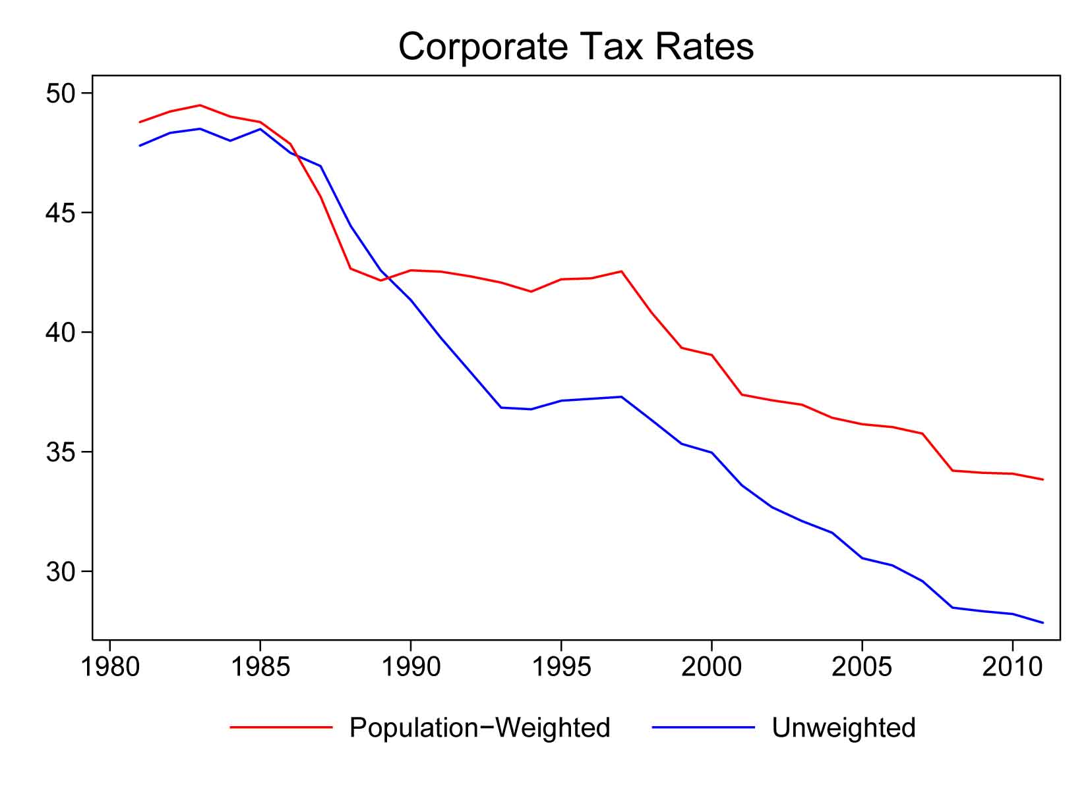
In our paper, we combine the public finance and globalization literature and show that political preferences are not independent of structural conditions. It is not only size that matters, but party politics matter for tax competition as well. Yet, we argue that party politics only matter in large countries. Here, left-wing governments attempt to keep up the capital tax rate to use the revenue for redistribution. By contrast, in smaller countries left-wing governments support competitive tax cuts as their constituency actually benefits from international tax competition. By having lower capital taxes then their large neighbors, they can lure international investments. This leads to a more flourishing economy, from which also people without capital income gain via increased employment opportunities and higher wages. Although the poor of the small country gain in terms of net income and thus drive international tax competition (or at least hinder harmonization), this comes at a high cost: both domestic and international inequality increase.
The paper is structured as follows: The next part provides a brief literature review on international tax competition. Following the review, we present our theoretical model, which includes two countries (big and small), two classes (rich and poor), and two types of income (capital and labor). The median voter is poor and sets the capital tax rate. The model shows that political preferences are highly dependent on structural conditions. The fact, that party politics is only effective in large countries, has surprising results for income levels and equality, which are not usually thought of when discussing international tax competition. Contrary to the general assumption that the poor should be in favor of taxing capital at a high rate to use the income for redistribution, we show that the poor in the small country can be in favor of lower capital tax rates under tax competition as they achieve a higher net income. In section 3 we test our argument based on self-collected data for the corporate tax choices of four small and four large countries from 1960 to 2011. Moreover, we briefly look at the implications of the model: has domestic and international inequality really increased since capital market liberalization? Finally, in section 4, we conclude.

2. Tax Competition: A Literature Review
While the economic literature on tax competition is extensive (see Genschel and Schwarz 2011; Keen and Konrad 2012, for recent reviews), most of it starts from the same baseline model. In its simplest form, this model is about two identical countries sharing one internationally mobile tax base, capital (Wilson 1999; Zodrow and Mieszkowski 1986). The tax policies of both countries are interdependent because one country’s capital tax revenue depends on the other country’s capital tax rate: higher taxes in country A swell country B’s revenues by pushing a larger share of mobile capital towards B; lower taxes in A depress B’s revenues by poaching capital from B. This interdependency triggers a ‘race to the bottom’ in taxation as each country tries to attract capital from the other. In equilibrium, capital taxes no longer exist.
This first model triggered strong reactions among policy makers and scholars alike who envisioned the end of public good provisions and redistribution together with the end of capital taxation. Yet, as some time went by, scholars realized that capital tax rates such as corporate tax rates depicted in figure 1 might be declining, but were still far from zero and also still very diverse across the OECD. This led to a range of modifications of the baseline model, both by public finance scholars as well as by political economists.
The perhaps most important extension by economists concerns the influence of country size (Bucovetsky 1991; Kanbur and Keen 1993) In a symmetric setting of same-sized countries, the baseline model predicts that country A and B face the same incentives to cut taxes and suffer equal welfare losses in the non-cooperative equilibrium. In an asymmetric setting, however, the smaller country faces stronger incentives to cut tax rates than the larger country and suffers a smaller welfare-loss in the competitive equilibrium. Indeed, if the difference in country size is large enough, the smaller country is better off under tax competition than in its absence. There is a structural “advantage of ‘smallness’” (Wilson 1999, 288) in tax competition. Smaller countries gain more from lower corporate tax rates. This is also reflected in figure 1, which illustrates that once we weight the average OECD tax rates by population size (i.e. give more weight to the big countries) the downwards trend is slower. Why is small size a competitive advantage? Intuitively, in pondering capital tax cuts governments have to weigh the costs in terms of lost revenue from domestic capital against the benefits associated with capital inflows from the other country. In the small country with a narrow domestic capital tax base and lots of foreign capital to attract, the cost-benefit ratio is more likely to be favorable than in the large country with lots of domestic capital to lose and little foreign capital to win. We will illustrate this more formally in our theoretical section, which is built on these models.
But let’s turn first to the political side of the tax competition story. Whereas public finance scholars were concerned with structural factors in the world economy that shape tax policy choices, political economists naturally cared more about institutional and ideological differences across countries that influence tax policy outcomes (for exceptions seeGrazzini and Van Ypersele 2003; Haufler 1997; Persson and Tabellini 1992). Whereas some are more concerned with the dynamics of tax competition and the speed in which it takes place, others argue that there are genuinely different preferences at work, which affect the long-term equilibrium. In the first group are scholars who emphasize domestic factors such as the number and ideological range of veto players (Basinger and Hallerberg 2004; Ganghof 2006), the structure of electoral institutions (Hays 2003, 2009), or budget constraints (Ganghof 2000; Genschel 2002; Swank and Steinmo 2002), which are found to slow down tax competition. The second group of researchers argues that national differences such as in the partisan composition of government (Garrett 1998; Garrett and Lange 1991), welfare regimes (Campbell 2005), the variety of capitalism (Swank 2013) or equity norms (Plümper, Troeger, and Winner 2009) shape national responses differently and allow for more capital taxation under conditions of capital mobility than the baseline model would seem to suggest. Thus, it is politics rather than economic structure, which shape tax policy choices.
In our model, we bring these two schools together and illustrate that political preferences are not independent of structural conditions. We show that party politics matter for tax competition, but only in large countries (for similar models in the public finance see Gabszewicz and Van Ypersele 1996; Lejour and Verbon 1996). This has surprising results for income levels and equality, which are not usually thought of when discussing international tax competition.

3. A Model of Asymmetric Tax Competition with the Left in Charge
In the following we present a theoretical model, which is based on the dream-state of the international left, namely a world which is solely governed by representatives of the poor. Nevertheless, tax competition persists. After discussing the main mechanisms behind the model and why poor voters in small countries still prefer tax competition over a 100% capital tax under autarky, we systematically show the effect of asymmetric tax competition on domestic and international income inequality.
In order to keep the model as simple as possible, we assume that there are only two countries $i∈${$H$,$F$}, the home ($H$) and the foreign ($F$) country, which are completely the same except for their population $N$. We assume $N_{H}≥N_{F},$ i.e. the home country is at least as "large" as the foreign country. We furthermore normalize $N_{H}=1$ and $N_{H}=ϕ≤1$. There are two groups, $j∈\{P,R$}, in each country and we call them the poor, $P$, and the rich, $R$, respectively. The poor have only wage income$,$ while the rich have both wage income and capital income. Each of them owns one unit of capital, $k=1$. We assume that the poor group has one more resident than the rich and for a large population the share of rich and poor are both equal to $0.5$. The total capital endowment is thus given by ${\overline{K}}_{i}=0.5N_{i}$ and the capital endowment per capita is ${\overline{k}}_{i}=0.5$.
Both countries produce a homogenous good with the input of capital and labor. Each resident supplies the same fixed time of labor, which is normalized to one. The production technology exhibits constant returns to scale and is quadratic:
$$f\left(k_{i}\right)=\left(a-bk_{i}\right)k_{i},$$
where $k_{i}$denotes capital investment per capita in country $i$. By assuming perfect competition, the gross return to capital $r_{i}$ depends negatively on $k_{i}$and the wage rate $w_{i }$depends positively on $k_{i}$. Each country levies a unit tax $t_{i}$ on invested capital and the tax revenue is redistributed to the residents in form of a lump-sum transfer $τ_{i}=t_{i}k_{i}$. The capital tax rate is determined by voting and, according to our assumption, the poor decide upon the tax rate.
If capital is immobile, the capital tax rate would be confiscatory, because the poor would choose to tax away all capital income in order to maximize their net income. As a result, all residents would have the same net income, no matter if they own capital or not.
However, if capital is perfectly mobile, an increase in the capital tax rate will cause capital flight to the other country. The equilibrium at the capital market ensures that the net return to capital is equalized in both countries:
$$ρ=r_{H}-t_{H}=r_{F}-t_{F}.$$
Consequently, for a given tax rate in the foreign country, increasing capital taxation reduces domestic capital investment and the net return to capital in both countries. The lower capital investment reduces the capital tax base and the wage rate. We rely on the Nash-equilibrium concept: the poor in each country decide upon capital tax rate by maximizing their net income, under the consideration of the negative effect of capital taxation on domestic capital investment and while taking the capital tax rate in the other country as given. We derive the equilibrium tax rates as:
$$t_{H}^{*}-t_{F}^{*}=\frac{b}{2}\frac{1-ϕ^{2}}{ϕ},$$
and the equilibrium capital investment as
$$k_{F}^{*}-k_{H}^{*}=\frac{1}{4}\frac{1-ϕ^{2}}{ϕ}.$$
From these two equations we can see that if both countries are of the same size, they choose the same tax rate and there is no international capital movement. Yet, the equilibrium capital tax rate would still be lower than that under autarky. Due to the potential threat of capital flight, the poor cannot set the capital tax rate as high as under conditions of closed capital markets.
If the countries differ in size, however, the home country will choose a higher capital tax rate than the foreign country. Due to the tax rate difference, the foreign country has a higher capital investment per capita than the home country. Moreover, the differences between the tax rates and between the capital investments are larger, the smaller the foreign country is relative to the home country.
The impact of capital mobility on income differs between groups and between countries due to three effects: the wage, the tax base and the fiscal effect. First, in the non-cooperative equilibrium, the small country undercuts the large country’s tax rate and ends up with a disproportionately large share of the mobile capital tax base (base effect). Hence, the tax base in the foreign country expands, while it shrinks in the home country. Moreover, the inflow of capital from the large country pushes up the capital-labor ratio, fuels labor demand and thus leads to higher employment, higher wages and, eventually, to higher tax revenues from labor and consumption (wage effect). In this way, not only capital profits from tax competition but labor as well – in the small country. Whereas the base and the wage effect both describe the influence of international tax competition on market outcomes, the different tax rates have of course also an effect on net incomes. Given the lower capital rate under capital mobility, the tax system is less able to redistribute income from the rich to the poor (fiscal effect).While the wage and the tax base effect differ between countries the fiscal effect varies between groups. Table 1 summarizes the different effects, also for the case of symmetric countries, where only the fiscal effect matters.
Table 1: The Effects of Tax Competition on Net Income
 | Wage Effect | Tax Base Effect | Fiscal Effect | Total Effect
Symmetric tax competition
Poor | none | none | - | -
Rich | none | none | + | +
Asymmetric tax competition
Poor large | - | - | - | -
Poor small | + | + | - | +/-
Rich large | - | - | + | +/-
Rich small | + | + | + | +

The impact of capital mobility on income differs between groups and between countries due to the three effects described above. Table 1 shows that compared to autarky, the poor in the home country always lose from tax competition, while the rich in the foreign country always gain. However, the net income of the poor in the small country and of the rich in the large country can either increase or decrease depending on the relative importance of the different effects. Given that the poor set the tax policy in our model, the ambiguous findings for the rich in the large country do not matter for international tax competition (or harmonisation). Thus, we need to look at the poor in the small country to learn more about the drivers of international tax competition.
The simulation in figure 2 illustrates that if the country size difference φ is large enough, the wage effect and the tax base effect over-compensate the fiscal effect (figure 2). In this case, the poor in the small country have a higher net income under tax competition than under autarky (where size differences do not matter). This mechanism is what we believe drives international tax competition and hinders tax harmonisation efforts between democratically elected governments.

Result: If $ϕ$ is small enough, the poor in the foreign country have a higher net income under capital tax competition than under autarky. Hence, only left governments in larger countries differ in their tax policy choices from their right-wing counterparts.
Figure 2: Simulated Net Incomes of the Poor in the Big (Home) and Small (Foreign) Country

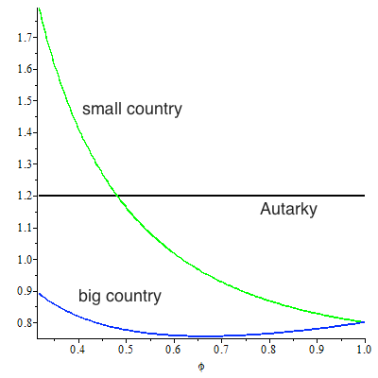

Before we test the empirical implications of our model by looking at tax policies of eight OECD countries for the last fifty years, we discuss the theoretical implications of our model on income inequality. What does our model imply for national and international inequality? Although the poor of the small country can achieve a higher net income under tax competition than under autarky, tax competition brings about more income inequality within and between countries. Under autarky, each resident in either country has the same net income. However, under tax competition, income inequality arises due to the three income effects (see Table 1). We measure inequality by income difference as the share of the income that is lower.

Table 2 summarizes the influence of tax competition on net income inequality between groups and countries: first, income inequality between the rich and the poor increases in both countries, i.e. the rich have a higher net income than the poor in both the small and the large country. Second, both groups in the small country – the poor and the rich – have a higher income than the respective income group in the large country. Finally, we compare the within-country inequality between the small and the large country. The results show that the within-country inequality is lower in the small country because the poor in the small country have a higher net income than the poor in the large one. This result is somewhat surprising as the small country has a lower capital tax rate. It might also partly explain what our empirical results indicate, namely that the left in the smaller countries is less concerned with tax competition and the resulting inequality than the left in larger countries.

Table 2: Effect of Tax Competition on Net Income Inequality within and between Countries
Within and Between countries... | (Compared to autarky) net income inequality...
Rich vs. Poor in large country | increases
Rich vs. Poor in small country | increases
Poor in small vs. Poor in large country | increases
Rich in small vs. Rich in large country | increases
Small vs. large within-country inequality | increases

4. Empirical Implications for Tax Policy Choices
To test the driving mechanism of our theoretical model, we compare the corporate tax decisions made by left- and right-wing governments in small and large countries. As the poor from the small country gain from tax competition, we expect that left-wing parties are more favourable of corporate tax cuts in small countries than in large ones, where the poor lose from engaging in competitive capital tax cuts. Based on a self-coded dataset, which involves tax rate and base decisions as well as timing effect of eight European countries from 1961 until 2013, we show that party politics only matters in larger countries. After having found empirical evidence for our theoretical mechanism, we discuss the implications of our model for national and international inequality by looking at gini coefficients and growth rates across the OECD. Inequality seems to have risen according to our predictions.

Data and Methodology
Based on OECD Country Reports, we constructed a database, which captures the corporate tax changes of eight European countries since the 1960s. As the four large countries, we chose France, Germany, Italy and the United Kingdom and as the four small, we selected Austria, Luxembourg, Ireland and Switzerland. These countries do not only represent the largest and smallest European countries, but they also have different historical roots with different tax regimes, which allows testing our argument. Although a sample of eight countries is rather small compared to the usual OECD22, we put the emphasis on the historical development and the tax decisions over time to gain a sufficiently large sample of corporate tax decisions under different administrations.
The main advantage of our tax dataset is that it is based on an overarching concept of tax policy decisions. Tax policy is not a straightforward concept to measure. With the exception of some remarkable research (Jensen and Lindstädt 2012; Mahon 2004), scholars often use the tax revenue and not tax decisions as the dependent variable. However, tax revenue does not only measure the policy choice as it is also affected by economic developments. Besides the tax revenue, scholars also tend to use the tax rate as a measurement of policy decisions. Although this is a better indicator than the revenue, a tax increase cannot only be achieved by raising the tax rate but also by broadening the tax base. Furthermore, as Jensen and Lindstädt (2012) illustrate, tax rate changes are often decided by administrations several years before the actual change takes place. Given our interest in the political choices, we collected data on tax rate and base changes as well as timing effects for four small and four large European countries from 1961 to 2013. A further advantage of compiling this data is that it allows us to know which government decided upon a corporate tax change. Our data captures when a policy change was passed by a government and not when it was implemented (further information and the codebook is available upon request). Hence, our dependent variable is the count of increases and decreases of corporate taxes based on information from the OECD country reports. Although it does not provide insights into the amount of change, we believe that this count variable is the best measure of tax policy changes, especially given our theoretical focus on the political decision-making.
The main independent variables are country size and government partisanship, as well as their interaction. Size is measured in terms of logged population and the data for government partisanship is a dummy variable based on the gov_left indicator from the Comparative Political Dataset (Armingeon et al. 2014). The variable measures the Cabinet composition: social-democratic and other left parties in percentage of total cabinet posts, weighted by days. The classification of parties follows (Schmidt 1996). As such, ‘left’ denotes social democratic parties and political parties to the left of social democrats, ‘right’ involves liberal and conservative parties and ‘centre’ refers to parties such as Christian Democratic or Catholic ones. We refer to a government as left, when it is dominated or fully controlled by social-democratic parties. Besides size and government partisanship, we also control for a number of other variables such as the debt level, unemployment and gdp growth. All data for the controls stem from the Comparative Political Dataset.
We run a probit model with random effects clustered around countries. Before we interpret the results of our analytical model, we provide some descriptive evidence.

Findings
Table 3 summarizes the data according to government partisanship and country size. It shows the total number of tax increases and decreases as well as the average changes per year calculated by the years a left- and right-wing government was in office.

Table 3: Corporate Tax Decisions by Government Partisanship and Country Size
Country Size | Large/Left | Large/Right | Small/Left | Small/Right
Corporate tax increases
Number of increases | 43 | 21 | 6 | 9
Changes per year by left/right-wing governments in office | 0.5 | 0.2 | 0.1 | 0.1
Corporate tax decreases
Number of decreases | 67 | 72 | 28 | 31
Changes per year by left/right-wing governments in office | 0.7 | 0.6 | 0.4 | 0.2

First, left governments always implement more tax policy changes. This is in line with the view that they are more interventionist than their right-wing counterparts. Second, governments in large countries implement more changes than those in the smaller countries. This is not surprising given their more and more heterogeneous population which requires more tax policy adjustments in general. Third, a look at the combined partisan-size variation highlights that left-wing governments in the four large countries have adopted most corporate tax increases and decreases. They conducted on average 0.5 increases and 0.7 decreases per year. However, the difference to the right-wing governments in their own countries and the left- and right-wing governments of the small countries is only pronounced for corporate tax increases (rather than decreases). The other three governments raised the tax on average merely 0.2 and 0.1 times per year but cut the corporate tax on average 0.6 and 0.4 times. In other words, the findings show that left-wing and large governments tend to do more increases and decreases. However, only left-wing governments raise substantially more corporate taxes. Yet, there is no difference in partisan politics when it comes to tax decreases. This is in line with our analysis below.

Table 4: Probit Results for Corporate Tax Increases and Decreases
 | Increases |  | Decreases
 | Without Interaction | Full Model | Without Interaction | Full Model
Left Dummy | 0.51*** | -1.28 | -0.35* | -1.48
 | (0.19) | (2.32) | (0.21) | (2.58)
Log. Population | 0.11 | 0.053 | 0.073 | 0.038
 | (0.068) | (0.096) | (0.10) | (0.13)
Interaction |  | 0.11 |  | 0.065
 |  | (0.14) |  | (0.15)
Debt | 0.0056 | 0.0052 | -0.0046 | -0.0047
 | (0.0046) | (0.0046) | (0.0057) | (0.0057)
Unemployment | 0.021 | 0.020 | 0.061 | 0.062
 | (0.034) | (0.034) | (0.039) | (0.039)
Growth | 0.026 | 0.026 | -0.011 | -0.0096
 | (0.038) | (0.038) | (0.040) | (0.040)
Observations | 217 | 217 | 217 | 217
Countries | 8 | 8 | 8 | 8
Constant not reported. Standard errors in parentheses. *** p<0.01, ** p<0.05, * p<0.1

This asymmetric effect also becomes apparent once we turn to our regression analysis. Table 4 shows our separate results for corporate tax increases and decreases. For each type we have run the regression first without and then with the interaction effect. The models without the interaction effect show the typical result from the literature: left governments are more likely to increase corporate taxes and less likely to decrease them. This effect seemingly vanishes, once we include the interaction term. To interpret the effect of left parties depending on country size we have run simulations for each model. The results are presented in figure 3 and 4.
Figure 3 and 4 support the descriptive finding that left-wing governments of large countries are more likely to raise corporate taxes. It illustrates that the effect of government partisanship differs according to country size. Controlling for a number of variables, left-wing governments in large countries have a significant effect on corporate tax increases. Think, for instance, of Francois Hollande’s bid during the French Presidential elections 2012 to shift the tax burden from small business to large corporations (Hollande 2012, Point 6 of Hollande's presidential program).
Figure 3: Simulated Effect of Left-wing Governments on Corporate Tax Increases depending on Country Size
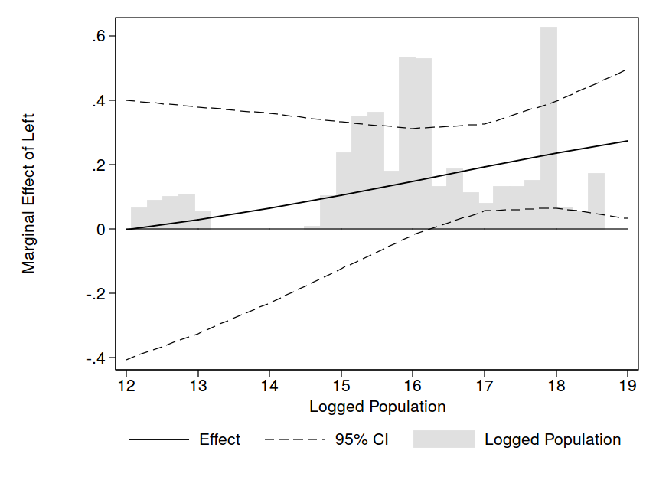

Figure 4: Simulated Effect of Left-wing Governments on Corporate Tax Decreases depending on Country Size
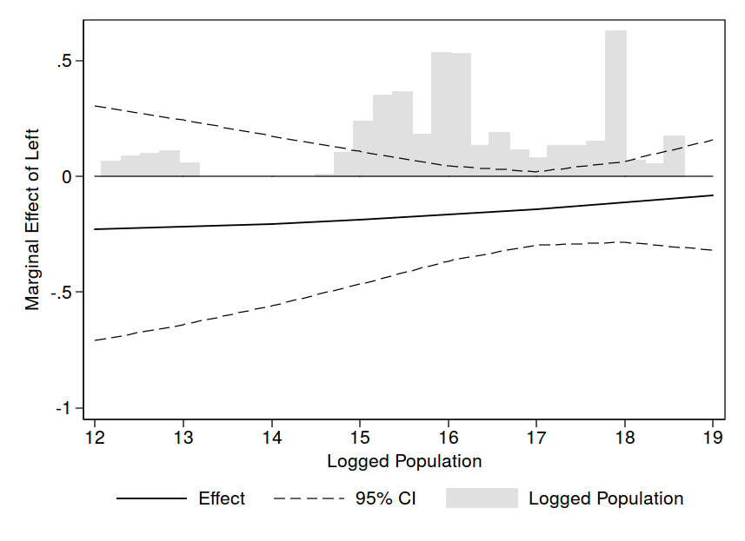

Partisanship in smaller countries, in contrast, has no effect on increases of the corporate tax rate. This is reflected in the statement of the Irish Labour Party, which has been a staunch supporter of low Irish corporate taxation: “Labour in government introduced the 12.5 percent corporation profits tax, and we will insist that it remains in place” (Labour 2011, 15). Interestingly, left governments in larger countries only conduct a significantly different corporate tax policy than their right-wing counterparts when it comes to increases, but not for tax decreases as figure 4 reveals. Here, the asymmetric effect of size on partisanship is not significant. Left parties seem to be slightly less likely to decrease corporate taxes than their right counterparts, but insignificantly so and – more importantly - independent of country size. This might be due to the general downwards trend in corporate taxation.
In general, our findings are - at least for tax increases - in line with our theoretical model and show that left-wing governments of large countries tend to conduct a tax policy, which is more progressive than the one of their small left neighbors, where not only the rich but also the poor gain by receiving a higher net income from engaging in international tax competition and thus support it. In large democracies, the median voter loses from tax competition because the negative effect of less redistribution from a shrinking domestic capital tax base is compounded by the economic disadvantages of capital outflows: depressed labor demand, stagnating wages, shrinking revenues. These negative effects create an incentive for governments to go slow on tax competition and restrict capital tax cuts. An example outside the traditional OECD group is the decision of Mexico’s left-leaning government in 2013 to suspend the mild corporate tax cuts adopted by its conservative predecessor and to increase other capital taxes to consolidate the budget (Day 2013). Left parties in smaller countries such as Ireland or Denmark on the other hand agree with there conservative counterparts on the countries’ low corporate tax strategy. Tellingly, all initiatives to reign in “harmful” tax competition in Europe and worldwide have come from large countries such as Germany, France, the UK and most importantly the United States (Genschel and Schwarz 2011, 359-363).

Implications for domestic and international inequality
Given our theoretical and empirical results, what can we learn about the real winners and losers from international tax competition? Do the inequality implications hold and can we find the predicted differences as regards domestic and international inequality over time (see Table 2)? A descriptive glance supports the results of our theory.
Figure 5 depicts the gini coefficients for 22 OECD countries from 1980 to today. We can see the well-known increase of inequality in developed democracies. Yet, this development is not the same across all member states. Whereas the dotted line shows the unweighted average and thus implies a modest increase in inequality by three points, the finding changes once we control for population size.

Figure 5: Development of Post-Market Ginis in the OECD, 1980 to 2011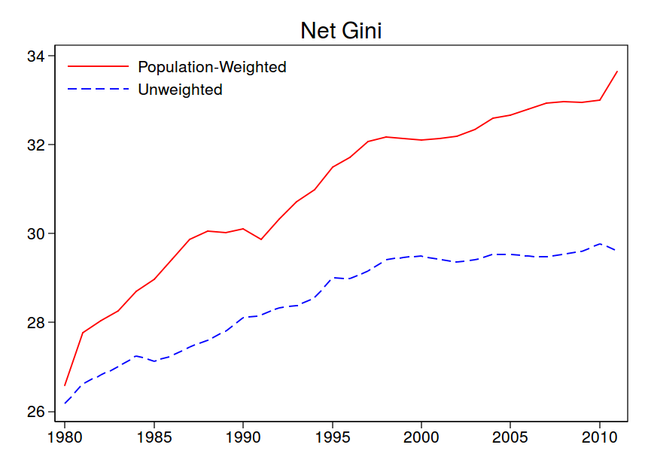
Weighted by inhabitants, thus giving increases in inequality in the United States or Germany more weight than increases in Luxembourg or Switzerland, the overall inequality within developed democracies has increased much more, namely by almost eight points. This is in line with our model, which predicts more modest increases in inequality for smaller countries.
Yet what about international inequality? Do small states manage to beggar their bigger neighbors? In our model, both states had the same income endowment to start with. This of course does not apply to reality. Whereas some small states such as Switzerland have been wealthy for quite some decades, Ireland once was the poor man of Europe. The same applies for larger countries. Thus, we measure the development of international inequality more indirectly and look at growth rates. Figure 6 illustrates that - with the exception of the financial crisis – growth rates in the OECD move around three percent. Both larger and smaller countries follow similar business cycles. What has changed, however, is that growth rates in smaller countries (unweigthed average, dotted line) have since the mid1990s until the crisis been constantly higher than the ones in their larger counterparts. Thus, not only has the majority of people (i.e. the poor in the larger countries) to deal with higher inequality, they also experience lower growth.

Figure 6: Development of Growth Rates in the OECD, 1980 to 2011
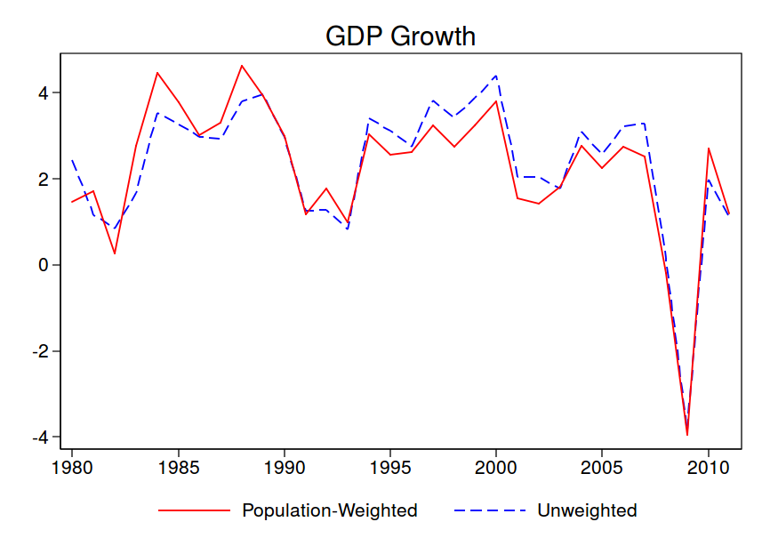

5. Conclusion
Our findings illustrate who the main losers of tax competition are: poor people in large countries. In a theoretical model which includes two countries (big and small), two classes (rich and poor), and two types of income (capital and labor) this is the only group, who does not potentially gain from tax competition. Interestingly, and contrary to the expectations of many, the poor of the small country, who are in pursuit of a higher net income, are a major driver of international tax competition. By undercutting the large country’s tax rate, the small country achieves an inflow of capital, which increases the tax base. Moreover, the inflow of capital also fuels labor demand, leads to more employment, higher wages and, eventually, to higher tax revenues from labor and consumption. In this way, not only capital profits from tax competition but labor as well – in the small country. This explains why many left-wing parties around the world, are in favor of competitive tax cuts. They cater to their supporters by lowering the capital taxes. By contrast, the large country cannot attract a sufficiently high amount of foreign capital from the small country to benefit from tax competition. Hence, the left-wing parties in larger states favor higher capital taxes, which can be used for domestic redistribution towards their poorer constituency.
Our empirical findings provide initial support for the theoretical prediction of our model. The data confirms that structural conditions shape political preferences: party politics matters in time of globalization, however, only in large countries. Here, the left-right cleavage influences the corporate tax decisions of governments. Based on an analysis of the corporate tax choices of eight countries from 1960 to 2011, our findings indicate that left-wing governments of large countries adopt more capital tax increases then their right-wing counterparts. Although left-wing and large governments tend to adopt both, more increases and decreases, only left-wing governments of large countries raise substantially more corporate taxes. Yet this cannot stop the growing trend towards more national and international inequality: poorer voters in large countries loose relative to their own richer fellow citizens as well as to the citizens of smaller countries.
Our model and our analytics show that we need to take asymmetric tax competition seriously: as long as countries differ enough in size, the citizens of small states, including the poor, can actually gain from tax competition – not just relative, but absolutely. This structural difference also shapes institutional and political answers within countries: it is the left and right alike in small countries, and not just the ‘the richest 1%’ (LeftUnity NA) that drive international tax competition. This of course has important implications for any serious attempts to reign in international tax competition via international cooperation – be it within the European Union or across a wider spectrum of OECD and partner countries. As long as the median voter in small countries cares more about her own income gains rather than about national or even international equality, the workers of the world and their governments will not unite to curb harmful tax competition.

Bibliography
Armingeon, Klaus, Laura Knöpfel, David Weisstanner, Sarah Engler, Panajotis Potolidis, and Marlène Gerber. 2014. "Comparative Political Data Set I, 1960-2011." In Last updated: 2014-01-06.
Basinger, Scott J., and Mark Hallerberg. 2004. Remodeling the Competition for Capital: How Domestic Politics Erases the Race to the Bottom. The American Political Science Review 98 (2): 261-276.
Bucovetsky, S. 1991. Asymmetric Tax Competition. Journal of Urban Economics 30 (2): 167-181.
Campbell, John L. , ed. 2005. Fiscal Sociology in an Age of Globalization: Comparing Tax Regimes in Advanced Capitalist Countries. Edited by Victor Nee and Richard Swedberg, The Economic Sociology of Capitalism. Princeton: Princeton University Press.
Cerny, P. G. 1997. Paradoxes of the Competition State: The Dynamics of Political Globalization. Government and Opposition 32 (2): 257-274.
Day, Jones. 2013. "Mexican Tax Reform Update." In, ed. Jones Day Publications.
ETUC. 1995. “Our Priorities: ETUC Resolutions 1995-1996.
Gabszewicz, J.J. , and T. Van Ypersele. 1996. Social Protection and Political Competition. Journal of Public Economics 61: 193-208.
Ganghof, S. 2000. "Adjusting National Tax Policy to Economic Internationalization: Strategies and Outcomes." In From Vulnerability to Competitiveness: Welfare and Work in the Global Economy, Volume II, , eds. F. W. Scharpf and V. A. Schmidt. Oxford: Oxford University Press. 597-664.
———. 2006. The Politics of Income Taxation. A Comparative Analysis of Advanced Industrial Countries. Colchester: ECPR Press.
Garrett, G., and P. Lange. 1991. Political responses to interdependence: what's "left" for the left? International Organization 45 (4): 539-564.
Garrett, Geoffrey. 1998. Partisan Politics in the Global Economy. Cambridge: Cambridge University Press.
Genschel, P. 2002. Globalization, Tax Competition, and the Welfare State. Politics & Society 30 (2): 245-275.
Genschel, P., and P. Schwarz. 2011. Tax competition: a literature review. Socio-Economic Review 9 (2): 339-370.
Grazzini, Lisa , and Tanguy Van Ypersele. 2003. Fiscal Coordination and Political Competition. Journal of Public Economic Theory 5 (2): 305–325.
Haufler, A. 1997. Factor taxation, income distribution and capital market integration. Scandinavian Journal of Economics 99: 425–446.
Hays, Jude C. 2003. Globalization and Capital Taxation in Consensus and Majoritarian Democracies. World Politics 56 (1): 79-113.
———. 2009. Globalization and the New Politics of Embedded Liberalism. Oxford: Oxford University Press.
Hollande, Francois. 2012. Election Présidentielle 2012: Mes 60 Engagements Pour La France.
ICFTU. 2006. Having Their Cake and Eating it too: the big corporate tax break.
Jensen, N. M., and R. Lindstädt. 2012. Leaning right and learning from the left: Diffusion of corporate tax policy across borders. Comparative Political Studies 45 (3): 283-311.
Jessop, Bob. 2002. The Future of the Capitalist State. Cambridge: Polity.
Kanbur, R., and M. Keen. 1993. Jeux-Sans-Frontieres - Tax Competition and Tax Coordination When Countries Differ in Size. American Economic Review 83 (4): 877-892.
Keen, M. , and K. A. Konrad. 2012. The theory of international tax competition and coordination. Working Paper July 2012 (06).
———, eds. 2013. The theory of international tax competition and coordination. Edited by A. J. Auerbach, R. Chetty, M. Feldstein and E Saez. Vol. 5, Handbook of Public Economics. Amsterdam & Oxford: Elsevier.
Labour. 2011. Labour's Plan for Stability and Growth Budget.
LeftUnity. NA. "Economics policy." In: Left Unity.
Lejour, A.M. , and H. A .A. Verbon. 1996. Capital mobility, wage bargaining, and social insurance policies in an economic union. International Tax and Public Finance 3 (4): 495-513.
Mahon, J. E. 2004. Causes of Tax Reform in Latin America, 1977-95. Latin American Research Review 39 (1): 3-30.
Persson, T. , and G Tabellini. 1992. The politics of 1992: Fiscal policy and European integration. Review of Economic Studies 59: 689–701.
Plümper, Thomas, Vera E. Troeger, and Hannes Winner. 2009. Why Is There No Race to the Bottom in Capital Taxation? International Studies Quarterly 53 (3): 761-786.
Schmidt, Manfred G. 1996. When Parties Matter: A Review of the Possibilities and Limits of Partisan Influence on Public Policy. European Journal of Political Research 30 (155-183).
Swank, D., and S. Steinmo. 2002. The new political economy of taxation in advanced capitalist democracies. American Journal of Political Science 46 (3): 642-655.
Swank, Duane. 2013. "Taxing Choices: International Competition, Domestic Institutions, and the Transformation of Corporate Tax Policy." Presented at the Annual Meeting of the International Studies Association, San Francisco, CA.
Wilson, J. D. 1999. Theories of tax competition. National Tax Journal 52 (2): 269-304.
Zodrow, G. R. , and P. Mieszkowski. 1986. Pigou, Tiebout, Proberty Taxation, and the Underprovision of Local Public Goods. Journal of Urban Economics 19: 356-370.

As graph 1 already suggests, data on OECD corporate tax rates is only available from the 1980s onwards. Furthermore, this captures only actual changes in the rate, rather than the political decisions on the whole tax system, which also include base changes.
Table 3 provides the corporate tax changes by the year of the OECD country report instead of the year the reform was passed. As the correlation coefficient is very high with 0.99, it provides the advantage that we have substantially more observations.

