Suicidal Mainstream News Media:
Outsourcing Anti-Semitism to European Jihadis

An alarming development occurred this last summer, at least from the point of view of people who believe in the post-Holocaust consensus about human rights and free societies in a peaceful global community, for those who believe that Nie Wieder would the madness that generated World War II return to invade European culture. This summer, throughout Western Europe and Scandinavia, gangs of crudely armed rioters ran through the streets shouting “Hamas! Hamas! Jews to the Gas!...”; “Death to Jews! Slit Jews Throats!” This proliferation of sometimes deadly attacks on Jews has convinced some observers that at current rates of open hostility, Europe will have no more Jews in little more than a generation.

In 2000, when the European Union looked forward to a new period of global prominence – one book title read Why Europe will run the 21st century – if you had told the leaders of the French, or any other Western European democracy, that in the opening decades of the 21st century, increasingly unrestrained Muslim Jew-hatred would drive Jews from Western Europe, they would have mocked your alarmism. Unthinkable! Impossible! Ridiculous. Islamophobic.

How did this happen? And what does it portend?

I can give you the five minute version and you can leave if you wish:

Historically, fascists hate Jews, and totalitarian fascists hate Jews with a special passion. The totalitarian formula, from the Inquisition to the Communists, to the Nazis, runs: Get rid of the Jews and you can destroy freedom. As long as there are Jews around, someone will always talk back. For Jihadi totalitarians of the 21st century, getting rid of European Jews prepares that territory for Islamic conquest; it creates the conditions under which harbis, that is the inhabitants of Dar al Harb, the realm of the sword, can be brought into and under Dar al Islam, the realm of submission. In other words, the expulsion of the Jews from Europe is a major preliminary step on the path to the Muslim conquest of Europe, or, as Bat Ye’or called it in a book that received universal scorn when published a decade ago, it paves the way for Eurabia.

Let me straightaway assure you that I am not some Houellebecqian historian imagining a Muslim Europe takeover of Europe. I don’t think the Jihadis will succeed in their millennial ambitions. As a student of the genre, I can assure you that all such movements fail. But they can, and in this case, I am convinced will, do enormous damage on the way to that failure, and I think that, unchecked at a fundamental level, what survives their assault will not look anything like the Europe the creators and shapers of the EU had in mind.

It is, of course, entirely against the interests of the (post-)Christian world of democratic and progressive Europe to allow this proxy expulsion of the Jews. In doing so, Europeans would abandon a major cultural ally in the development of progressive civic values, even as they allow sworn enemies to violate both the letter and the spirit of democracy. It was tragic enough for Europeans in the first half of the 20th century to pursue millennial dreams that rapidly became totalitarian nightmares, it’s quite another to enable (and encourage) radical Muslim enemies to pursue dreams that target European culture for conquest. And yet the European elites, both political and among the intelligentsia, have been far more likely to encourage these Jihadi hatred of Jews, than to oppose them.

One of the key contributors to this dynamic that threatens to drive the Jews from Europe, and contribute to Eurabia, is a school of journalism that consistently presents Palestinian (and other Jihadi) lethal narratives about Israel as news. These “lethal journalists” have dominated the coverage of the conflict between Israel and her neighbors for almost fifteen years. And every time they move into high gear – namely every time Israel responds to attacks from enemies who target Israeli civilians from the midst of Palestinian civilians – they incite Jihadi hatreds among the Muslim population in their midst.

It turns out that the stories that Westerners think show Israel’s mistreatment of Palestinians, actually register among many Muslim viewers, as the Jews attacking innocent Muslims. So while telling stories that for a variety of reasons please their intended audiences, European journalists wave the flag of Jihad before a restive immigrant population, especially “les jeunes.” European jails are filled with Muslims who first got their call to Jihad by watching TV.
One sees on the television how the Israeli Army, with the help of America, mistreats the youth of the Intifada. When I see that, I want to go fight against them, against the Americans, against all those who repress Islam…
Just watch the TV and the humiliation to which the Israeli army subjects the Palestinian chebab [youth]…
When one sees on the TV how the Israeli tanks fire on youths armed with slingshots or Molotov cocktails and no one moves a finger. One asks oneself whether there is any justice in the world.
Using such images as a form of initial recruiting – especially the al Durah image – Jihadis have spread a form of anti-Semitism that rivals that of the Nazis: If we do not eliminate the Jews, they will destroy us. The warrant for genocide: exterminate or be exterminated.

Indeed, no single factor has contributed more to the success of genocidal hatreds among Muslims and so constrained the resistance among Europeans, than these waves of lethal journalism: “le petit Mohamed” Al Durah, the “Jenin Massacre,” the “Bethlehem siege,” the family wiped out on Gaza Beach, Kafr Qana, the Mavi Marmara, etc. Each time Israel fights and the journalists pour images of Palestinian suffering into the public sphere, Western capitals are subjected to public displays of Jihadi hatreds against the Jews, of which this last summer’s round represents only the most recent and most aggressive manifestation.

Hence, one of the most urgent and significant internal reforms that Western democratic societies can do to protect themselves from a serious and pitiless enemy, is to address the professional and ethical failures of the news media. Merely by adhering to the core professional values of a free press – the commitment to report important stories as accurately as possible – democratic societies would significantly lower the amount of incitement to Jew-hatred circulating in their public sphere. Indeed, more proportionate attention to the vastly greater number of Mumslim victims of Arab Jihadis might serve to temper the ardor of some to sign up. Indeed, it might help those Muslims who want to live at peace in the West to defend their position.

That’s the five minute version. What follows is fifteen minutes of reflection on what prevents such a reform:

A Blow to Pride: Defending the Honor of the Profession

One great resistance to reform comes from the journalist’s profession itself, and is nowhere more evident in the response to the deeply damaging Al Durah Affair, which the rest of the profession has systematically protected from correction for the last fifteen years. On September 30, 2000, Charles Enderlin, chief Middle East correspondent for France2, using footage and narration from his Gaza cameraman Talal abu Rahmah, reported that the Israelis had targeted and killed a 12 year old boy in his father’s arms. The outrage over the video and its accompanying “lethal narrative” went viral and produced a ferocious response both in the region and in the West. The first demonstration recorded since WW II calling for “Death to Jews” in a European capital was the protest at Place de la Republique, where a large poster equated the star of David with the Swastika.

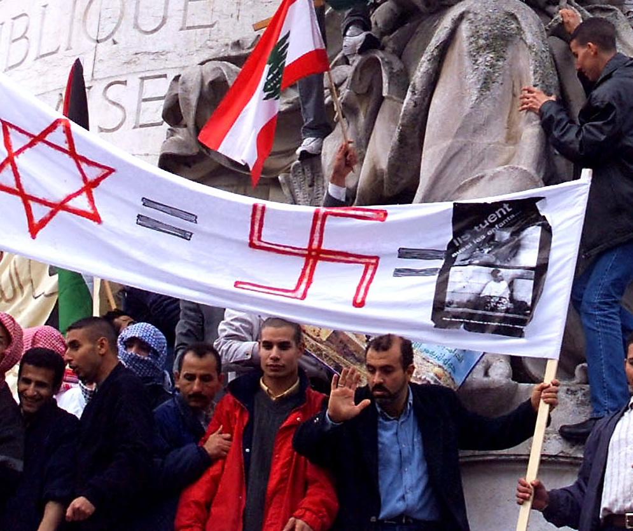

Bin Laden quickly used the footage for a recruiting video for global Jihad, a relay picked up by Muslim militants on Western campuses. With the help of Al Jazeera, which played the footage incessantly, it operated as a modern blood libel: Bin Laden cited the symbolic meaning of Israel’s killing of Muhammad al Durah to justify 9-11:
The deliberate killing of children in Palestine today is the ugliest, most oppressive, and hostile act, and something that threatens all of humanity. The whole world has witnessed Israeli soldiers killing Muhammad al Durreh and many others like him…
So in fact it is as if Israel — and those backing it in America — have killed all the children in the world. The events of the 22nd of Jamada al Thani or Aylul [9-11] are merely a response to the continuous injustice inflicted upon our sons in Palestine…
Thus while Western news agencies constantly showed the “image choc de l’intifada” on TV – it introduced daily updates on the Intifada – they were in fact waving the flag of Jihad in front of their Muslim immigrant population.

And yet, the footage Talal abu Rahmah shot contradicted both his and Enderlin’s lethal narration. Nothing in the footage indicated that the fire came from the Israeli position; on the contrary all reliable evidence showed it came from the Palestinian position. Nothing in the footage supported the claim that the boy had been shot in the stomach and bled out for twenty minutes on the ground. On the contrary, almost all the “action” scenes in the footage that his cameraman provided Enderlin with that day were staged, footage Enderlin edited carefully to give credence to the claims of his lethal narrative. On the contrary, a close look at the final footage – which Enderlin, having already declared the boy dead in an earlier take, cut from his broadcast – shows the boy still alive, showing no signs of a stomach wound, lifting up his arm and looking out at the camera.

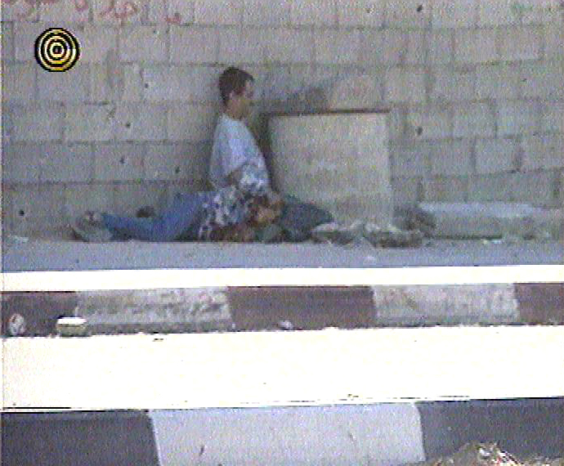

Despite this extensive evidence, neither Enderlin, nor his colleagues seriously reconsidered. Esther Schapira, a German filmmaker, and James Fallows at the Atlantic, did some investigative reporting in 2002-3, but few if any journalists followed up (except Schapira). On the contrary, Enderlin sued some of his critics for defaming his “honor” – I kid you not, this is based on a law from 1881, when journalists still fought duels over honor. When the court saw the footage upon which he based his broadcast they found against his claim, and added harsh words about his professional standards. The response: the Jewish editor of one of the most prominent weeklies, Le Nouvel Obs, started a petition in his defense, denouncing the court for infringing on the freedom of the press, which in this case, apparently means the freedom of journalists to say whatever they want without interference from critics from the unwashed masses. Hundreds of the most prominent journalists signed this petition, in many cases without reviewing the evidence. If there were ever a journalistic display of solidarity for a medieval sense of honor, with no regard for professional standards, this was it.

The refusal of the news media to review and correct this case, which may be the single most damaging hoax in the history of the news, represents one of the most egregious ethical and professional failures on record. When the Ministry of Strategic Affairs in Israel published an official Israeli report on the case, for the first time explicitly disavowing any culpability, the media reported the politely, but refused to ask the key question: if this report was even somewhat accurate, how can one explain the behavior of the media?

If I have spent some time on this case, it’s because it in a profound sense, this story represents at once, the most powerful force of radicalization of Muslim youth in France, as well as the paradigmatic victory of the school of lethal journalism that currently dominates the coverage from the Middle East. But it hardly stands alone. Indeed, few things better embodied the news media’s corruption – the media intifada, in the words of one critic – than journalists’ constant repetition of the Hamas supplied talking point that “the vast majority” of the casualties were civilians. On the contrary, even the data supplied by Hamas contradicted this claim, and carefully examined, makes Operation Protective Edge one of the most exceptional cases of keeping down civilian casualties in urban warfare, a record significantly superior to the record of US or NATO forces in similar conditions. Instead, fed on a diet of Palestinian victims, sometimes direct victims of Hamas rockets, blamed on Israel, Western, and especially European audiences understandably considered the IDF one of the most brutal armies on the planet. Now we can expect another UNHRC report that restates the deeply dishonest “first draft” of journalism with a “second draft” not of critics, but amplifiers among the weaponized “human rights” NGOs: the IDF as war criminals; the Jihadis who kill their own to blame the IDF, get a pass.

When Matti Friedman, a journalist for years with the AP, published his account of working for a dishonest, biased international news agency that systematically reported negatively on Israel and positively on the Palestinians, ignoring favorable stories about Israel and negative ones on Palestinians, the response was an indignant denial, followed by a moral justification for behaving the way Friedman described. Despite the massive failures of journalists to understand or anticipate events like the outcome of the Arab Spring, we are far from a self-critical examination from the journalists who right now dominate reporting from the Middle East.

Instead, James Fallows, one of the early pioneers who bailed rapidly from the Al Durah tale – the Israelis didn’t do it, but don’t ask me to investigate further who did or what happened – wrote a paeon of praise to journalists whose vocation was to bear “witnesses to their times,” who deserved our respect and admiration and not backchair critics who, in the words of one harried journalist, “bully ” from the sidelines.

The Appeal of Moral Schadenfreude: “You Jews…”

To some extent, journalists are merely giving their audiences what they want. The enthusiasm with which audiences in the West, especially among Europeans broadly and more specifically among the “Global Progressive Left,” should not be underestimated. As a German photographer learned this last summer in Gaza, there’s a much greater audience for pictures of Palestinian children killed by Israelis than Syrians children killed by fellow Muslims. BBC reporter Jon Donnison retweeted a picture of a wounded Syrian girl as a Gazan and added the comment: “heart breaking.” The immense disparity between the extensive coverage of Palestinians (allegedly) killed by Israelis and those killed by fellow Arabs (or any Arab of Muslims killed by fellow Arabs e.g., in Sudan, or in Syria) testifies to the importance not of the victim, but of the perpetrator in “moving” audiences.

Why do Western audiences have this almost insatiable appetite for “lethal narratives” about Jews behaving badly? My answer is “moral Schadenfreude,” the pleasure derived from the moral discomfiture of Jews. Indeed, the whole discourse of Israeli apartheid and genocide, the Zionazi meme as it were, when racist, apartheid, and genocidal impulses and actions far more accurately describe Arab and Muslim behavior, reveals the importance of denigrating Israelis. This in turn reflects the revival in the post-Christian West of a supersessionist impulse, in which the chosenness of the GPL as the moral cutting edge of the planet can only assert itself by disqualifying any Israeli claim to moral stature: thus the most moral army in the world by any standards of concern for the lives of enemy civilians, becomes one of, or the most, brutal and cruel armies on this benighted planet. The result: the enormous appeal among “leftists” of a replacement theology, whereby the Israelis are the new Nazis, and the Palestinians the new victims of genocide.

Again the al Durah affair illustrates this dynamic quite strikingly. One of the reasons that Europeans found the story so powerfully attractive was that it offered a kind of “get-out-of-Holocaust-guilt-free” card. As Catherine Nay, a prominent, mainstream journalist in France noted, and in so doing, spoke for many: “symbolically, this death [sic] erases, replaces the image of the boy in the Warsaw Ghetto.” The old Nazis are replaced by the new ones, Israel, the old Jews, by the new ones, the Palestinians. It’s hard to imagine a better illustration of the moral disorientation brought on by supersessionist needs than this use of a highly dubious picture of a boy caught in a crossfire admittedly begun by his own side to “replace” a picture that symbolizes the systematic extermination of 1.5 billion children. It’s almost as if Bin Laden’s blood libel – “it is as if Israel… killed all the children in the world” – went viral not only in the Arab world, but among the European intelligentsia.

Controlling this visceral need to demean Israelis unfortunately seems to demand almost superhuman efforts from Europeans, especially the reporters who stand at the heart of the discourse. Repeatedly since both this summer’s events and their further extension in January’s Charlie Hebdo massacres, journalists have returned to the theme: in January, a BBC reporter interrupted a Holocaust survivor who was comparing the current situation to the 30s, with the question: “Many critics of Israel’s policy would suggest that the Palestinians suffer hugely at Jewish hands as well.” As with Catherine Nay, so with here. Notes Nick Cohen, “Wilcox is not some isolated and aberrant racist; his views are the standard opinions of the European left middle class. I meet them every day in my political neighborhood. They are the result of ignorance rather than malice.”

A month later, a Skye reporter repeatedly challenged the chief rabbi of England in a Holocaust Memorial Day interview: “Don’t you think Israeli actions fuel anti-Semitism?” even as the network ran images of Gazan wounded from the summer during the interview. Apparently the addiction to this narrative by which Israel causes anti-Semitism is difficult to relinquish. How much the less can we imagine journalists reframing Wilcox’s question in a more pertinent and accurate fashion: “Don’t you think that the media’s portrayal of Israeli actions fuel anti-Semitism?”

Considered from this angle, the European toleration, even encouragement, of virulent Muslim anti-Semitism could be considered a form of outsourcing. Sipping the wine of their distaste for Jews, Europeans stock an open and free bar of the much more heady distillations that, since the Holocaust, they cannot openly embrace. The imminent danger to which it exposes itself by persisting in this indulgence suggests that the feeling of moral superiority over Jews holds enormous significance. It is something like an overweight man with a cholesterol count through the roof, who cannot stop wolfing down bacon cheese burgers and washing them down with chocolate truffles.

Fear of Retaliation: Proleptic Dhimmitude

When all is said and done, however, I don’t think it’s either the fierce and protective pride of the journalists’ guild, nor the insatiable appetite of some journalists and their audiences for lethal narratives about Jews that poses the most serious problem. I think the greatest factor that inhibits democratic society from closing one of its most vulnerable fronts in a war with a merciless enemy, lies in the problem of fear of retaliation. Intimidation is the magnet under the table that lines up the filings above the surface to conform to war propaganda that favors the Jihadis.

This is, of course, especially true of the journalists on the ground, in Gaza for example, where the news media play so critical to Palestinian war strategy. On October 12, 2000, shortly after the Al Durah footage showed, one Italian crew snuck out damning footage of Palestinians who, shouting revenge for the blood of Muhammad al Durah, savagely dismembered two Israeli soldiers and dragged their body parts through the streets of Ramallah. Arafat’s rage at this violation of Palestinian media protocols – every journalist there was expected to hand over their film to the police – provoked the head of the other Italian news agency to write a letter reassuring Chairman Arafat that his crew would never do such a thing because they always “obey the journalistic procedures in reporting from Palestine.”

A sympathetic Israeli reporter asked Charles Enderlin years later why, if he had no evidence to support it, he had said “targeted by fire from the Israeli position.” An important question, given the importance of intent in promoting the blood libel, and the fact that his reporting this way violated the code of ethics of his profession. Enderlin responded
I don’t think so. If I had not said that the boy and the father were victims (קורבנות) of fire coming coming from the direction of the IDF position, in Gaza they would have said, “How come Enderlin doesn’t say it was the IDF?”
Hard to find a better example of Palestinians dictating to allegedly professional Western journalists, the language they must use in disseminating their war propaganda. Perhaps understanding this, Ha-aretz cut the damning comment from the English version.

This summer the situation got so bad in Gaza that some (few) reporters (briefly) admitted to a pervasive intimidation, and for the first time in a long history of denouncing Israeli intimidation of reporters, the Foreign Press Association stationed in Jerusalem, denounced Hamas’ behavior.
The FPA protests in the strongest terms the blatant, incessant, forceful and unorthodox methods employed by the Hamas authorities and their representatives against visiting international journalists in Gaza over the past month.
By this they referred to detentions for questioning, house arrest, expulsion, threats made with loaded weapons pointed at journalists who took pictures of Hamas combatants, all aimed at those who wrote – or even tweeted – stories that undermined the tale of Israeli caused Palestinian suffering. Only by accident did any reporter film the firing of rockets from populated centers including schools, hospitals, sites where Gazans warned by Israel had, against Hamas instructions, gathered for shelter.

“Nonsense,” responded Jodi Rudoren of the NYT to the FPA protest, “dangerous” nonsense. Why dangerous? Because the condemnation might confirm “the Israeli narrative” and thereby violate Palestinian media protocols, but it also she noted, “because it undermined what I consider to have been brave and excellent work by very talented people” – a nice illustration of the media too proud to admit its own failures.

Meantime, a young Italian reporter, just out of Gaza, tweeted what he couldn’t say the previous day in Gaza City, namely that the air strike that broke a ceasefire and killed ten people at Shaati refugee camp, eight of them children playing for the first time in days, came from Hamas, not from Israel as so many compliant journalists had reported. Apparently, even tweeting takes courage these days.

But this problem extends far beyond the reporters in Gaza. None of the mainstream media – BBC, CNN, NYT – picked up on this story, and to this day most people who followed the events of this summer think that Israel killed those children whose heartbreaking pictures adorned many a news site. Pressured to violate Palestinian media protocols, news media balk, and admit, obliquely, to intimidation. Challenged to use the word “terrorist” to describe attacks targeting civilians, Reuters’ global managing editor responded that such a change
could lead to ‘confusion’ about what Reuters is reporting and possibly endanger its reporters in volatile areas or situations… My goal is to protect our reporters and protect our editorial integrity.
Well maybe protect the reporters, but at the price of editorial integrity.

The “Muhammad Cartoon Scandal” took full advantage of this Jihadi ability to intimidate Westerners with threats of violence. Not only have some died in the battle, like Theo Van Gogh and the Charlie Hebdo staff, but others have taken to hiding, like Robert Redeker in France and Mollie Norris in the USA. As a result, not only do newspapers avoid showing drawings of Muhammad, but even scholarly presses like Yale University comply with radical demands. Most recently, in language virtually unchanged in almost a decade of this intimidation, the NYT explained why the cover of Charlie Hebdo, even the one done after the attack, was not news fit to print:
[The Washington Post] doesn’t publish material that is ‘pointedly, deliberately, or needlessly offensive to members of religious groups…’ Ultimately, [the executive director of the NYT] decided against it… because he had to consider foremost the sensibilities of Times readers, especially its Muslim readers. To many of them, he said, depictions of the prophet Muhammad are sacrilegious; those that are meant to mock even more so. “We have a standard that is long held and that serves us well: that there is a line between insult and satire. Most of these are gratuitous insult.”
But since so many other papers did publish it, the Times explained why it did not.
[It is] easy for an editor in New York or Washington to take a stand (or strike a pose) about publishing the images… [but] an editor, running a large, high profile, global news organization has to consider the potential consequences for reporters, photographers, translators and other staff… the dangers fall on journalists in the field. If you've had a few of your people murdered, as The Times has, this is not a concern you take lightly.
Note that what the NYT says about itself applies three-fold to international news agencies like AP, BBC, AFP, and Reuters. Our news is heavily (self-)censored; it is compliant with demands to play a key role in the Jihadi war against the West.

An old communist joke runs as follows:
A guy was sent to work in East Germany from Siberia. He knew his mail would be read by censors, so he told his friends, ‘Let’s establish a code. If a letter you get from me is written in blue ink, it is true what I say; if it is written in red ink, it is false.’ After a month, his friends get a first letter. Everything is in blue. It says, this letter: ‘Everything is wonderful here. The stores are full of good food, movie theatres show good films from the West, apartments are large and luxurious. The only thing you cannot find is red ink.’
Instead of our journalists somehow signaling to us that what they’re writing should be read as if it were in red ink, they insist on their honor. In the petition supporting Enderlin, Jean Daniel wrote that the court’s decision to find Enderlin’s critic innocent was a serious blow to professional journalism,
…because it grants the same credibility to a journalist known for the seriousness and rigor of his work, who exercises his profession in sometimes difficult conditions, and to his detractors, engaged in a campaign of negation and discrediting, who ignore all the realities of the terrain and have no experience of reporting from a conflict zone.
In other words, the critic, ignorant of the pressures on (i.e. the intimidation of) journalists, has no right to claim that the those “exercising their profession in difficult conditions,” have written in blue ink what should have been written in red ink.
The end result of this journalistic web of intimidation, compliance, and self-deceit, often heavily overlayed with a patina of moral advocacy for the Palestinian and Muslim “underdogs,” is a world in which Westerners are fully misinformed, not only about Israel’s fight with its neighbors, but about the Jihadi assault on the democratic West of which Israel’s battle is a salient front. And the result of this massive cognitive war victory for Jihadis of all stripes – Sunni and Shi’i – is not “merely” the end of Jewish life in Europe, but far more serious problems for democracy, human rights, and global peace than anyone wants to contemplate. For those who fervently insist that Nie Wieder!, it’s our move.

