European Parliamentary Elections: Global Lessons from a Regional Political Crisis

Paper prepared for delivery to the Fourteenth Biennial Conference of the European Union Studies Association, Boston, March 5-7, 2015
ROUGH DRAFT: PLEASE DO NOT CITE WITHOUT PERMISSION
Vicki L. Birchfield
The Sam Nunn School of International Affairs
Georgia Institute of Technology
vicki.birchfield@inta.gatech.edu

*Geoffrey Harris
European Parliament
Deputy Head EP Liaison Office with U.S. Congress
geoffrey.harris@ep.europa.eu

Abstract: In May 2014 for the eighth time in the history of European integration, citizens across Europe had the opportunity to vote in the only directly elected transnational legislative elections in the world. This was the first EU parliamentary election held since the ratification of the Lisbon Treaty, which brought political and institutional changes ostensibly designed to enhance the democratic legitimacy of the EU. Ironically, neither the expanded powers of the European Parliament, nor its rallying slogan of “this time it’s different” succeeded in mobilizing voters and instead, the downward trend in turnout continued with an abstention rate of nearly 58 %. What was in fact ‘different this time’ around was the strongest showing to date of radical right and anti-EU parties gaining a record number of seats. This paper aims to show that this result is intrinsically linked to the on-going global economic crisis and the subsequent austerity policies adopted by the EU, which created a veritable Petri dish for growth of populist backlash. In contrast to media characterizations of the election outcome as a “political earthquake” and a disaster for the European project, we argue that the results were fairly predictable and less damaging than generally presumed by critics of the purported democratic deficit. To substantiate this assertion, we put EU voter turnout and the present partisan and ideological trends in historical and comparative perspective and discuss the relationship between EU level developments and attitudes within the Member States. An in-depth analysis of the elections then shows that the regional political crisis stems largely from a mismatch between tenacious national identities and political discourses, and EU level policies operating within an ever integrated, dysfunctional global economy.

*Publication Disclaimer: The views expressed in this paper are entirely those of the author and do not necessarily reflect the views of the European Parliament.

In late May of 2014 elections across the 28 Member States of the European Union took place bringing 751 members (MEPs) to serve a five year term in the only transnational, directly elected legislative body in the world. The European Parliament is a complex institution that--like the EU more broadly—is sometimes poorly understood by European citizens and the media alike. These particular elections, the eighth time since direct elections began in 1979, marked the first European Parliamentary elections since the ratification of the Treaty of Lisbon, which is notable because of its intention of enhancing the democratic legitimacy of the EU. Indeed the EU promoted the elections under the slogan of “this time it’s different”--a big claim but, in fact, a rather prosaic reference to the treaty’s injunction to European government leaders to propose a candidate for Commission President that would “take into account” the results of the elections of the European Parliament. Various initiatives were launched capitalizing on this opportunity to assert the growing powers of the EU’s only directly elected body and to show voters that by participating in the legislative elections, they could also influence the future leadership of the Commission, the executive (and , in public perception, the most technocratic) authority of the EU. The most innovative “get out the vote” effort was the introduction of the Spitzenkandidaten – “lead candidates” nominated by the major European political parties for the European Commission presidency, who participated in a series of public, televised and online debates. The first of such debates was held at the University of Maastricht and webcast to many other university campuses underscoring the concern for appealing to younger generations.
In reality, these developments were eclipsed by the media’s fascination with the campaigns of figures such as France’s Marine Le Pen and UKIP’s Nigel Farage and despite initial estimates of a 43.09% turnout and a much hoped for reversal of declining turnout, the final figure was confirmed at 42.54. Low turnout and the success of the radical right and anti-EU parties in gaining more seats than ever before dominated the news reports of the election outcome with the term “political earthquake” being the most common depiction of the results and an almost universal conclusion that the elections were a harbinger of the potential, slow demise of the European project.
This paper offers a more tempered interpretation of the elections and attempts to draw out the implications for the state of the European Union and global democratic politics more generally. We organize the paper into two main parts beginning by putting EU voter turnout and the present partisan and ideological trends in historical and comparative perspective and discussing the relationship between EU level developments and political attitudes within the Member States. The second part of the paper provides an in-depth analysis and discussion of the elections. The paper concludes with a summary of our argument that the regional political crisis in Europe cannot be understood in isolation from the deeper global economic crisis which at the EU level is manifested largely as a mismatch between national political discourses, EU level policies and global economic realities.

The EU Elections in Historical and Comparative Perspective
In her 2006 book Democracy in Europe Vivien Schmidt made the strikingly simple yet trenchant observation that a key problem for the national polities of the EU Member States and for the EU itself, which she describes as a “regional state,” is that European integration has produced a phenomenon of ‘politics without policies’ at the national level and ‘policies without politics’ at the EU level (2006, 9). The direct election of the European Parliament and the process of constitutional development leading up to the Lisbon Treaty in some ways was intended as part of a process to address this dilemma by connecting voters and national parliaments more directly to the realities of multi-level governance and policy making in the EU. For instance, the Citizens Initiative introduces a mechanism whereby European citizens can introduce a petition or request to the Commission to take up an issue or develop a policy proposition on any issue for which they have authority (trade, agriculture, etc.). The initiative requires the participation of seven individuals from seven different Member States who submit a proposal that must then acquire a minimum of one million signatures from citizens from at least seven different Member States. To address the concerns of national parliaments that they were in a sense becoming the “biggest losers” from expanding policy integration and the increasing powers of the EU parliament, the Lisbon Treaty introduced an early-warning mechanism whereby national parliaments can indicate whether a Commission proposal threatens to violate the subsidiarity principle, which states that the EU will not take action unless it is more effective than action taken at a national, regional, or local level. If one-third of national parliaments submit such an objection, the Commission must review the proposal—known as a yellow card. If a simple majority of national parliaments objects, then the Council and European Parliament can reject the proposal immediately—an orange card.
These measures illustrate that EU leaders have certainly not been oblivious to the political dilemmas Schmidt was pointing out but it is worth remembering that as the sole directly elected body among the EU institutions and in the face of persistent criticisms of the democratic deficit, it is only logical that European Parliament (EP hereafter) come into its own as a fuller, more legitimate political actor. Indeed the EP’s decision making authority has incrementally expanded from an advisory and consultative (Treaty of Paris 1952 and Treaties of Rome 1957) to a cooperative role (Single European Act 1986) giving the EP the right to a second reading for certain laws being considered by the Council, to its current role as a full legislative actor initiated with the co-decision procedure and rights to a third reading introduced by the Maastricht Treaty in 1993, extended in the Amsterdam Treaty in 1997 and further strengthened with the 2009 Lisbon Treaty. In addition to these legislative powers, the Parliament also exercises joint powers with the Council over fixing the EU budget and enjoys supervisory authority over other EU institutions, including the right to approve the College of Commissioners, and with a two-thirds majority, to force the resignation of the Commission through a vote of censure. In short, nothing very important can happen in the EU without the agreement of the EP. Because the EP functions in an overarching political system that is partly supranational and partly intergovernmental, there are nonetheless significant constraints on its power, in particular, its inability to introduce legislation and raise revenue—the classic instruments of power wielded by traditional legislatures. However, in an empirical analysis of the EP’s relative policy making authority vis-à-vis national parliaments, Bergman and Raunio concluded that “...MEPs probably have a more direct impact on policy outputs at the EU level than many national MPs have on national-level policy (2001, 123). The Lisbon Treaty continued this trend by extending the legislative authority of the EP to 40 new policy areas and requiring Parliament’s approval for international treaties and increased budgetary oversight, essentially making the EP an even stronger co-legislator with the Council.
This gradual enhancement of the EP’s power has not been matched by a corresponding affection among voters for the institution and as the historical trend shows, in each parliamentary election, voter turnout has steadily decreased. It is worth noting that the decline in the most recent election was not as significant as the drop-off between the 2004 and 2009 elections and in fact the turnout difference between 2009 and 2014 is pretty trivial, though the negative headlines in the media certainly belied this simple fact.

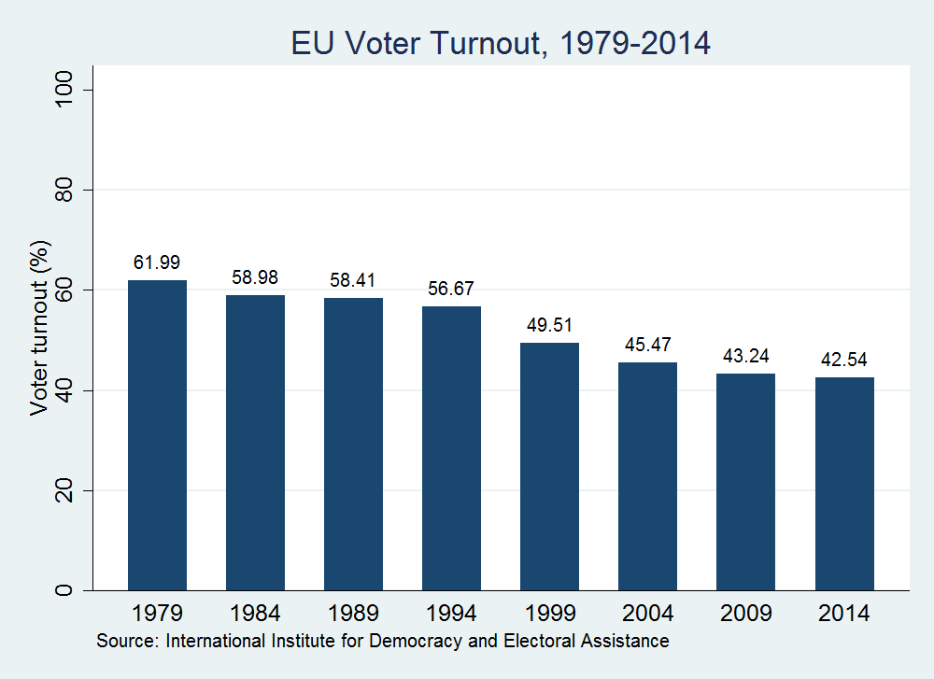

It is also important to compare these results with the general trend across the advanced democracies over the same period of time. As the next table shows, the clear pattern is one of declining voter turnout in almost all of the trilateral countries, which the study by Pharr and Putnam diagnosed as “disaffected democracies” and decried the fact that as more countries than ever before were adopting democratic systems of government, voters in the established democracies were growing increasingly apathetic and disinterested in the ballot box. Though published in early 2000, their analysis proved prescient and continues to hold true. In the recent U.S. congressional midterm elections for example, the national turnout was 36.3 %, the worst record in any U.S. federal election over the past 72 years.

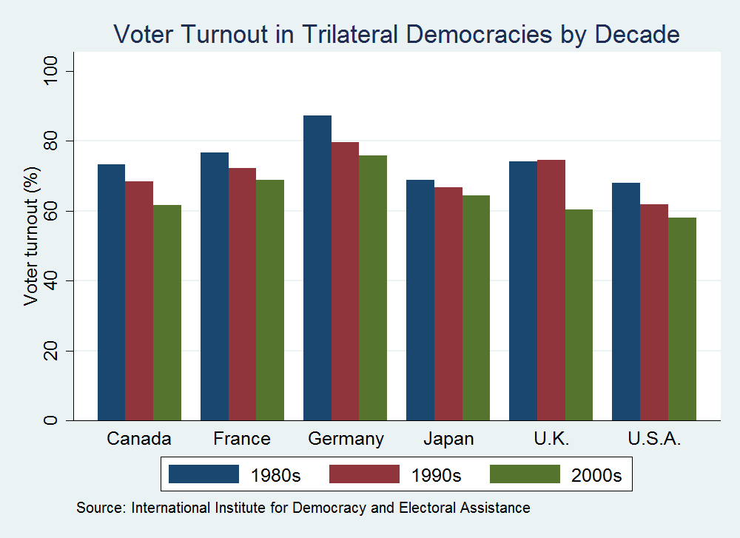

While these comparisons provide perspective and a much needed counterpoint to the overwhelmingly negative and somewhat misleading reports by the global media, it is the relative success of the extreme right parties that represents the biggest cause for concern given that they uniformly want to undermine the whole spirit of the European project even if there are considerable differences among the parties. As the analysis in the next section will show, the relative lack of unity also precludes the radical right from exercising any significant influence within the parliament. This does not, however, diminish the symbolic and political significance of their electoral advance and their victories in France and the UK. An analysis of the ideological and partisan trends in both the national and the European elections over time shows that there is a broad tendency of EU elections to reflect the political trends in domestic politics. In other words, EU elections cannot be described in a general sense as vehicles for proxy or protest votes. Instead, election data show that the ideological makeup of the European Parliament has largely reflected the trends that are seen in national parliamentary elections. In the early period, we see relative parity between center-right and center-left in the elections of 1979 and 1984. Around the time of the fall of the Berlin Wall, however we do see a slight change as there is a rise of center-right parties at the national level but a dominance of center-left groups in the EU. However, elections in 1994 largely resulted in parity again between center-left and center-right parties, which could be related to the salience and contentiousness of European issues as the Maastricht Treaty had just been ratified and referenda had been held in Denmark and France drawing even more attention to the stakes of the treaty that would lay the groundwork for the single currency. It is notable that we also see the rise of far-right groups in this period at least in the 1994 national elections. The 1999 and 2004 elections see emergence of center-right groups and a slight decrease in far-left groups, both at national and EU levels. Most telling are the results from the 2009 and 2014 elections with the former just on the heels of the global financial crisis and the latter at the climax of the Eurozone crisis. Although we see a clear dominance of center-right groups over center-left parties, there are increases in both far-left and far-right groups. The data clearly track a trend of decline among far-left groups at the EU level since the first elections of 1979, which is not particularly surprising given the disarray and fractured nature of many of the communist and other left-wing parties. Importantly, the data also show that representation of conservative, far-right, nationalist, and Euroskeptic groups in the EU had also been steadily decreasing since 1979, until 2014, which saw a significant uptick.

Party Ideologies Represented at EU and National Levels, 1979-2014
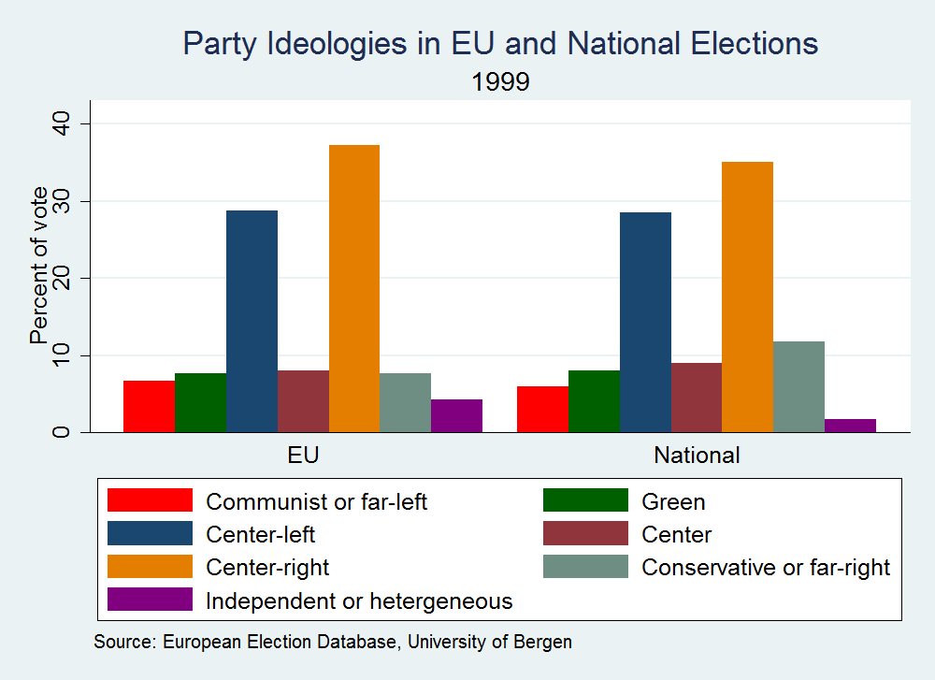
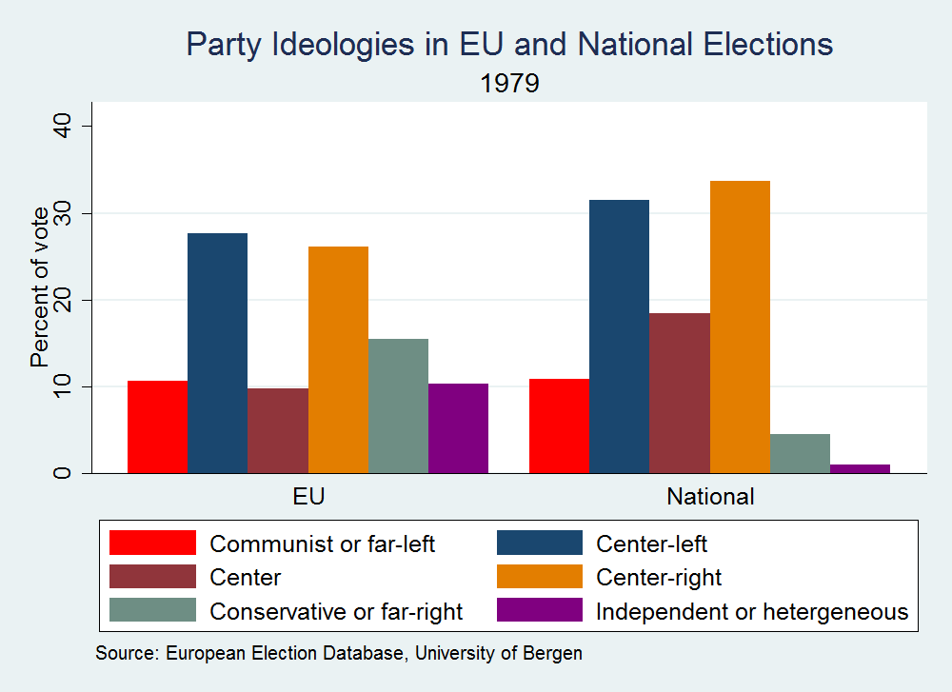
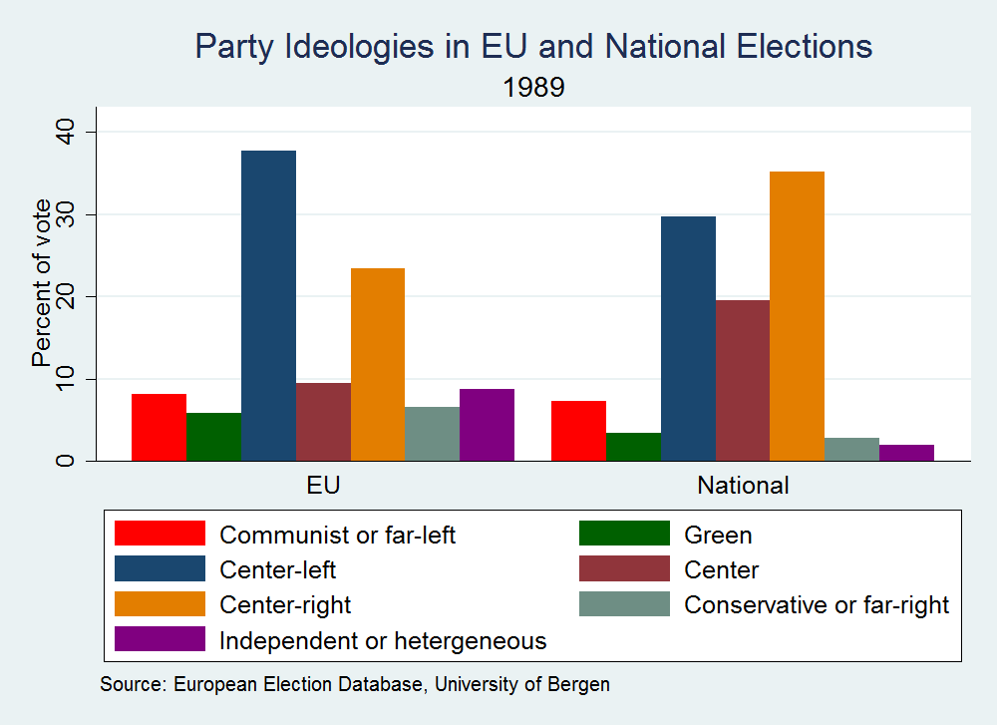
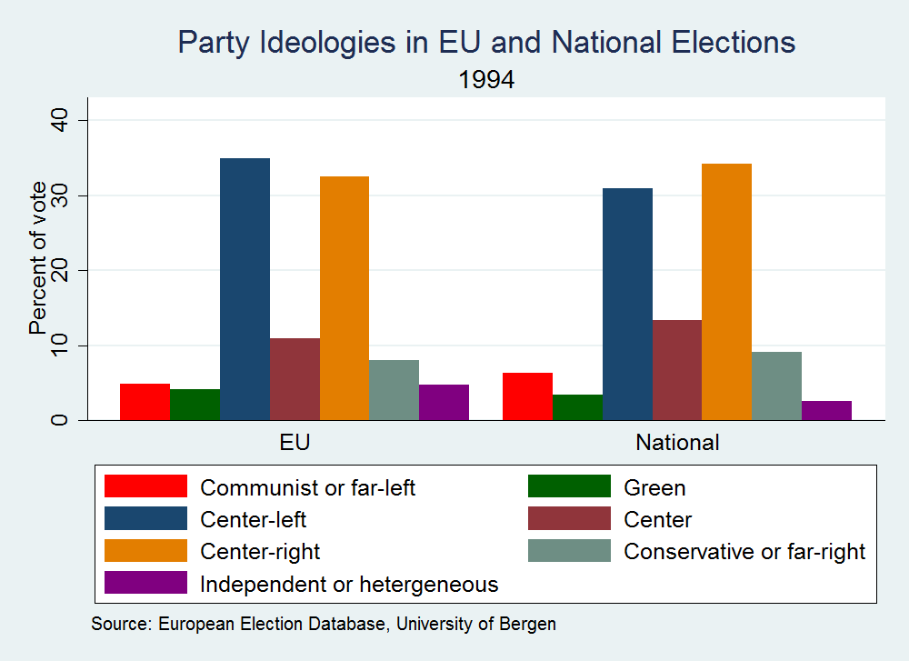
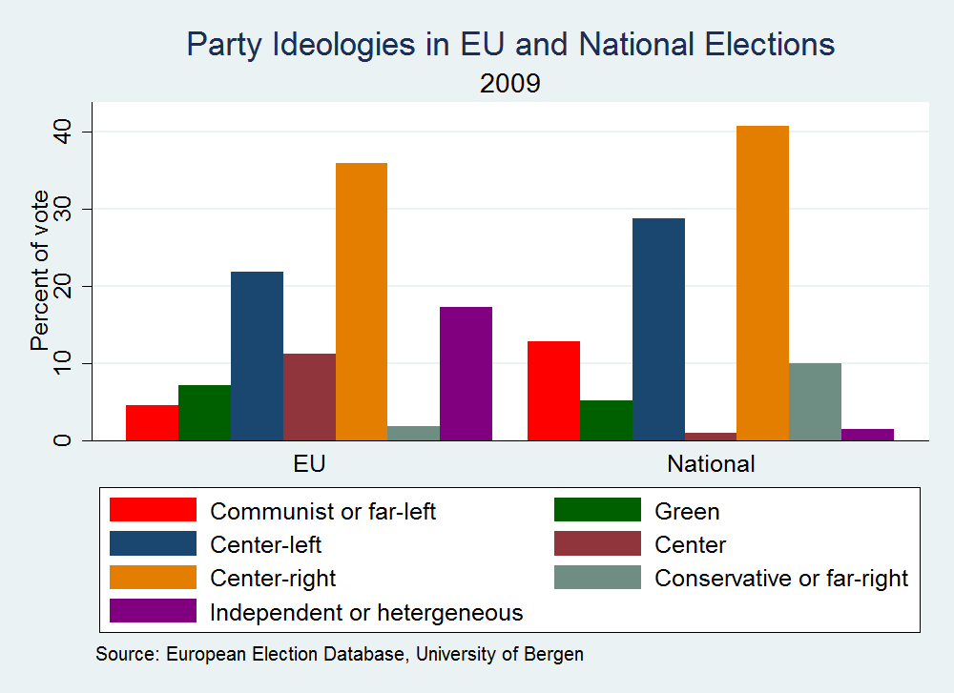
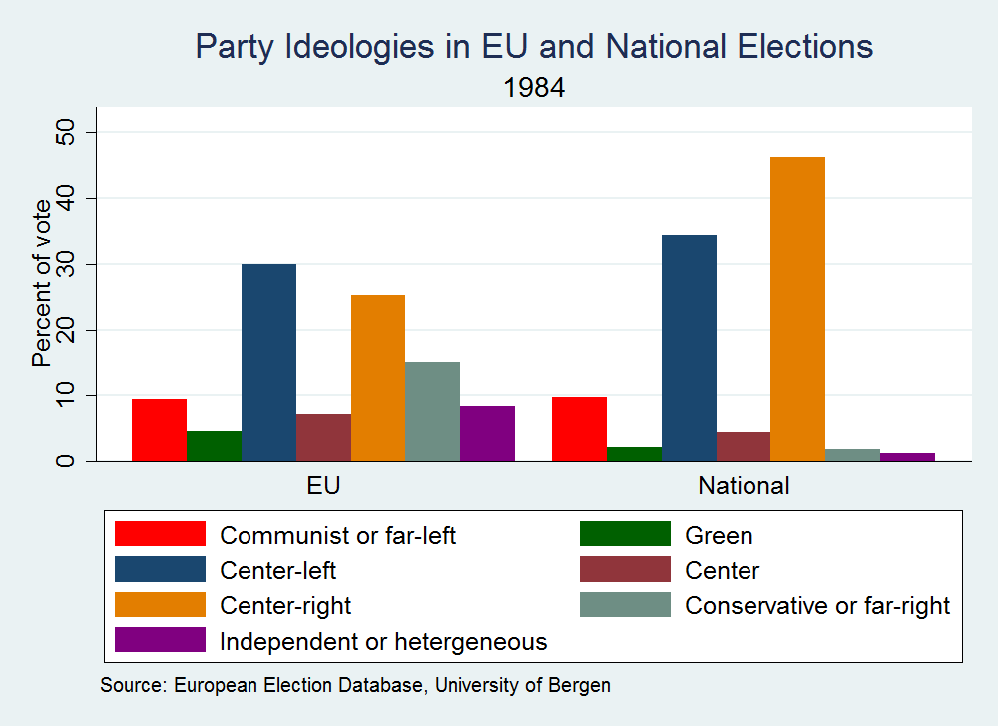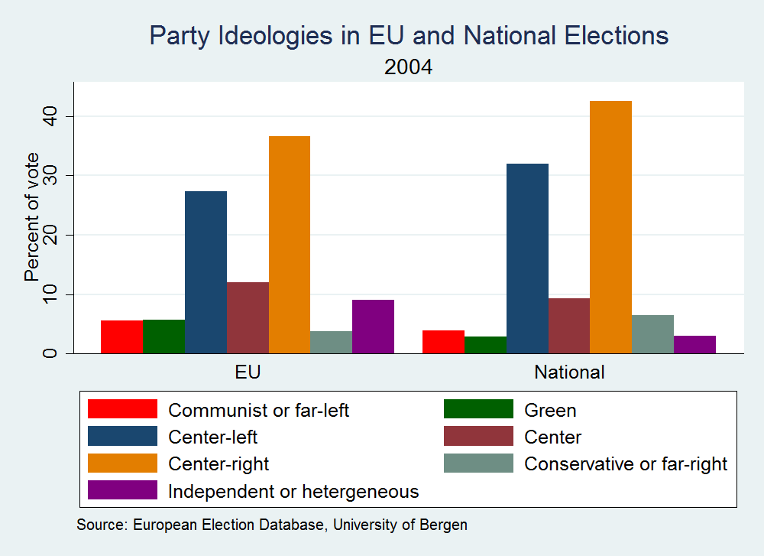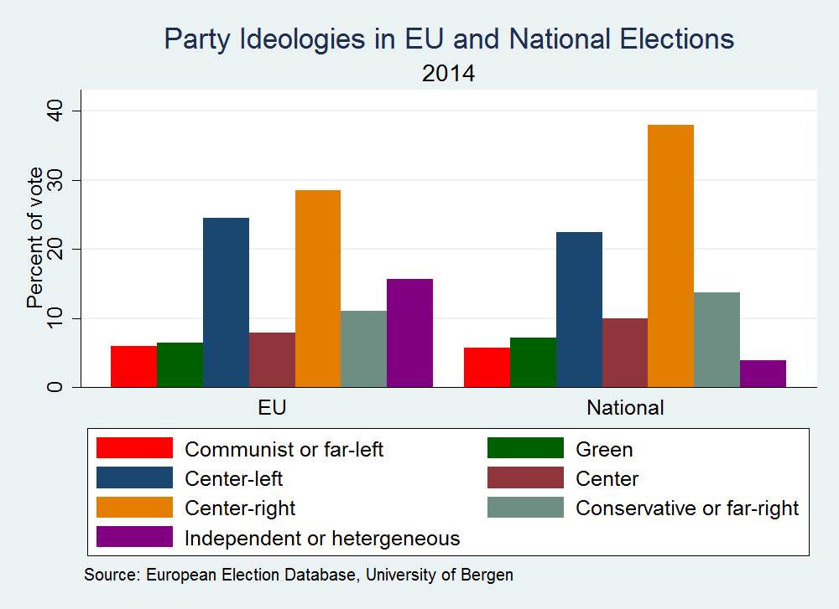
Notes about data: These graphs were created by using party data from the European Election Database. Parties were assigned to an ideological category based on domestic context. Only national elections that coincided with a European Union parliamentary election are represented. Note that the percentage displayed for national elections reflects the popular vote, while the percentage for EU elections represents the grouping of seats within the European Parliament, not the popular vote. The authors gratefully acknowledge the research assistance of Josh Jacob in compiling the data and constructing the graphs.
Two central points emerge from this brief analysis of election trends. First, economic duress breeds extremism and second, there is no significant ideological discrepancy between electoral politics at the EU and the national levels, which confirms a ‘normalization’ of politics within the EU. This phenomenon has been underway for the past two decades as many authors have noted (Checkel and Katzenstein 2009; Risse 2010). Recent research has further confirmed the trend as characterized by Risse: “EU politics is losing its technocratic and depoliticized nature and is becoming “normal” politics subject to similar debates and controversies, as in the case of domestic affairs (2015: 3). The growing politicization of European affairs in the domestic politics of member states is thus an important and positive development in terms of transnational democratic deliberation and at least institutionally speaking this could be interpreted as holding a favorable lesson for the prospects of democratization of global politics. Furthermore, as alarming and repugnant as many of the ideas and values embodied in some of the more overtly xenophobic and nationalistic parties achieving electoral success, these results are just as much a socio-economic and cultural crisis within domestic societies as a political crisis within the EU.
Analysis of voter turnout in national elections which took place simultaneously with European Parliamentary elections (See Appendix for data; note that countries which have mandatory voting were excluded from the analysis) reveal that whereas voters do indeed show up in higher numbers for domestic elections, the gap is not as significant as might be commonly assumed. This comparison has obvious limitations in that there are different member states holding national elections in each instance of EU level elections and electoral politics differ from country to country; nonetheless, we see over the span of these elections that voter turnout in each of the national elections was not extraordinarily higher than the turnout for the at least half of the EP elections in 1989, 1994, 2004 and to a lesser extent 2009, yet the most recent election had a fairly substantial gap. Ultimately we can conclude then that national politics may be drawing more interest as expressed through voter turnout, but these comparisons also show that the turnout is not as abysmal as is often suggested. That is not to argue that national political identities are waning in favor of an emerging European identity. National identities and discourses are remarkably tenacious as confirmed not only at the ballot box but also borne out in survey research. Data from both the Eurobarometer and the World Values Survey consistently show that the majority of individuals identify first and foremost with their nation. In 2013, only 46 percent of Europeans conveyed that they feel an attachment to the EU, whereas 52 percent feel no such connection; by contrast, 87 percent express attachment to their town or city, and 91 percent to their country. European identity exists, but only 9 percent of the respondents identify themselves primarily as European, whereas 87 percent give their nationality as their primary identification. A more extensive academic examination of the concept of European identity documented a slightly stronger case of European identity but still found that in no EU Member State (except Luxembourg) does the percentage of citizens who think of themselves mainly as European rise above 16 percent (Fligstein 2008:). As studies have shown, education and income are fairly strong determinants of European identity with the most well-off and better educated more likely to see themselves as Europeans as they are the groups who can reap the benefits of market integration and mobility whereas the older, less educated and poorer citizens cannot. Fligstein’s recent sociological study sums it up thusly:
Put simply, most citizens in different countries want their nation-states to protect them from the vagaries of the economy, illness, and old age. This sets up a potential clash in each nation-state between the winners of economic integration, many of who identify themselves as Europeans, and the losers of economic integration, many of whom remain wedded to national identities (2008: 245).

The global economic crisis, which expedited and worsened the euro and sovereign debt crises combined with the austerity measures and the further deterioration of the economies in many of the EU countries drew out this tendency even more as the following analysis of the 2014 election will highlight.

Contextualizing the 2014 EU Parliamentary Elections
The 2014 European Parliamentary elections provided a platform for right wing anti-EU parties to break through in national elections in several EU member states. This was initially seen as a potential threat to the whole European supranational integration project of which the direct election of MEPs is an integral part. The visions of the future of Europe presented by such parties have in common a rejection of further political and economic integration even if these visions vary between those calling for exit from the Union or just the single currency. Distrust of all EU institutions, a desire to return power to national institutions, opposition to further EU enlargement and calls for reduced immigration form part of the common ground of populist and extreme right MEPs and this distinguishes them very clearly from left-wing challengers to Europe’s mainstream parties. In some cases the origins of the parties concerned date back to the post-war era during which neo-Nazi and “new right” alternatives to the European idea continued to circulate in intellectual and activist circles. Since the second euro-elections of 1984 extreme right parties have, from time to time, achieved electoral success. Since the early 1990s referenda and elections have provided signals of an increasing challenge to the official narrative of European integration embodied, most notably, in the failed attempt to achieve ratification of the draft Constitution for Europe.
The deepening economic and social problems in many parts of Europe are part of the political context but do not explain the attraction of the radically different view of Europe’s future for which the extreme right stands. Seventy years after the end of the Second World War and 25 years since end of the Cold War, the success of these particular challengers may also represent a failure of the EU institutions and mainstream leaders to modernise their own narrative in a way which convinces a new generation of Europeans that the original idea behind this project remains relevant and worthy of support. Given the relevance of the EU model and the global significance of political stability in the region the potential global significance of such a crisis have not been lost on other powers. Looking around the landscape of the European Union early in 2015, the casual observer may wonder what happened to the political earthquake announced around the time of the time of the May 2014 European Parliament elections? Amongst the direst predictions was not only a surge in support for parties challenging the very idea of European integration to the election of a “self-hating Parliament.” (Leonard 2013) In fact, around 30% of seats in the current legislature are held by members who could to varying degrees, and with varying solutions be considered as opposing key aspects of EU policy or seeking to advance their countries´ exit from the Union. Even if this can be described as an earthquake it does not, so far at least, appear to have led to a breakdown in the functioning of the EU in general or the European Parliament in particular.
Less than 9 months earlier two apparently rising stars on the Eurosceptic right, Marine Le Pen of the French National Front and Geert Wilders of the Dutch Freedom Party had announced their joint plan to ¨wreck the EU from within (Ian Traynor, The Guardian 15.11.13). In fact Wilders party fell short of his expected progress in the elections and even though his French ally performed better than ever the two of them did not establish enough momentum or support to establish a functioning alliance after the election results came in. Even before the elections there were some experts doubting the severity of the storm about to hit the EU. Cas Mudde wrote in March 2014 that in spite of obvious voter concerns at the economic situation or the perceived rise in immigration “neither the far right or the anti-European populists are on track to win a significant victory in the upcoming European elections.” * Cas Mudde University of Georgia March 2014 .With 70% of MEPs still committed, in spite of policy differences, to making the EU function as effectively as possible it would clearly be an exaggeration to see the elections as some kind of watershed victory for those who want to destroy it.
In this paper we are trying to assess these events and their on-going aftermath in terms of their possible significance for transnational governance and, therefore, an election which is being interpreted as announcing the possible failure of the EU project is particularly relevant, even if, in our view, it is far too early to jump to any particular conclusion. One specific factual element is not open to dispute: the 43% turnout in the 2014 elections (more or less the same as in 2009 after a steady decrease from the 62% turnout in the first such elections in 1979) does suggest that these elections remain entrenched as something of a minority interest. In this view, based on the social background of those who actually did vote the British pollster, Peter Kellner of YOUGOV suggests that the “ surge of insurgent parties is the political consequence of the economic trends that Thomas Piketty described in his work on rising inequality.” * New Statesman 5.6.14
As Piedrofalta and Lauenroth had perceptively predicted that
“ final turnout will be decided by a mix of apathy and anger on the part of the electorate….the increased fragmentation and radicalisation of the next EP that polls suggest might complicate the adoption of decisions in a number of policy areas and accentuate the conflict between national and European levels and tensions among member states.” (2014: 11)
This is perhaps a more sober definition of the expected earthquake as compared with media comments around the time of the elections. Indeed it is necessary to look at the impact of the elections not just on day to day operations in Brussels and Strasbourg but also on national politics and the relations between particular governments and the EU more generally. The victory in Britain of the UKIP has, for example, led the current British Prime Minister to take up positions on EU reform which have heightened the risk to continued British membership of the EU. In Sweden the strengthened Swedish Democrats who won two seats in the EP last May helped in November to bring down the newly elected centre-left government. Even so our casual observer limiting his observations to what is going on inside the European Parliament itself might come to the view summarised by Oliver Treib ( 2014) of a situation where “ the voters say no , but nobody listens.” The EP continues to be presided over by German Social Democrat Martin Schulz as it has been since January 2012.Following his party´s failure to win the largest proportion of seats in the EP, Mr. Schulz accepted the logic of his personal and institutional position and the supported the EPP candidate for Commission President Mr. Juncker represented some kind of continuity following 19 years as a member of the European Council. Although his party the EPP lost 70 seats the party still claimed the top job with support not just from the mainstream left and the Liberals but also from the Greens and the far left.
To argue that the establishment of a broad form of co-operation made up of parties supporting continued European integration represents a failure to listen to the voters is something of an exaggeration. The EU is not perhaps a classical parliamentary democracy but the majority, if it can prove stable, has the right and indeed the responsibility to act effectively with its opponents free to act upon their own quite different views. The debate is still on-going as to whether the “ spitzenkandidaten” system was just a power grab by Parliament or a step towards a strengthening the legitimacy of the EU institutions. The integrationist majority had been clear in advance of election day that “this time it’s different.” Such an outcome is not just business as usual especially when Mr. Juncker himself describes his term of office as some kind of “ last chance” for the EU to stabilise and advance in the face of increasing domestic and external challenges. Mr. Schulz has made similar remarks and indeed far from becoming a self-hating institution the Parliament shows signs of being all too aware of the challenges it faces.
Within the institution it was always likely that the bite of the opponents of integration would be much less substantial than their bark but before looking at the reasons this is the case it is necessary to look closer at the nature of this particular political phenomenon. Certainly it is somewhat ironic that participation in the euro-elections held up at the same level precisely because of increased mobilisation by parties intending to use their seats in parliament not just to attack the EU from within but also, primarily, to advance their impact at national level. In the decades since 1979 the logic of the idea of a directly elected Parliament seemed to be working more or less as expected. Slowly but surely an Assembly with hardly any power developed its budgetary and legislative powers into a joint authority with the member states represented in the Council. With the power to elect the Commission President and to ratify treaties with other countries the EP had come of age and not by abrogating power but by making its ambitions plain and negotiating a series of treaties whereby the EEC became the EU.
Equally clearly the sense of citizen engagement which might have been expected to emerge alongside such a major constitutional development has not materialised. Even here any rush to judgement or simplification based on recent events should be resisted. The million signature petition calling on the EU to stop negotiations with the US for a TTIP has been presented to the Parliament which, most likely during its current term, will be called upon to ratify it. The outcome of the 2014 EP election does indeed oblige the mainstream majority to be all the more sensitive to the need to be seen as not ignoring public opinion. The insurgents are, however, a very diverse and indeed divided grouping even if for the purposes of this paper we leave out the strengthened left wing challenge to the mainstream which has been very successful in Greece and Spain and concentrates its criticism on economic policy rather than any wholesale rejection of the EU project.
Within days of the European elections it became clear that Ms Le Pen and Mr Wilders were not only in no position to wreck the Union from within but they were not even in a position to form a European Parliament Group (requirement: minimum of 25 MEPs format least 7 member states. In fact the earthquake image underestimated the heterogeneity of this part of Europe’s political landscape (Bertocino and Koenig 2014). have produced one of the earliest attempts to assess the composition and impact of the euro-sceptics arguing that the term itself represents an over-inclusive category. They have attempted a more precise distinction between more moderate euro-sceptics and what they define as Europhobes. Basically they distinguish between reformist critics of the EU and those who want to pull out of the Union or at least the Eurozone and/or Schengen. In their calculation there are now 30 euro-sceptic parties from 18 countries with a total of 125 seats in the EP, i.e.16.6% of the total. They are, in fact so divided and dispersed that they sit in three different political groups, with some, Le Pen included, left among the “ non-attached.” In effect this substantially reduces whatever chances such a relative and divided minority has to really influence EP decisions let alone EU legislation and policy making.
The other grouping or category relevant to our analysis is the Europhobes who the same authors calculate as coming from 16 parties and 13 member states with a total of 82 MEPs, namely 10.9% of the total. In fact “due to their diverse convictions and exit preferences as well as their structural difficulty to form cohesive political or voting alliances, they are less likely to shape political decisions in the EP.”(*Bertocino and Koenig)
Together, in spite of their heterogeneity, these parties do indeed represent a challenge to the remaining 72.4% of members of the institution. Their presence certainly does confirm the end of the “permissive consensus” which had hitherto facilitated European integration. Even this is not, however, really a new phenomenon. The French National Front scored its first electoral breakthrough in the second EP elections of 1984 and their presence in fact led the Parliament and the EU more generally to become increasingly active in coming to terms with racism and xenophobia. (Harris 1993) Numerous referenda in France, the Netherlands and Ireland have shown the difficulty of assuring public support for deeper integration. The economic stagnation and continuing uncertainty as to the future of the Eurozone economy confirms a reality that lead President Juncker to describe dramatically his term of office as a “ last chance “ to save the project. Even so it is necessary to avoid over-simplification.
As Cas Mudde (* op.cit) observed before the 2014 election “ the economic crisis has caused an increase in public dissatisfaction with both European and national elites, as well as electoral losses for most governing parties in EU member states. But there is no clear trend in the electoral fortunes of far right parties. Overall the Great Recession has not produced a sharp rise in support for far right parties, and neither the far right nor the anti-European populists are on track to win a significant victory in the upcoming European Parliament elections.” He also reiterated the view that “terminological confusion and conceptual stretching have always muddied the debate about the far right” and emphasised the “nativist” nature of such parties with their combination of nationalism and xenophobia.
A few weeks before the elections PEW Research produced a major opinion survey with title “Fragile rebound for EU image threatened by disaffection with Brussels, Immigration.” This poll encapsulated the voters´ mood which the elections confirmed. The salience of the issue of immigration confirms how to a great extent anti-immigrant politicians use their European platform as little more than a base to advance their national strategies. With over 50% of those polled wanting to “allow fewer immigrants into our country” parties wishing to attract their support are obliged to campaign for action at national level. The EU is based upon free movement within its borders and the desire to curb immigration (often linked with anti-Muslim or anti-Roma sentiments) reflects concerned being felt very much at local level with the only possible response coming from the national government action. By way of example the UKIP victory in May 2014 led the British Conservative Prime Minister to respond to this political reality with plans to act against immigration in a way that could endanger his avowed ambition for Britain to stay as a member of a reformed EU. It is also worth noting that Wilders PVV in the Netherlands failed to increase its level of support after he shifted his emphasis away from immigration and towards his alliance with Ms Le Pen with the objective of precipitating the collapse of the EU.
The distinction between euro-scepticism and Europhobia (or even neo-Fascism) is much more than a question of terminological clarity. Parties such as Jobbik in Hungary or Golden Dawn in Greece fall into the latter category and find themselves operating on the birders of legality with members facing prosecution for violence, threats to democracy or hate speech. Ironically the Republican US Senator John McCain accused Hungary’s Prime Minister of being “ neo-Fascist. “ This followed controversial changes to the constitution of Hungary and Mr Orban’s explicit commitment to develop some form of “illiberal democracy.” Sometimes the line of distinction between the views of Orban’s FIDESZ party and those of Jobbik are not clear. The Senator’s remarks reflect concerns in the US that Europe is not doing enough to respond to increasing anti-Semitism and racism. In this case Mr Orban is the Prime Minister of his country and leads a party fully integrated into the mainstream EPP whose leader Joseph Daul publicly supports him and welcomes his electoral victories. One of Orban’s closest allies is the Vice-chairman of the EPP group in the European Parliament. This is the party also of Jean-Claude Juncker.
If then we can, for the moment, conclude that the various xenophobic and nationalist parties do not seem to be in a position to destroy the EU from within the question arises as to how the mainstream majority, working in a broad coalition to help Mr Juncker to achieve a successful term, has reacted to the presence of such parties within the Parliament. Further research such as drawing up reports on policy matters or examining items of legislation would be necessary to address this question.
Experience of coalitions in West Germany or Italy can suggest that they leave open spaces for anti-system radicals of all kinds, even terrorists, denouncing the political failure or self-serving arrangements which voters are encouraged to perceive as an abuse of power. That is certainly a risk but even those who question the nature of the Juncker coalition have not come up with any convincing alternative arrangement in terms of personnel or policy. The first thing that can be observed as a reaction by the political mainstream is that there has been no attempt to prevent the MEPs elected as members of parties critical of the EU from exercising their full rights as MEPs. The rules which apply to the formation of groups and the occupation of places in parliamentary committees have been applied to them in the same way as applies to all other MEPs. They receive the resources of staff, funding and office space as individuals and members of groups in accordance with established arrangements. Whilst it is too early to make an objective judgement there is anecdotal evidence that these particular MEPs are not particularly active in committee work and certainly the other groups are not ready to see them in any positions of leadership in committees or to appoint any of them to draw up reports on policy matters or legislative proposals. This does not prevent them as individuals or members of groups from speaking, tabling resolutions or travelling as members of parliamentary delegations. They can use the facilities of the EP information offices in the member states or invite their constituents to visit the Parliament in Brussels or Strasbourg. For example, one of the major issues to be dealt with in the current legislative term is the TTIP and Ms Le Pen has astutely taken up a position in the Parliament’s International Trade Committee to ensure for herself an excellent prominent platform to denounce the US and the European Commission for the threats they bring, in her view, to French identity and interests.
In the first weeks of Mr. Juncker’s term revelations concerning tax avoidance schemes in his native Luxembourg put him on the defensive. His critics were not limited to the extremists all too quick to attack him and they even saw the “ Luxleaks” scandal as an early chance to sap his credibility. Having firmly rejected any alliance with the French National Front, the political group of which UKIP is a member with its Italian Five Star Movement members jointly tabled a motion of censure calling for Mr Juncker to resign already. Left wing and Green critics of Juncker refused to support this proposal which in the end drew just over 100 votes, far short of the two-thirds required to achieve its objective. In the run-up to the 2014 elections the second largest European parliamentary group, the Socialists and Democrats, was concerned enough at the potential threat to analyse and attempt to find a response to what it had already identified as a threat from extremism and populism. In the report it prepared, the Groups then Chairman Hannes Swoboda from Austria argued that ¨Today as we celebrate the anniversary of the tragic events of 1914, that marked the beginning of World War 1….we need to remember that Europe was born from this tragedy to secure peace, welfare, prosperity and ensure that nationalism and populism would never again lead the way. If we look at the European Union today we cannot say these core objectives of the European project have yet been secured. New nationalisms and new movements and parties using fear and hatred against minorities are again on the rise and new divisions between East and West, North and South are created and exploited. The truth is that the European Union today is, in many ways, failing to fulfil its promises and duties.”(Extremism Working Group Report? 2014 p 4).
Around the same time the German Marshall Fund published its own study posing questions about the “unstoppable rise “of the far right and arguing that “right-populists can only increase their vote if established, moderate political actors have already legitimised their arguments.” (GMF The Unstoppable Far Right, Timo Lochocki ?2014). Rather than trying to compete on the populists´terrain Mark Leonard argued that “Europe needs more politics and more disagreements. Rather than huddling together mainstream parties need to give people real choice and address the issues that really concern people.” (ECFR op. cit. p.10)
The events following the May 2014 elections could be seen precisely as a form of huddling together by the main party groups in the European Parliament leading such an observer as Oliver Treib to argue that “excluding the growing camp of Euro-sceptics from the EU´s corridors of power could prove fatal in the long run.” Teri opacity p.1552)
This may sound convincing but to suggest that somehow the European Commission should include such elements amongst its members does not seem a feasible approach rejection of the very institutional structure to which they have been elected with a view to weakening it or destroying it altogether. Even Alexis Tsirpas from a left party Syriza in Greece accepted the logic of the procedure by which Mr. Juncker was elected. In advance of the election Mark Leonard had expressed the concern that this would be seen merely as “business as usual. “ His proposal was to go beyond the consideration of proposals for “ more Europe,” recognise the real structural and policy problems the EU faces and “instead of forming a pro-European they should try to create the space for the political battles between competing visions of Europe and thereby try to preserve left-right competition on both national and European levels.” ( ECFR op. cit p.9)
Again this sounds an attractive and quite different idea from Treib and from what is now functioning in Brussels and Strasbourg, sometimes described as the “ Juncker coalition.” In fact, in the meantime urgent decisions have to be made on the economy, Russian aggression or TTIP negotiations. Such decisions require often majorities in the Council and Parliament and are also issues being taken up by the right-wing challengers to the European mainstream. Indeed whilst the US is increasingly concerned about the stability of Europe, there is much evidence that Russia is actively developing relationships with parties opposing further European integration. The Centre for European Strategic Intelligence (www.cesieuropeanintelligence.org) has found confirmation of support to such parties in the UK, France, Hungary, Bulgaria and Greece.) This appears to be a recycling of a Soviet era practice whereby the USSR subsidised parties and movements whose objectives fitted in with their objectives. Support for anti-TTIP or anti- fracking movements is perhaps less of a concern than an EU Member State Prime Minister seeing Putin as some kind of model for the “ illiberal democracy” he favours in Hungary. Combined with diplomacy, soft power and modern communications it remains to be seen what will be achieved by Russia as it clearly seeks to weaken the EU, its relationship with the US and its ability to unite effectively in support of its neighbours in the east and south-east. Inquiries have been initiated in the European Parliament in relations to financial arrangements between Russia and MEPs from France and Hungary.
The European Union is a unique political entity and the political and economic significance of its current internal challenges are clear enough. As the problems it faces are not amenable to any quick solutions the ant-European populist tide is, at least, likely to remain a fixed part of Europe´s political life. Unfolding developments and upcoming elections in the UK, France, Greece and Sweden will provide the successful parties with a chance to build on their euro-election successes. It is, however, not yet clear what global lessons can be drawn from this regional crisis. It is, however, already apparent that if the EU fails to overcome its current difficulties other powers will be affected. Russia is enjoying the political spectacle even if it has so far failed to undermine European and trans-Atlantic unity which has led to it facing very strong economic sanctions following its intervention in Ukraine. Its allies in the EU oppose these measures and sometimes actively support Russian action, for example in relation to elections in occupied parts of Ukraine. China has tended to prefer a stronger EU as a counter-balance to the US and would be happy enough to see problems with the TTIP which it perceives as a geo-strategic challenge. The US itself has publicly expressed concerns about developments in Hungary and for the opposite reason from China is concerned at rising populist opposition to TTIP. NGOs such as Human Rights First (We are not Nazis but…the rise of Hate Parties in Hungary and Greece and why America should care. August 2014) have contributed to a wider awareness in the US of the threat to political stability in Europe which may be developing.
This awareness of what may be at stake in terms of a challenge to post-cold war European stability was publicly expressed by US Ambassador Samantha Power in Berlin on November 13th 2014 when she addressed the OSCE´s Berlin Conference on Anti-Semitism) and referred publicly and specifically to the outcome of the May euro-election results saying calling on those present to “look at May´s European parliamentary elections. In Denmark the anti-immigrant Danish Peoples´ Party finished first. In France, the far right National Front won over a quarter of the vote-more than any other party. In Greece the overly anti-Semitic and xenophobic Golden Dawn received 10% of the vote…..in Hungary- where extreme ethnic nationalist Jobbik party finished second in May elections and where public opinion polling has shown a high level of anti-Semitism…” she referred to also to Hungarian Government actions to limit the activities of NGOs and to build a monument to the “ victims of German occupation” without mentioning the role of the war-time Hungarian Government and citizens in the extermination of Jews. “There is an important lesson here: rising anti-Semitism is rarely the lone or last manifestation of intolerance in a society. Quite the contrary, it is often the canary in the coal mine for the degradation of human rights more broadly.” For the moment European Ministers have not drawn these threads together so clearly. The European Parliament´s Civil Liberties Committee which, in the last term, produced a report on developments in Hungary (Tavares report….) has held a hearing and the Hungarian member of the European Commission was stripped of his responsibility for EU cultural policy but confirmed on office as another consequence of coalition building in the EP.
The European elections of May 2014 may or not be defined as an earthquake but the results and consequent developments provide a test for the credibility and, maybe, the survival of the European project.

Conclusion
The recent elections as now seen against the backdrop of the on-going difficulties of stabilizing the Eurozone, the falling value of the Euro, the Greek elections and the threat of a “Grexit” should compromises not be reached through some form of debt forgiveness or restructuring, and the Swiss decision to de-peg the Swiss Franc from the Euro, all add up to an even worsening regional political crisis. The real irony however is that the EU for all of its flaws nonetheless represents the most developed transnational and democratically legitimate institutional response to the realities of an ever integrated world economy that under neoliberalism has not been met with proper mechanisms of global regulation. The EU is both a product of and a response to the globalization phenomenon and it is the only region that offers levers of democratic control and coordination beyond national capitals, yet the current leaders squandered the opportunity to defend the European social model and have instead become more neoliberal than the very progenitor of the Washington consensus. As the economist Dani Rodrick pointed out in The Globalization Paradox we can’t have hyper-globalization, democracy, and national self-determination all at once. At most, we can choose two out of the three. Rodrick sees Europe as a halfway house, a well -developed model of economic integration and regional hyper-globalism where democratic and political institutions and infrastructure remain a work in progress but when economics are under stress, the response (discourse, policy preferences of the dominant) is overwhelmingly national. Effective transnational governance in the midst of a global economic crisis which also laid bare the wildly varying macroeconomic conditions among the members of the Eurozone requires a solidarity that thus far is proving absent as confirmed by both the rising strength of the radical right parties as well as the survey research that confirms the predominance and persistence of national identity over a common European identity. However, the success of Syriza and the mounting popularity of Podemos may mark a shift in national and transnational political responses to the economic crisis and shake up or wake up call to the mainstream center-left and center-right parties in a way that will redress the excesses of austerity policies. It is too soon to draw any definitive conclusions, but the recent compromise struck in Brussels and the tentative reprieve for Greece underscore that the linkages between domestic and European level politics matter more than ever. As Mr. Schäuble said to the Bundestag in his defense of the latest deal for Greece, “We Germans should do everything possible to keep Europe together as much as we can.” (BBC 2014) If Europe cannot get this right and move forward by hanging together, then there is little hope that the global economy can ever be managed in a more humane and social just manner.

REFERENCES
BBC. 2014. “Greek debt crisis: German MPS back bailout extension” British Broadcasting Corporation. 27.2.2015. Retrieved: <www.bbc.com/news/world- europe-31654989>

Bertocino and Koenig. 2014. “Euro-scepticism or Euro-phobia: Voice vs. Exit” Jacques Delors Institute 27.11.14

Bergman and Raunio. (2001)
Checkel, Jeffrey and Peter Katzenstein. (2009) European Identity. Cambridge: Cambrdige University Press.
Fligstein, Neil. (2008) Euro-clash: The EU, European Identity and the Future of Europe.
Oxford: Oxford University Press.

Harris, Geoffrey. (1993) The Dark Side of Europe. New York: Columbia University Press.

Mark Leonard (2013) ECFR Need Citation

Mudde, Cas. (2014). Need Citation

Piedrofalta and Lauenroth. 2014. “EU Divisions Laid Bare by Elections to the European Parliament” EPIN: 39.

Pharr, S, and Putnam, R. (2000) Disaffected Democracies: What’s troubling the Trilateral Countries? Princeton: Princeton University Press.

Rodrick, Dani. (2011) The Globalization Paradox: Democracy and the Future of the World Economy New York: W.W. Norton and Co.

Schmidt. V. (2006) Democracy in Europe: The EU and National Polities. Oxford: Oxford University Press.

Treib, Oliver. (2014) The voter says no, but nobody listens: causes and consequences of the Eurosceptic vote in the 2014 European election Journal of European Public Policy 2014, vol 21, Number 10 pp. 1541-1 554

APPENDIX:
National and European Level Elections Compared
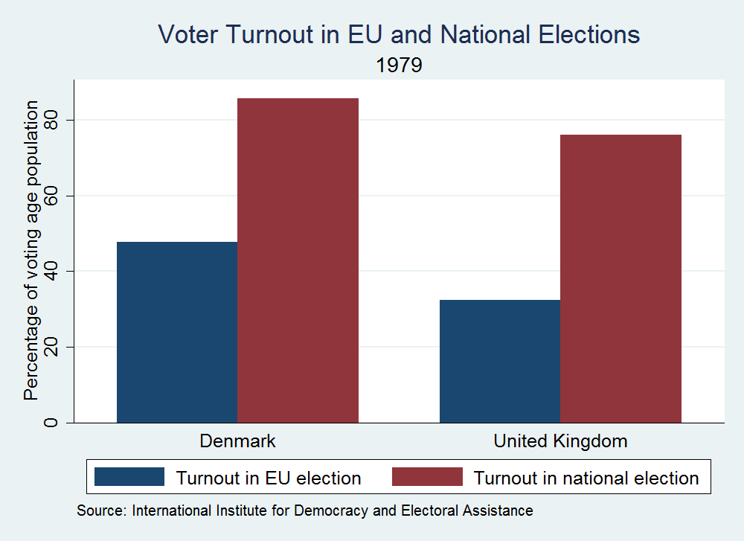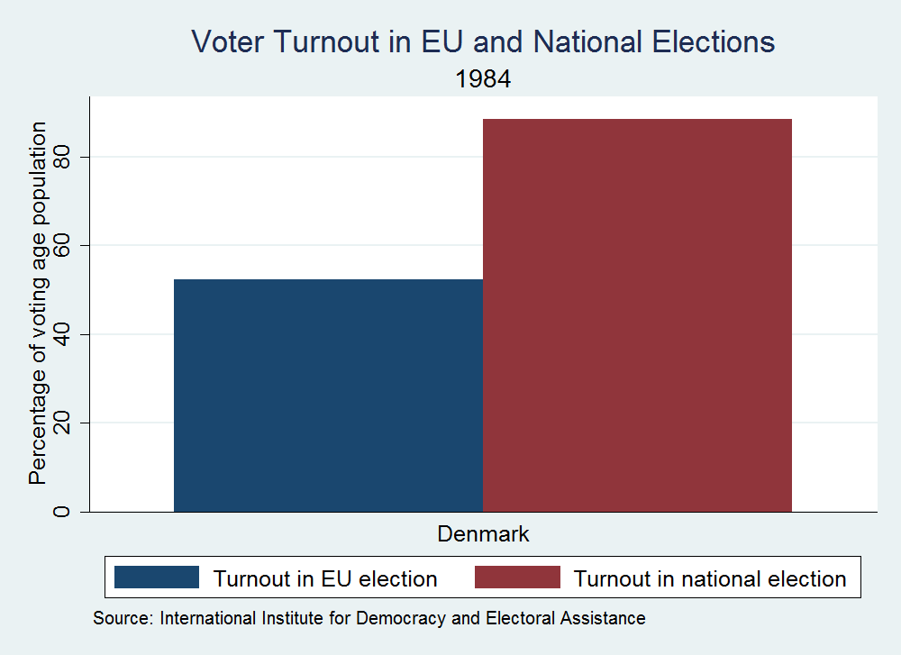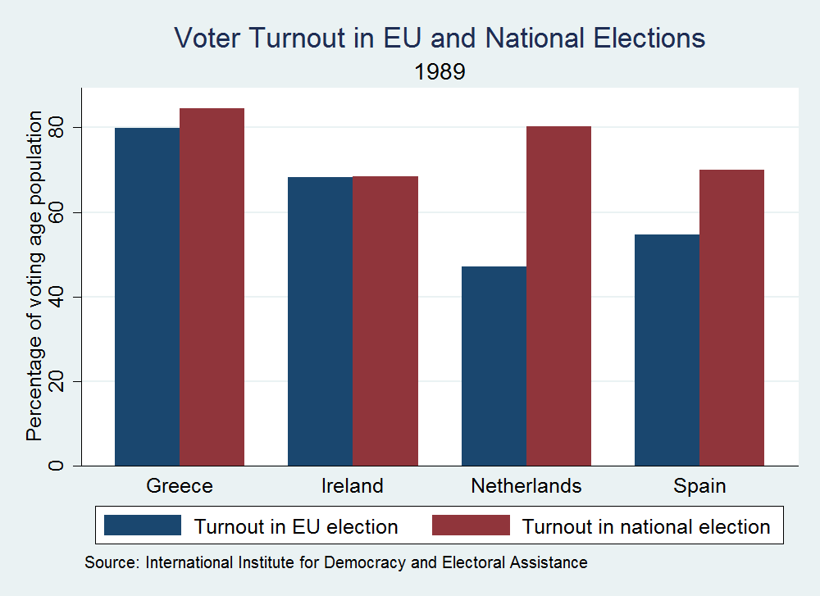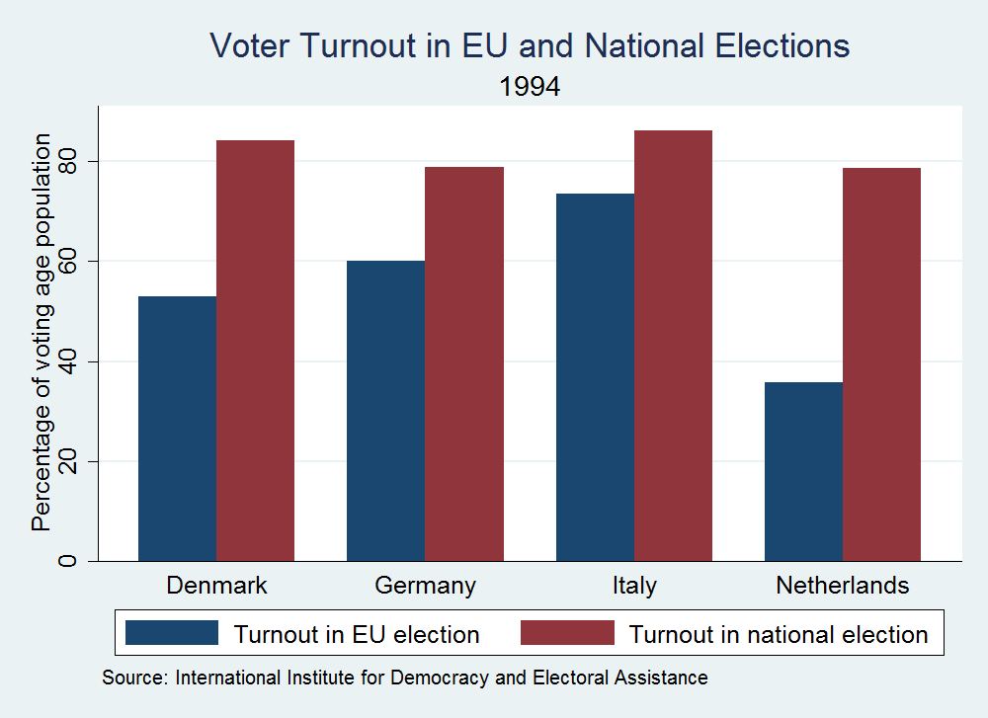
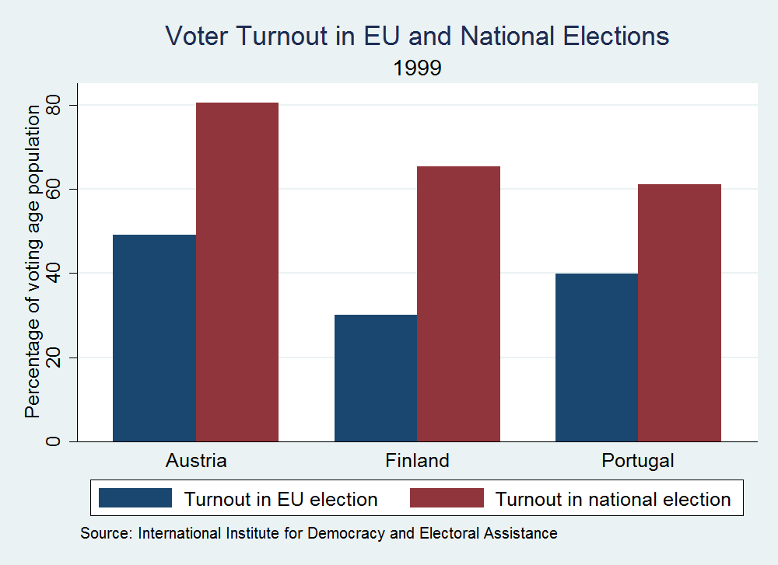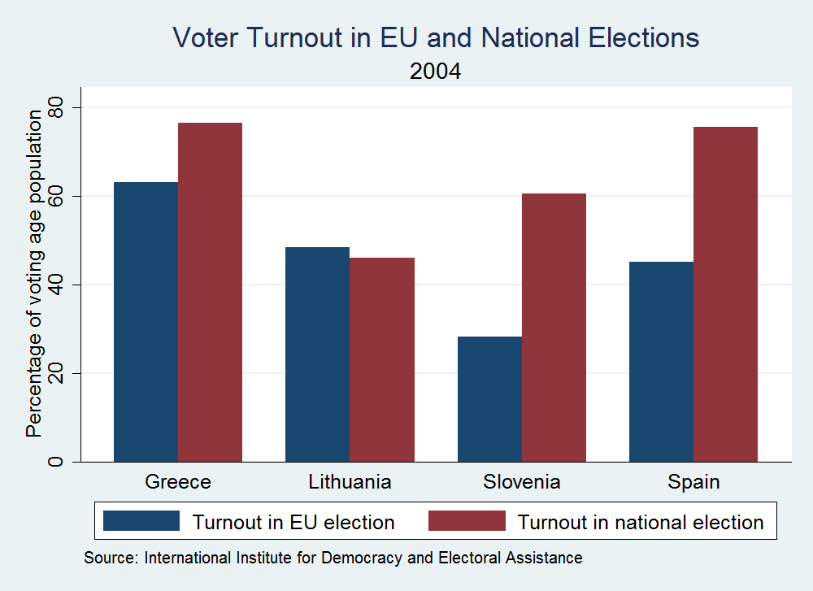

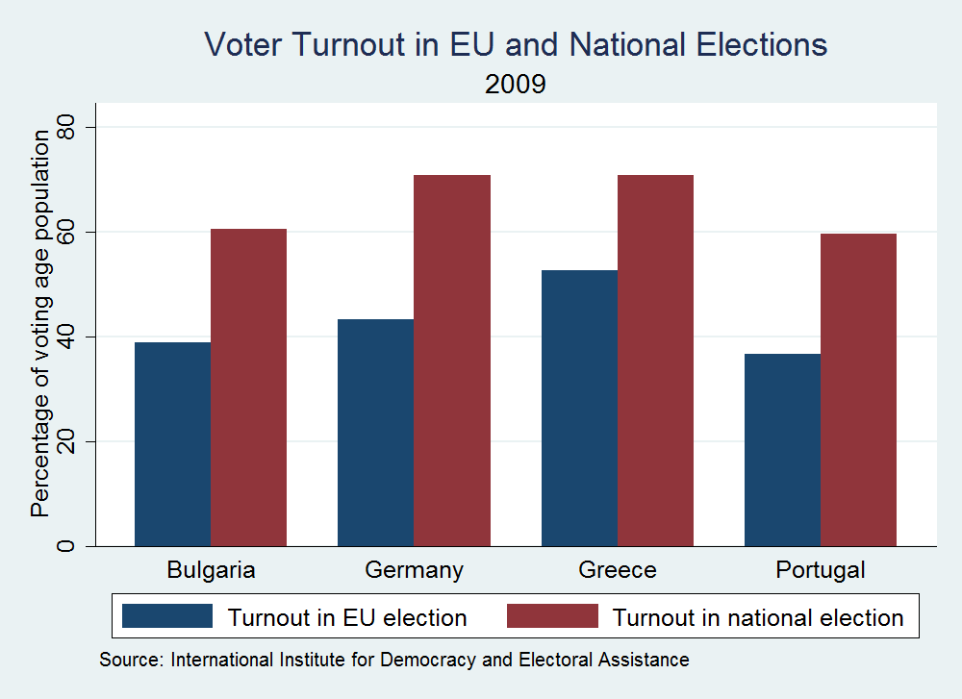

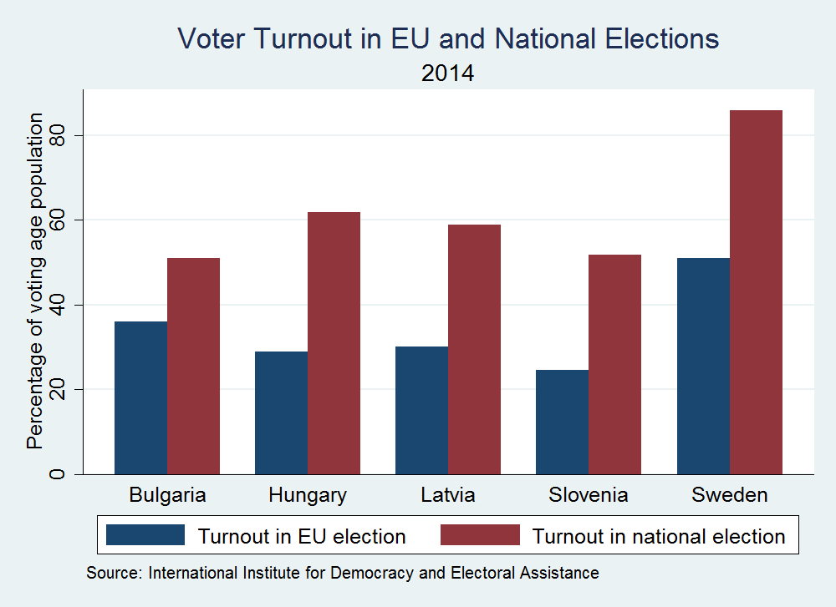

http://www.europarl.europa.eu/news/en/news-room/content/20140210BKG35568/html/THE-2014-EUROPEAN-ELECTIONS-THIS-TIME-IT’S-DIFFERENT
Article 17(7) TEU For more discussion of this change, see http://www.europarl.europa.eu/EPRS/140829REV1-Role-of-the-President-of-the-European-Commission-FINAL.pdf
The term trilateral refers to the countries of Western Europe, North America and Japan and was coined with the establishment of the Trilateral Commission in 1973.
http://www.nytimes.com/2014/11/12/opinion/the-worst-voter-turnout-in-72-years.html?_r=0
Standard Eurobarometer 80, Autumn 2013. As reported in: http://carnegieeurope.eu/2015/01/26/emotional-intelligence-for-eu-democracy/i0nq?mkt_tok=3RkMMJWWfF9wsRoluKTNZKXonjHpfsX57u0lXa6g38431UFwdcjKPmjr1YAFTMR0aPyQAgobGp5I5FEIQ7XYTLB2t60MWA%3D%3D

