**Global Power Transition and the Future of the European Union**

Will EU Leaders Stop Missing Key Opportunities?

Birol Yeşilada, Portland State University & Osman Göktuğ Tanrıkulu, Portland State University

**Abstract**

Paper presented at the 2015 Conference of the European Union Studies Association in Boston, March 5-8. This paper applies power transition theory to EU’s future as a global power. It assesses economic and political/strategic capabilities of the EU vis-à-vis other global contenders as Transatlantic Alliance is challenged by rising powers in the east - China and India. Analysis includes simulations of how structural reforms (i.e fiscal union) and membership enlargement(s) are likely to affect EU’s ability to achieve its goal of becoming a global actor.

# Introduction

The future of the European Union (EU) rests on a delicate balance of policy challenges. On the one hand, recent financial crisis exposed EU’s failure to match economic and monetary union (EMU) with necessary integration along political union. Once more, it became crystal clear that monetary union cannot be sustained without a serious political union. An additional problem facing the EU on this front is unwillingness of Britain to fully commit itself to a true fiscal/political union. On another policy front, EU’s security policies remain hostage of its worsening relations with Turkey. As EU pushed Turkey away from potential membership, this country’s Islamist oriented government reoriented its policies toward the Middle East and China while holding EU-NATO partnership in limbo. Result has been damaging for full implementation of Transatlantic security agenda with no resolution in sight. Yet, another failure concerns EU-Russia relations. For reasons discussed later, if Russia decides to lean more toward the East and withdraw from reliance on its current European trade partners, the prospects for a long peace may vanish as well on EU’s eastern borders. There are no simple solutions out of these challenges unless EU leaders can reach a consensus on a serious fiscal union (political union) and repair relations with Russia and Turkey.

The magnitude of the financial crisis is so grave that observers and analysts[1] have concluded a big decision must be made regarding fiscal union (thus political union) to save EMU. Failure to formulate a viable fiscal union could derail Monetary Union and possible breakup the Eurozone. Not only does this problem threatens deepening of economic and monetary integration, it spills over to EU’s Common Security and Defense Policy (CSDP), part of its overall Common Foreign and Security Policy (CFSP), and makes it difficult to complete EU-NATO partnership and enable Europe to meet challenges posed by rising powers like China and India.

# The Magnitude of Challenges Facing the EU

The European Union provides the most interesting argument in favor of integration. The expectation is that members of such a community will grow faster and become more competitive largely due to economies of scale. In today’s competitive economy, societies that do not take advantage of all the opportunities are likely to fall behind and be unable to maintain continuous growth in the face of competitors with much larger markets and investment potential. The second argument is that integration reduces the likelihood of conflict among agents because they provide a modicum of consistent rules, make each component dependent on the others and presumably increase the level of trust among participants. Yet financial crisis, problems pertaining to future enlargement, and relations with Britain, Russia and Turkey also affect EU’s ability to formulate a viable CSDP.

## The Fiscal Union & the UK Challenge

Whereas the EU represents the most successful and complex form of regional economic and political integration between sovereign member states, it is faced with the most severe financial crisis of its history. Moreover, the EU’s bold leap forward into EMU failed to make it the leader of global economy. Problems facing the EU are product of its unique approach to regional economic integration that span sixty years of intergovernmental and supranational mix of policy making. Throughout its history, the EU has followed a continuing, though irregular, course of integration. It has been on a course that has always found a middle way between integration that is strictly economic in nature and integration that is strongly political, and it has, with each integrative step, brought institutional changes representing compromises between the principles of inter-governmentalism and supranationalism. The outcome of their collective efforts was the completion of the Common Market (Single Market) in 1992 that met the original intent of the Treaty of Rome. However, complex internal and external challenges that EU member states faced convinced them to take the next logical step in economic integration – Economic and Monetary Union. However, European leaders did not make a similar bold move in establishing a true political union. This shortcoming became the Achilles heal of EMU as seen in recent financial crisis and the inability of the EU to get itself out of the ensuing mess. As Kugler, Fisunoglu, and Yesilada notes (2015:17) “reluctance and, in some cases, opposition among some members to deepening political union resulted in a lopsided regional integration characterized by: (1) EMU among 17 member states, (2) Economic Union between all members, and (3) intergovernmentalist political union.”

Debate over the need of a fiscal, thus deeper political union remained. There are two schools of thought characterized the nature of the debate in the EU. According to one school monetary union could not survive in the long run unless a strong political union accompanied it and cited numerous historical cases to support its position. Going as far back to work of William Riker (1964) in his powerful analysis of the rise of a federated United States argued that confederations couldn’t succeed unless there are continuous positive gains for the members. Indeed, he showed that the United States confederation collapsed when taxes were to be imposed on the US population. In a similar manner, this is the type of crisis that the EU faces today.

1. Are EU members willing to support others?
2. What are the limits of national as opposed to European actions?
3. What are the consequences of the weakening or disintegration of the EU?

The other school of thought maintains that the present degree of political union in the EU is sufficient for the long run survival of the monetary union and that there is no urgency of creating a federal structure in the Union similar to one found in the US. As De Grauwe (2009) correctly states, debate between these two views about the link between political and monetary union is somewhat difficult by a lack of clarity about the meaning of political union. One can look at a monetary union as a union between countries that use the same currency and have a single monetary authority. However, a political union is much more difficult to define because it involves several key policy issue areas and institutions of governance that could cover foreign and security policies, taxation, judiciary and similar policy areas.

Political union affects monetary union in several ways. First, it makes it possible to centralize a large part of national budgets at the supranational level and enables significant fiscal transfers between states as insurance against asymmetric shocks. Second, it reduces the risk of asymmetric shocks that are political in nature. When member states are independent in pursuing their respective fiscal policies, unilateral decision of any member to increase or lower taxes creates an asymmetric shock. A simple Stability and growth Pact that followed EMU was simply insufficient to correct these imbalances as apparent from the current crisis. The magnitude of the problem is reflected in another asymmetry that is found in the degree of integration between two camps of EU member states – thus creating a two-track EU. Moreover, failure to deepen political integration carries with it the danger of weakening collaboration on the CFSP/CSDP front. Kugler et al demonstrated that how two-track EU emerged based on Genna’s (2003) Integration Achievement Score. Figure 1 provides a summary of what we mean by two-track EU. The two lines show different levels of integration between the two sets of member states – those who are in EMU and others that are outside the Euro zone.

Figure 1: Integration in the EU

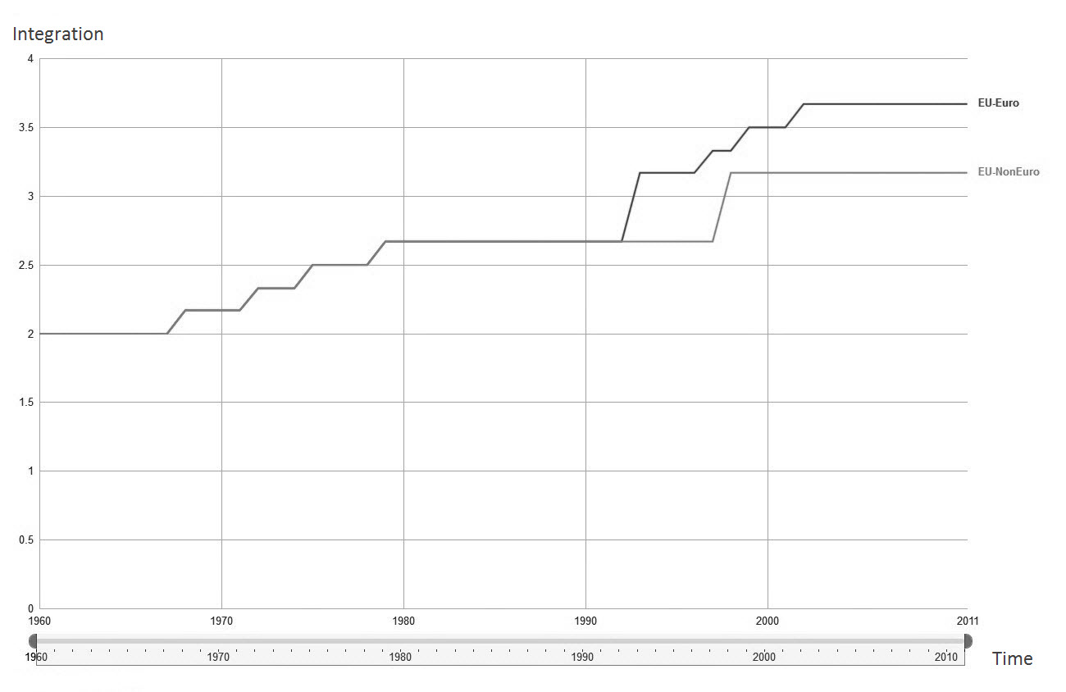

Source: Kugler, Fisunoglu, Yesilada, 2015: 49.

Among the non-Eurozone EU countries, the United Kingdom, Sweden and Denmark prefer nothing more than what one might call a loose confederal system of governance for political union. The UK’s opposition to further deepening of economic and monetary integration is exemplified by its resistance to fuller fiscal union and by its decision not to join the banking union. On the other hand, a larger number of member states are willing to join the Eurozone as full participants. The recent addition of Eastern European nations following the collapse of the Soviet Union in 1989 added Poland, Hungary, Czech Republic, Romania, Bulgaria, Lithuania to the Union. These nations in general are on a waiting list to join the Euro area. With such diverse commitment of members to future of full economic and monetary integration it is debatable if the EU could meet its ambition to be a global actor.

It is fair to say that Britain has always been a dissatisfied partner in the Union, but it has never been as close as it is now to relinquishing its membership. Due to the devastating Euro Crisis, the European member states came to a state where further integration is the only suitable option to prevent any future crisis and save the European Union. For this reason, recently, members under Germany’s leadership have taken concrete steps towards some degree of fiscal union that is short of full fiscal union with a Treasury and EU level income tax. However, for a country, which has not even become a member of the Monetary Union, due to issues of national sovereignty and lack of European ideals, joining the fiscal union would be almost impossible. As a result, Britain’s Prime Minister David Cameron announced the referendum option for British citizens, which stated that they would be able to make the decision whether to stay or leave the European Union. This move clearly annoyed other EU member states that want Britain to make a decision, and refrain from using departing from the EU as a bargaining tool. Under increasing pressure from other big powers in the EU to “play ball” it is conceivable that UK might chose to leave the EU. Most Britons favor UK leaving the EU according to a survey by *Daily Mail* (October 20, 2012). The British politicians are divided over the matter and the *Economist* outlined the benefits and costs of such a move (December 8, 2012). It should be noted, however, that UK’s potential departure would not only affect Britain’s economic and political relations with the EU but would also affect the Union’s aspirations to be a global actor as it competes with other giants on the world scene – namely China, India, and the United States (Yesilada et al. 2006).

However, no one knows exactly what the benefits and challenges would be for Britain and the EU if Britain leaves the EU, or if it stays. We will address this in the Analysis Section of the paper.

## Problems with CSDP

The EU’s CSDP is important for regional integration demonstrating that the Union is not a mere economic enterprise and aims to place Europe as a global power in every respect of that term. As Wolfgang Wessels and Franziska Bopp explain:

The provisions for CFSP and, increasingly also the Common Security and Defence Policy (CSDP), can be regarded as the cornerstone of the Lisbon Treaty. Furthermore, the challenges the Union faces within the international system are ever growing and requiring an ever-increasing scope of action across different policy fields, geographical regions and arenas of policy-making. This makes the policy field a very relevant, although sometimes diffusing research area as three types of foreign interactions intertwine: traditional national foreign policy, the foreign policy of the EU as prescribed in the treaty articles on CFSP and CSDP, and the EC external relations, which concentrate on long-standing and mostly economic foreign relations and development policy.

(Wessels and Bopp 2008:1)

It is beyond the scope of this paper to discuss CDSP’s evolution but it should suffice to say that as a result of the Lisbon Treaty, the CFSP became embedded in a whole range of other EU policies that have implications for external action by member states. The Lisbon Treaty elevated the European Security and Defense Policy (ESDP) to a Common Security and Defense Policy (CSDP, while still being within CFSP) and made it clear that this change indicates a greater willingness by member states to develop a military arm of the EU – yet without a greater push for a more a supranational approach. The reference to partnership with NATO as the foundation of member states’ security policy (for those who are members of NATO) is proof of an intergovernmentalist approach to the CSDP. This is apparent in upholding of Article 17 of the Treaty of the European Union by the Lisbon Treaty (ToL, Art. 28A, par. 2) reasserting “progressive framing of a common Union defense policy will lead to a common defense, when the European Council, acting unanimously, so decides.” It is clear from recent developments that the CFSP needs NATO for territorial defense of the EU. In most, if not all, of its overseas operations the EU relied on the assistance of NATO in one way or another. Thus, the phrase “separable, but not separate” describes the current partnership between the CSDP and NATO. Since the enlargement of NATO and the European Union in 2004 and the accession of Bulgaria and Romania to the European Union in 2007, the organizations have 21 member countries in common (see Figure 2).

Figure 2. Transatlantic and Other Affiliated Countries Overlapping Defense Commitments

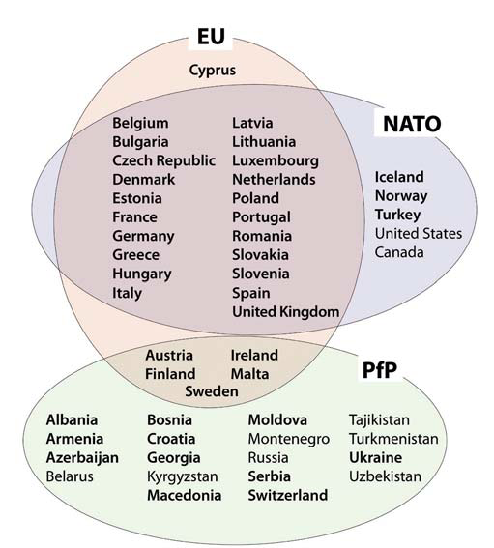

Source: IISS, *European Military Capabilities*, p.3.

It is not surprising that the current partnership framework heavily relies on NATO capabilities, more precisely on the US’s heavy lift aircraft and advanced spy satellites, in advancing the CSDP of the Union. The reliance of the CFSP on the U.S. becomes more clear when one considers the future defense expenditures of these Allies. According to a report by the *Financial Times* (November 17, 2010:9), the EU suffers not only from declining defense expenditures but also from heavy over duplication of its members’ defense infrastructure. Figure 3 shows defense expenditures for the EU and US during 2001-2009.

Figure 3. EU-US Defense Expenditures ($million in 2010 prices)

Source: SIPRI (http://www.sipri.org/databases/).

The observed trend is likely to get worse when one considers planned defense budget cuts among NATO’s leading EU members for reasons related to fiscal austerity following the financial crisis. Since 2008, NATO members have been reducing their defense budgets while Russia has been steadily increasing its defense spending (Jonathan Beale, BBC, February 25, 2015).

Table 1: Military Expenditures

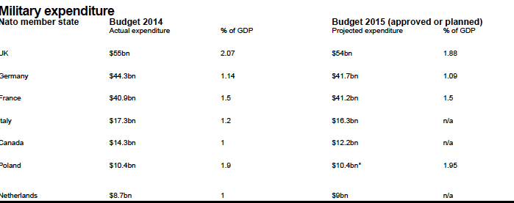

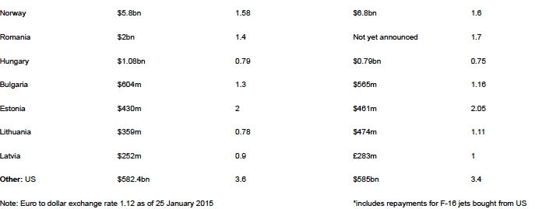

Contrast this with Russia's defense spending, which is rising from 3.4% of its GDP this year to 4.2% in 2016 ($81bn or £52.2bn). Russia is also stepping up its military activities and is actively seeking to draw Turkey away from NATO by signing a lucrative gas agreement with that country’s government. At the same time, Russia signaled that it is a potential source of credit to Greece if this country’s government does not secure a favorable deal from Eurozone finance ministers. One additional example of how Russia is actively undermining EU’s CSDP is the new agreement it signed with Cyprus that grants Russian navy access to Cypriot ports (BBC February 25, 2015). The Cyprus government also acknowledged that the two countries were discussing the possibility of Russia using an air base on Cyprus for humanitarian relief missions. All this happening as Cyprus maintains that it wants to be a full participant in EU-NATO partnership and desires to join NATO!

As if these developments did not create enough challenges for EU’s CSDP, members continue to duplicate their defense industries to such an extent that collective efficiency is nonexistent. A strong intergovernmental approach to the CFSP and CSDP assures that each member state continues to maintain national defense industries rather than determine which country should specialize in manufacturing of which weapons systems. This further complicates integrated defense systems and fails to achieve economies of scale. Currently the EU has 21 naval shipyards compared to 3 in the US, 89 different European weapons programs as opposed to 27 American systems, and Europe has 11 different tank productions while the US has two. Moreover, technological advantage of American defense industries continues to put the US ahead of her European allies. Moreover, the new members of the EU that also joined NATO (former Communist states) continue to present a costly modernization program for these countries’ militaries. Without a fully integrated EU-NATO partnership, and a deeper political union among EU member states, the European side of the Alliance will continue to feel the pressure of falling behind the US and will remain a junior partner. The bottom line is that until EU members formulate an integrated and optimized defense industries, their expenditures in this area will continue to be inefficient and present an obstacle in developing costly systems, i.e., heavy lift capability aircraft, which would reduce Europe’s dependence on the Americans.

## Problems with Turkey and the Russian Challenge

#### Turkey

It can be argued that the EU could significantly bolster its defense capabilities if Turkey were to become a member of the Union. Findings by scholars (Grant 2005, Hughes 2004, Independent Commission 2009, Onis 2008, Tocci 2007, and Yesilada 2012) show that for the EU, having Turkey as a member would make significant contributions to Union’s CFSP and energy security, and contribute to regional stability. It will also go a long way in showcasing to the rest of the world that EU is not a Christian club. These are monumental opportunities that should not be overlooked by officials in Brussels and EU capitols. Yet, shortsighted policies of some of the member states’ governments threaten realization of this historic opportunity.

However, given all the current problems surrounding this topic, how could Transatlantic Allies find a compromise position? In other words, would it be possible or acceptable to bring Turkey into the CSDP prior to full membership in the EU? It is in this area that Turkey, representing a crucial link in the EU-NATO partnership and one which is an important factor in the future development of the Union’s CSDP, can turn the table on those member states opposing its accession. Until recently, Turkish governments carefully balanced their foreign and security policies between their European and NATO Allies (primarily the US). Today, however, this is hardly the case. Since the failed Annan Plan (2004) to reunite Cyprus followed by accession of only the Greek part of that country to the Union and the subsequent election of anti-Turkey governments in France and Germany, relations between EU-Turkey took a turn to the worse.

The alternative scenario of closing the door on Turkey is far more dangerous and unpredictable. It could result in numerous outcomes including one where Turkey stop viewing the EU as a friend and partner, turns its back on Europe and looks to the East and/or South. There are several scenarios hypothesized by observers of EU-Turkey relations that include one where Turks could also look at Russia, and possibly China, as future strategic partners. As Cengiz Aktar noted (Bilefkey 2009) “the West should fear a wounded Turkey turning to Russia. Already, Russia has been courting it as a distribution point for energy supplies, while Turkish investment in Russia is intensifying. . .This government is perfectly capable of saying ‘no thanks’ to Europe and instead shifting toward Russia.” Recent decision by the Turkish government to purchase Chinese anti-missile system that cannot be integrated in to NATO’s defense infrastructure further underscores how far the Erdogan government is willing to push the envelope in reorienting Turkey’s defense strategies. As for AKP’s natural preferences for foreign relations, the global financial crisis had contracted European economies, prompting Turkey, a large exporter, to seek different markets and that leaders of AKP felt more at home in Riyadh, Damascus and Baghdad than in Paris, London or Rome. Indeed, this has been the focus of AKP’s foreign policy during the last several years and has caused serious damage to Turkey’s relations with Israel while raising concerns in Washington.

The immediate impact of post-Annan Plan developments can also be seen in the level of trust affected people held towards the EU (see Figure 4). The figure shows steady and then sharp decline in EU support among these peoples. It is interesting to note that among the Cypriots it is the Greeks who display least favorable view towards the EU. One wonders what this picture would look like today in light of financial bailout terms the EU wants to impose on Greek Cypriot bank depositors. Turkish Cypriots, on the other hand, are more favorable towards the EU, which could be explained as a sign of desperation. Everyday life in north Cyprus is plagued with crime, worsening public services, corruption, and overt Islamization activities imposed upon the Turkish Cypriots by the AKP government in Turkey. Although unhappy with how they were treated by the EU after the Annan Plan, broken promises and all, the Turkish Cypriots see their emancipation only through the EU.

Figure 4: Support for EU Among Cypriots and Turks

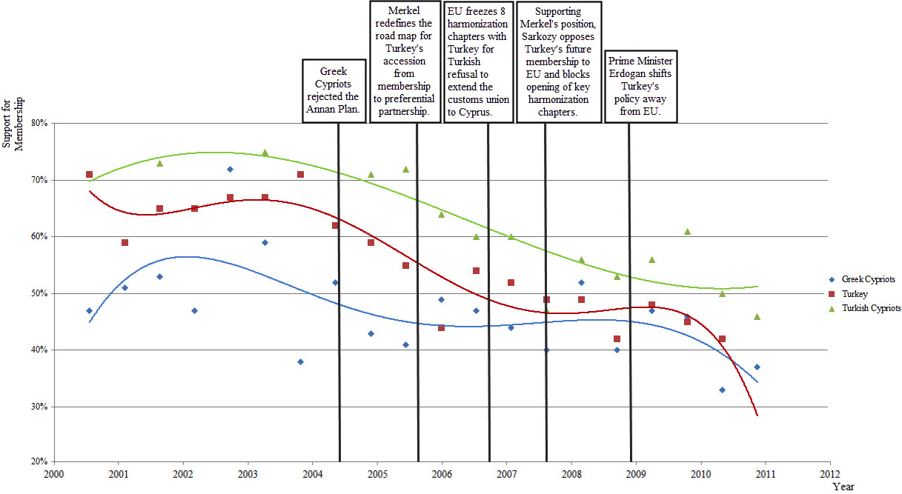

Source: Figures obtained from *Eurobarometer surveys.*

This figure also supports the argument that since 2004 public opinion towards the EU has been on a decline among Turks. Recently, Birol Yesilada (2012) showed a direct relationship between decline in public opinion support for EU in Turkey and Turks’ perception of anti-Turkey EU policies and mistreatment of Turkish Cypriots. To make matters worse, the AKP government seems less than enthusiastic to continue with Copenhagen reforms and Prime Minister Tayyip Erdogan has fueled anti-European public sentiment by equally damaging outbursts. As far as the Turks are concerned, the blame is on the Europeans.

#### Russia

When it comes to EU’s security policies (economic and political), one can argue that Russia is the elephant in the room. While EU-US and Russia disagreements began to emerge as NATO expanded into former Soviet areas, the two sides still continued to cooperate on nuclear agreements and proceeded to discuss a cooperation agreement under President Clinton and President Yeltsin. However, this agreement did not materialize before the first expansion of NATO. About this time, a great opportunity to anchor Russia as a link between West and China was lost and subsequent rise to power of Putin in Russia further added to growing dissatisfaction of this country with NATO’s strategic ambitions.

Russia’s annexation of Crimea and the subsequent bloodshed in eastern Ukraine is the first major conflict at the border of East and West since World War II. In response to the illegal annexation of Crimea and Russia’s aggressive military intervention in eastern Ukraine, the West has imposed heavy economic sanctions on Russia. These developments represent the deepest plunge in U.S.-EU-Russian relations since the Cold War. Western leaders had hoped economic measures would suffice to pressure Kremlin to change its political course in Ukraine. Instead, such policies simply serve to further push Russia into closer relationship with China. Vladimir Putin continues to back separatist forces in Ukraine and signed a 30-year gas agreement with China worth $400 billion (http://www.bloomberg.com/news/articles/2014-11-10/russia-china-add-to-400-billion-gas-deal-with-accord). According to Kugler and Tuzova (2015) the emergent Sino-Russian coalition creates a link between very large military powers that have large populations and growing economies that might by mid-century match or surpass that of G7. Such comprehensive security, economic, and military cooperation between Russia and China weakens any attempts by the West to change Russia’s behavior by economic sanctions. There is a danger that China-Russia interactions will continue to increase, particularly if China perceives a threat from the West. The size of the joint territories, populations, natural resources, and technology will make the alliance of the two countries a major force in world politics.

# Power Transition Analysis of EU’s Future

Power Transition theory provides a useful perspective to analyze how the EU would fair in its global competition with other great powers. The theory is based on A. F. K. Organski’s (1958) pioneering work that describes a hierarchical global system. According to this theory, the distribution of power in the international system is uneven. Power Transition specifies the relative roles of nations within this hierarchy, the system of governing rules, and then outlines how powerful countries attempt to manage global politics. Power Transition paints a picture of world politics that is integrated horizontally and vertically (Tammen 2000, Kugler and Tammen 2012). Additional application of this theory is found in Lemke (2002) who made a major breakthrough moving Power Transition toward a general theory of world politics by demonstrating the applicability of this perspective to regional hierarchies. His careful empirical analysis shows that the same principles that hold at the global level define interactions within regional hierarchies as shown in Figure 5. Members of regional hierarchies interact with each other. Understanding regional hierarchies adds complexity and generality to the Power Transition perspective. Global powers like the US, EU, Russia and soon China can directly intervene to alter outcomes in a region. They are able to interact, of course, but on matters of strategic importance it is a one-way street. There is more reason and opportunity for global powers to intervene in those other regions (Efird et al. 2003; Yesilada et al. 2006). This interferes with the ability of regional powers to operate under the normal rules. Lemke informs us that the rules within regional hierarchies normally match those at the global level but the ability of global powers to intervene does not make this an exact parallel (Lemke 1996, 2002; Lemke and Reed, 1996).

Dynamically, the theory stipulates that political interactions among nations are based on the varying commitment among national elites to the existing institutional *status quo.* This broad acceptance of international rules and norms determines whether a country is satisfied or dissatisfied with its position in the hierarchy and trust that the institutions created advances their interests. The most powerful nations hold a position at the top of the global or regional hierarchy. The dominant nation attempts to manage the regional system with a coalition of stable, satisfied supporters. When agreement is in place, the dominant nation can ease the process of integration. When disagreements emerge among large nations who do not trust the institutions created, integration comes to a standstill or recedes. Power Transitions perspective tells us that currently, the United States is the dominant power in the international power hierarchy. According to the same perspective, at present, the great powers are China, the EU, India, and Russia are also regional powers in their respective geographic regions.

Figure 5: Global and regional hierarchies



*Source:* Kugler, Yeşilada, & Fisunoğlu, “Consequences of Reversing the EU Integration” (2015:7)

According to Power Transition theory, power defines the conditions of war and peace in the international system. Power is defined as the ability to make opponents comply with demands. Power is composed of three elements: population, economic productivity (GDP) and the ability of the political system in extracting resources from society. Population is an essential component of the power equation; however, in order to be relatively powerful, population must be more productive than the rivals. High political capacity is the other requirement to be powerful or developed. Politically capable governments can relatively extract more resources and utilize them for national goals (Kugler and Tammen 2012).

In addition to power and status quo dynamics, power transition theory includes the concept of hierarchal relationships among global and regional powers. An unordered hierarchy is one where most nations hold roughly equal shares of power. This situation presents the most likely conditions for conflict and the least likely conditions for integration. The reason is that nations in uniform hierarchies face few power constraints and are only restrained by the degree of satisfaction with the status quo. In the absence of a regionally dominant country supporting the status quo, competition among two or more contenders is the rule to resolve disputes among parties that vie for control of the region. Thus, conflict is more likely to occur within a uniform hierarchy as each contender with different interests and incentives attempts to impose its influence upon the region. In uniform hierarchies, the larger powers focus on protecting themselves from emerging challengers. In this context even when nations are satisfied with each other, cooperation is less likely.

Asymmetric hierarchies are characterized by power concentrated in the hands of a dominant global or regional power that establishes and supports the status quo. In structural environments where the dominant nation is at least twenty percent stronger than any contender, the hierarchy is deemed ordered (Organski and Kugler 1980). The dominant nation can spend more of its resources ensuring the best support possible for the economic and political terms established in the status quo. In an asymmetric environment, war may still be waged, but it is less likely and will result in relatively low casualties – as is the case in the ongoing “war against terrorism”.

Efird (2001) and Efird, and Genna (2002) and Efird et.al. (2003) extended the theory and argued that the development of regional integration after a power transition between two satisfied powers improves because the formerly less powerful country has a vital interest in not only maintaining but also furthering and institutionalizing the arrangements that it believes to have contributed to its rise. Efird and Genna’s statistical test provides strong support for their hypothesis. Efird (2001) expanded in Efird et.al. (2003) argued that the following relationship captures the dynamics preceding conflict and cooperation in the international system:



Where;

CI = Conflict = Integration;

RP = Relative Power;

S = Status Quo;

Hc = Hierarchy of Challenger; and

HD = Hierarchy of Defender

Assumptions behind this model can be found in various works and are summarized in Yesilada, Efird, and Noordijk (2006). First, when relative power is at parity, the severity of conflict is maximized because both sides anticipate an equal probability of success. Formal work on the median voter theory indicates that this insight is consistent with rational expectations. Indeed, as Black anticipated, when two candidates with opposing points of view enter an election they will attempt to reach the median first-- assuring them of victory. Contested elections are those where the outcome is unclear – i.e. the last two Presidential elections in the US. Moreover, when parity is approached and policy differences are fundamental, tempers flare and electoral conflicts escalate to direct confrontations. The same process takes place in world politics. When nations are satisfied with international norms (S>0) the cubed RP term shifts the highest propensity for conflict past the parity point. Thus, greater asymmetry improves the likelihood of cooperation assuming that the dyad is at least somewhat jointly satisfied, especially when dyads are highly asymmetric. Further, Organski and Kugler (1980:59) found that the dissatisfied challenger initiates conflict in the post-transition period pointing to a cubed RP term. Such results proved again to be consistent with later formal proofs. Kugler and Zagare (1986), Bueno de Mesquita and Lalman (1992), Alsharabati (1997) show game theoretically that the defender does not preempt at preponderance because it values the *status quo* and prefers to postpone action. On the other hand, the dissatisfied challenger is willing to wage war since the highest likelihood of success is anticipated after the transition point.

Operationalization of this model’s variables is based on estimation of following indicators (Tanrikulu 2013). Relative power is the capacity of one nation to influence another either by persuasion or by force. The more relatively powerful a nation is, the more capable it is to impose its preferences on the others in its hierarchy. In this model GDP at purchasing power parity (with 2005 US Dollars) will be used to measure power. Since it is intended to run a simulation with the model until 2050, GDP data is taken from International Futures version 6.69. In trying to determine how influential the UK can be against German leadership, relative power is going to be taken as follows:

*RP=*



The closer the level of GDP of the challenger to the dominant power, the less orderliness there is in that hierarchy. Therefore, the higher the level of UK’s GDP relative to Germany’s, the lower the level of orderliness will be in the European hierarchy. This situation is captured by the formula because an increase in RP will be reflected as an increase in the conflict-integration score, meaning a higher probability of conflict. When Germany’s GDP level increases more than the UK’s GDP, RP will start to get smaller and decrease the probability of conflict on the conflict- integration continuum.

The satisfaction variable represented with ‘S’ in the formula defines whether the RP will create conflict or not. As it is mentioned before, two Eurobarometer questions related to ‘trust’ and ‘membership’ are going to be used to account for the level of satisfaction with the status quo. The survey question data related to ‘trust’ and ‘membership’ are in percentages. To be able to use these data in the conflict- integration formula, it is rescaled between -1 to 1. As a result, percentages between 50 to 0 are rescaled between 0 to -1, and percentages between 50 to 100 are rescaled between 0 to -1. When the level of satisfaction is below 50%, it is going to be transformed into a negative number representing dissatisfaction between 0 and -1, and due to the negative sign before the ‘S’ variable in the formula, the dissatisfaction level will cause an increase on the continuum representing an increase in the level of conflict. If the level of satisfaction is higher than 50%, rescaling the number will transform it into a positive number between 0 to 1, and due to the negative sign before the ‘S’ variable in the formula, the model will perceive it as an increasing level of cooperation/ integration.

The data of the question related to ‘trust’ is adjusted to be able to use in the conflict- integration model. It should be noted that data of the question related to trust between 1999 and 1993 is missing. This missing period is interpolated to be able to use in the formula. Furthermore, data on the first question ‘trust’ does not go back to 1973 like the data of the second question regarding ‘membership’. Therefore, the ‘trust’ data is extrapolated from 1993 to 1973, which is the date when the UK became a member of the Union.

The trust variable captures the level of satisfaction with the status quo better than the alliance portfolios. In classic Power Transitions analysis, the similarity of alliance portfolios have been used to measure the level of satisfaction with the status quo. The similarity of alliance portfolios is calculated via dyadic relationships. It is inferred that “dyads with similar portfolios are satisfied with each other’s view of the international system or dyadic relationship, and those with dissimilar portfolios are regarded as less satisfied with each other” (Efird, Kugler, & Genna, 2003, p. 297). However, this measurement comes with two fundamental problems in terms of what this paper assesses. First, similarity of alliance portfolios does not directly account for the status quo. Second, dyadic relationship does not capture the behavior or interaction of multiple countries. Encapsulating multiple countries functioning is significant especially when there is a certain level of integration between multiple countries. When countries go into integration, the rules and guidelines of the integration become the status quo. In this situation, to be able to account satisfaction, one should directly focus on integration instead of dyadic alliance similarities. Therefore, directly representing the European integration, trust and membership variables capture the level of satisfaction with the status quo.

The cubed RP term in the formula captures the propensity for conflict in Power Transitions. If the RP term in the interactive part of the equation were linear, each unit increase of RP would cause equal increases on the conflict- integration continuum. If RP were squared, it would not reflect the likelihood of conflict at parity points. Since *RP=PowerChallenger/PowerDominant*, the formula should reflect the probability of conflict once the relative power of the challenger increases in terms of the dominant power. It is anticipated that the likelihood of conflict peaks when the challenger and the dominant power are in parity. For this reason, squaring RP would underemphasize the amount of conflict. However, cubing RP gives the highest propensity for conflict right after the challenger passes the parity point with the defender. Additionally, the cubed RP also reflects the higher probability of cooperation when the asymmetry between the dominant power and the challenger increases (Efird et al., 2003).

HD and HC reflect the relative power of the dominant power in terms of all the contenders in the region. The calculations of these variables are as follows:

*HD =*



*HC =*



When the power of the dominant country decreases compared to the contenders in the hierarchy, the total of HC and HD increases to reflect the increasing propensity for conflict. When the powers of the contenders increase compared to the dominant power, HC’s increase will be more than HD’s decrease to reflect higher propensity for conflict. The model will first take the regional contenders as UK, France, Italy, Spain and Poland.

## Analysis

Given the growing power of China in world affairs and its implications for global power transition (Kugler and Tammen 2005, Tammen at. all. 2005), we looked at how different scenarios of EU integration/disintegration would affect global power transition and its impact on EU’s competitiveness in the international system. Figure 6 compares how a fully integrated EU fairs in global competition with other great powers. Results, which are updates of previous calculations (Kugler, Yesilada, Fisunoglu 2015), are sobering. Both Western powers (EU and US) will be overtaken by China and India as the dominant economies in the world. By the end of the 21st century the EU and its likely ally the US are expected to have half the economic power of China and India, and one-third the size of their respective populations.

Figure 6: The timeline of USA, EU, China, and India, 1960-2100.

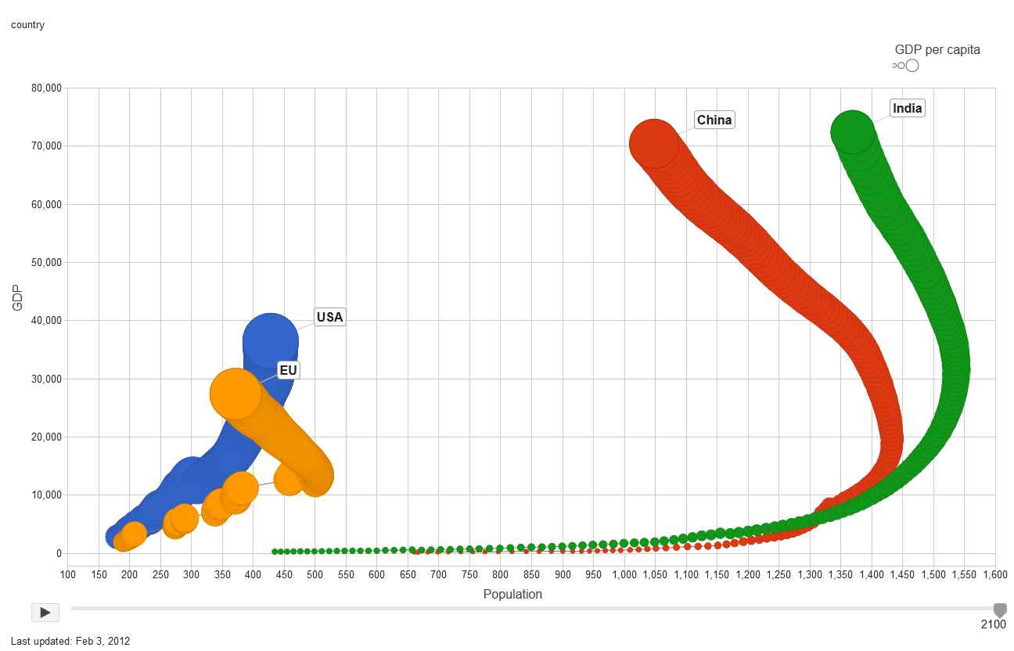

China or India alone will have the overall capabilities of the United States and the current EU. These Asian giants will no doubt dominate global affairs in the next century. For this reason an expansion of the EU and the recreation of an Atlantic alliance are central if the western nations are to play a principal role in the next Century.

Figure 7 shows the regional consequences of a more integrated Eurozone led by Germany that excludes large free riders like the UK, compared with the European Union and an enlarged European Union that includes Turkey. The United States is added to provide a size comparison This four dimensional graph presents total output to assess the size of the society in y-axis and population to assess the future potential of the society in x-axis. The size of the bubble is the GDP per capita to approximate the productivity of the population. Lastly, the time dimension is embedded through the ﬂow of bubbles. The initial bubbles, which start near the origin, stand for the year 1960, and the outermost bubbles, where the labels are attached, stand for the year 2100. Each bubble in-between represents a year from 1960 to 2100. Bubbles linked by lines indicate EU expansions.

Figure 7: USA, European Union (with or without Turkey), and Eurozone, 1960–2100

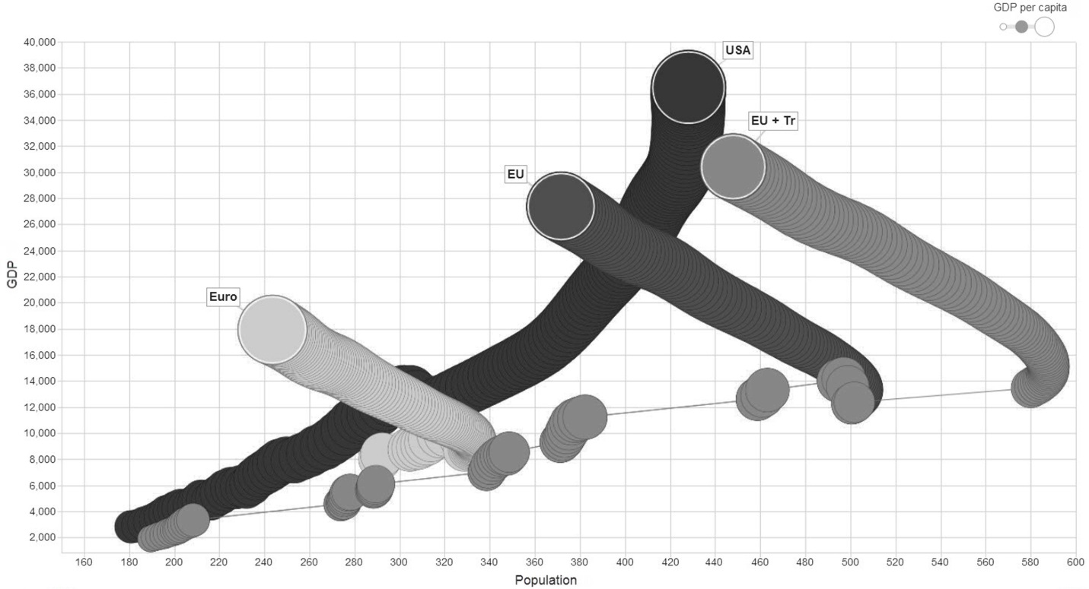

Results indicate that a smaller Eurozone could become more of a federation but at the expense of reducing much of the population and power capability of the current Euro-pean Union. While not inconsequential, this unit would represent about half of the power of the United States and less than half its population. The current European Union would be closer to 75% of the United States. This situation points out a classic Catch-22. A smaller Euro group would be cohesive, but would have far less capacity to incorporate other large members and would be less powerful at the global level. A more intergovernmental European Union that reverts back to a Single Market could attract more new potential large members. Yet, with reduced trust, it would be less powerful at the global level for lack of cohesiveness.

We next looked at the consequences of reversing EU integration with two scenarios – one with Britain leaving and another where Germany leaves the Union. Figures 8 and 9 provide results for these simulations. In the case of German withdrawal from the Eurozone, this country will become a minor player on the world scene (Figure 8).

Figure 8: The timeline of Germany, USA, China, and India, 1960-2100.

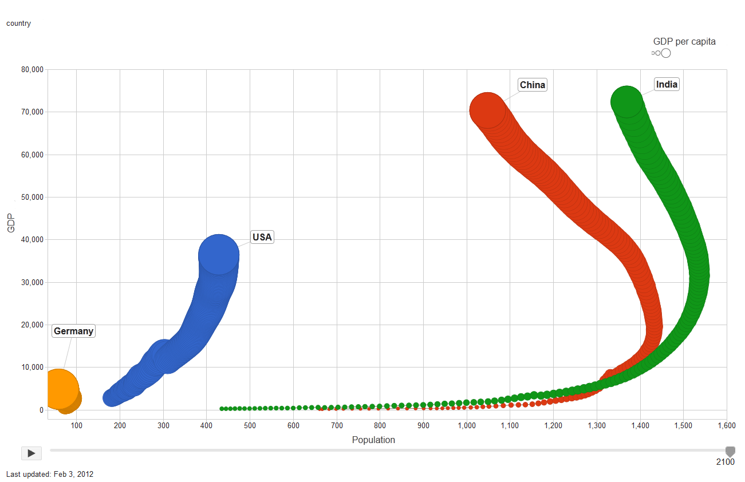

As for the UK, the results are very similar to those of Germany. If Britain withdraws from the EU, it will be a minor player on the world stage (Figure 9). Results clearly indicate that the UK would lose its economic and political power in the global system if it departs from the EU. As a single country, it is not possible for the UK to keep up with the rising Asian powers: China and India. The deeper the level of integration with the EU, the higher the UK’s level of influence will be in the international system.

Figure 9: Forecasting UK’s departure from the EU, 1960 – 2100

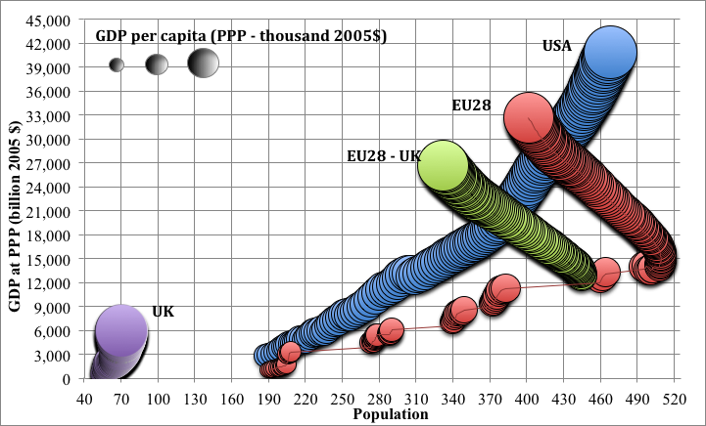

For the EU, the benefit of having a powerful member is smaller than the costs it brings. If Britain leaves the EU, this would be a serious loss in terms of its level of capability. However, the debt crisis showed that commitment to the integration is more important than the level of GDP to sustain the Union as a global actor. The EU has to avoid any conflict directed to the integration process coming from the members. Otherwise, the Union would lose its coherence and become a weaker actor in the international arena. If Britain is going to stay in the EU, it is significant that it has the European vision for integration. Including Britain into further level of integration without enough commitment for the Union would jeopardize the integration process. If the UK is included in further level of integration without enough commitment, the propensity of conflict will be higher. To avoid further conflict, a two-tract formulation can be formulated. Thus Britain and similar countries can take that track, which is a lower level of integration, until they have the vision for further integration (Tanrikulu 2013).

The future of both the UK and the EU is bound to their ability to compromise and cooperate. Realizing its own capacity and the future power transitions in the global arena should make the UK appreciate its EU membership. On the other hand, the EU should work for methods that will increase the coherence of the member states. Mechanisms that will keep the less commitment members apart will save the speed and the development of the integration process. The highest level of utility in the long run can only come with higher level of cooperation.

As if these internal challenges of the EU were not enough, Russia now represents a serious problem for Transatlantic Allies. Events in Ukraine destroyed any hope of erasing mistrust between NATO and Russia that emerged after expansion of the Atlantic Alliance to former Soviet republics of Central and Eastern Europe. Moreover, increasing economic sanctions are likely to cause serious problems for the Russian economy and this, in turn, will fuel more anti-Western sentiment among the Russians. There is no doubt that Putin’s actions have isolated his country from the developed world and he has increasingly turned toward China for economic agreements to offset the impact of Western sanctions. There is no realistic option available for Putin to challenge the West on his own as shown by data in Figure 10. Prospects for the Russian economic power are grim, as it will lose ground to other regional powers. In a serious way, Russia is increasingly becoming dependent on China and given the fact that both of these countries’ leaders are dissatisfied with the status quo international regimes they are likely to form a Sino-Russian coalition to challenge the Transatlantic Allies.

Figure 10: Future growth of the Russian economy relative to major powers

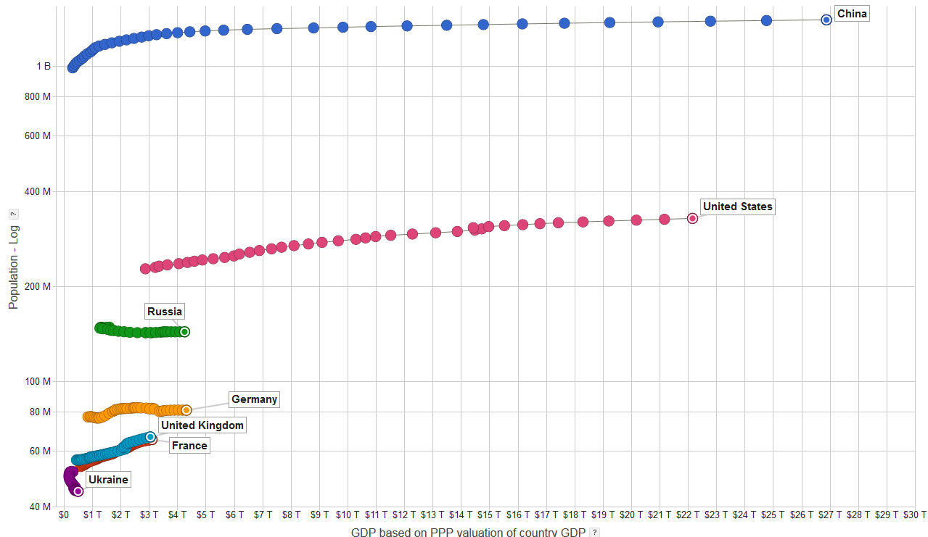

*Source: Jacek Kugler and Yelena Tuzova (2015).*

We next applied conflict=cooperation estimation of Efird, Genna, and Kugler (2003) to UK-EU and Transatlantic (EU+US) – China dyads to show prospects for future relations between these countries. Figures 11 and 12 show results of these relationships.

Figure 11: Forecasting Conflict-Cooperation, EU & US-China, 2000-2050

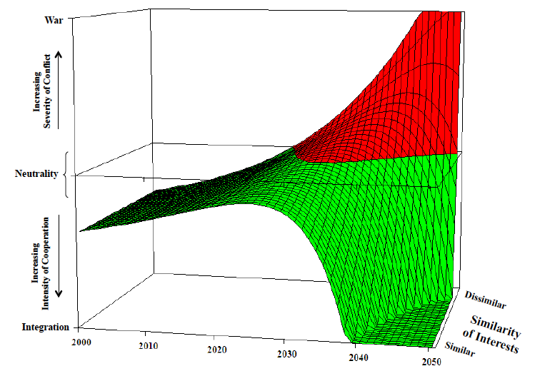

Figure 11: Forecasting the probability of conflict between the UK and the EU

These results show that in case of Transatlantic-China relations, probability of conflict increases in line with rising power of China that was shown and discussed above. A dissatisfied China is likely to confront current dominant powers as parity is reached by mid-century. In this competition, China is likely to look for additional allies, like dissatisfied Russia, to further increase its capacity to challenge the Western alliance.

With regard to internal EU relations, the UK is currently in no position to challenge the other countries until it reaches parity with Germany by 2030 – give or take a few years. If UK’s dissatisfaction persists during this period, then we observe a gradual increase in probability of conflict (gradually intensifying with each passing year) beginning around 2035. This rising propensity of conflict is a serious threat on the European integration process and should be of concern for current EU leadership as they debate future of the Union.

# Conclusions and Prospects

This analysis shows that implications of problems facing EU integration are far more complex than finding a quick fix to its current financial crisis. Failure to achieve a realistic fiscal union (political union) has serious implications for EU members to fulfill their obligations in another policy domain – namely CSDP. Recent slowdown in EU integration not only adds to regional problems, but it also has serious consequences for the economic stability of the international system. Moreover, the slowdown in integration that previously reduced tensions within the European region could reset the stage not only for regional confrontations but also to increase the likelihood of a global conflict. Missed opportunities with Russia and Turkey have set in motion developments that could seriously alter the balance of power at the systemic level that could only benefit China.

Regionally and globally the EU cannot afford to move from the cooperative contest to a confrontational one, i.e. the UK breaking away or Germany dropping out of the Eurozone, where solutions are arrived at by force rather than reason. EU leaders need to resolve the current crisis in the EMU, build upon it to reinvigorate the integration process and provide a path for complete regional integration that includes a real political union. The alternative scenarios of member states reverting back to pre-Maastricht or pre-Single European Act years are simply non-starters for the future of a stable European Union and global peace.

# References

Alsharabati, C. (1997) *Dynamics of War Initiation* unpublished Doctoral Dissertation, Claremont Graduate University.

Bilefsky, D. (2009) “Angers of Rejecting Turkey,” *New York Times,* October 27.

Black, D., (1948). On the Rationale of Group Decision Making, *Econometrica* 16 245-261.

Bueno de Mesquita, B, and D. Lalman. (1992). *War and Reason,* Yale University Press.

*Daily Mail* (October 20, 2012). “Most Voters Want Britain to Leave EU: Support for Pulling Out at Highest Level for 30 Years”. http://www.dailymail.co.uk/news/article-2220778/Most-voters-want-Britain-leave-EU-Support-pulling-highest-level-30-years.html

De Grauwe, P. (2009). Some thoughts on Monetary and Political Union. In *The Future of the EMU,* edited by Leila Simona Talani. London and New York: Palgrave Macmillan.

Efird, B. (2001). *From Conflict to Integration: A Generalized Power Transition Dynamic.* Ph.D. Dissertation: School of Politics and Economics, Claremont Graduate University.

Efird, B., and G. Genna. 2002. Structural Conditions and the Propensity for Regional Integration. *European Union Politics* 3(3).

Efird, B., G. Genna, and J. Kugler. (2003) “From War to Integration: Generalizing the Dynamic of Power Transitions.” *International Interactions* 29(4):293–314.

Genna, G. (2002). *Changing Power, Sovereignty, and Loyalty in the European Union.* Ph.D. Dissertation, Claremont Graduate University.

Genna, G., and T. Hiroi (2004). Power Preponderance and Domestic Politics: Explaining Regional Economic Integration in Latin America and the Caribbean: 1960–1997. *International Interactions,* 30(1): 143–165.

Grant, C. (2005) “Turkey offers EU more punch,” *Center for European Reform Comment and Analysis,* (Published by European Voice, September, 1-7).

Hughes, E. (2011). *Turkey’s Accession to the European Union: The politics of exclusion?* London: Routledge.

Hughes, K. (2004) *Turkey and the European Union: Just Another Enlargement?* Brussels: Friends of Europe.

Independent Commission on Turkey (2009) *Turkey in Europe: Breaking the vicious circle,* Open Society Foundation and the British Consul.

Kugler, J. and Y. Tuzova (2015). “Implications of Demographic, Economic, and Political Shifts in Eurasia.” Paper presented at the 2015 Annual Conference of the *International Studies Association* in New Orleans, February 18-21.

Kugler, J. A. Fisunoglu and B. Yesilada (2015). “Consequences of Reversing the European Union Integration” *Foreign Policy Analysis* 11: 45-67.

Kugler, J. and R. Tammen eds. (2012). *The Performance of Nations.* Boulder: Rowman and Littlefield.

Kugler, J., R. Tammen & Efird, B. (2004). Integrating Theory and Policy: Global Implications of the War in Iraq. *International Studies Review*, *6*(4), 163–179.

Tammen, R. and J. Kugler. (2005). “China: Satisfied Or Dissatisfied: The Strategic Equation.” Paper presented at the *Annual Conference of the International Studies Association* in Honolulu, Hawaii. March 1-4.

Kugler, J. and F. Zagare (1986) *Exploring the Stability of Deterrence,* Colorado: Westview Press

Lemke, D. (2002). *Regions of War and Peace*. Cambridge: Cambridge University Press.

Lemke, D., and W. Reed (1996) Regime Type and Status Quo Evaluations: Power Transitions the Democratic Peace Proposition. *International Interactions* 22:143–164.

Organski, A.F.K. (1958) *World Politics*, New York: Alfred A. Knop.

Organski, A.F. K. and Kugler, J. (1980) *The War Ledger*. Chicago: University of Chicago Press.

Öniş, Z. (2008) “Turkey-EU Relations: Beyond the Current Stalemate,” *Insight Turkey,* vol. 10, 35-50.

Riker, W. (1964). *Federalism: Origin, Operation, Significance.* Boston: Little, Brown.

Tammen, R., et al. (2000) *Power Transitions: Strategic Policies for the 21st Century*. New York: Chatham House.

Tanrikulu, O. (2013) *A Dissatisfied Partner: A Conflict-Integration Analysis of Britain’s Membership in the European Union.* Masters thesis. Portland State University.

Tocci, N. (2007) *The EU and Conflict Resolution: Promoting Peace in the Backyard,* London and New York: Routledge.

Wessels, W. and Boop, F. (2008) “The Institutional Architecture of CFSP After the Lisbon Treaty,” Research Paper No. 10. Brussels: Center for European Policy Studies. <http://www.ceps.eu>.

Yesilada, B. (2012) *EU-Turkey Relations in the 21st Century.* London: Routledge.

Yesilada, B. and D. Wood (2010. *The Emerging European Union.* 5th edition. New York: Longman.

Yesilada, B., B. Efird, and P. Noordijk (2006). “Competition among Giants: A Look at How Future Enlargement of the European Union Could Affect Global Power Transition,” *International Studies Review* Vol. 8, no. 4 (December 2006):607-622.

1. For a detailed discussion of this crisis see proceedings of the conference on *Redefining European Economic Governance*  in College of Europe, Bruges March 1, 2012.