The European Council as a crisis driven ‘gouvernement économique’

by Wolfgang Wessels
Jean Monnet Chair
University of Cologne
w.wessels@uni-koeln.de

Paper for the 14th EUSA Conference, Boston
Friday 18 March 2015, 1:45-3:15 p.m.

Please do not quote without the author’s permission

Based on a preliminary version of the chapter
“Economic Governance: Towards a ‘gouvernement économique’?”
In: Wessels, W. (forthcoming 2015):
The European Council
Houndsmill: Palgrave Macmillian.

Prepared within the framework of the project:
„EU-GLOBAL: Transatlantic Perspectives in a Changing Global Context:
Multilateralism Through Regionalism”
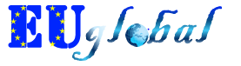
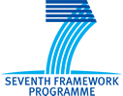

The European Commission support for the production of this publication does not constitute an endorsement of the contents which reflects the views only of the authors, and the Commission cannot be held responsible for any use which may be made of the information contained therein.

Content
Economic Governance: Crisis driven and institutional 3
The European Council as constitutional architect 5
Managing the Economic and Financial Crisis: A Reinforced Leadership Role 8
At the Institutional Centre of the Multi-Pillar Architecture: Treaty Rules and Actual Practices 12
Conclusion: Towards a Crisis-Driven ‘Gouvernement Économique’ 15

Economic Governance: Crisis driven and institutional
High on the agenda of the European Council as the key institution within the EU’s architecture are issues of economic governance. The various policies that form part of economic governance – monetary, fiscal, and other economic and social policies – are usually regarded as the most important or at least the most often discussed areas of the European Council’s policy-making (see for example Van Rompuy 2010). Following their problem-solving instinct, since the 1970s, the Union’s political leaders have regularly and extensively used the European Council to cope with economic challenges that the European states were faced with.
The performance and profile of the European Council in this area is difficult to capture. The term ’economic governance’, used by the European Council itself (for example March 2011), is only useful for a first general orientation as this policy field is characterised by a confusing array of institutions, processes, mechanisms and instruments (Begg 2011: 337-339). To consider the European Council’s performance in the economic realm, this paper takes a closer look at the institution’s activities as constitutional architect, at its leadership-role as crisis manager and at its institutional position in the centre of the multi-pillar architecture.

Figure 1 The European Council and Economic Governance: Five Pillars
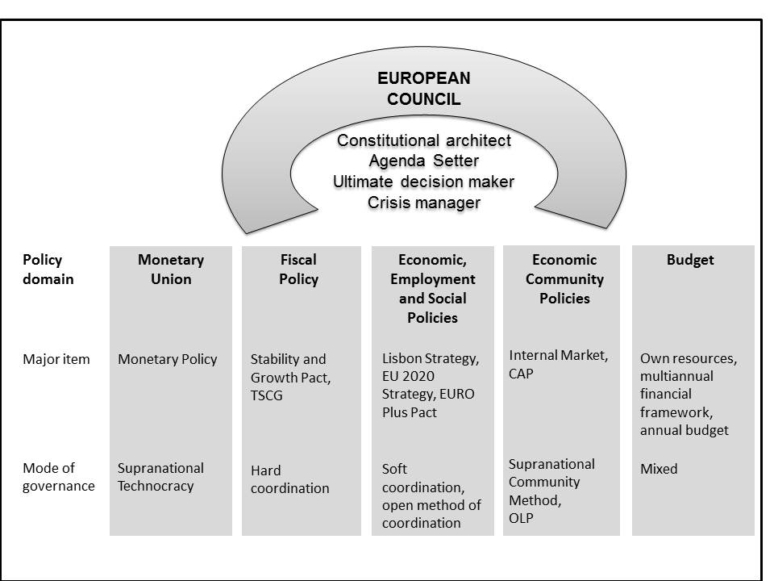
Source: Compiled by the author (see also Wessels/Linsenmann 2002: 66-70).

This paper studies one of the most significant activities of the European Council for economic governance, namely as a ‘constitutional architect’. The Heads of State or Government have initiated, framed and agreed on major steps shaping ‘exclusive competences for monetary policy’ at EU level for the eurozone countries (Art.3 TFEU).
Second, complementing these history-making agreements, the EU’s executive leaders have pursued a leadership role in managing the EURO crisis. In the crisis years, they adopted the ‘Treaty for Stability, Coordination and Governance’ (TSCG), better known for its main element, the ‘fiscal compact’ (Euro Summit March 2012).
As the (Presidency) Conclusions indicate (see Figure 13.2), the Heads of State or Government have regularly, albeit to varying degrees, dealt with all of the pillars. One year which saw significant output from the European Council is the year 2000, when the European Council formulated a comprehensive and wide-ranging list of positions in the field of economic governance. This output can be explained as a direct consequence of the start of Economic and Monetary Union (EMU).

Figure 2 Summits and the European Council: Statements on Economic Governance, 1969-2012
Source: Compiled by the author.

This paper also discusses the general role of the European Council as an emerging ‘gouvernement économique’ (Gillissen 2011: 112-114; Jabko 2011: 10-13; Commissariat Général du Plan 1999: 188) which documents a fusion of both national and EU agendas (vertical fusion) as well as a more elaborate institutional architecture (horizontal fusion).

The European Council as constitutional architect
The creation of the Economic and Monetary Union (EMU) is generally acknowledged as one of the most outstanding accomplishments of the European Council, underlining its role as constitutional architect Over several generations, its members have concluded history-making agreements on the creation and subsequent reforms of EMU
Table 1 Summits and the European Council: Main Agreements on the EMU 1969-2007
Year and Place | Topic
December 1969  The Hague | Plan for an EMU
December 1978  Brussels | Creation of the European Monetary System (EMS)
June 1986  The Hague | Single European Act: Area without internal frontiers
June 1988  Hannover | Delors committee to propose concrete stages leading towards EMU
December 1991  Maastricht | Treaty provisions for EMU
December 1995  Madrid | Decision on the use of the name ‘Euro’ and on the European Employment Strategy.
June 1997  Amsterdam and  December 1997  Luxembourg | Conclusion of the Stability and Growth Pact and the provisions for the employment chapter of the Amsterdam Treaty  Special summit on employment and the creation of the informal Eurogroup
March 2000  Lisbon | Special summit adopting the Lisbon Strategy: ‘the transition to a competitive, dynamic and knowledge-based economy’
March 2005  Brussels | Revision of the Stability and Growth Pact
October 2007  Lisbon | Agreement on Lisbon Treaty, involving minimal changes to the provisions on the EMU
Source: Compiled by the author. Adapted from Kunstein/Wessels (2011: 309-310); see also Appendix I. For a follow-up from 2010 onwards see Table 2.

Already at the early summits, the Heads of State or Government agreed on significant objectives relating to EMU. At the The Hague conference in 1969 the national leaders of the then six Members States declared, that ‘a plan in stages will be worked out during 1970 with a view to the creation of an economic and monetary union’ as part of their strategy to deepen European integration (The Hague, December 1969). This summit initiative and the subsequent Werner report, undertaken by the then Prime Minister of Luxembourg following a mandate from the Heads of State or Government, became victims of the collapse of the Bretton Woods regime, which precipitated major currency turbulences among the Member States of the Community. Reacting to these monetary disturbances, French President Giscard d’Estaing and German Chancellor Schmidt with some support from Commission President Jenkins, in 1978 convinced other members of the European Council to agree on the creation of the European Monetary System (EMS) (see Ludlow 1982). Their initiative was a significant step towards system-making, as this arrangement served as a precursor to EMU
The subsequent ‘generation of 1989’, in particular French President Mitterrand and German Chancellor Kohl, together with the Commission President Delors, prepared and concluded several treaty revisions. In an initial step they supported proposals from the European Commission to achieve a ‘Europe without frontiers’ (The Hague, June 1986). Agreeing on the Single European Act (SEA), which came into force in 1987, the Heads of State or Government revised and reinforced treaty provisions in order to achieve the internal market by 1992. Through this first major revision of the Rome Treaty, they confirmed and extended a set of rules for the EU’s economic constitution.
In a second step following the SEA, the European Council re-launched plans for EMU: It installed the ‘Delors Committee’ in which, under the chairmanship of the President of the Commission, national central bankers were given the task of ‘studying and proposing concrete stages leading towards this union’ (Hannover, June 1988). After the upheaval caused by the end of the European post-war order in 1989, and in light of German unification, the ‘generation of 1989’ adopted an agreement on far-reaching provisions for the Monetary Union and some less binding rules for the Economic Union at the Maastricht summit (December 1991). Pushed by different economic interests and considerable (geo-)political pressures, national leaders agreed on a far-reaching and history-making set of decisions.
Exercising its power to conclude institutional adaptations or arrangements within the framework of the treaties the European Council also created the Eurogroup (Luxembourg, December 1997), an informal body which the member states later formalised in Protocol No. 14 attached to the Lisbon TEU and TFEU. Interpreting the ambiguous provisions of the Maastricht Treaty in that area, the European Council also formulated guidelines on the external representation of the Community and the eurozone (Vienna, December 1998). As some kind of social counterweight to the treaty provisions for monetary and economic integration, the Heads of State or Government (June 1997) also inserted an ‘employment title’ into the Amsterdam Treaty (Art.128 TEC).
Following the entry into force of EMU in 1999 and during the constitutional decade, the Heads of State or Government revised the provisions for EMU only to a limited degree (Umbach/Wessels 2008: 55-57). When negotiating the ‘Constitutional Treaty’ and later the Lisbon TFEU they did not want to re-open the package they had laboriously agreed upon in the Maastricht Treaty. In hindsight, they missed an opportunity to prepare the EMU architecture in order to adequately manage the eurozone crisis that fully erupted in 2010.
In reacting to the crisis after 2008, the European Council intensified again its work as constitutional architect.

Managing the Economic and Financial Crisis: A Reinforced Leadership Role
Besides pursuing a broad set of regular activities the European Council acted as crisis manager on several occasions. Facing the financial and economic shocks from 2008 onwards and the subsequent sovereign debt turbulences that erupted in 2010, this role has become one of the main features of the institution’s profile. In the crisis years, ‘[s]afeguarding the Eurozone’s financial stability was […] the overriding objective’ (Van Rompuy 2012a: 6). Via the European Council, the EU’s national leaders showed a high degree of personal involvement to tackle the crisis through coordinated activities. The European Council and increasingly the Euro Summit met with unprecedented frequency (see Table 2). These summits at the highest level served its members – often also including the President of the European Central Bank (ECB) – as the key arena in which reactions to the dramatic turbulence and serious challenges that were unravelling throughout the continent could be developed.
In some sessions, the chief national executives were under extreme pressure from external shocks which necessitated rapid responses. Late at night or even in the early morning, the Heads of State or Government concluded agreements which have deep and long lasting effects on national economies. As an unintended consequence of earlier acts of treaty-making, members of the European Council were forced to take decisions reaching, both in scope and depth, far beyond the conventional concepts and doctrines of European economic policies before the crisis They re-interpreted existing treaty articles and adopted further legal texts that have significant influence on the fiscal sovereignty of EU Member States. The European Council strengthened the economic pillar of EMU to achieve a new quality of policy coordination and reinforced the stability mechanisms of the eurozone using strict budgetary rules for national economies (see Van Rompuy 2012a: 5-9). Driven by events in the markets and by expectations from international partners such as the US President, the Union’s executive leaders agreed on an amendment to the Lisbon TFEU and on two additional treaties outside of the EU legal framework among other steps
.

Table 2 The European Council and Economic Government: Main Agreements in the Eurozone Crisis, 2008-2013
Date | Institutional Form | Main Results
11 February 2010 | Informal European Council | Declaration on Greece.
25 March 2010 | Euro Summit | Agreement to contribute to coordinated bilateral loans. Request to President of the European Council to establish Task Force on Economic Governance.
25-26 March 2010 | European Council | Agreement on EU 2020 headline targets. Request to President of the European Council to establish Task Force on Economic Governance.
7 May 2010 | Euro Summit | Announcement of European stabilization mechanism.
17 June 2010 | European Council | Adoption of Europe 2020 strategy.
16 September 2010 | European Council | ---
28-29 October 2010 | European Council | Endorsement of Task Force on economic governance report. Agreement on need to establish permanent rescue mechanism through limited treaty change.
16-17 December 2010 | European Council | Agreement on amending Article 136 TFEU to allow for the establishment of a permanent European Stability Mechanism for the euro area.
4 February 2011 | European Council | ---
11 March 2011 | European Council | ---
11 March 2011 | Euro Summit | Endorsement of ‘Pact for the Euro’ and decision to increase lending capacity of EFSF.
24-25 March 2011 | European Council | Adoption of a ‘comprehensive package of measures’ as a response to the financial crises. Endorsement of Euro Plus Pact. Agreement on establishment of the ESM and the respective treaty changes.
23-24 June 2011 | European Council | Agreement on the European Stability Mechanism Treaty and on the amendment to the EFSF.
21 July 2011 | Euro Summit | Agreement on second package for Greece involving the private sector. Pledge to bring public deficits in all non-programme countries below 3% by 2013 at the latest.
23 October 2011 | European Council | Identification of key priorities for internal economic governance and internal and external aspects of economic policy; Preparation of G20 summit
26 October 2011 | Informal European Council | Consensus on banking package.
23-26 October 2011 | Euro Summit | Agreement to leverage the resources of the EFSF and to impose a 50% haircut for private investors in Greek bonds. Adoption of ten measures to improve the governance of the euro area.
8-9. December 2011 | European Council and Euro Summit | Agreement to establish fiscal compact. Adoption of adjustments to the ESM treaty and acceleration of its entering into force.
30 January 2012 | Informal meeting of Members of the European Council and the Euro Area | Finalization of the Treaty on Stability, Coordination and Governance (TSCG).
1-2 March 2012 | European Council and Euro Summit | Signing of Treaty on Stability, Coordination and Governance (TSCG)
23 May 2012 | Informal European Council | Discussion of growth strategy, the euro area and Greece
28-29 June 2012 | European Council and Euro Summit | Compact for Growth and Jobs; endorsement of country-specific recommendations to guide Member States’ policies and budgets; Presentation of report ‘Towards a Genuine Economic and Monetary Union’; Promise to break the vicious circle between banks and sovereigns through SSM
18-19 October 2012 | European Council | Presentation of interim report on road map for the achievement of a genuine EMU; Invitation to legislators to proceed  with work on the SSM and other financial and economic regulatory measures
22-23 November 2012 | Special meeting of the European Council | Multiannual Financial Framework
13-14 December 2012 | European Council | Adoption of “Blueprint” (Roadmap) for the completion of EMU, call for progress on SSM, SRM and other financial and economic regulatory measures
Source: Compiled by the author. Adapted from Kunstein/Wessels (2011: 309-310).
Remarkably, the Heads of State or Government initially adopted many important agreements without changing the relevant provisions of the TFEU. Some of these decisions by the Union’s highest executive leaders however implied interpretations of the EMU treaty provisions which proved to be highly controversial among lawyers and economists. The decision to rescue Greece by the voluntary use of bilateral credit lines seemed to run counter, if not to the legal wording, then to the spirit of the treaties as interpreted by many commentators (see Müller-Graff 2011: 291).
The chief national executives also used the European Council and the Euro Summit to act again as the constitutional architect to change treaty provisions: The European Council adopted the ‘Decision amending the TFEU with regard to the setting up of the European Stability Mechanism’ (ESM) and laid down the concrete formulations for this Treaty amendment (March 2011). Outside of EU primary law the texts of the ‘Treaty establishing the European Stability Mechanism’ and of the ‘Treaty on Stability, Coordination and Governance in the Economic and Monetary Union’ were agreed upon among the Heads of State or Government of the participating Member States (January 2012). The national leaders tried to solve imminent problems of a fundamental economic but also of a clearly political nature. Under pressure from external shocks, intense clashes are reported to have occurred between the chief executives of creditor states who pushed for fiscal discipline, while the debtor states called for solidarity. German Chancellor Merkel apparently played a key role as a ‘reluctant hegemon’ by offering leadership, but only under pressure to do so (see especially Bulmer/Paterson 2013; Schäfer 2013; The Economist 2013).
These agreements and acts of the European Council had a large impact on the EU system and also on its own role. It seems that the deep economic and political interdependences uncovered by the euro crisis have provoked a ‘new awareness of co-responsibility among Europe’s leaders’ (Van Rompuy 2012b: 2).

At the Institutional Centre of the Multi-Pillar Architecture: Treaty Rules and Actual Practices
Following earlier provisions of primary EU law, as well as ongoing practices, the Lisbon Treaty has confirmed and formalised a number of tasks to the European Council for the dealing with economic governance. However, as with other examples of the EU’s system- and policy-making, the written treaty provisions do not fully inform the observer regarding the actual role of the European Council in key areas of economic governance.
The engagement of chief national executives was confirmed, extended and differentiated as a significant part of their reactions to the crisis after 2008, as they installed a set of new procedures and institutional arrangements.
One of the specific forms of the European Council’s involvement is based on the procedures of the ‘European semester’, where the European Council is empowered to set guidelines for the budgetary projections of the Member States. In line with this provision, the European Council concluded the 2013 European Semester by generally endorsing the country-specific recommendations prepared by the Commission and the Council (June 2013).
Of particular importance for the EU’s institutional architecture is most probably the establishment of the Euro Summit. The French position, voiced by President Sarkozy, claimed that it was up to the Heads of State or Government of the eurozone to take on additional responsibilities for dealing with the crisis, as they were, in his understanding, the only policy-makers with the necessary democratic legitimacy to do so (Sarkozy 2011; Sarkozy 2008). Other members of this group, particularly German Chancellor Merkel, were more hesitant and several members of the European Council outside of the eurozone voiced strong concerns regarding their exclusion from deliberations and decision-making, which could arguably undermine the unity of the European Council. Despite such concerns the chief executives of the eurozone set up the Euro Summit which would be separate from the European Council. The rationale for this exclusive set-up was succinctly summarised by the President of both the European Council and the Euro Summit: ‘It is natural that those who share a common currency – which by the way in the Union is the norm and not the exception – need to take some common decisions’ (Van Rompuy 2012a: 18).
The Euro Summit itself adopted ‘Ten measures to improve the governance of the euro area [eurozone]’ (Euro Summit, October 2011). The objective is ‘to strengthen economic policy coordination and surveillance within the euro area [eurozone], to improve the effectiveness of decision-making and to ensure more consistent communication’ (Euro Summit, October 2011; see Figure 13.4). In addition, the eurozone members adopted specific rules of procedure, entitled ‘The guiding principles for the conduct of proceedings of Euro Summit meetings’ (March 2013). It is notable that these rules follow those of the European Council in many respects.

Figure 4 The Euro Summit in the Eurozone’s Institutional Architecture
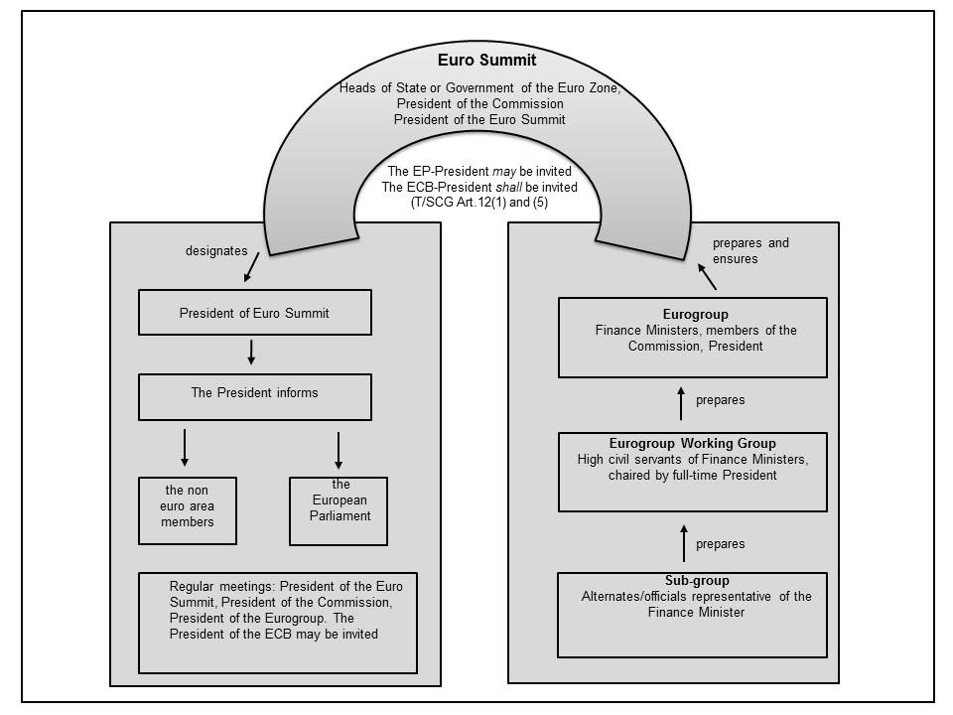 Source: Compiled by the author. Adapted from Conclusions Euro Summit (October 2011: Annex I, TSCG Art.12 and Conclusion 2013 and its Annex ‘Guiding Principles’).

Euro Summit meetings consist of the Heads of State or Government of the eurozone, a president who is appointed at the same time that the European Council elects its president, and the President of the Commission. The President of the ECB is also invited to take part in the meetings. The President of the Euro group, the grouping of eurozone finance ministers, may be invited to attend, and the President of the EP may also be invited in order to be granted a hearing (Art. 4 Guiding Principles of the Euro Summit). A general rule allows for the participation of non-Euro members of the European Council who have ratified the TSCG for discussions concerning competitiveness, the modification of the eurozone’s architecture and the implementation of the TSCG (Art.4(5) Guiding Principles of the Euro Summit).
Efforts to use synergies between the two different summit formats are evident, as ‘The Euro Summit shall meet at least twice a year, convened by its President. Its ordinary meetings shall, whenever possible, take place after the European Council’ (Art.1(1) Guiding Principles of the Euro Summit). In real life, the frequency of meetings depends on the issues at hand and on the overall political context. The Euro Summit met four times each in 2011 and 2012, and only once in 2013 and once in 2014. With a view to achieving continuity and inter-institutional coherence, the rules of procedure stipulate that the ’President of the Euro Summit will ensure the preparation and continuity of the work of the Euro Summit, in close cooperation with the President of the Commission and on the basis of the preparatory work of the Euro Group’ (Art.2(1) Guiding Principles of the Euro Summit;).
Also with the intention of ensuring some consistency between the Euro Summit and the plenary of the European Council, the Heads of State or Government of the eurozone appointed both the first and second permanent President of the European Council also as President of the Euro Summit (Euro Summit March 2012, European Council August 2014). This ‘double hat’ was supposed to alleviate the concerns of those countries that are not part of the Euro Summit that they would become second-rank members, by being obliged to accept what the smaller circle decides, while being unable to influence proceedings directly (see Van Rompuy 2012a: 28). In this sense ‘the President of the Euro Summit will keep the non-euro area Member States closely informed of the preparation and outcome of the Summits. The President will also inform the European Parliament of the outcome of the Euro Summits’ (Art.3 Guiding Principles of the Euro Summit).
The crisis management of the European Council also had other consequences for the institutional set-up, some intended and some unintended. The reinforcement of the position of the President of the European Council vis-à-vis the Commission President is one example. On several occasions members have asked their president to make proposals for the reform of the eurozone. In 2010, Van Rompuy at the behest of the members of the European Council, established and chaired a task force on Economic Governance and in 2012 he presented a paper entitled ‘Towards a genuine Economic and Monetary Union’. While the Commission was involved in both initiatives, the President of the European Council took full responsibility for a task that had previously been offered to the Presidents of the Commission

Conclusion: Towards a Crisis-Driven ‘Gouvernement Économique’
Looking at the multi-faceted performance of the European Council in this policy area, the Heads of State or Government have been highly engaged as a constitutional architect and as a crisis manager. Revisiting this set of activities of the European Council, characterised by the ‘plurality and diversity of instruments and techniques’ (Armstrong 2013: 33), it is stimulating to discuss whether, and in what ways, the European Council or its core group, the Euro Summit, has developed into a dominant ‘gouvernement économique’.
One point of departure for such an analysis is the observation that the deliberations of the European Council have repeatedly demonstrated a fundamental dilemma of the EU’s national leaders. Their problem-solving instinct pushed the Heads of State or Government to make use of the institutional opportunities that their predecessors had created, and to implement an active economic policy. However, the sovereignty reflex can push members of the European Council at least to prioritise forms of ‘soft (economic) governance’ with a process of ‘weak Europeanisation’ (Meyer/Umbach 2007: 114-116). As a consequence of this attitude, the Heads of State or Government failed to create ‘a sovereign political power at the European level to bolster domestic fiscal discipline, create cross-national fiscal stabilisation or strengthen institutional capability to secure banking and financial stability’ (Dyson 2008: 8). Through the Maastricht Treaty and in subsequent treaty revisions and amendments including the Lisbon Treaties, the European Council has tried to narrow the capability-expectations gap (see for the term Hill 1993), caused by the asymmetric ‘fuzzy’ character of EMU (Dyson 2008: 7). However, the activities of the Heads of State or Government and other relevant EU actors remained rather fragmented across the different pillars and levels. Empirical studies until 2008 observed a ‘loose coordination [of European policies] as a patchwork’ (Linsenmann/Meyer et al. 2007b: 218-221).
This reality of having a ‘monetary union without a state’ (Dyson 2008: 6; Deutsche Bundesbank 1992) has supported a trend towards a mixed degree of vertical fusion and a low degree of horizontal fusion (see Linsenmann 2007: 159).
This analysis concerning the first years of EMU has to be revisited in light of the European Council’s measures to react to the financial and economic turbulences and to the eurozone crisis. As expected before (see for example Linsenmann et al. 2007b: 230-231), asymmetric external economic shocks and their widely different consequences for the eurozone states increased the problem-solving demands which the members of the European Council had to face. The Union’s highest executive leaders experienced a dramatic increase in shared responsibilities and felt the need to extend their joint exercise of national and EU instruments in common policy areas. To stabilise the Euro and the EU polity in general, the European Council – and increasingly the Euro Summit – has devised significant initiatives and actions with far-reaching consequences. In direct response to the economic shock, national leaders have used the European Council more than before to shape the work of the EU in all areas of economic governance. Driven by the manifold challenges of various crises, the Heads of State or Government have placed the European Council in the centre of a multilevel, multi-institutional and also multi-governance architecture. This institution has been central to steer growing and increasingly complex economic governance.
In summing up, the European Council has arguably emerged as some kind of ‘economic government’ in the ‘centre of economic governance’ (Puetter 2012: 175). In such a view, ‘the European Council has taken over executive powers in the economic policies that formerly belonged to national decision making´ (De Schoutheete/Micossi 2013: 4) or, in the words of its first permanent President: ‘The European Council becomes something like the ‘gouvernement économique’ […]. The financial and economic crisis obliges us to take steps on this road’ (Van Rompuy 2010).
However, even with the extended list of agreements and acts, the European Council has not yet become a fully-fledged economic government in the convention sense. It does not exercise a complete range of budgetary, social and fiscal competences, and it has left several measures of crisis management from the five pillars weakly coordinated. The record of the crisis years show that the European Council has pursued and reinforced a hybrid mix of modes of governance. Despite considerable efforts, it continues to constitute the imperfect institutional reaction to the fuzziness, fragility and lack of power to deliver answers to collective action problems in the Union´s core area of competence (Dyson 2008: 6-9).
In view of the theoretical approaches often mentioned in the state of the art the assessment of the European Council’s performance and profile in this key area of economic governance varies depending on the focus the observer chooses.
Most observers stress the intergovernmental character of the European Council’s activities, in particular the acts of the Heads of State or Government to create treaties outside the EU’s legal framework. Some characterize major part of these activities as ‘deliberative intergovernmentalism’ (Puetter 2012). However, others argue that the European Council has, in several ways, acted as the primary driving agent for a significant process of spill-over, involving a move towards supranational surveillance of Members States by the Commission and the European Court of Justice (see Fabbrini 2013: 1024-25; Van Rompuy 2012ab: 6).
My analysis claims that the European Council has been the key institution in a transformative process that is driving a vertical fusion between the national and the EU levels, and a horizontal fusion that is taking place between the different EU institutions. The chief national executives have merged their economic agendas and economic instruments from across the national and EU levels. They also have increasingly exercised a shared management of competences and instruments jointly with other EU institutions (Wessels 2009: 177; Howarth 2008: 125-127; Linsenmann/Meyer et al. 2007aa: 17). In reaction to the crisis, the European Council directed policies across a fragmented set of different pillars of economic governance. This practise might change if and when the chief national executives see less need to stabilize the eurozone. The political relevance of the European Council’s activities in economic governance is also high in light of another set of general strategies designed to construct the EU polity. From the founding of the EMS in the late 1970s up until the creation of the Euro Summit, a group of Heads of State or Government has set lasting paths for a (geo-)political and (geo-)economic differentiation within the EU system, for which labels such as ‘core‘, ‘multi-tier’ or ‘two-speed Europe’ are used (see for example Piris 2012; Tekin 2012; Begg 2011: 342-344; Diedrichs/Faber et al. 2011).
The political relevance of these activities is even greater as it goes beyond just looking at the European Council’s record in framing and making economic policy. Since the Schuman declaration in the early 1950s, and following implicitly the Monnet method (Wessels 2014), gradual steps towards economic integration have repeatedly served many governments as a fundamental strategy to pursue (geo-)political interests in and through the EU system. National governments launched economic projects which led to major spill-over into other domains of public policy. Far from merely perceiving the EU as an arena in which to deal only with issues of economic governance, European chief executives have often used the European Council’s economic projects for altering and extending the scope of the EU’s agenda as well as deepening its political construction in the process. A major issue of debate is the way national leaders used economic initiatives as strategic instruments for balancing the power of the largest Member State(s).
Overall, these activities and agreements do not only contribute to a yet inconclusive process towards a ‘gouvernement économique’ but had significant impact on the nature and finalité of the EU polity as a multi-level system in general.

References

Documents:
European Council: European Council Conclusion, 11 March, 2011.
Retrievable under: http://www.consilium.europa.eu/en/european-council/. (last access: 24.02.2015).

Council of the European Union: Guiding Principles of the Euro Summit, 14 March 2013.
Retrievable under: http://www.consilium.europa.eu/en/european-council/pdf/20130314-eurosummits-rules-of-procedure_pdf/. (last access: 24.02.2015).

Euro Summit: Statement of Euro area Heads of State or Government, 2 March 2012.
Retrievable under:
http://www.consilium.europa.eu/uedocs/cms_data/docs/pressdata/en/ec/128521.pdf. (last access: 24.02.2015).

European Council: European Council Conclusions 30 August 2014, EUCO 163/14.
Retrievable under:
http://www.consilium.europa.eu/uedocs/cms_data/docs/pressdata/en/ec/144538.pdf. (last access: 24.02.2015).

Literature:
Armstrong, Kenneth (2013): 'The New Governance of EU Fiscal Discipline', European Law Review: pp. 1-34.
Begg, Iain (2011): 'Lisbon as economic governance: Fusion by dif-fusion?', in Diedrichs, Udo/ Faber, Anne/ Tekin, Funda/ Umbach, Gaby (eds): Europe Reloaded - Differentiation or Fusion? (Baden-Baden: Nomos), pp. 331-351.
Bulmer, Simon/Paterson, William E. (2013): 'Germany as the EU's reluctant hegemon? Of economic strength and political constraints', Journal of European Public Policy, 20(10): pp. 1387-1405.
Commissariat Général du Plan (1999): Le Gouvernement économique de la zone euro, Rapport du groupe présidé par Robert Boyer.
De Schoutheete, Philippe/Micossi, Stefano (2013): 'On Political Union in Europe: The changing landscape of decision-making and political accountability', CEPS Essays, 21 February 2013.
Deutsche Bundesbank (1992): Stellungnahme des Zentralbankrates der Deutschen Bundesbank, in: Die Beschlüsse von Maastricht zur Europäischen Wirtschafts- und Währungsunion, Monatsbericht der Deutschen Bundesbank, Februar.
Diedrichs, Udo/Faber, Anne/Tekin, Funda/Umbach, Gaby (eds) (2011): Europe Reloaded. Differentiation or Fusion?, edn (Baden-Baden: Nomos Verlagsgesellschaft).
Dyson, Kenneth (2008): 'The First Decade: Credibility, Identity and Institutional 'Fuzziness'', in Dyson, Kenneth (ed): The Euro at Ten. Europeanization, Power, and Convergence (New York: Oxford University Press), pp. 1-36.
Fabbrini, Sergio (2013): 'Intergovernmentalism and Its Limits: Assessing the European Union's Answer to the Euro Crisis', Comparative Political Studies, 46(9): pp. 1003-1029.
Gillissen, André (2011): 'Le Conseil européen: un état des lieux', in Charléty, Véronique (ed): Le sytème présidentiel de l´Union européene apès Lisbonne (Strasbourg: École nationale d´aministration), pp. 105-123.
Hill, Christopher (1993): 'The Capability-Expectation Gap, or Conceptualizing Europe's International Role', Journal of Common Market Studies, 31(3): pp. 305-328.
Howarth, David (2008): 'France: The Political Management of Paradoxical Interests', in Dyson, Kenneth (ed): The Euro at Ten. Europeanization, Power, and Convergence (New York: Oxford University Press), pp. 111-132.
Kunstein, Tobias/Wessels, Wolfgang (2011): 'Die Europäische Union in der Währungskrise: Eckdaten und Schlüsselentscheidungen', integration, 34(4): pp. 308-322.
Linsenmann, Ingo (2007): Towards a Horizontal Fusion of Governing Structures? Co-ordinating the Co-ordination Processes Through the Broad Economic Policy Guidelines, edn (Basingstoke: Palgrave Macmillan).
Linsenmann, Ingo/Meyer, Christoph O./Wessels, Wolfgang (2007a): 'Evolution Towards a European Economic Government? Research Design and Theoretical Expectations', in Linsenmann, Ingo/Meyer, Christoph O./Wessels, Wolfgang (eds): EU Economic Government. A Balance Sheet of New Modes of Policy Coordination
(Basingstoke: Palgrave Macmillan
), pp. 11-36.
Linsenmann, Ingo/Meyer, Christoph O./Wessels, Wolfgang (2007b): 'The Limitations of European Economic Governance', in Linsenmann, Ingo/Meyer, Christoph O./Wessels, Wolfgang (eds): Economic Government of the EU (Houndmills, Basingstoke: Palgrave), pp. 211-233.
Ludlow, Peter (1982): The making of the European monetary system : a case study of the politics of the European Community, 1st edn (London Butterworths).
Meyer, Christoph O./Umbach, Gaby (2007): 'Europeanisation of National Economic Governance Through Policy Co-ordination? Gains and Pains of a New Policy Instrument', in Linsenmann, Ingo, Meyer, Christoph O., Wessels, Wolfgang T. (ed): Economic Government of the EU: A Balance Sheet of New Modes of Policy Coordination (Basingstoke: Palgrave Macmillan).
Müller-Graff, Peter-Christian (2011): 'Euroraum-Budgethilfenpolitik im rechtlichen Neuland', integration 4/2011: pp. 289-307.
Paterson, William E. (2011): 'The Reluctant Hegemon? Germany Moves Centre Stage in the European Union', Journal of Common Market Studies (JCMS), 49(S1): pp. 57-75.
Piris, Jean-Claude (2012): The Future of Europe: Towards a Two-Speed Europe?, 1st edn (New York: Cambridge University Press).
Puetter, Uwe (2012): 'Europe's deliberative intergovernmentalism - the role of the Council and European Council in EU economic governance', Journal of European Public Policy, 19(2): pp. 161-178.
Sarkozy, Nicolas (2008): Speech by M. Nicolas Sarkozy, President of the Republic, before the European Parliament, Strasbourg, October 21st 2008 Available at http://www.ambafrance-uk.org/President-Sarkozy-s-speech-before.html [last access: 18.06.2012].
Sarkozy, Nicolas (2011): Discours du Président de la République à Toulon, 1 December 2011 Available at http://de.scribd.com/doc/74394422/Discours-de-Nicolas-Sarkozy-Toulon-le-1er-decembre-2011 [last access: 30/10/2013].
Schäfer, David (2013): 'Der Fiskalvertrag – ein Ausdruck deutscher Hegemonie in der Europäischen Union?', Integration, 2013(2).
Tekin, Funda (2012): Differentiated Integration at Work: The Institutionalisation and Implementation of Opt-Outs from European Integration in the Area of Freedom, Security and Justice, edn (Baden-Baden: Nomos Verlagsgesellschaft).
The Economist (2013): Europe's reluctant hegemon, 15 June 2013, Special report: Germany, pp. 3-6 [last access: 13/09/2013].
Umbach, Gaby/Wessels, Wolfgang (2008): 'The Changing European Context of Economic and Monetary Union: 'Deepening', 'Widening' and Stability', in Dyson, Kenneth (ed): The Euro at Ten. Europeanization, Power, and Convergence (New York: Oxford University Press), pp. 54-68.
Van Rompuy, Herman (2010): 'Address by Herman van Rompuy President of the European Council to the Collège d'Europe, Bruges Concert Hall 'tZand. "The Challenges for Europe in a changing world"').
Van Rompuy, Herman (2012a): 'The European Council in 2011', (Luxembourg): Publications Office of the European Union).
Van Rompuy, Herman (2012b): 'Speech at the Humboldt University, Walter Hallstein Institute for European Constitutional Law "The discovery of co-responsibility: Europe in the debt crisis" ', (Berlin)).
Wessels, Wolfgang (2009): 'Der Europäische Rat als Wirtschaftsregierung, Zur französisch-deutschen Kontroverse', in Knoll, Bodo/Pitlik, Hans (eds): Entwicklung und Perspektiven der Europäischen Union. Festschrift für Dr. Rolf Caesar (Baden-Baden: Nomos Verlagsgesellschaft), pp. 177-191.
Wessels, Wolfgang (2014): 'Revisiting the Monnet Method – A contribution to the periodisation of the European Union’s history', in Bachem-Rehm, Michaela/Türk, Henning (Hrsg.) (ed): Periodisation of the European Union’s History, pp. 49-59.
Wessels, Wolfgang/Linsenmann, Ingo (2002): 'EMU's Impact on National Institutions: Fusion towards a 'Gouvernance Économique' or Fragmentation', in Dyson, Kenneth (ed): European States and the Euro: Europeanization, Variation and Convergence (New York: Oxford University Press), pp. 53-77.

Conclusion of the European Council (March 2011)

